Report
Learning Algorithm:

Our agent uses dqn learning algorithm to train itself. In dqn we train a neural network to estimate the q value for every action.
We uses experience replay to avoid the harmful correlation obtained by taking samples from sequential order. We also use fixed Q targets to avoid carrot stick dangling and avoid noise.
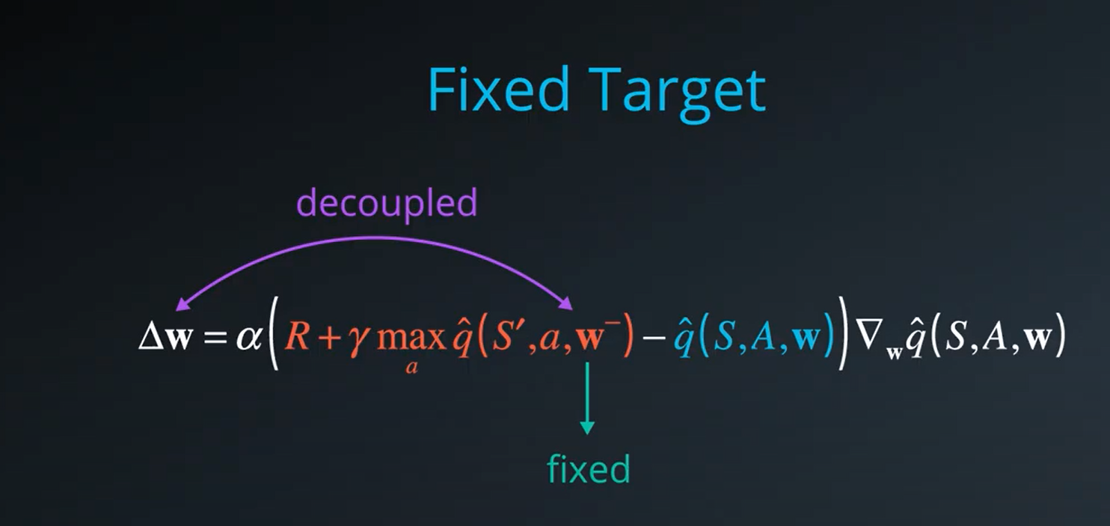

Hyperparameters:
Epsilon is used in epsilon greedy policy the value of epsilon determines the randomness
eps_start=1.0, eps_end=0.01, eps_decay=0.995

replay buffer size = 100000
minibatch size for training = 64
discount factor GAMMA = 0.99
for soft update of target parameters TAU = 1e-3
LR for the optimizer = 5e-4
UPDATE_EVERY = 4 steps for every learning step
plot of average rewards:
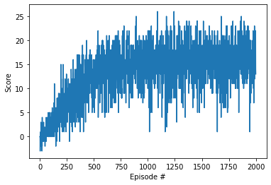

QNetwork deep learning Model:

First layer: 37 X 64

Second layer: 64 X 64

Final layer: 64 X 4

Ideas for Future Work:
To make training process more efficient we can use multi step boostrap targets which is taught in a3c we can also use dueling dqn to separate the advantage and value functions.
We can also use deep minds rainbow algorithm which incorporates many ideas and said to outperform all these individual ideas.

