MIS 6380.002

DATA VISUALIZATION

GROUP 9 PROJECT REPORT

PREPARED BY

Akshata Sasalatti

Shilpa Nataraju

Dheeraj Atmakuri

Sai Teja Reddy Kakuru

Rahul Palisetti

**EXECUTIVE SUMMARY**

***Project Title***

‘Texas Mobility Insights: Navigating the Impact of COVID-19 Policies’

***Project Overview***

This project focuses on evaluating the impacts of COVID-19 policies on human mobility within Texas, targeting specific counties such as Anderson, Dallas, Denton, and others. By harnessing anonymized data from Google's COVID-19 Community Mobility Reports, this study delves into daily changes in people’s movements to various locations, aiming to understand the behavioral shifts due to pandemic-related measures.

***Objectives***

The primary objective is to analyze how various COVID-19 containment measures, such as lockdowns and social distancing mandates, have influenced how individuals work, live, and move within their communities in Texas. This analysis seeks to offer insights into the effectiveness of these public health strategies.

***Hypothesis***

The project posits several hypotheses related to changes in mobility patterns across Texas Counties from 2020 to 2022, focusing on workplaces, grocery and pharmacy visits, park visits, public transit use, and residential stay durations. Key findings include a 20% increase in workplace commuting in 2021 and significant changes in retail and recreation activities, indicating shifts in public behavior in response to the easing of COVID-19 restrictions.

***Data Sources and Methodology***

The data for this analysis is derived from Google’s Community Mobility Reports, which track movement trends over time by geography. Metrics such as changes from a baseline in retail, parks, transit stations, workplaces, and residential areas are examined. The project utilizes a combination of Excel for data cleansing and Tableau for data visualization, enabling effective data manipulation and insightful graphical presentations.

***Key Findings***

* Workplace Mobility: A noticeable increase in people returning to physical workplaces in 2021, suggesting a rebound in economic activities as restrictions eased.
* Retail and Recreation: Improvements were seen in the number of people visiting grocery stores and pharmacies, reflecting a restoration of consumer confidence as the pandemic progressed.
* Park Visitation: There was a substantial increase in park visits in 2021, likely due to the public seeking outdoor activities after periods of stringent lockdowns.
* Public Transit: While there was a slight improvement in public transit use from 2021 to 2022, the figures still reflect a cautious return to public transportation.

**INDEX**

**Table of Contents**

1. Executive Summary .................................................................................... 2
2. INDEX .......................................................................................................... 3
3. Data Description ......................................................................................... 4

* Description of Attributes
* Source of the Data

1. Data Cleaning .............................................................................................. 6
2. General Introduction .................................................................................. 7
3. Insights and Findings ................................................................................... 9

* Hypothesis 1 (Workplace Mobility)
* Hypothesis 2 (Grocery & Pharmacy Stores Mobility)
* Hypothesis 3 (Park Visitation Trends)
* Hypothesis 4 (Public Transit Usage)
* Hypothesis 5 (Residential Mobility)

1. Conclusion .................................................................................................. 26

7.1 Summary of Findings

7.2 Implications of Research

**DATA DESCRIPTION**

**Description of Attributes:**

We have used three Main datasets for our analysis, which contain regional mobility information for three different years: 2020, 2021, and 2022. The number of records in each of them is as follows:

1. 2020_US_Region_Mobility_Report: 5078 records.
2. 2021_US_Region_Mobility_Report: 5340 records.
3. 2022_US_Region_Mobility_Report: 4900 records.

We have 15 attributes/columns in this dataset: ‘2020_US_Region_Mobility_Report’ namely,

* country_region_code – represents the country's region code, which is considered for analysis.
* country_region – represents the name of the country considered for analysis.
* sub_region_1- represents the state in the US. In our dataset, we have chosen only the state of Texas.
* sub_region_2 - represents the county of its respective state in the US. We have considered multiple counties in Texas.
* metro_area – represents the metropolitan area in each county.
* iso_3166_2_code – an international standard created by the International Organization for Standardization (ISO) to provide concise and unique alphanumeric codes for representing the primary administrative divisions and dependent territories of countries. The format typically consists of a two-letter ISO 3166-1 alpha-2 country code followed by alphanumeric characters specific to the subdivision or territory.
* census_fips_code – this code represents the numbers uniquely identifying geographic regions.
* place_id – represents a textual identifier that uniquely identifies a place.
* date – represents the date on which the data was recorded.
* retail_and_recreation_percent_change_from_baseline – represents the amount of retail and recreation percentage change compared to the median value recorded during the 5 weeks Jan 3–Feb 6, 2020.
* grocery_and_pharmacy_percent_change_from_baseline - represents the amount of grocery and pharmacy consumption percentage change compared to the median value recorded during the 5 weeks Jan 3–Feb 6, 2020.
* parks_percent_change_from_baseline - represents the utilization of parks percentage change compared to the median value recorded during the 5 weeks Jan 3–Feb 6, 2020.
* transit_stations_percent_change_from_baseline - represents the utilization of transit stations percentage change compared to the median value recorded during the 5 weeks Jan 3–Feb 6, 2020.
* workplaces_percent_change_from_baseline - represents the percentage change of workplace consumption compared to the median value recorded during the 5 weeks Jan 3–Feb 6, 2020.
* residential_percent_change_from_baseline - represents the amount of residential place consumption percentage change compared to the median value recorded during the 5 weeks Jan 3–Feb 6, 2020.

**Source of the Data:** The data source references to our datasets are:

1. http[s://www.google.com/covid19/mobility/](http://www.google.com/covid19/mobility/)
2. Understand the data - Community Mobility Reports Help (google.com)
3. google.com/covid19/mobility/data_documentation.html?hl=en
4. https://www.dshs.texas.gov/covid-19-coronavirus-disease-2019/texas-covid-19-data

**D****ATA CLEANING**

We have used Microsoft Excel for data cleansing due to its user-friendly interface, extensive range of features, and adaptability. Excel allows us to easily format, sort, and filter data, validate and clean textual data using text functions, locate and replace specific values, and analyze data using built-in tools such as pivot tables and charts. Its comprehensive suite of functions serves as a one-stop solution for efficiently preparing datasets for in-depth analysis. Moreover, Excel's compatibility with various data formats enhances its utility across diverse data sources. In summary, Excel provides a comprehensive solution for efficiently cleaning and preparing our dataset for analysis.

**GENERAL INTRODUCTION**

The COVID-19 pandemic has profoundly impacted global societies, fundamentally altering how people work, socialize, and move within their environments. In response to the spread of the virus, governments worldwide implemented various public health measures ranging from complete lockdowns to social distancing mandates. While necessary to curb the virus's spread, these measures have greatly affected human mobility and economic activities.

**Background**

The state of Texas, like many regions, faced significant challenges during the COVID-19 pandemic. The measures to control the virus's spread drastically changed everyday life, influencing how residents of Texas engaged with their communities and environments. As the state navigated through different phases of restrictions and reopening, understanding the effects of these policy decisions on mobility became crucial. Mobility patterns provide insights into the broader impacts of the pandemic, revealing changes in public behavior and the economic health of various sectors.

**Purpose of the Study**

This project, titled "Texas Mobility Insights: Navigating the Impact of COVID-19 Policies," aims to evaluate the specific impacts of COVID-19-related public health policies on human mobility across Texas. Focusing on selected counties, the study utilizes anonymized mobility data from Google's COVID-19 Community Mobility Reports to analyze shifts in movement to workplaces, retail locations, parks, transit stations, and residential areas.

The project seeks to answer critical questions about the efficacy of public health measures, their socio-economic impacts, and the resilience of communities in adapting to new norms. By examining mobility data from before and during the pandemic, the research aims to highlight how different sectors and regions within Texas responded to the changes brought about by COVID-19 policies.

**Significance**

Understanding these mobility trends is vital for multiple stakeholders, including policymakers, public health officials, urban planners, and the public. The insights gained from this study can inform future strategies for managing public health crises and guide decisions in urban planning and economic recovery initiatives. This research not only contributes to the academic field by providing empirical evidence on the impacts of pandemic policies but also serves practical purposes by formulating more targeted and effective measures should similar situations arise.

By bridging the gap between policy decisions and actual human behavior, this project contributes to a more nuanced understanding of the dynamic interplay between public health directives and community responses in Texas during an unprecedented global health crisis.

**INSIGHTS AND FINDINGS**

**Hypothesis 1:**

There was a noticeable shift in commuting patterns in Texas from 2020 to 2021. Specifically, in 2021, there was a 20% increase in the number of individuals commuting to their workplaces across various counties in Texas. This change can be attributed to the easing of strict lockdown measures and the gradual reopening of businesses, which allowed more employees to return to their workplaces physically.

**Insights:**

* Urban areas like Dallas, Denton, and Collin counties experienced significantly higher case numbers than rural counties like Coke and Bailey.
* The initial months of the pandemic saw a sharp decline in workplace attendance, indicating a swift transition to remote work and adherence to lockdown measures.
* Although there were fluctuations throughout 2020 and 2021, overall workplace mobility remained below pre-pandemic levels, indicating a persistent impact on work patterns.
* By November 2021, there was a slight improvement, suggesting a cautious return to workplaces as conditions improved.
* The trajectory of confirmed cases steadily increased from February 2020 to November 2021, with significant jumps around August and November 2020.
* Despite various efforts, including lockdowns and public health measures, the data reflects the relentless and escalating nature of the virus over the two years.

Below are the Tableau visualizations done for Hypothesis 1:

**Findings:**

• A clear correlation exists between the increase in confirmed COVID-19 cases and the decrease in workplace mobility, indicating a responsive adjustment to mitigate virus transmission.

• The disparities in case numbers between Texas counties underscore the necessity for tailored public health approaches to cater to the unique needs of diverse communities.

• Workplace mobility patterns demonstrate the flexibility of businesses and employees in adapting to remote work and evolving work dynamics during health emergencies.

• Despite minor fluctuations, workplace mobility remained consistently lower than pre-pandemic levels throughout 2020 and 2021, suggesting businesses' and employees' sustained adoption of remote work practices. This adaptation has implications for future workforce management strategies.

• While Texas experienced an overall increase in confirmed COVID-19 cases, the timing and severity of outbreaks varied across different counties, emphasizing the importance of localized responses to public health challenges.

Hence, we accept Hypothesis 1.

**Hypothesis 2:**

In Texas, from April 2020 to August 2021, there was a significant improvement in the number of people visiting U.S. Grocery & Pharmacy Stores. The percentage increased from -15.57% to 4.00%, representing 19.57% growth. This indicates a noticeable change in consumer behavior. This can be attributed to easing COVID-19 restrictions and increased public confidence, making people more comfortable shopping.

**Insights:**

* The year 2020 started with a sharp decline in visits to grocery and pharmacy stores, reaching a low in April (-4,069 percent change from baseline). This dip can be associated with the initial impact of COVID-19 and the implementation of restrictive measures.
* A substantial rebound was observed in May 2020 (2,280 percent change from baseline), possibly due to the stockpiling behavior as consumers adjusted to the pandemic conditions.
* Post-May, there's a general downward trend in the number of visits, stabilizing toward the end of the year. This could be due to the adaptation of online shopping or continued concerns about COVID-19 exposure.
* The year 2021 begins with negative values but shows an overall upward trend. The significant rise in July and August (above 3,000 percent change from baseline) supports the improvement hypothesis.
* The consistent growth from January 2021 suggests a return to regular shopping patterns as restrictions might have been eased and vaccination programs rolled out, contributing to increased consumer confidence.

Below are the Tableau visualizations done for Hypothesis 2

**Findings:**

* The data supports the hypothesis that there was a significant improvement in visits to grocery and pharmacy stores from the lowest point in 2020 to a point of growth in 2021.
* The initial sharp decline and subsequent increase in visits are consistent with the timeline of the pandemic's impact, the introduction of restrictions, and, later, the lifting of these restrictions.
* The data also suggests a possible shift in consumer behavior with a more pronounced return to in-store shopping in 2021, likely influenced by the public’s adaptation to the pandemic and the sense of safety from vaccination campaigns.
* While the national trend shows improvement, the county-wise analysis indicates that experiences varied locally, with some counties recovering faster than others.

Hence, we accept Hypothesis 2.

**Hypothesis 3:**

In April 2021, the number of people visiting parks and other outdoor recreational areas in Texas increased by 31.57% compared to April 2020. This rise can be attributed to the easing of restrictions, which has allowed these establishments to reopen with limited capacity and safety protocols. As a result, more visitors have been attracted to these locations.

**Insights:**

1. Weather and Mobility Correlation:
   * Favourable weather conditions, particularly the mild temperature ranges in April 2021, played a crucial role in the increased park visitations, as mild weather makes outdoor activities more appealing.
2. Public Confidence Boosted by Vaccination:
   * The widespread distribution of COVID-19 vaccines, especially in densely populated counties, appears to have significantly boosted public confidence, allowing more individuals to feel safe engaging in public and outdoor activities.
3. Perception of Safety and Fatality Trends:
   * A decrease in COVID-19 fatalities, particularly noticeable in the latter half of 2021, correlates with increased public perception of safety, contributing to more people venturing outdoors.
4. Impact of Public Health Policies on Outdoor Activity:
   * Fluctuations in park visitation reflect the direct impact of public health policies and pandemic trends. Periods of eased restrictions and successful vaccination campaigns correlate with spikes in park visitation.

Below are the Tableau visualizations done for Hypothesis 3.

**Findings:**

* 31% Increase in Park Visitation:
  + There was a significant 31% increase in the number of people visiting parks in April 2021 compared to April 2020, driven by the easing of COVID-19 restrictions.
* Variability in Park Visitation Trends:
  + The data shows substantial variability in park visitation over time, with notable increases when COVID-19 restrictions were lifted or when vaccination rates were high.
* Role of Specific Factors in Behavioural Shifts:
  + Key factors such as vaccination rates, weather conditions, and COVID-19 fatality trends play crucial roles in influencing behavioural shifts towards increased park visitation.
* Dashboard Utility in Analysing Trends:
  + Overall, the dashboard presents a comprehensive analysis showing the interplay between weather, vaccination progress, fatality trends, and mobility changes, which collectively support the hypothesis of increased park visitation following the easing of COVID-19 restrictions.
  + Utilizing a dashboard that combines different data visualizations provides a comprehensive view of how various factors impact human mobility and behaviour, mainly outdoor recreational activities during the pandemic.

So, after analysing the hypothesis by considering these various factors, I accept the hypothesis 3 statement that visits to parks in Texas increased considerably in April 2021 than compared to April 2020.

**Hypothesis 4:**

Between March 2020 and March 2022, there has been a gradual increase in the use of public transportation by the citizens of Texas, according to the Transit Stations mobility reports. In March 2021, the mobility of individuals was down by -26.00% compared to March 2020. However, by March 2022, it had slightly improved to -24.43%. This represents a 1.29 percentage point increase from 2021 to 2022, indicating a slow but ongoing return to public transit use.

**Insights:**

* Initial Decrease in Public Transit Use: In March 2020, there was a significant decrease in public transit usage, with mobility at transit stations down by 26%. This decrease was likely due to the initial impact of COVID-19, which included lockdown measures, social distancing guidelines, and public hesitancy to use shared transportation modes due to health concerns.
* Recovery and increase in 2021: By March 2021, the mobility in transit stations had improved by 30% compared to the previous year. This suggests a substantial rebound, indicating a return of confidence in public transit as a safe mode of transportation.
* Influence of Public Health Measures and Vaccine Rollout: The improvement in public transportation use can be associated with several factors, including the implementation of enhanced safety and sanitation measures in public transit systems, the gradual lifting of lockdown measures, and the commencement of COVID-19 vaccination programs, which may have contributed to increased public confidence.
* Economic and Social Reopening: The increase in public transportation use also aligns with the broader economic and social reopening during this period. As businesses and workplaces began to reopen, more people resumed their usual commuting patterns.

Below are the Tableau visualizations done for Hypothesis 4:

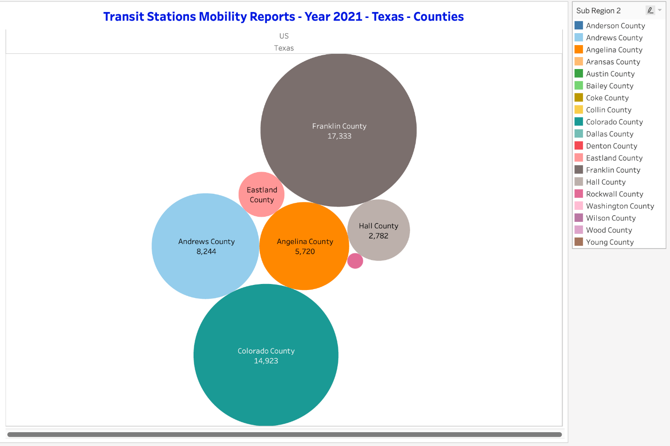

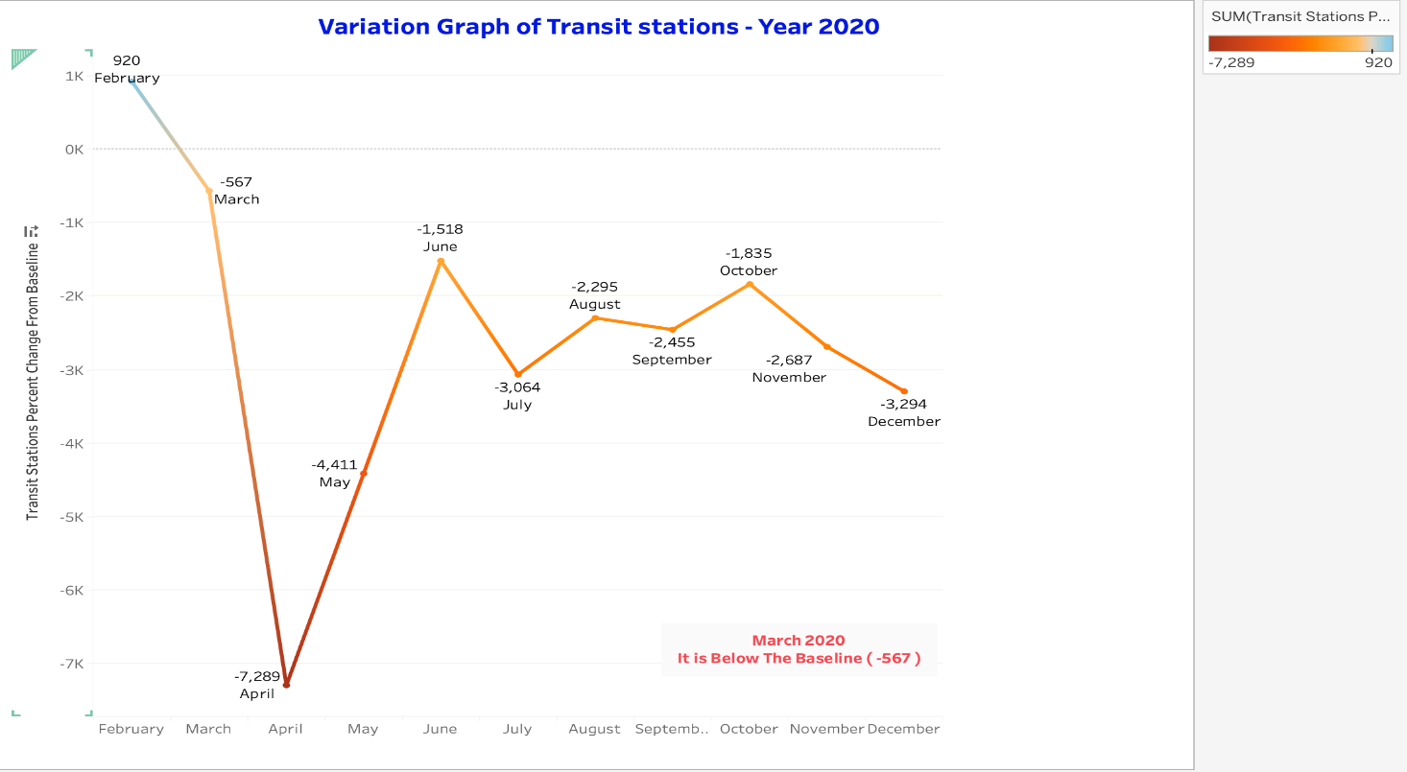

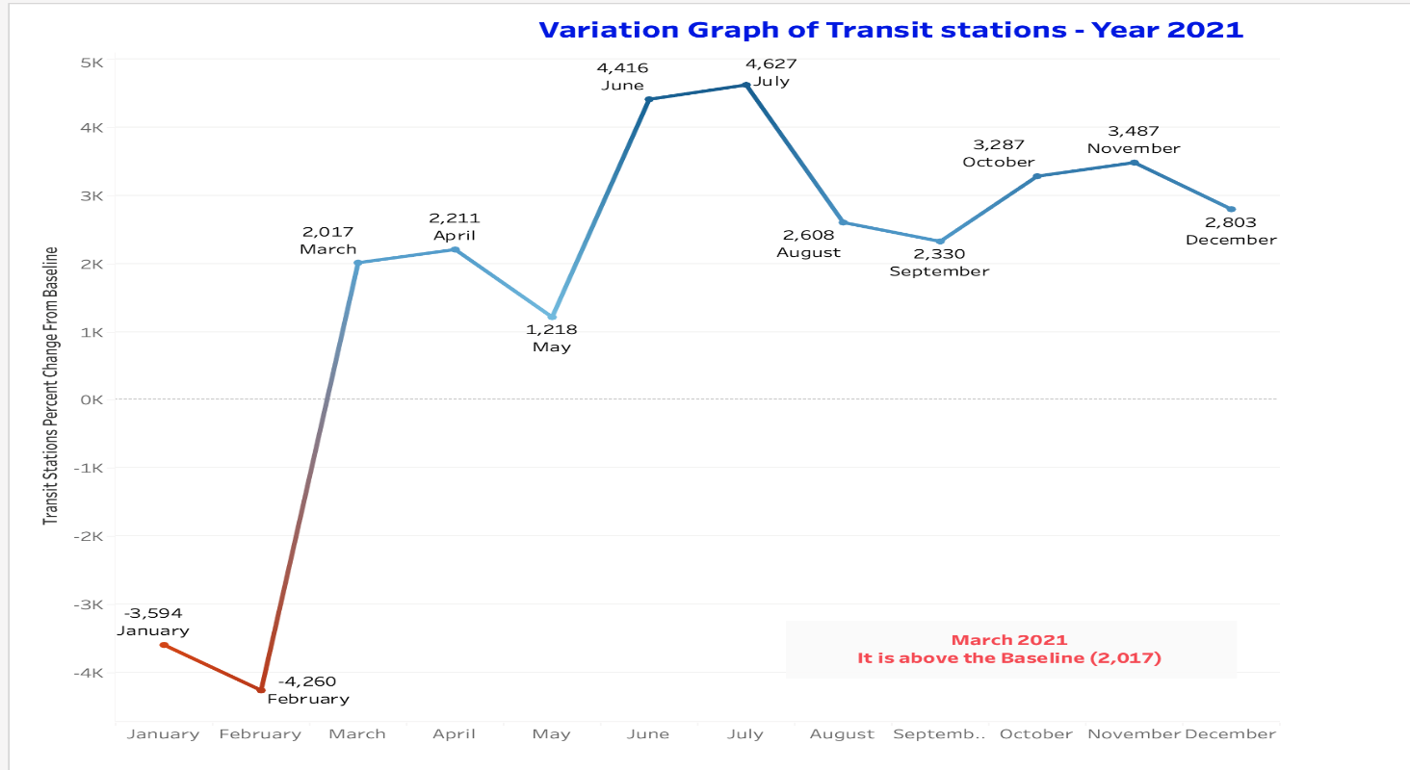

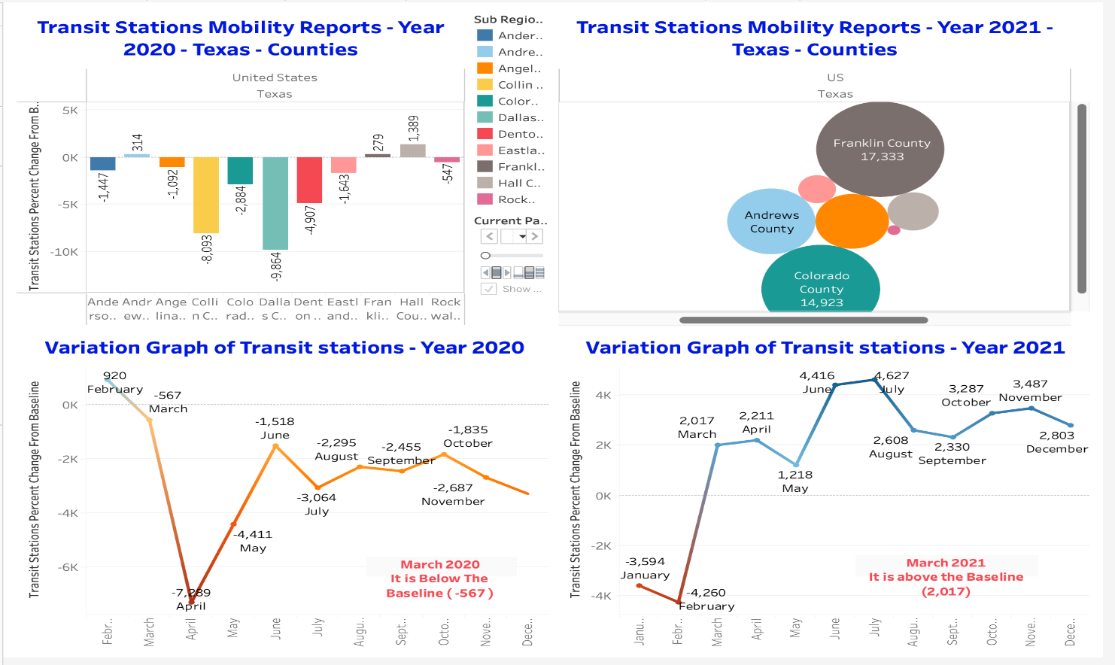

**Findings:**

* In March 2020, there was a precipitous drop in mobility at transit stations, falling to an adverse change from the baseline, reflecting the immediate impact of the COVID-19 outbreak and subsequent lockdown measures.
* April 2020 saw the lowest point in public transit usage, with the change from baseline hitting nearly -7,800, indicating that public transit stations were extremely low, likely due to the strictest phase of lockdown and public apprehension regarding the use of shared transportation modes.
* Following the low point in April, there appears to be a slight improvement from May 2020 onwards, suggesting the beginning of a slow recovery in public transit use as restrictions started to be eased.
* Throughout the remainder of 2020, transit station mobility remained below the baseline, indicating a sustained reduction in usage compared to pre-pandemic levels, although the negative values were becoming less severe over time.
* By March 2021, the situation had improved considerably, with the mobility at transit stations rising above the baseline by over 2,000, reflecting a 30% increase from the previous year. This shift suggests a significant rebound in public transit usage.
* The bubble chart for 2021 shows variance among different counties, with some, like Franklin and Colorado County, experiencing high positive changes from the baseline, which may indicate regional differences in recovery rates or the easing of restrictions.
* The variation graph for 2021 displays a fluctuating trend, with some months showing high positive changes, indicating a return to or even an increase beyond pre-pandemic usage of transit stations in specific periods.

Hence, we accept Hypothesis 4.

**Hypothesis 5:**

In Texas, residents spent an average of 13.43% less time at home in 2021 than the previous year. This decrease can be attributed to the fact that in 2020, many people chose to stay at home and limit their social activities due to concerns about COVID-19. However, as COVID-19 cases declined, individuals gradually started venturing out more and resuming socializing with others.

**Insights:**

* The significant reduction in time spent at home in 2021 indicates a shift towards more normal social and work behaviors as people adapted to changing COVID-19 conditions.
* The easing of restrictions and the decrease in COVID-19 cases likely encouraged people to resume social activities and reduce the time spent confined at home.
* The availability of COVID-19 vaccines and decreased case numbers boosted public confidence, allowing individuals to feel safer while engaging in activities outside their homes.
* Different sectors saw varying degrees of mobility change, with significant increases in outdoor activity and gradual improvements in public transportation usage, highlighting areas where public confidence in safety measures improved more quickly.

Below are the Tableau visualizations done for the Hypothesis 5

**Findings:**

* Residents in Texas spent 13.43% less time at home in 2021 compared to 2020.
* There was a 20% increase in the number of individuals commuting to their workplaces, reflecting a shift to physical office environments.
* Visits to parks and outdoor recreational areas increased by 31.57% in April 2021 compared to April 2020.
* From March 2020 to March 2022, there was a slow but ongoing increase in the use of public transportation, with a slight improvement noted from March 2021 to March 2022.

Hence, we accept Hypothesis 5.

**CONCLUSION**

**Summary of Findings:**

The study "Texas Mobility Insights: Navigating the Impact of COVID-19 Policies" has provided significant insights into how COVID-19 containment measures affected mobility patterns across various sectors in Texas.

Key findings include:

1. *Increased Workplace Commuting*: Data indicated a 20% increase in commuting to workplaces by 2021, suggesting a significant rebound in physical office attendance as restrictions eased and businesses reopened.

2. *Retail and Recreation Recovery*: There was a noticeable improvement in visits to grocery stores and pharmacies, with a shift from a -15.57% change at the start of the pandemic to a 4% increase, reflecting a return of consumer confidence and adaptation to new shopping behaviours.

3. *Enhanced Park Visitation*: The easing of restrictions led to a 31.57% increase in park visitation in April 2021 compared to the same month in 2020, highlighting a strong public desire to engage in outdoor activities after prolonged lockdown periods.

4. *Slow Return to Public Transit*: While public transit usage showed a marginal improvement from 2021 to 2022, it remained below pre-pandemic levels, indicating ongoing public caution or shifts to alternative modes of transportation.

5. *Decreased Residential Stay*: There was a 13.43% decrease in time spent at home in 2021 compared to 2020, suggesting that individuals increasingly engaged in activities outside their homes as fears about the pandemic diminished.

**Implications of Research:**

The findings of this research have several important implications for public policy, urban planning, and future pandemic response strategies:

* *Policy Adaptation*: Understanding mobility trends can help policymakers tailor public health directives that better align with actual behaviour patterns, ensuring that measures such as lockdowns or reopening are timed appropriately to maximize compliance and effectiveness.
* *Urban Planning*: Insights into how people move within their communities can inform urban planning decisions, such as enhancing public transit systems or expanding green spaces to accommodate increased demand for outdoor activities.
* *Public Health Strategies*: The correlation between vaccination rates and increased mobility underscores the importance of effective vaccination campaigns in restoring public confidence and normalizing activities.
* *Economic Recovery*: Data on workplace and retail mobility can guide economic recovery strategies, helping to identify sectors that are rebounding and those that may require additional support or intervention.
* *Long-term Behavioural Insights*: The shifts in residential and park visitation patterns offer a glimpse into potential long-term changes in lifestyle, which could have lasting impacts on everything from real estate markets to recreational industry investments.

In conclusion, this study sheds light on the immediate impacts of COVID-19 policies on mobility and provides a foundation for anticipating and managing future crises. By leveraging detailed mobility data, stakeholders can craft more responsive and practical approaches to public health and urban management, enhancing resilience in the face of pandemic threats.