Its a simple web application where our aim is to import data in oracle database using excel file.

Prerequisites:
These s/w needs to be installed first:
Ruby, rails , Oracle

Following steps needs to be follow:

- rails new blog -d oracle
- cd blog
- rails g scaffold comic title:string issue:integer publisher:string

Above mention steps prepare all the necessary structure for the application

Now we need to configure the database.yml file for oracle database connection.

Below is the database.yml configuration for development environment.
default: &default
adapter: oracle_enhanced //for rails4 and above rails version
username: dheeraj //User name for database
password: root //password for database
development:
<<: *default
database: xe //SID, This is very important step
Apart from database.yml configuration, we need to install few additional gems(below mentioned gems) for the oracle database connection.
Gem ‘ruby-oci8’
Gem ’activerecord-oracle_enhanced-adapter’
then run the bundle install command for update the gem file.
- rake db:migrate
- rails server
Open web browser and type http://localhost:3000
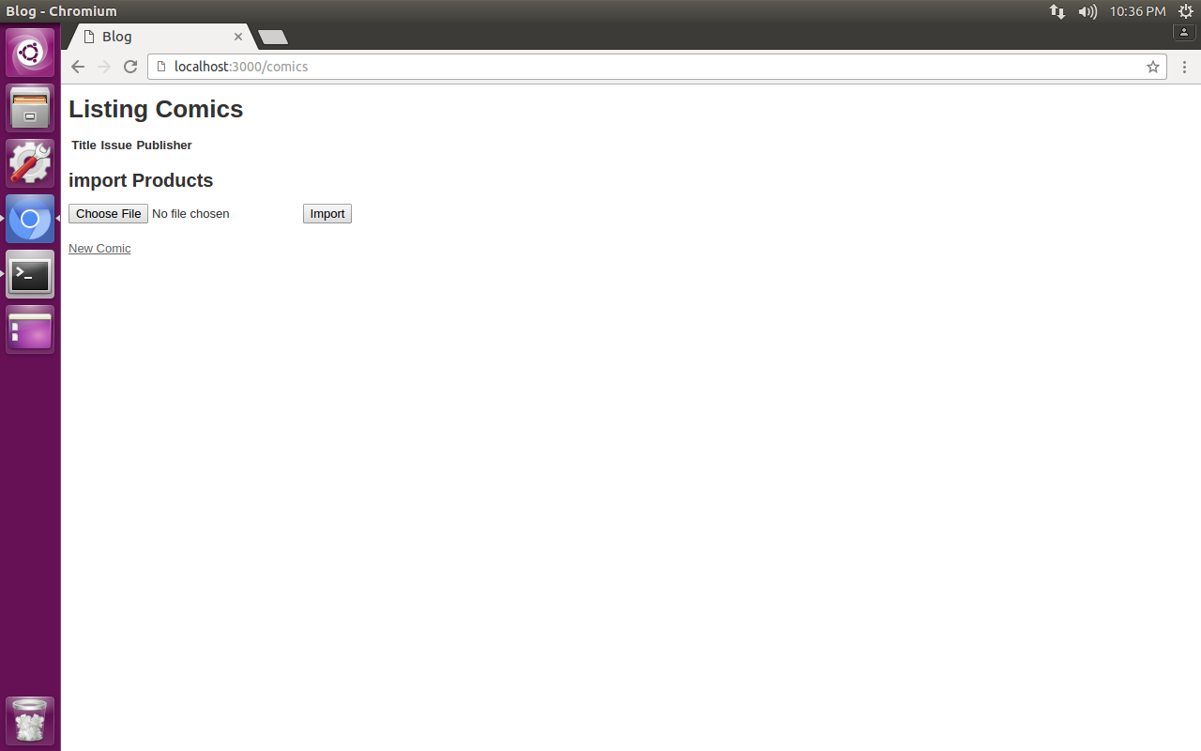
Here you can add single record or import whole xls/csv file.
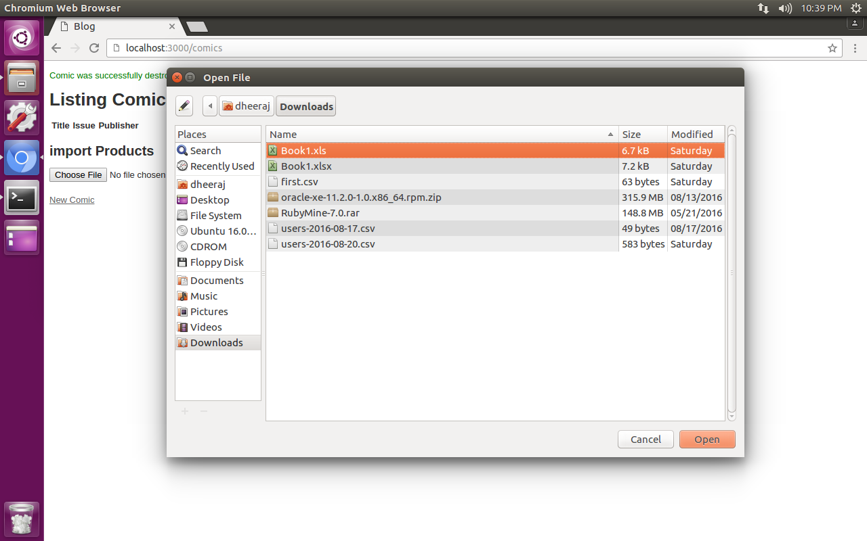
Import xls or csv file.
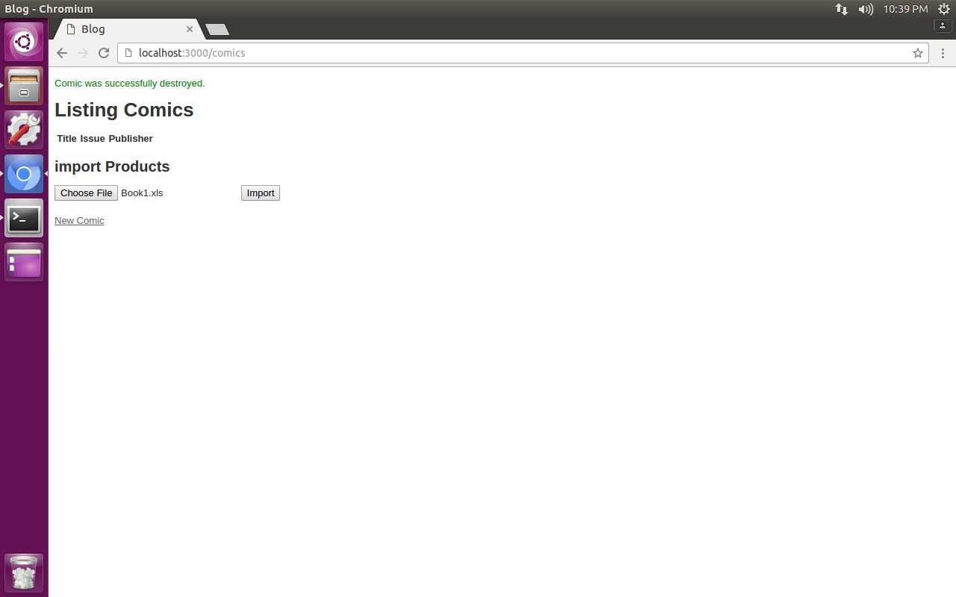
Here xls file imported now click on import button data would added successfully in database.
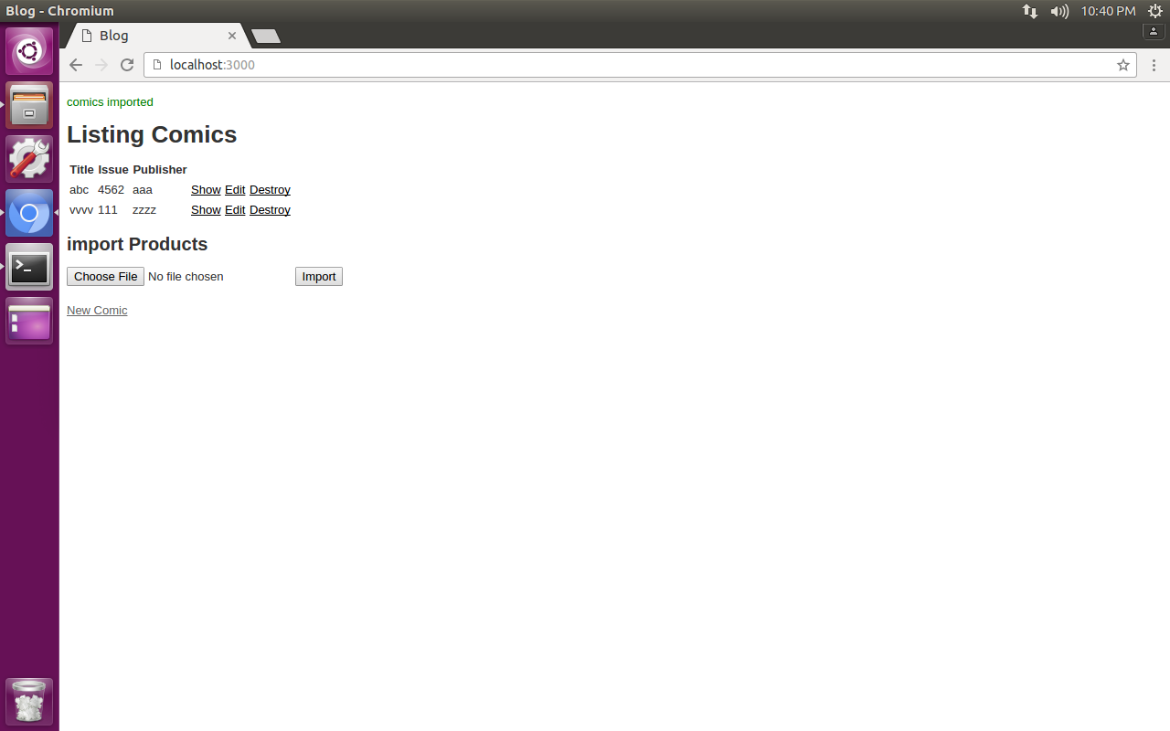

All the recored successfully installed in the database.

