|  |  |
| --- | --- |
| **Technologies** |  |
| Backend | Spring Boot, Jpa |
| Database(In memory) | H2 |

Store longest palindrom value <http://localhost:8080/saveLongestPalindrome>

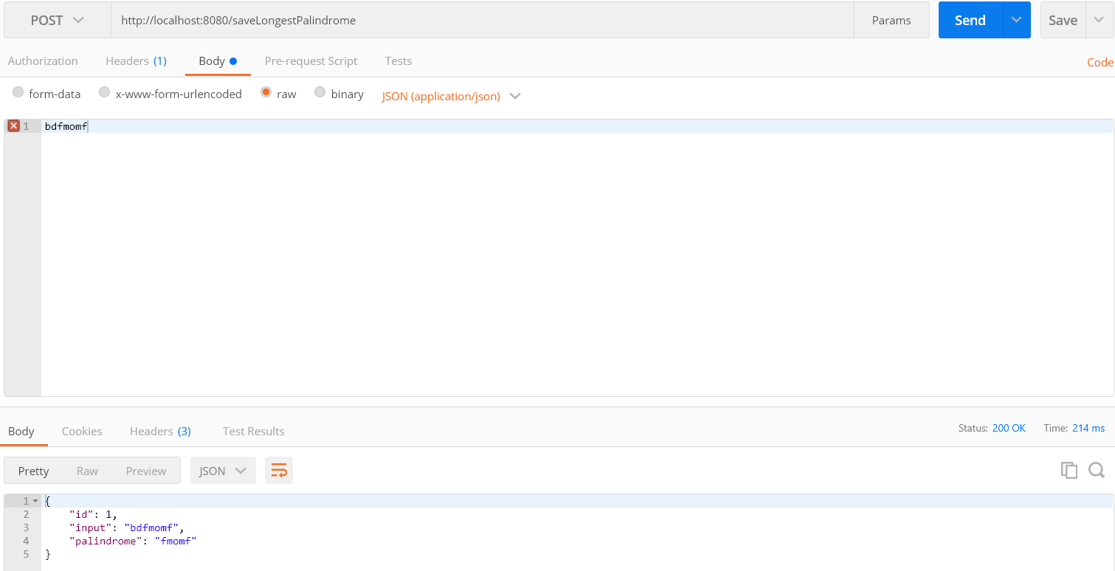

Input length is morethan 1000, we will get exception(“Please try with less than 1000 characters”)

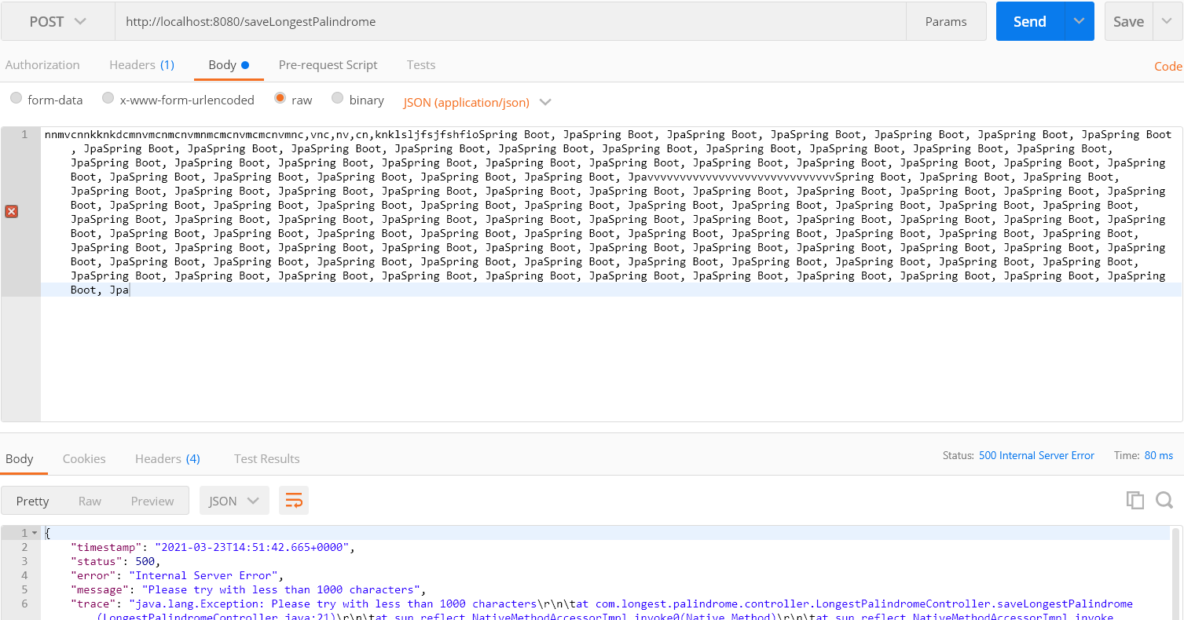

Get the longest palindrom value, <http://localhost:8080/getLongestPalindrome/bdfmomf>

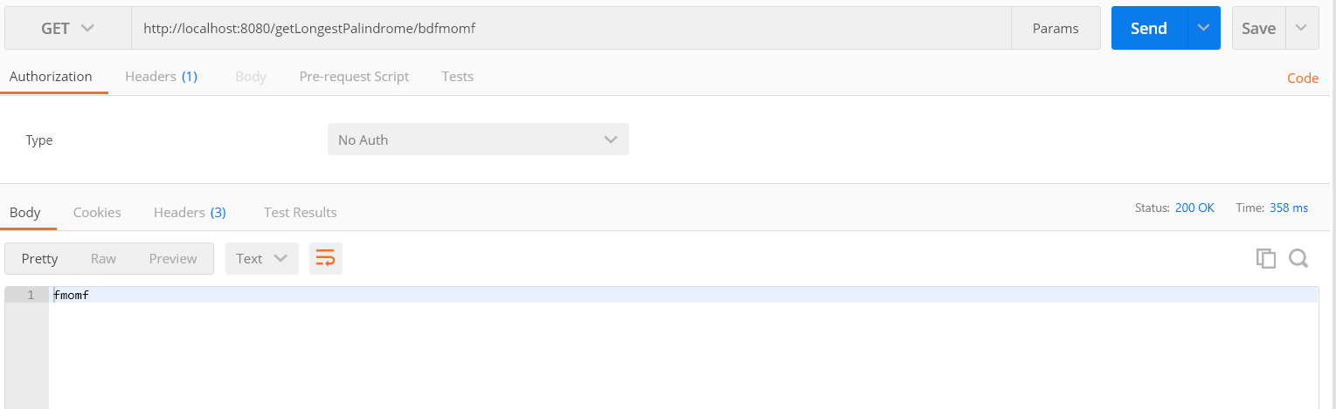

Incase of value is not available in Database

