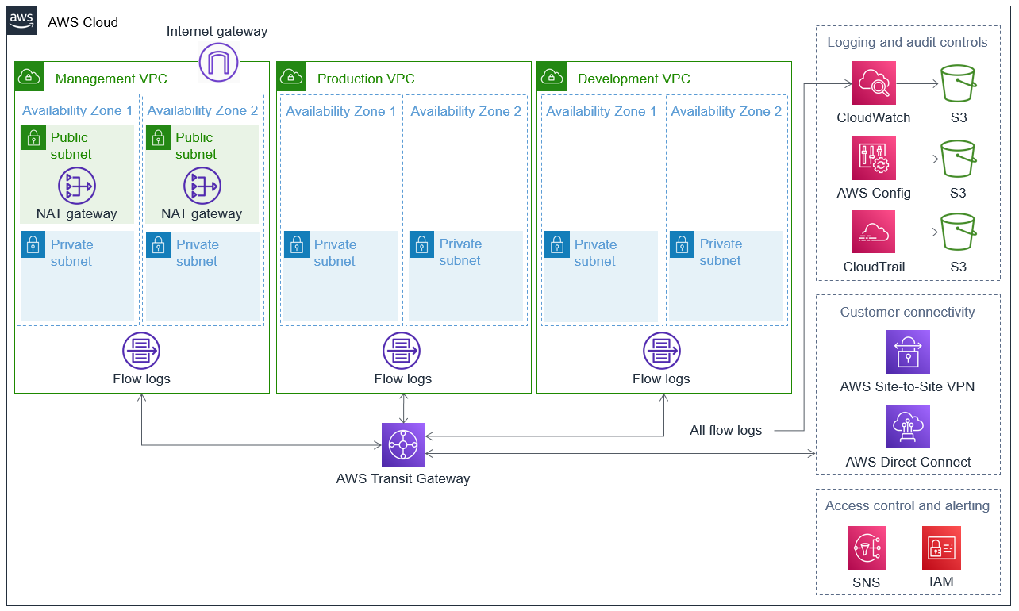

the Quick Start sets up the following:

* A highly available architecture that spans two Availability Zones.
* Three virtual private clouds (VPCs): management, production, and development. The VPCs are configured with subnets, according to AWS best practices, to provide you with your own virtual network on AWS.

In the management VPC:

* + The internet gateway, which serves as a highly available centralized point of egress for internet traffic.
  + **Public subnets** that include managed network address translation (NAT) gateways to allow outbound internet access for resources in the private subnets.
  + **Private subnets** for deploying your security and infrastructure controls.
  + Flow logs for auditing

In the production VPC:

* + Private subnets for deploying your production workloads.
  + Flow logs for auditing.

In the development VPC:

* + Private subnets for deploying your development workloads.
  + Flow logs for auditing
* AWS Transit Gateway for VPC-to-VPC communication and customer connectivity.
* For logging and audit controls:
  + Amazon CloudWatch for metric monitoring and threshold alarms. This service delivers flow logs to an S3 bucket.
  + AWS Config with the conformance pack for HIPAA, maps HIPAA requirements to AWS configuration items. This service delivers flow logs to an S3 bucket.
  + AWS CloudTrail for AWS access logging. This service delivers flow logs to an S3 bucket.
* For access control and alerting:
  + Amazon Simple Notification Service (Amazon SNS) for sending email alerts from alarms.
  + AWS Identity and Access Management (IAM) for access control and authorization