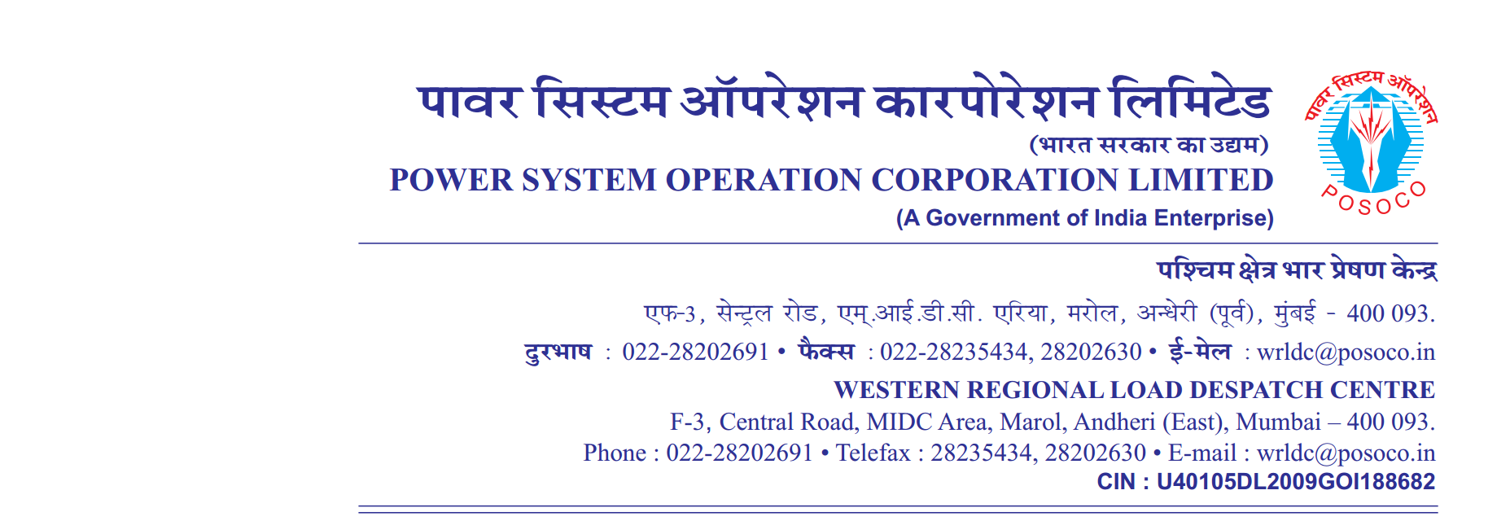

**साप्ताहिक विवरण**

Weekly Report वर्ष 2020-21/ सप्ताह संख्या 18 अवधि 2020-07-23 से 2020-07-31

Year 2020-21 / Week No 18 Period from 2020-07-23 to 2020-07-31

**Annexture-II**

**Instances of persistent/significant non-complainceof IEGC 5.5.1(e) (2020-07-23 to 2020-07-31)**

**Desired Output:**

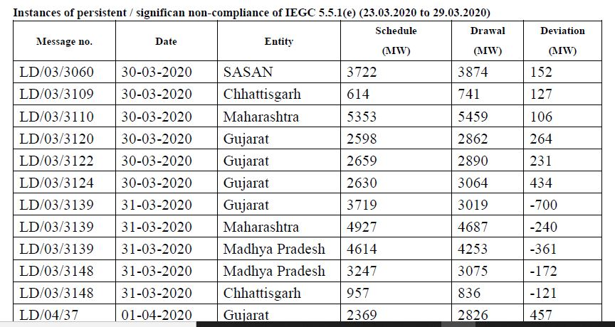

**output(as per template syntax)**

|  |  |  |  |  |  |
| --- | --- | --- | --- | --- | --- |
| **Message no.** | **Date** | **Entity** | **Schedule**  **(MW)** | **Drawl**  **(MW)** | **Deviation**  **(MW)** |

|  |  |  |  |  |  |
| --- | --- | --- | --- | --- | --- |
| क्रमांक  Sr.No. | वाइड एंगल जोड़ी  Wide Angle pair | कोणीय सीमा  Angular limit | उल्लंघन(प्रतिशत में )  violation | अधिकतम डिग्री  max (degrees) | न्यूनतम डिग्री  min (degrees) |
| 1. | CGPL-Dehgam | 40 | 35.63 | 79.43 |  |
| 1. | CGPL-Dehgam | 40 | 0 | 79.43 |  |
| 1. | VSTPS-Asoj | 60 | 0 | 33.91 |  |
| 1. | Raipur-Kalwa | 60 | 0 | 37.5 |  |
| 1. | Korba-Raipur | 30 | 0 | 8.37 |  |
| 1. | Jabalpur-Bina(MP) | 30 | 0 | 6.97 |  |
| 1. | Korba-Kalwa | 65 | 0 | 45.43 |  |
| 1. | Kalwa-Solapur | 30 | 0 | nan |  |
| 1. | Raipur-Solapur | 50 | 0 | nan |  |
| 1. | Jabalpur-Asoj | 40 | 0 | 21.53 |  |
| 1. | VSTPS-Bina(MP) | 40 | 0 | 18.85 |  |
| 1. | Boisar-Kalwa | 30 | 0 | 5.88 |  |

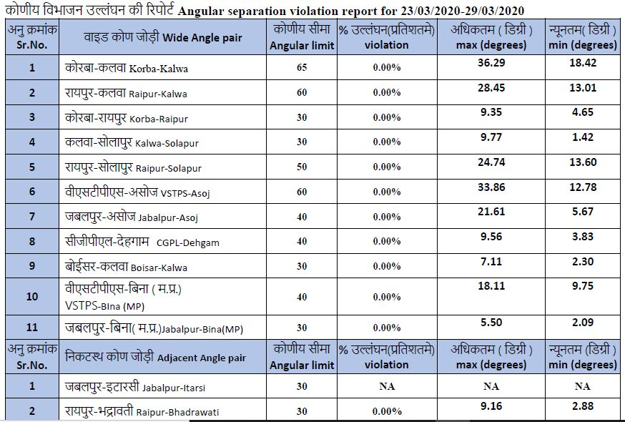

**output(as per template syntax)**