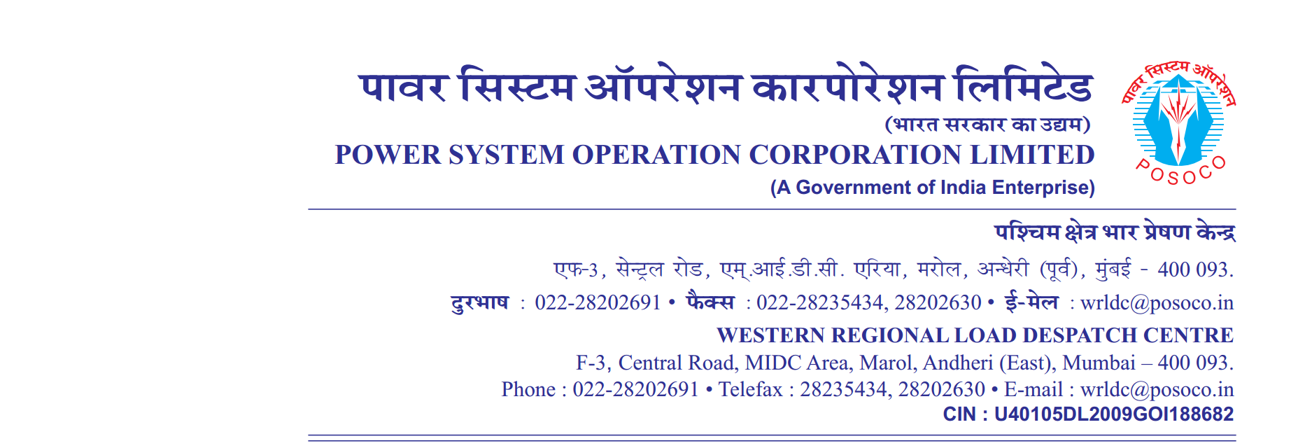

**साप्ताहिक विवरण**

Weekly Report वर्ष {{yr_str}}/ सप्ताह संख्या {{wk_num}} अवधि {{st_dt}} से {{end_dt}}

Year {{yr_str}} / Week No {{wk_num}} Period from {{st_dt}} to {{end_dt}}

**Annexture-II**

**Instances of persistent/significant non-complainceof IEGC 5.5.1(e) ({{**st_dt}} to {{end_dt}}**)**

**Desired Output:**

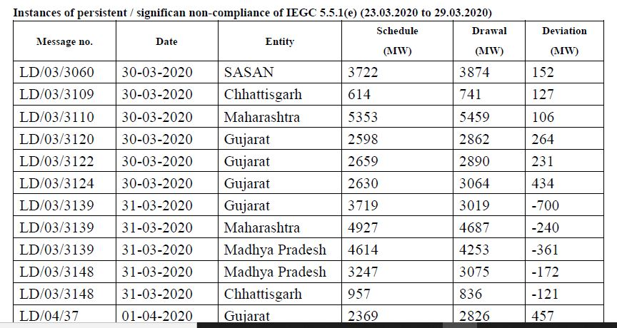

**output(as per template syntax)**

|  |  |  |  |  |  |
| --- | --- | --- | --- | --- | --- |
| **Message no.** | **Date** | **Entity** | **Schedule**  **(MW)** | **Drawl**  **(MW)** | **Deviation**  **(MW)** |
| {%tr for row in iegc_data%} | | | | | |
| {{row.message}} | {{row.date}} | {{row.entity}} | {{row.schedule }} | {{row.drawal }} | {{row.deviation }} |
| {%tr endfor %} | | | | | |

|  |  |  |  |  |  |
| --- | --- | --- | --- | --- | --- |
| क्रमांक  Sr.No. | वाइड एंगल जोड़ी  Wide Angle pair | कोणीय सीमा  Angular limit | उल्लंघन(प्रतिशत में )  violation | अधिकतम डिग्री  max (degrees) | न्यूनतम डिग्री  min (degrees) |
| {%tr for row in angleData %} | | | | | |
| 1. | {{ row.wide_angle_pair}} | {{ row.angular_limit}} | {{ row.violation}} | {{ row.max_degree}} | {{ row.min_degree }} |
| {%tr endfor %} | | | | | |

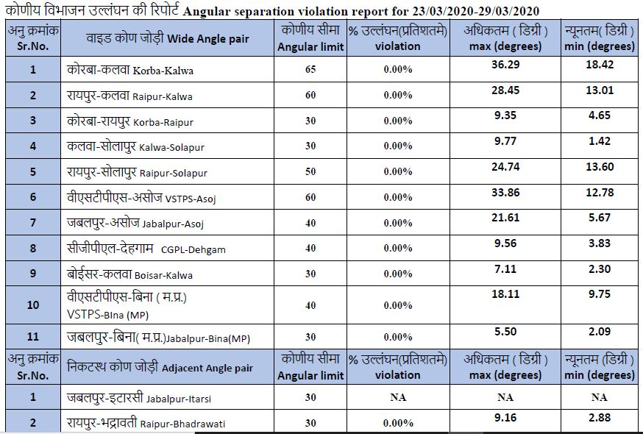

**output(as per template syntax)**