**Configuration File Format:**

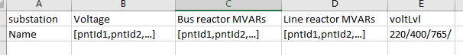

**Code Flow:**

Step 1: Loop on substation

Step 2: Check for Bus 1 voltage:

If Data correct > Continue with Bus 1 Voltage

Else Check for Bus 2 Voltage and continue with Bus 2 Voltage

Step 3: Call Data Fetcher Function with format as follows:

DataFetch(Point Id, Start Time, End Time)

Step 4: Do the analysis for current substation if any High Voltage or Under Voltage is observed

Step 5: Take decision based on the Voltage Condition