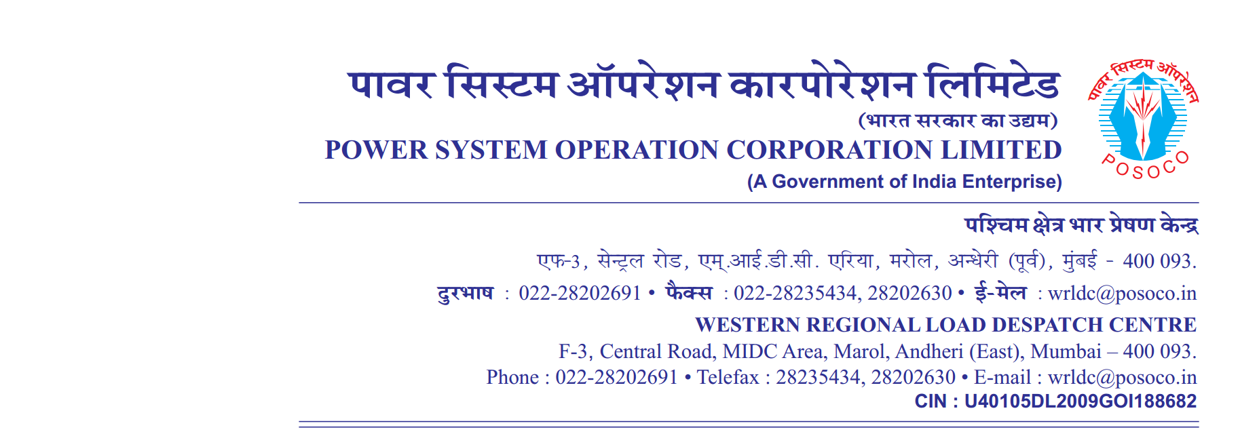

**साप्ताहिक विवरण**

Weekly Report वर्ष {{yr_str}}/ सप्ताह संख्या {{wk_num}} अवधि {{st_dt}} से {{end_dt}}

Year {{yr_str}} / Week No {{wk_num}} Period from {{st_dt}} to {{end_dt}}

**Annexture-II**

**Instances of persistent/significant non-complainceof IEGC 5.5.1(e) ({{**st_dt}} to {{end_dt}}**)**

| **Sr. No.** | **Message No.** | **Date** | **Entity** | **Schedule**  **(MW)** | **Drawal**  **(MW)** | **Deviation**  **(MW)** |  |  |
| --- | --- | --- | --- | --- | --- | --- | --- | --- |
| {%tr for row in iegc_data %} | | | | | | | | |
|  | {{ row.message }} | {{ row.date }} | {{ row.entity }} | {{ row.schedule }} | {{ row.drawal }} | {{ row.deviation }} |  |  |
| {%tr endfor %} | | | | | | | | |

D. परागमन का प्रतिबंध (यदि कोई हो) Transmission Constraints IEGC 5.5.1.C (D) (IF ANY) : Annexure-I

E. Instances of Persistent / Significant Non-Compliance of IEGC 5.5.1.C (E) : Annexure-II

F. Instances of Congestion In Transmission System IEGC 5.5.1.C (F) (IF ANY) : Annexure-III -NIL

G.कोणीय विभाजन उल्लंघन की रिपोर्टAngular separation violation **:** Annexure-IV

H**.** साप्ताहिक विद्युत दाब विचलन सूचकांकWeekly VDI From **:** Annexure-V

**( ABCD )**

**महाप्रबंधक**