OUTPUT IMAGES FOR TASK I
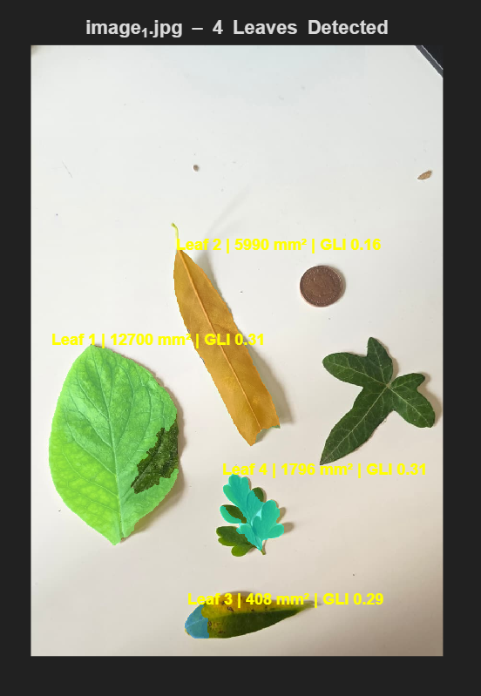 | 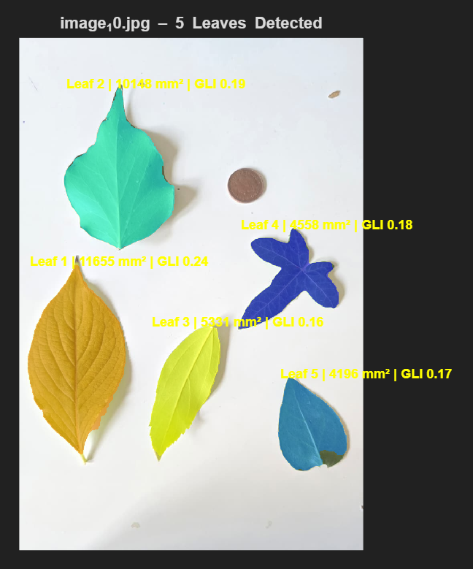
OUTPUT IMAGE 1 | OUTPUT IMAGE 2
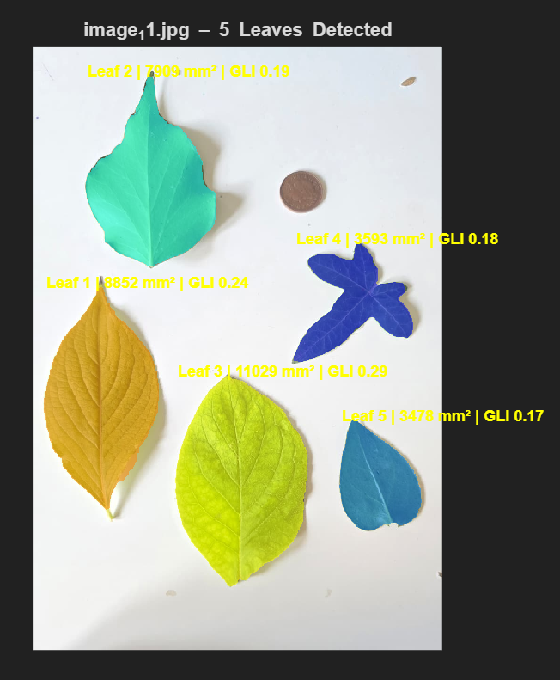 | 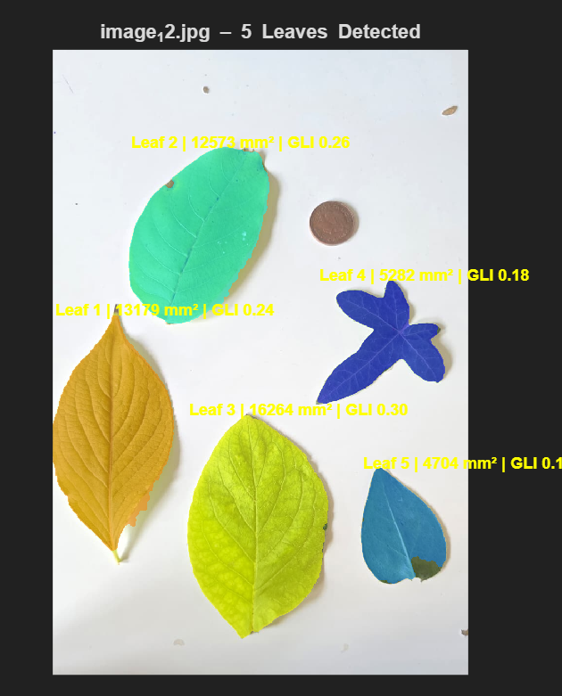
OUTPUT IMAGE 3 | OUTPUT IMAGE 4

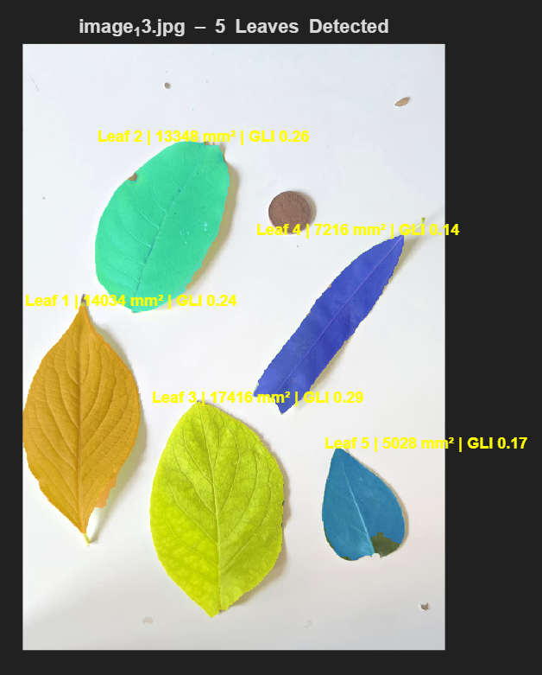 | 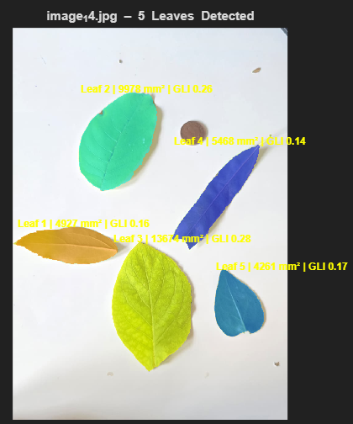
OUTPUT IMAGE 5 | OUTPUT IMAGE 6
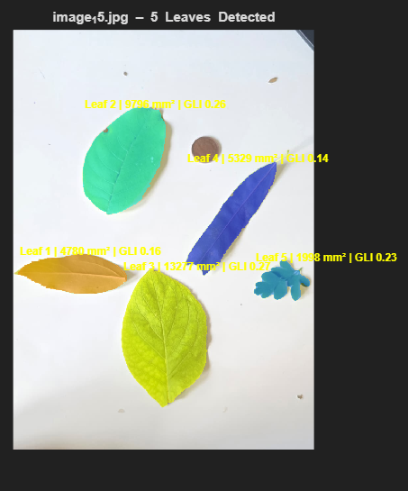 | 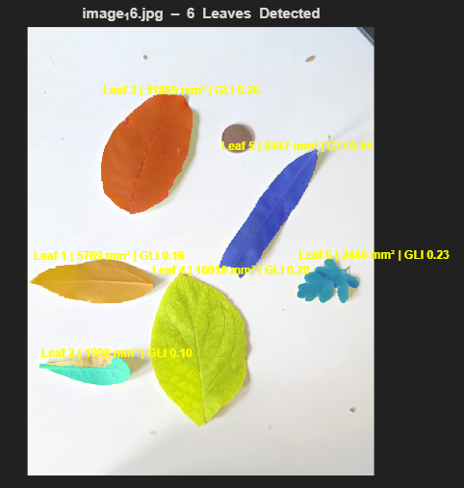
OUTPUT IMAGE 7 | OUTPUT IMAGE 8

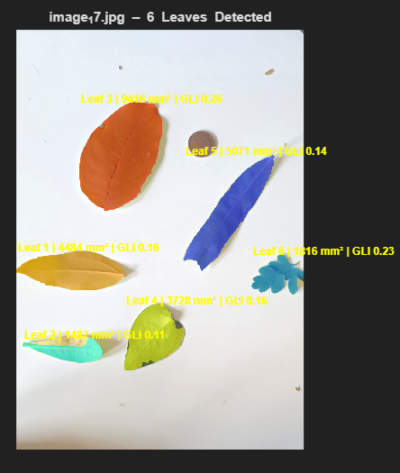 | 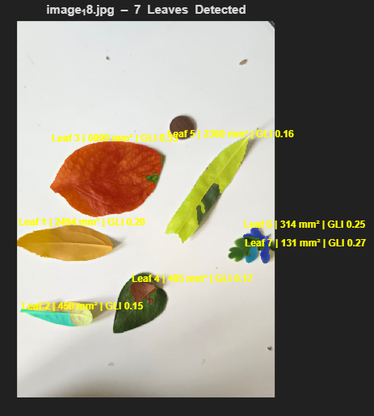
OUTPUT IMAGE 9 | OUTPUT IMAGE 10
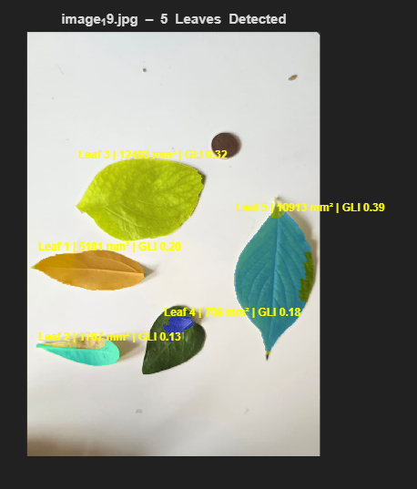 | 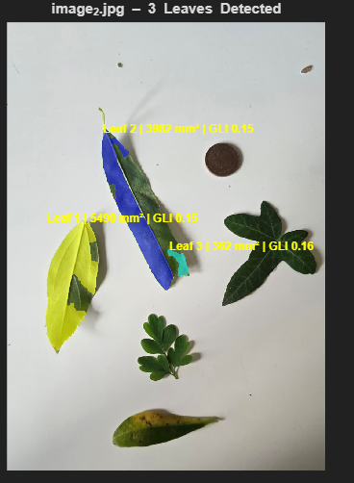
OUTPUT IMAGE 11 | OUTPUT IMAGE 12

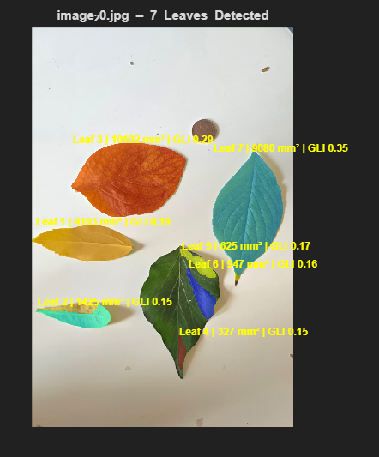 | 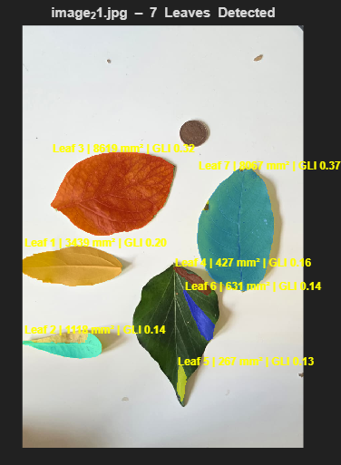
OUTPUT IMAGE13 | OUTPUT IMAGE 14
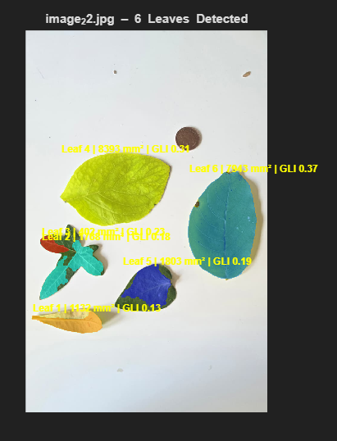 | 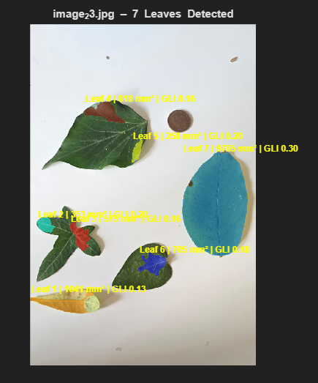
OUTPUT IMAGE 15 | OUTPUT IMAGE 16

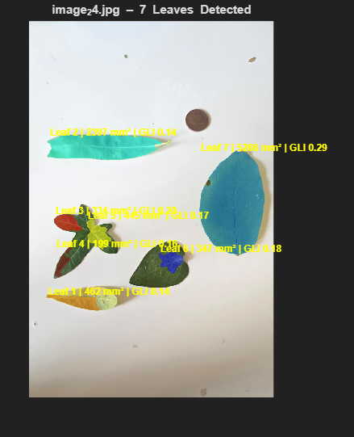 | 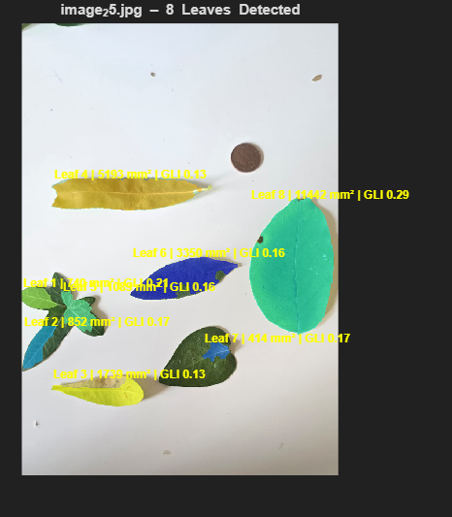
OUTPUT IMAGE 17 | OUTPUT IMAGE 18
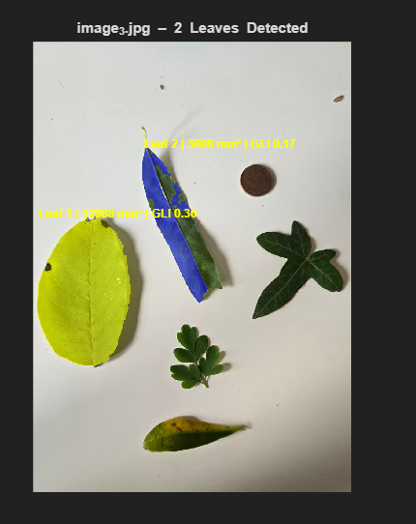 | 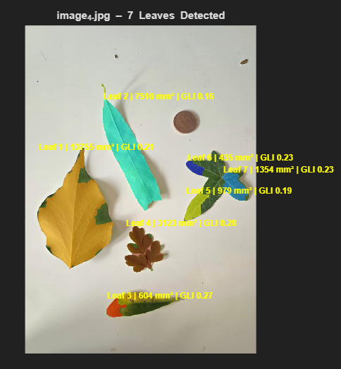
OUTPUT IMAGE 19 | OUTPUT IMAGE 20

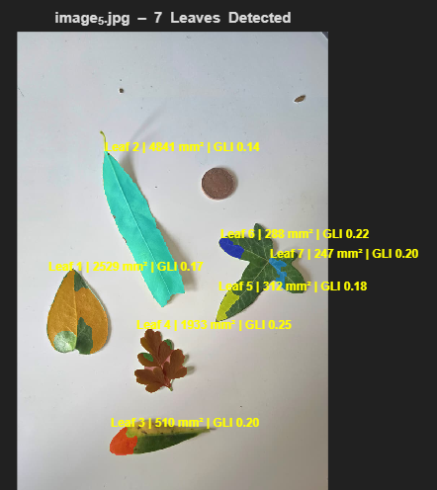 | 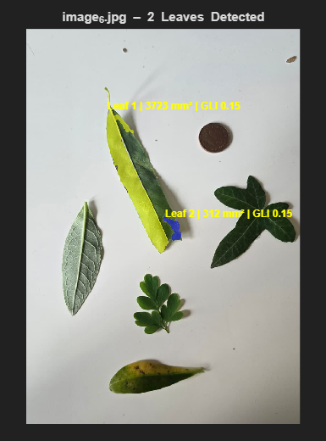
OUTPUT IMAGE 21 | OUTPUT IMAGE 22
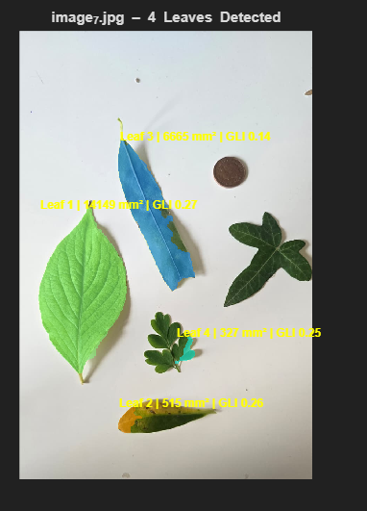 | 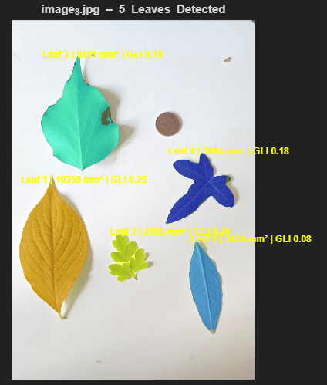
OUTPUT IMAGE 23 | OUTPUT IMAGE 24

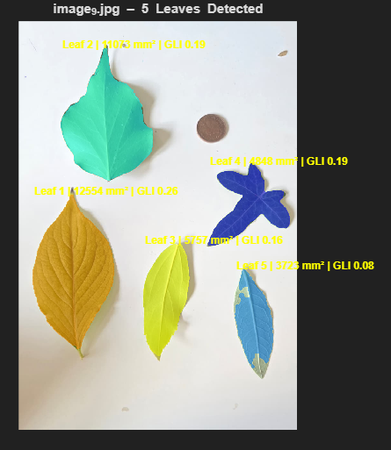
OUTPUT IMAGE 25

