Q1. DAXPY Loop(./q1)

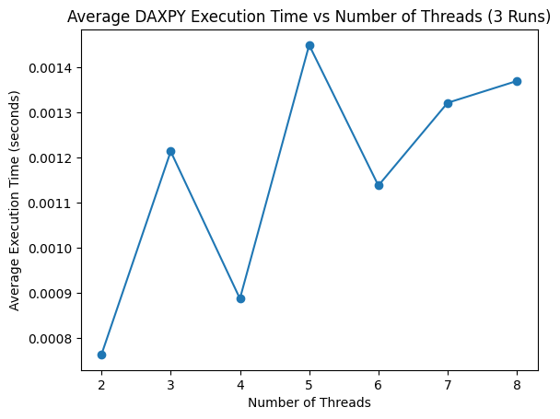

Threads | Time (s)
2 | 0.000764
3 | 0.001214
4 | 0.000888
5 | 0.001450
6 | 0.001138
7 | 0.001322
8 | 0.001370

Inferences
- The maximum performance is achieved at 2 threads. All higher thread counts result in slower execution due to overhead to memory banwidth saturation and OpenMP overhead.
Since DAXPY performs very little computation per memory access. i.e. highly memory bound.

Q2. Matrix Computation(./q2)

N | Sequential |  | Parallel |  | Optimised |  | Effieciency
 | Time(sec) | Speedup | Time(sec) | Speedup | Time(sec) | Speedup
512 | 0.45 | 1x | 0.08 | 5.996x | 0.09 | 5.299x | 44%
1024 | 6.82 | 1x | 0.69 | 9.888x | 0.67 | 10.124x | 84%
2048 | 97.03 | 1x | 16.91 | 5.737x | 11.83 | 8.202x | 68%
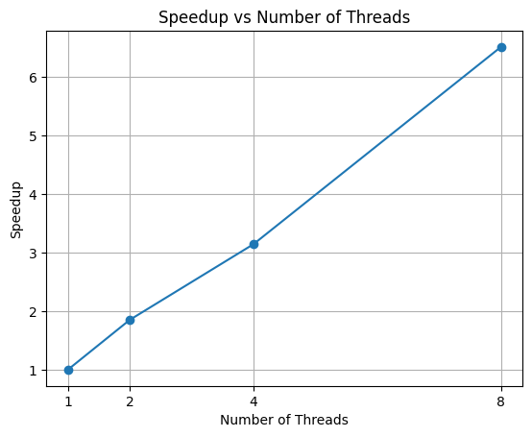
Total Threads = 12

Threads | Time(sec) | Speedup
1 | 5.16 | 1x
2 | 2.79 | 1.852x
4 | 1.64 | 3.146x
8 | 0.79 | 6.518x
N = 1024

Inferences:
- Speedup Efficiency
The optimised version achieves 6.11x speedup on 12 threads, giving ~51% efficiency. It shows successful parallelization.
- Limited CPU Utilization
Despite using 12 threads, only 3.26 CPUs were utilised effectively. It happens due to multiple threads compete for the same RAM bandwidth, causing cores to stall.
This is practical demonstration of Amdahl’s Law combined with Memory wall(adding more threads does not increase performance once memory bandwidth becomes bottleneck).
- Impact of using transpose matrix
The tranpose matrix implementation improves speedup from 5.13x to 6.11x
Transposing matrix Y converts column-wise access into row-wise access, improving spatial locality and reducing cache misses. As a result, the CPU spends more time computing then waiting fore memory access.
- High IPC
IPC of ~2.75 shows CPU executes effectively when data is available.
- Low Branch Miss rate
Branch miss rate is less than 0.1%. It depicts the nested loops are highly predictable, control flow is not a bottlenect

Q3. Calculation of π (./q3)
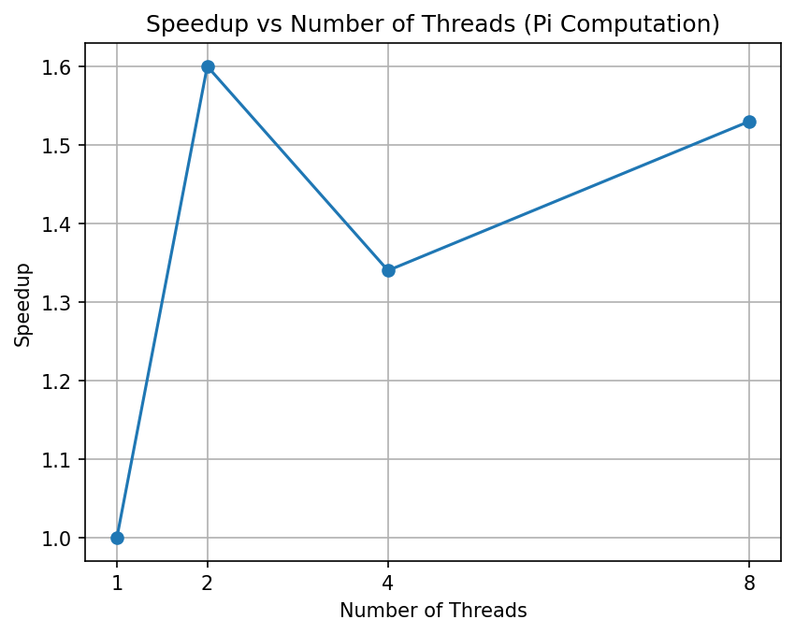

num_of_steps = 10,000

Threads | Time(sec) | Speedup
1 | 0.001969 | 1x
2 | 0.001228 | 1.60x
4 | 0.001466 | 1.34x
8 | 0.001285 | 1.53x

Inferences

- Accuracy of π remains constant for different thread counts
pi = 3.141593

- Limited Speedup with Increase in threads
The calculation of π workload is small. Thread creation, synchronization overhead dominates execution time. As a result, adding more threads does not improve performance. Low effective CPU Utilization.

- Low effective CPU Utilization
Most threads spend their idle/waiting. The computation per iteration is small, hence cores finish work quickly and stall on synchronization, The program is overhead-bound rather compute-bound.
- IPC degradation with Higher Threads.
Instructions per cycle decrease when moving from 1-2 threads (~2.3) to 4-8 threads (~1.8).
With more threads, contention and synchronization increase, reducing instruction throughput. Indicates diminishing returns from parallelism for this workload.

- Speedup Curve (Amdahl’s Law)
The speedup curve bends downward because the sequential portion dominates. Each iteration performs very little computation

