# TECHNICAL PROJECT REPORT

# Title of Invention / Project:

# Led cube

# Team Members / Inventors:

|  |  |  |  |  |  |
| --- | --- | --- | --- | --- | --- |
| **S.No.** | **Name** | **Department** | **Designation** | **Mobile** | **E-Mail** |
| 1. | Dheeraj kumar verma | ECE | Student | 8176952564 | dheerajkumarverma24@gmail.com |
| 2. | Deekshagupta | ECE | Student | 8427200542 | er.deeksha010@gmail.com |
| 3. | Ritika | ECE | Student | 9855654929 | ritikakashyap678@gmail.com |
| 4. | Khushal Thakur | ECE | Mentor | 9646030764 | khushal.thakur@cumail.in |
| 5. | Anshul Sharma | ECE | Mentor | 9478697475 | anshulsharma.ece@cumail.in |
| 6. | Kiran Jot Singh | ECE | Mentor | 9463909689 | kiranjotsingh.ece@cumal.in |
| 7. | Divneet Singh Kapoor | ECE | Mentor | 9878422653 | divneet.ece@cumail.in |

Section – 1 (IPR Related)

# Brief Abstract (500 words):

“Innovation is the ability to see change as an opportunity , not a threat “

Our Project consist of building a 3 dimensional LED cube which is run by a battery and the programming is given through arduinouno.

First we collected some info about the project and made the list of items we need to prepare our project .

. I am

After that we watched some videos how to connect the circuit , and after some observation we made the circuit and tested the leds that wether they are working or not. After that we made the programs and installed it in arduinouno , after that we tested it and it went successful as it was working perfectly .

We did our project work and learned many new things like soldering and circuit making . then we prepared the project report and submitted it .

# Existing state-of-the-art and Drawbacks in existing state-of-the-art

(*Brief background of the existing knowledge*)

|  |  |  |
| --- | --- | --- |
| **S. No.** | **Existing state of art** | **Drawbacks in existing state of art** |
| 1 | Long service life – it is one of the greatest benefits of LED lights. LEDs used in this type of lighting have a high work efficiency and thus may run for up to 11 years compared to energy saving lamps with service life less than a year. For example, LEDs operating 8 hours per day will last for about 20 years of service life, and only after this period, we will be forced to replace the light source for new one. In addition, frequent switching on and off has no negative impact on the service life, while it has such impact in case of an older type o lighting. | Price – LED lighting is more expensive investment than a traditional light sources. However, it is important to keep in mind that here the lifespan is much longer (over 10 years) than for regular light bulbs and at the same time it consumes several times less energy than the old type of lighting. During operation of one LED light source of a good quality, we would be forced to purchase min. 5-10 bulbs of the old type, which would not necessarily result in savings of our wallet. |

# Novel/Additional modifications that you can propose to improve upon drawbacks

*(List down the features)*

* Instead of soldering LEDs ,we soldered copper wires with the LEDs for better stability.

# Advantages

(*List down the advantages, if each feature is incorporated)*

* It can used for decorative purpose.

# Block Diagram

(*Functional diagram depicting the flow of information in your system. Do not define exact components, only use generic terms. Must include modifications as well.)*

|  |
| --- |
| Computer (USB) |

|  |  |  |
| --- | --- | --- |
| |  | | --- | | FTDI  USB to  RS 232 |  |  | | --- | | Atmeg 328  Micro-controller |   Arduino |

|  |
| --- |
| Chips are used to  Control the LED’S |

3*3*3 LED CUBE

Section 2

Material

# section-2 (real project)

MATERIALS

|  |  |  |  |
| --- | --- | --- | --- |
| S.NO. | NAME | QUANTITY | PRICE |
| 1 | Microcontroller | 1 | 520 |
| 2 | Led | 27 | 54 |
| 3 | Resistors | 9(220ohm) | 15 |
| 4 | Pcb board | 1 | 50 |
| 5 | Solders | 1 | 180 |
| 6 | Wire |  | 20 |
| Total |  |  | 839 |

# Circuit Diagram

(*Fully functional circuit diagram with exact connections. Can use Fritzing/Proteus*)

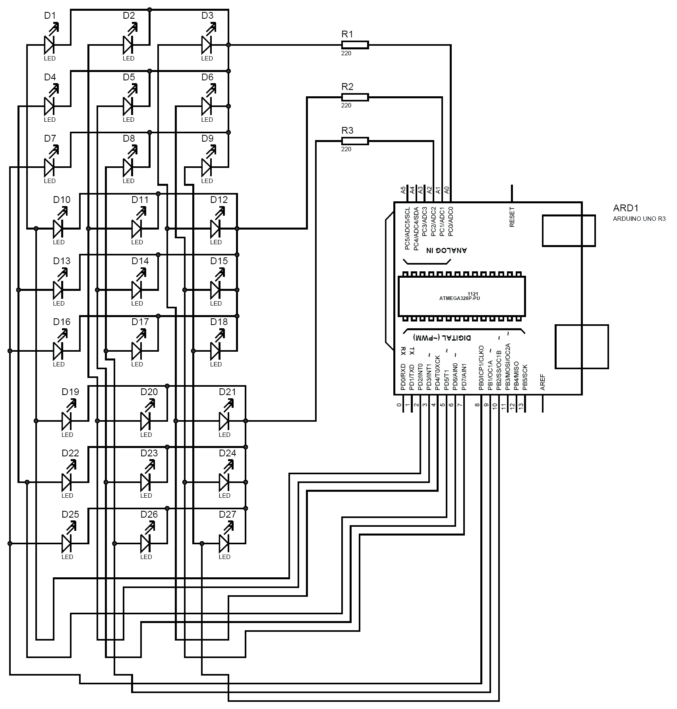

# Steps of Circuit Completion

(*Bifurcate the circuit completion in steps, specify with photographs, leading to final project*)

1. First, Start by printing out my 3x3x3 LED Cube Template and paste it to a cardboard box.Make sure that the printing settings are set to**actual size** and**landscape orientation**. Next, punch out all 25 LED holes(grey dashed circles) using a pencil. Insert a LED into the individual holes to test the fit.

2. Take the 9 LEDs and test them to ensure that they all work using a button cell battery.Next, insert 3 LEDs into the holes and bend the leads to the direction of the arrows using needle nose pliers. Solder all of the positive leads together and trim off the access of the leads. Now, you might have noticed that there are two gaps in the layer of the positive leads. This can be solved by straightening a length of craft wire by pulling both ends of the wire with pliers and trimming two 1" sections that are then soldered in place. After the hole positive layer is soldered together, flip the box over and start pushing the tips of the LEDs out of the holes in the jig. Make sure to do this evenly to avoid bending or damaging the layers structure. Now your first LED layer is finished! Follow this step three more times to end up with four layers. Next, take the four LED layers and solder the negative leads together by stacking the individual layers on the top of each other. Start by soldering the leads in the center, then work out totheleads on the edge**.**The 3x3x3 LED cube is starting to take shape! Straighten another length of craft wire and cut and bend four sections that will later connect the four layers to the perf boar

Steps 1

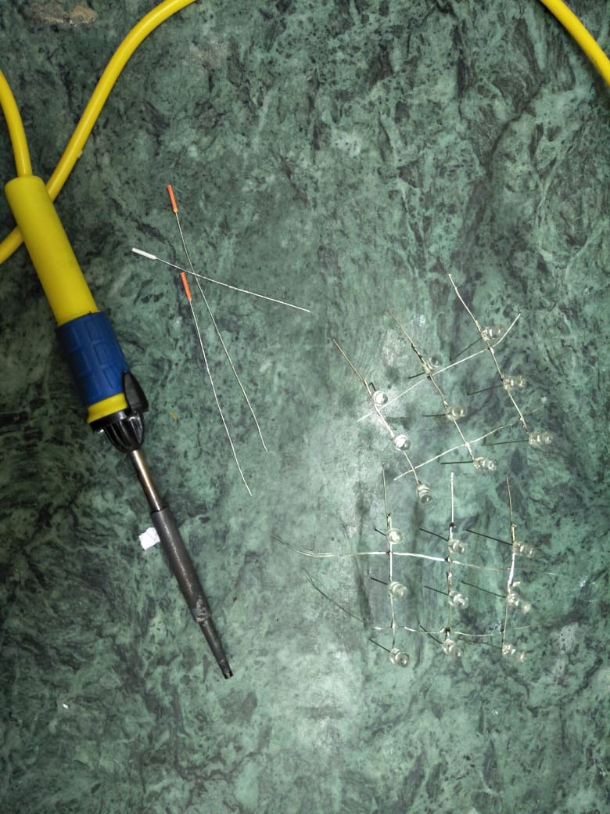d. Finally, solder them in place.

Steps 2

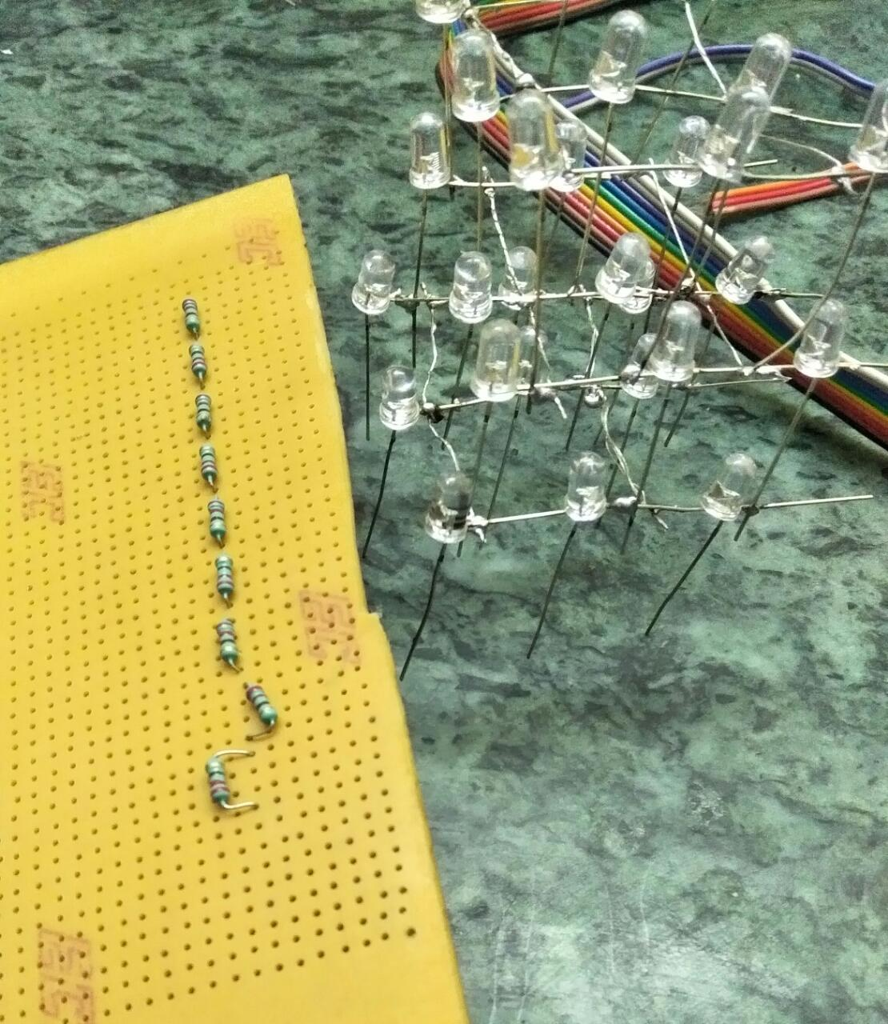

# Program Code