

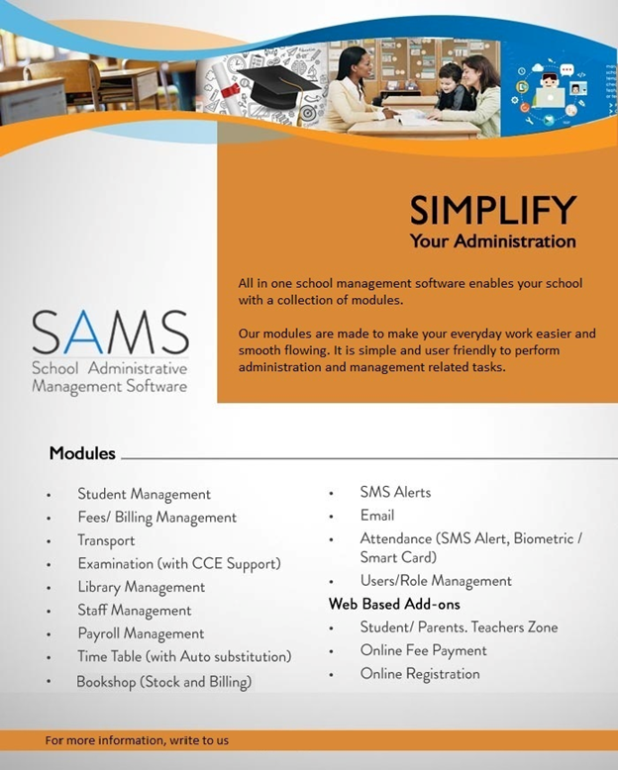

* **Introduction**

**Intellectual MindSystem** is serving to educational institutions. The company is founded by the people with proven experience and in-depth understanding of education enterprise with expertise in technology. Our solutions are designed keeping **“Think, implement and Deliver Quality Product”** this in mind Our goal is provide better quality with minimal cost to automate the world of education in exploiting technology for efficient education delivery and make the journey of studying and teaching a great experience.

**SAMS (School Administrative Management System)**

The administration of schools being highly sophisticated, it is almost necessary to get the whole administration automated. In order to automate the whole school administrations (so as to get error free accurate results) we feel happy to introduce SAMS (SCHOOL ADMINISTRATIVE MANAGEMENT SYSTEM), the complete school administration software. It covers each and every aspect of complete school automation.

` SAMS ' is a customised School Administrative Management System. It is developed in Microsoft Visual Studio. SAMS available in two different versions single user and multi-user. The multi-user version is also available online (**Web Based**) and **offline** or **cloud** based.

The modules of software are highly integrated and multi-user version can be implemented on PC-Network and online modules can deploy on web server. This ensures that more than one person can work on the same module at the same time, and reduce the redundancy thus ensuring improved efficiency of operations.

The modules of software are highly integrated e.g. Student and Fees if any student admits in the school as user fills the admission form system generate the fees automatically. If student leaves the school it automatically checks the Fees and Library pending etc. All the modules of the software are easy to use. And have the same user interface, thus enabling the user to operate without the need to remember even a single command, besides extensive analytical reports are also available. User could also export the data/report viewed to other applications such as Word, Excel, PDF formats.

The Software supports User defined password scheme, allowing each organisation to customise the security features to its own needs. All the reports generated by the System, could be viewed at the user’s convenience. For Management ease we divide the whole software in different modules which can operate independently or combined as integrated also the modules of the software are as follows:

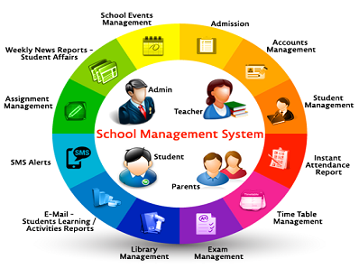

|  |
| --- |
| **Different Modules** |
| * Student Management |
| * Fees/ Billing Management |
| * Transport |
| * Examination |
| * Library Management |
| * Staff Management |
| * Payroll Management |
| * Time Table (with Auto substitution) |
| * SMS – Alerts , Attendance |
| * Users/Role Management |
| **Add-ons Web Based** |
| * Student Zone |
| * Parents Zone |
| * Online Fee Payment |
| * Online Registration |
| * Mobile Application (Notification Communication) * (Beta) |

**Student Management**

This Module will help you to search all the students according to class, Student ID, Academic Year, gender etc., also you can promote the student to higher classes after final Exams and record student transfers as well. With the help of this software one can have full details about the students from the very beginning (the moment Registration form gets entered in computer) His Personal Data such as Name, Address, City, Photograph, Age, Father's/ Guardian’s name, class, section, fee structure, subjects, parents occupation, School’s transport facility, scholarship, boarding/lodging facility etc. gets fed in database so as to be retrieved according to management requirements. Various kinds of reports could also be generated, based on specific criterion such as area wise, religion wise, parent’s profession wise, and class wise, new admission list, admit card, admission ledger etc.

**Fees / Billing Management**

This module will help you in taking Student Fee payments, Fine’s, Instalments and provide you reports on Students who paid fees, unpaid fees, fine’s etc. Due to huge number of students, it is quite cumbersome to manually handle the fee of students. To overcome this tiresome job, SAMS provides complete fee management automation. Tapping a few no. of keys could generate all kinds of reports one could ever imagine! (Such as defaulter’s list, total fee collection, daily Bank/Cash collection, head wise collection, receipts wise details). Additional utilities such as total concession given, outstanding fee could be known with just a click of mouse. Advanced statistical reports could also be generated.

**Transport Management**

This Module will help you to manage you transportation services more effectively where in you can define the Bus routes, Vehicle details, driver details, Transportation fees, Maintenance, students reports etc. this modules will give more security to the parents as they get SMS if there are any delay or changes in transportation.

**Examination (With CCE Support & Report Card)**

On the basis of feedback received from our esteemed clients the latest feature of SAMS is that it incorporates the printing of terminal mark sheets, graphical progress report and annual report card. Parents could browse the performance of their child in class. They could also view their ward’s performance with respect to other children in the class, and could also analyze the performance subject wise. Also we have the new **CCE card generation feature for CBSE schools**.

**Library Management**

This Module will give you a centralized management system for your Library; it helps you in managing Books Details, Returns, Issues, Books Availability, Books to Students and Staffs, Stock, Fines, and reports etc. Due to large no. of transactions regarding the issuing of the books it becomes necessary to keep the track of issued books, author name, price etc. At the time of issue the book name, bearer‘s name, date of issue gets fed so as to trace down every detail later on. Various utilities such as fine generation, stock at a particular point, no. of books issued to a particular student/on a particular date, list of books according to subject/author name etc. In essence every detail could be traced out.

**Staff Management**

First and foremost thing in office management is Personnel management, so that one can have full details about the staff i.e. Name, age, address, designation, which class he/she is handling as a class teacher, salary status, qualification, specialization in any subject, date of joining, job status (permanent/temporary), timings of the job etc. Various kinds of reports could also be generated, based on specific criterion such as experience wise, teaching staff, non-teaching staff etc.

**Payroll Management**

This is a Payroll module which helps you to manage the staff payrolls properly and more effectively. This includes managing leaves, allowances, deductions, Loan’s, Tax’s, PF’s, Pay slips and reports etc.

**Time-Table Management**

This module will help you to manage the time table according to the class and also provide individual time table to the Teacher as well. Module gave both options manual and auto linked substitution for absent teachers to run the institution smoothly and efficiently.

**Attendance**

These modules will help you to take Staff and Student Attendances accordingly and will generate necessary reports for further performance analysis. Necessary information will be sent to the Payroll module for further calculations. Also the schedule for absentee’s students can be linked with SMS to update the parents.

**Users/ Role Management**

This is an important module which helps you to manage all your administrators. You can provide permission to all you administrators so that the process and data is secure all times. If you want Administrator A1 to access only 10 Modules you can check them and you can also give permission to EDIT, VIEW, DELETE, PRINT etc. This module will make sure that no one can misuse the application.

**SMS Alerts**

SMS Module provides the opportunity for the School to be in constant touch with the parents and advise them of all the events almost instantly. SMS module can be customized to include additional areas as per specific needs of institutions. This facility can use to send SMS to parents or Guardian’s mobile No. for

* Student Attendance
* Fee Payable intimation as well as defaulters
* Exam Marks
* General Messages
* Transport
* Holiday
* Homework
* Parent Teacher Meeting
* Meeting Announcement to Staff

Users can send SMS to any of the selected numbers either for whole school, class wise or for a particular student. SMS module also will dynamically pick of information and send it to only the required students as needed by the school and can be sent to any number in India.

Messages can also be sent directly from the home by the authorized school user at late night or on non-working days through the web site itself.

**STUDENT/PARENTS (ZONE) Web Based (On-line)**

**Unique ID for Student/Parent** Fully secured separate user-id and password for each parent/student to view only their data.

**Student Profile** Here Parents can able to view and update the (only his/her) child’s profile.

**Attendance** Here Parents can able to check and monitor the students attendance easily

**Assignment** Here parents / students can view all their assignments and also can submit them online.

**Fee Status** is to view due, receipts & also has provision for making **Online Payment using Credit Card / Debit Card or Net Banking options**

**Examination** Parents can check their child’s exams and their results

**Library** Here Parents can able to view the library books details, his/her ward usage information of their child, pending/overdue books etc.

**Bulletin Board** Periodically important notification can be displayed via bulletin board and **SMS Alerts** to registered Mobile numbers of parents with important information/notification

Online Registration This module helps to parents to register online and also generate interview schedule/candidate list for school to manage the work load accordingly.

After receiving tremendous feedback during last eleven years our development team made this software ready for

|  |  |  |  |
| --- | --- | --- | --- |
| rightmark | Total School Automation | rightmark | Handle’s huge data |
| rightmark | Overall Centralized Monitoring | rightmark | User Friendly |
| rightmark | Easy Reports | rightmark | Backup/Restore |
| rightmark | Available Online and Offline | rightmark | Contain Teacher/Staff Control Panel |
| rightmark | Complete Secure | rightmark | Contain Student/Parent Control Panel |

**Software is designed for installation in all types of educational institutions - Schools (State Board, CBSE or ICSE/ISC.)**

**We have covered each & every aspect of complete school automation. What else could one dream of? If you could, let us know. If you can’t, install our software & vest that responsibility in us. Complete client satisfaction is our motto.**

**For any query please feel free to write us or call on below number.**

With Regards

Rajesh Thakur

Mobile: 91- 9873813334

Email: rajeshthakurmeerut@gmail.com