Class 7

Public subnets vs Private subnets?

Routing tables have some Subnets, if that RT is connected with IGW (internet gate way), all the subnets of that routing table becomes “Public subnets”

Routing tables have some Subnets, if that RT is not-connected with IGW (internet gate way), all the subnets of that routing table becomes “Private subnets”

Main Routing table: if one Routing table set as “main” by default the subnets that are created goes to main routing table, without subnets adding to it

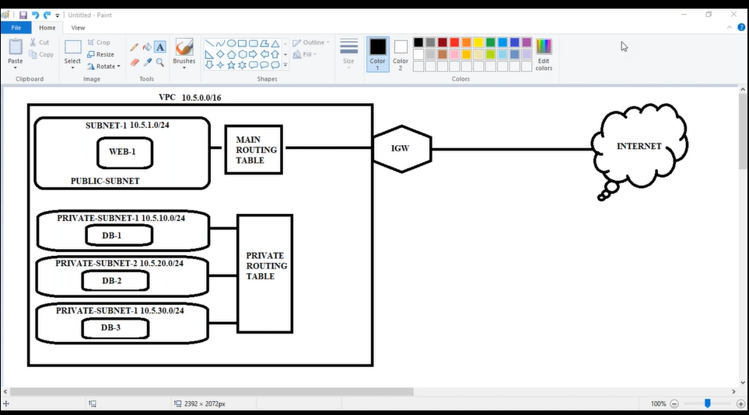

For “Private Routing Table” creation:

Create new routing table

|

Add subnets

|

Don’t give IGW to it (then it became private routing table)

Web instance to public subnet

DB instance to private subnet

But all subnets interconnected (you can know by ping)

🡪Public subnet public ip pings because it is connected with internet

🡪 Private subnet public ip not pings because it is nt connected with internet gate way

We open two putties to open two servers, now **how to move from one server to another server in one putty?**

Open web server in putty then

**Commands**:

Ssh [ec2-user@10.0.10.70](mailto:ec2-user@10.0.10.70) (10.0.10.70 is DB server ip)

|

It fails to move because we must give key to enter, copy key in .pem file

|

Nano awskey.pem (past in this file, this key should match with DB instance key)

|

Chmod 400 (for key permission security, read only option)

|

Ssh -i awskey.pem [ec2-user@10.0.10.70](mailto:ec2-user@10.0.10.70) (10.0.10.70 is DB server ip)

Now goes to DB server, but doesn’t ping to internet because of no IGW

**NAT Gateway:**

NAT Gateways

|

Connect it to public subnet

|

Edit private routing table and give 0.0.0.0/0 NATGW

|

If you want to install “nginx server in DB instance”

**: yum update && yum install nginx -y**

Delete NAT Gateway

Release Elastic IP

