Class 13

**Transit gateway: - VCP Peering + VPG**

Transit gate way is used to for connect all VPC’s instead of “VPC peering” (but VPC peering is free, TG is chargeable).

Transit gateway is also used to connect two Data centers or Two clouds instead of VPG (Virtual Private Gateway) using VPN.

**Design: - VPCs connect to Transit Gateway**

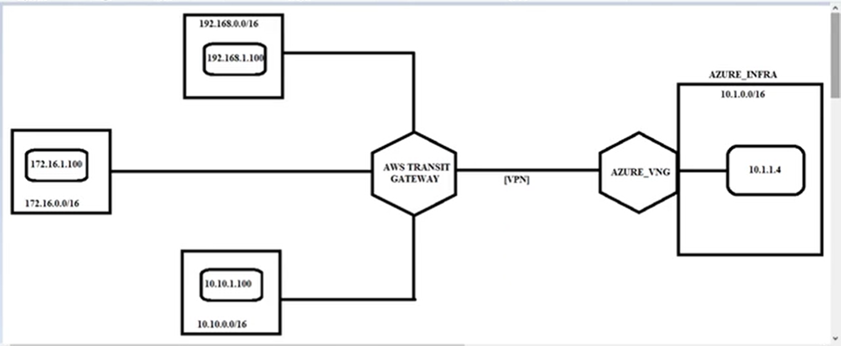

**Lab:**

**AZURE**

1, create VPC 10.1.0.0/16, Subnet 10.1.10.0/24, and instance, VNG in azure

**AWS**

2, create VPC-> 10.0.0.0/16 & subnet 10.0.1.0/24-> IG (attach vpc)-> RT

VPC-> 172.16.0.0/16 -> subnet 172.16.1.0/24 -> IG (attach vpc)-> RT

VPC-> 192.168.0.0/16 & subnet 192.168.1.0/24-> IG (attach vpc)-> RT

3, create 3 EC2 instances in 3 VPC’s -> subnets

10.0.1.100 in first VPC

172.16.1. 100 in second VPC

192.168.1. 100 in third VPC

4, putty -> 10.0.1.100, putty -> 172.16.1. 100, putty -> 192.168.1. 100

Here servers will not ping to each other because there is no connection between VPCs

5, In place of **VPG** gateway we create **Transit Gateways**

VPC -> Transit Gateways -> Create Transit Gateway -> Name tag: TGW & Description: TGW

6, Now connect VPCs to Transit Gateways, for that go to

VPC -> Transit Gateway Attachments -> Create Transit Gateway Attachment -> Transit Gateway ID*: tgw-08d03097dcc5f4248 **&** Attachment type: VPC & TGW-10-attachment **&** Attachment name tag: TGW-10-attachment **&** VPC ID: 10 vpc **&** Subnet ID: Us east-1

[Attach Transit Gateway to Server-10’s VPC and subnet]

Like wise

[Attach Transit Gateway to Server-172’s VPC and subnet]

[Attach Transit Gateway to Server-192’s VPC and subnet]

7, Now create Routing Tables and route for Azure IP, 172 IP, 192 IP Towards Transit Gateway in 10 VPC RT

Route Tables -> select 10VPC RT -> Edit routes -> (route VPC IPs towards Transit Gateway)

That means to go to other VPC route through Transit Gateway

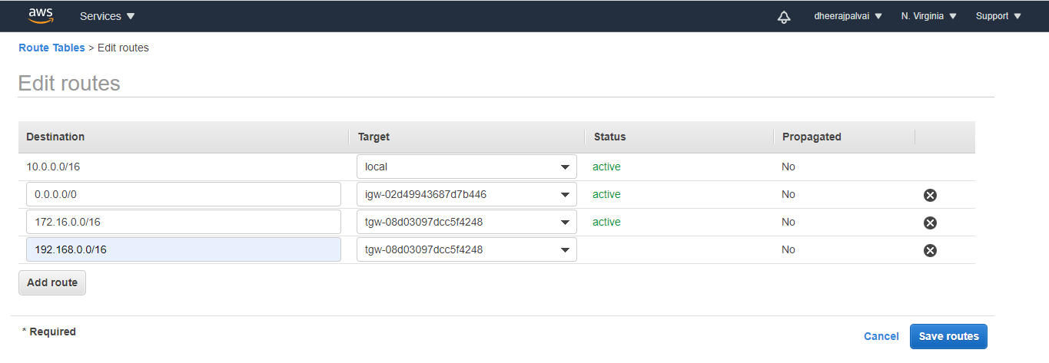

Route Tables -> select 172VPC RT -> Edit routes -> (route VPC IPs towards Transit Gateway)

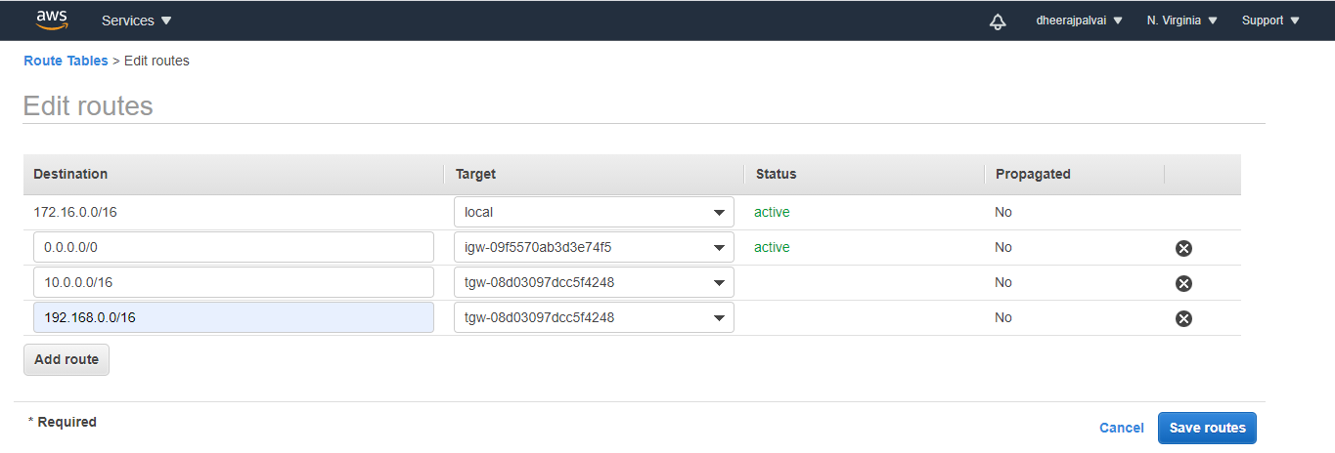

Route Tables -> select 192VPC RT -> Edit routes -> (route VPC IPs towards Transit Gateway)

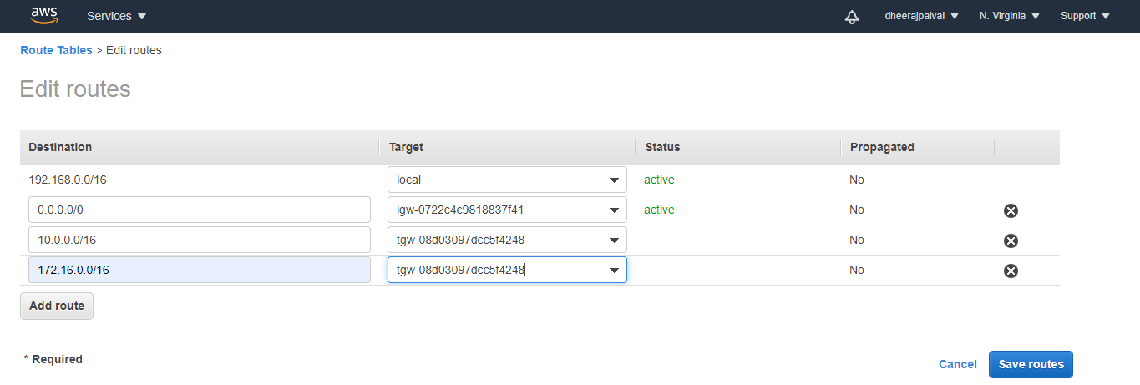

4, Putty -> 10 server -> ping 172.16.1.100 & ping 192.168.1.100(it pings because all VPCs are interconnected through Transit Gateway)

Putty -> 172 server -> ping 10.0.1.100 & ping 192.168.1.100(it pings because all VPCs are interconnected through Transit Gateway)

Putty -> 192 server -> ping 172.16.1.100 & ping 10.0.1.100(it pings because all VPCs are interconnected through Transit Gateway)

-------------------------------

8, Now we must connect servers in AWS to server in Azure, for that

VPC -> VIRTUAL PRIVATE NETWORK (VPN) -> Customer Gateways -> Create Customer Gateway -> Name: AZURE-VNG & IP Address: (copy past Azure VNG Public IP) --- to connect Transit Gateway to VNG

[connection from Azure in AWS is happened]

* Now attach this connection of Azure in AWS customer gateway - to Transit Gateway through VPN

6, VPC -> TRANSIT GATEWAYS -> Transit Gateway Attachments > Create Transit Gateway Attachment ->

Transit Gateway ID*: tgw-08d03097dcc5f4248 **&** Attachment type: **VPN** **&** Customer Gateway ID: (created Customer Gateway ID) **&** Routing options: Static

[Now we can see Azure IP attached to Transit Gateway]

**Azure**

9, VPC -> Site-to-Site VPN Connections -> Download Configuration -> Upload in Azure

10, VPC -> Transit Gateway Route Tables -> Routes -> Create static route (give Azure VPC IP)

[to ping Azure server to AWS Server’s]

-----------------------------------------

Now we create Transit Gateway in Ohio Region

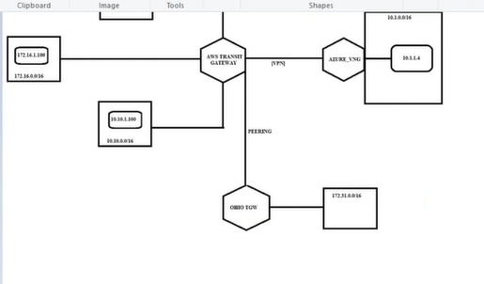

Workflow: **[1, VPCs**(subnets, instance) **– Transit Gateway**(create) **– Transit Gateway Attachments**(VPCs attach TGW) **– Routing Table**(VPC ip towards TGW) **– 2, { Customer Gateways**(Azure VNG IP in AWS) **– Transit Gateway Attachments**(Customer Gateways attach TGW) **– Site-to-Site VPN Connections**(Download Configuration & Upload in Azure) **– Transit Gateway Route Tables**(give Azure VPC IP)**}]**

**Deletion of Lab:**

**1, Transit Gateway Attachments**

**2, Transit Gateway**