Class 14: Ec2

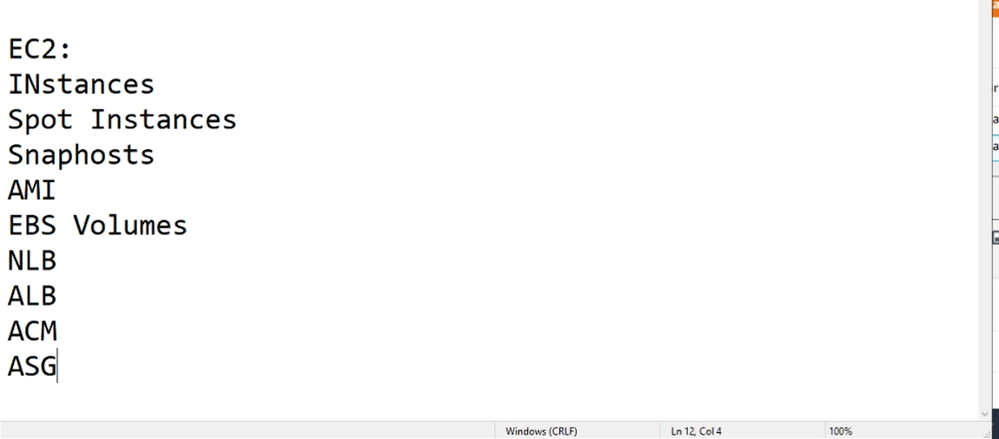

Launch Instances ->

1. Choose AMI

2. Choose Instance Type

3. Configure Instance

4. Add Storage

5. Add Tags

6. Configure Security Group

7. Review

1. Choose AMI: Amazon Machine Image

Quick Start: We are not installing OS, we are using existing images like

**Amazon Linux 2 AMI (HVM), SSD Volume Type** - ami-0947d2ba12ee1ff75

**Amazon Linux AMI 2018.03.0 (HVM), SSD Volume Type** - ami-032930428bf1abbff

Each machine is having id’s like “ami-0947d2ba12ee1ff75”

For same image also, id will vary for one Availability Zone to other

* These are plain operating systems (vanilla flavor)

My AMIs: When we start projects, we make our own images called “AMI creation or AMI baking”

AWS Marketplace: Vendors will create their own images and sell here

1. Choose Instance Type:

->How to decide instance types?

General purpose – Used for simple applications in web server

Compute optimized –Used for heavy DATABASES

Memory optimized –Used for heavy memory usages servers like SAP Hana

->Who will decide instance types?

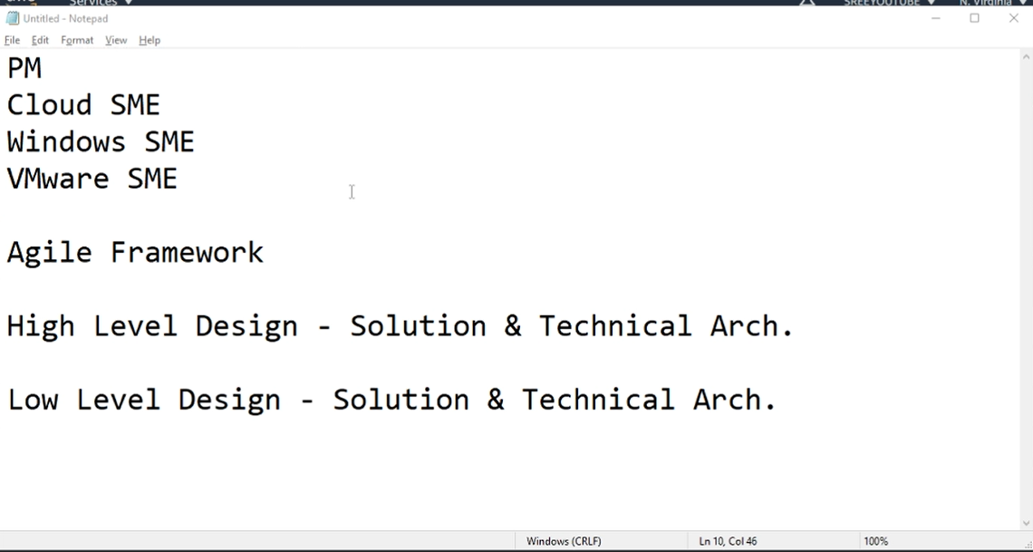

In generations: lets take sample generations

c1.xlarge (20 ECUs, 8 vCPUs, **Intel Xeon Family**, 7 GiB memory, 4 x 420 GiB Storage Capacity)

c3.xlarge (14 ECUs, 4 vCPUs, 2.8 GHz, **Intel Xeon E5-2680v2**, 7.5 GiB memory, 2 x 40 GiB Storage Capacity)

c4.xlarge (16 ECUs, 4 vCPUs, 2.9 GHz, **Intel Xeon E5-2666v3**, 7.5 GiB memory, EBS only)

c5.xlarge (17 ECUs, 4 vCPUs, 3.4 GHz, **Intel Xeon Platinum 8124M**, 8 GiB memory, EBS only)

in above cases the processors are upgraded, so whatever the number increases its latest version

1. Configure Instance

Options

**Placement group**:

<https://docs.aws.amazon.com/AWSEC2/latest/UserGuide/placement-groups.html>

cluster: for more performance

spread: with in the subnet or Availability Zone the web instances are distributed, rather being in one rack

partition: this is also same as spread but it divides all the server racks into equal partitions

eg, we have 90 racks, and we have 3 servers, so it partitioned into 30 30 30 racks and each server goes into one of the 30 racks if **number of partitions** are 3

**Shutdown behavior**: Stop (instance stopped when machine is shutdown)

Terminate (instance deleted when machine is shutdown)

**Enable termination protection**: check Protect against accidental termination

If we enable this, by mistake if we terminate instance also it will not terminate

**Monitoring**: check Enable CloudWatch detailed monitoring

Instance are website is monitored for every 5 minutes, for high priority servers if we want to monitor for 1 minute, we enable this.

**Tenancy:**  Shared - Run a shared hardware instance (hardware is shared by others instances also)

Dedicated – (only our instance will run on hardware or server)

Dedicated host – (only our instance will run on hardware or server and also, we have access to control)

**User Data:** is also called as boot strapping, this is to write CLI command line interface

|  |
| --- |
| #!/bin/bash  Yum update -y  yum install -y nginx stress  service nginx start  for i in {1..10}  do  echo $(date) > file$i  sleep 1  done |

1. Add Storage
2. Add Tags
3. Configure Security Group
4. Review