Class 16

Ec2 -> instances -> 4, Add Storage

**Block storage**: there are two types of block storages

1, Elastic Block Store (EBS)

2, Instance Store

If we go to 2, choose Instance types we see two storages EBS only & Local storage (we call it as instance store like “1 x 75 (SSD)”)

Elastic Block Store: is like an extra memory storage which exists as a separate machine that is attached

to our instances (like memory card in mobile).

We can extend upto 1GB to 16TB, available storage disks are GP1, IO1/IO2,SC1,ST1,Std

Instance Store: is that existing in physical machine itself (like internal memory in mobile)

We can’t extend store size, available storage disks are only SSD

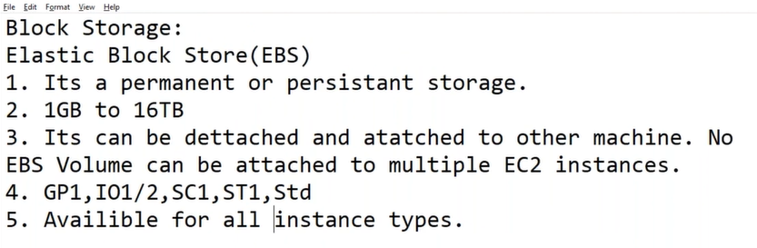

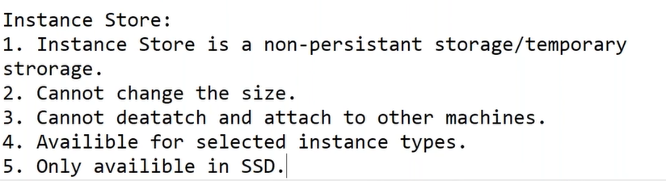

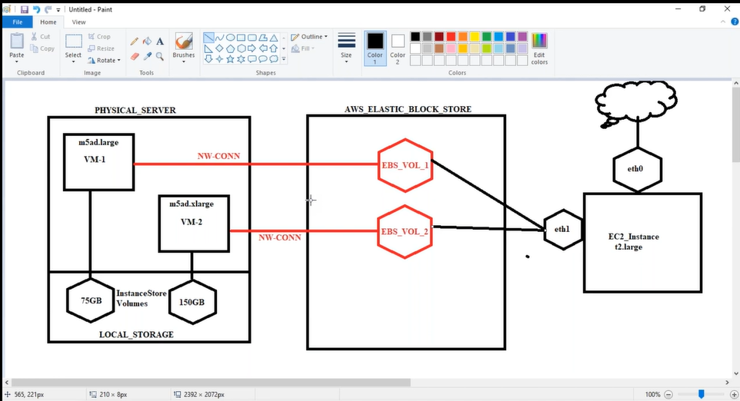

Some Physical server have local storage, some instance types like m5ad.large & m5ad.xlarge are in that physical servers which are having local storage. And we can also add EBS store also in addition.

Instance types which having Instance store as “EBS only”, doesn’t exists in physical servers which are having local storage

* “EBS Optimized” means AWS will add separate interface, so that performance will be fast, instead of going on same interface they will add a “nick”(ephermal 1)

Interview question:

How to increase performance of server?

If it is EC2 server

1, check proper CPU & Memory (check utilization in “Task Manager”)

2, check Disk performance (like standard or IO disks performance)

And should check these disks are “EBS Optimized” disks or not

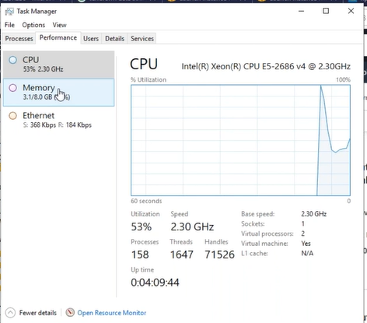

EC2

|

Launch an instance with instance type of instance store and EBS Optimized

Goto putty and open server

Cmd: lsblk (to see the disk space)

df -h

|

Now create volume 5gb (instance and volume should be in same Availability Zone)

Rc on volume and attach to instance

|

Goto putty and open server -> lsblk (here we can see EBS volume is attached)

Check volumes and make dir -> format disk -> create filesystems ->mount

1, check the volumes (raw volumes, those are attached, make dir)

Cmd: cd / (change to root)

lsblk (to see the disk space)

df -h (here we can see partition disks)

mkdir EBS_vol

mkdir IS_vol

ls

2, format disk

fdisk /dev/nvme1n1 (instance store disk)

Command (m for help): m (for help)

Command (m for help): n (create a new partition)

4 times enter button

Command (m for help): w (partition table is altered)

----

fdisk /dev/ nvme2n1 (EBS disk)

Command (m for help): m (for help)

Command (m for help): n (create a new partition)

4 times enter button

Command (m for help): w (partition table is altered)

3, create file system (mkfs – make file system)

mkfs.ext4 /dev/nvme1n1p1 (file system is created on instance store partitioned disk)

mkfs.ext4 /dev/nvme2n1p1 (file system is created on EBS partitioned disk)

4, mount

mount /dev/nvme1n1p1 /IS_VOL/ (mount instance store to dir ls_vol)

mount /dev/nvme2n1p1 /EBS_VOL/ (mount EBS store to dir EBS_vol)

lsblk

df -h (now we can see those are mounted)

but the problem here is these mounts are in temporary memory, if we reboot, they will vanish.

Now go to

nano /etc/fstab (here we save those mounts)

/dev/nvme1n1p1 /IS_VOL/ ext4 defaults,noatime 1 1(copy this in nano file to save permanently)

/dev/nvme2n1p1 /EBS_VOL/ ext4 defaults,noatime 1 1(copy this in nano file to save permanently)

Now unmount and check it is saved or not

umount /dev/nvme1n1p1 (mount instance store to dir IS_VOL)

umount /dev/nvme2n1p1 (mount EBS store to dir EBS_VOL)

mount -a (to mount both storages)

so now I goto EBS_VOL folder and download file

cd /EBS_VOL/

go to terraform site and download file

wget filepath

cp terraform_0.13.4_windows_amd64.zip file1.zip (copy file to folder1 in zip)

cp terraform_0.13.4_windows_amd64.zip file2.zip (copy file to folder2 in zip)

cp terraform_0.13.4_windows_amd64.zip file3.zip (copy file to folder3 in zip)

cp file* ../IS_VOL/ (copy same 3 files in IS_VOL also)

Now if you reboot instance the data in IS_VOL instance store will vanish because it is temporary storage

|

Now if I want to increase size of EBS volume

Ec2

|

Volumes

|

Modify volume

---

Now Goto putty and increase EBS volume

|

growpart /dev/ nvme2n1p1 (increase EBS Volume partition size )

resize2fs /dev/ nvme2n1p1 (resize partition file system)