Class 18

**Snapshot**:

snapshot and AMI are same, but we create instance using AMI and we take data backup using snapshot, snapshot is taking a timestamp at particular period like daily or weekly.

* AMI: In AMI Image we get Instance as a backup
* Snapshot: In snapshot we get EBS Volume with data as backup

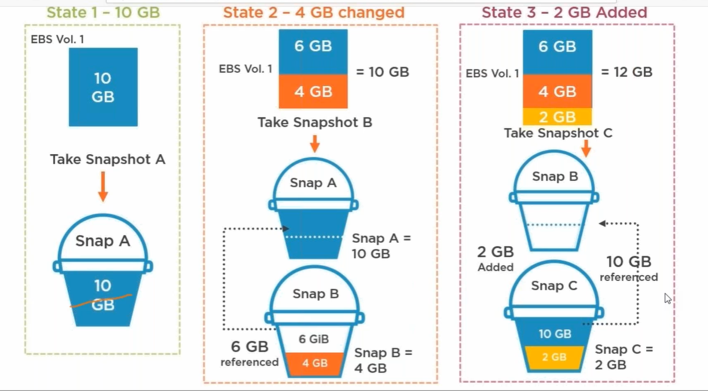

Here we get daily snapshot

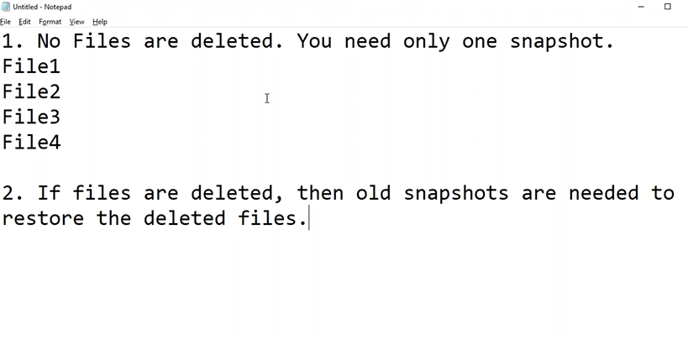

Ec2 instance -> t2.micro -> create

|

Goto putty and open server

Cmd: lsblk (to see the disk space)

df -h

|

Now create volume 5gb (instance and volume should be in same Availability Zone)

Rc on volume and attach to instance

|

Goto putty and open server -> lsblk (here we can see EBS volume is attached)

Check volumes and make dir -> format disk -> create filesystems ->mount

1, check the volumes (raw volumes, those are attached, make dir)

Cmd: cd / (change to root)

lsblk (to see the disk space)

df -h

mkdir EBS_vol

ls

2, format disk

fdisk /dev/ nvme2n1 (EBS disk)

Command (m for help): m (for help)

Command (m for help): n (create a new partition)

4 times enter button

Command (m for help): w (partition table is altered)

3, create file system

mkfs.ext4 /dev/nvme2n1p1 (file system is created on EBS partitioned disk)

4, mount

mount /dev/nvme2n1p1 /EBS_VOL/ (mount EBS store to dir EBS_vol)

lsblk

df -h (now we can see those are mounted)

but the problem here is these mounts are in temporary memory, if we reboot, they will vanish.

Now go to

nano /etc/fstab (here we save those mounts)

/dev/nvme2n1p1 /EBS_VOL/ ext4 defaults,noatime 1 1(copy this in nano file to save permanently)

Now unmount and check it is saved or not

umount /dev/nvme2n1p1 (mount EBS store to dir EBS_VOL)

mount -a (to mount both storages)

so now I goto EBS_VOL folder and download file

cd /EBS_VOL/

go to terraform site and download file

wget filepath

cp terraform_0.13.4_windows_amd64.zip file1.zip (copy file to folder1 in zip)

cp terraform_0.13.4_windows_amd64.zip file2.zip (copy file to folder2 in zip)

cp terraform_0.13.4_windows_amd64.zip file3.zip (copy file to folder3 in zip)

-----------------------------------------

now go to “Volumes”

|

Select volume and “create snapshot” Snap1

|

Snapshots (here you can see)

-------------------------------------------

Like wise in EBS volume create some files and take snapshot – snap2

delete some files and take snapshot – snap3..

---------------------------------------------

Now delete all files EBS volume, to get data back from deleted files

1, Go to

Snapshots

|

Snap4 -> RC -> create volume

2, Volumes

|

RC -> Attach volume to Ec2 instance

3, Goto putty

|

Since we are taking the data backup through snapshot, we already having “partition and filesystem” there

|

Mkdir 5_vol

|

Mount /dev/xvfd /5_vol

Nano /etc/fstab (copy and paste /dev/xvfd /5_vol in nano file)

Umount /dev/xvfd

Mount -a

|

Now you see all data in that directory “5_vol”

**Lifecycle Manager:**

**This is to automate the snapshots daily**

**Create Snapshot Lifecycle Policy**

**Select resource type:** we can create volume or instance as snapshot

We can schedule it for 30 days, 30 snapshots count,

And we can copy that files in other region, and keep there for 30 days

These snapshots save in “s3”