Class 19

<https://www.youtube.com/watch?v=eqyS_LYNDtk&list=PLie35GAskAJkXSTLxP3ERZ9BcorNkjaF-&index=23>

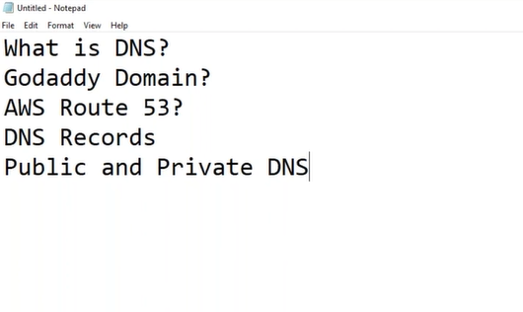 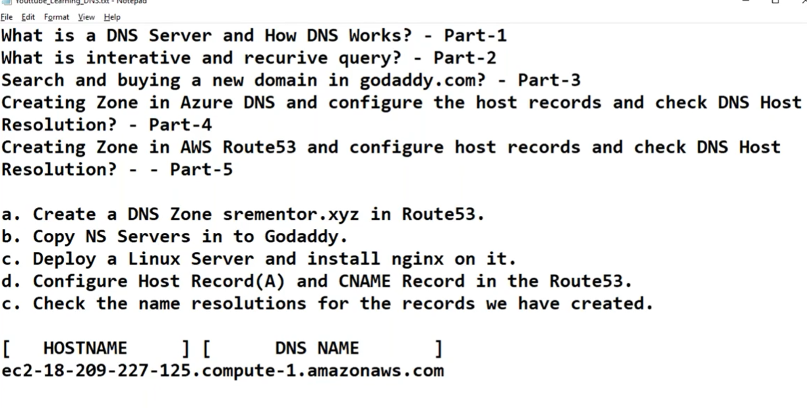

To see url is connecting to internet or not goto cmd: ping [www.google.com](http://www.google.com)

To see ip of url, goto cmd: nslookup [www.google.com](http://www.google.com)

eg

Forbes.ftl.com 🡸🡺 (Forbes – host name) & (ftl.com – Domain name) (totally – Fully qualified domain name(FQDS))

<https://www.iplocation.net/ip-lookup> (where ip is coming from)

root hint server - <https://www.iana.org/domains/root/servers> (they maintain all ips)

* Goto godaddy.com and buy domain name

**dheerajpalvai.xyz**

“#!/bin/bash” is called shebang

i, to work with Route 53, we Launch an instance [Ec2 - > launch an instance]

putty -> sudo su - -> nano /usr/share/nginx/html/index.html (make some changes)

here I give Public IPv4 DNS in browser I get nginx web server page,

now my target is to get same page when I give my Domain name (dheerajpalvai.xyz)

ii, AWS provider DNS as a service i.e., nothing but “Route 53”

Networking & Content Delivery -> Route 53

Route 53 -> Hosted zones -> Create hosted zone

dheerajpalvai.xyz -> create hosted zone

Here we get 2 records, we must take NS (name server records) and paste in GoDaddy Nameservers

iii, goto GoDaddy Nameservers -> My Products -> DNS ->Click on Using default nameservers [change]

ii, Goto Route 53 (here we route domain to instance by giving DNS an ip)

->Create record -> simple routing -> Define simple record

Naked domain=> ip address -> 35.175.117.63 (Public IPv4 address) ->A

Domain name=> www -> ip address -> 35.175.117.63 (Public IPv4 address) ->A

The above two records are called “A or Host name”: Name <-> IP

So, if I give url in browser its checks with IP and get the page

www -> Ip address -> ec2-35-175-117-63.compute-1.amazonaws.com -> CNAME

The above two records are called “CNAME or ALIAS record”: Name <-> Name

Here if I give url in browser its checks with DNS name and get the page

Now I have an account other cloud and if I give url from one account also it should access

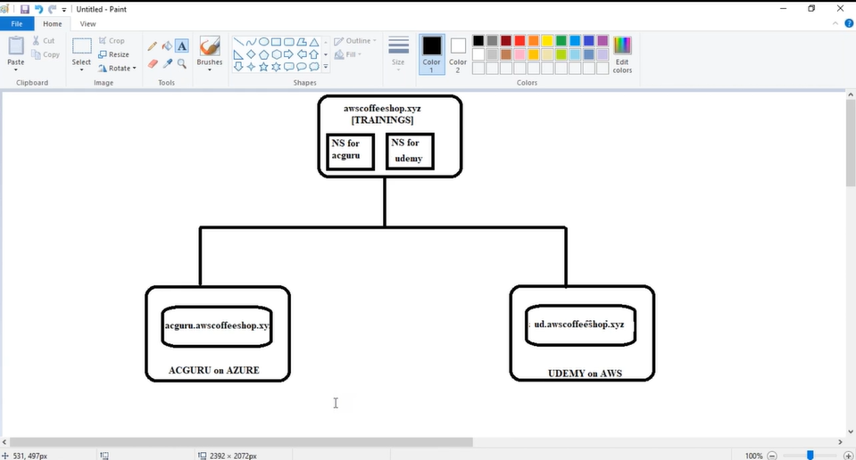

1, Now create an inctance -> ud_server

2, Route 53 -> Hosted zones -> Create hosted zone

i, ud.dheerajpalvai.xyz -> create hosted zone (ud hosted zone )

now copy ud.dheerajpalvai.xyz NS servers’ route traffic details

ii, now go into first hosted zone i.e., dheerajpalvai.xyz -> view details -> Create record-> ud-> IP-> past

route traffic details -> NS

i, now go into second hosted zone i.e., ud.dheerajpalvai.xyz -> view details -> Create record-> -> IP->

Public IP address of ud_server -> A

Now if you give dheerajpalvai.xyz or [www.dheerajpalvai.xyz](http://www.dheerajpalvai.xyz) it re directs to ud.dheerajpalvai.xyz

Till now we discussed about Public DNS…

Now we are going to see Private DNS…

Private DNS: companies maintain some web sites internally for that they use Private DNS

🡺Route 53 -> Hosted zones

Domain name = india.local (can give any name)

Private hosted zone (select)

Region = US East (N. Virginia) [us-east-1]

VPC ID = vpc-0187b51aedcbd91e2 (for example)

🡺 Ec2 here create an instance to test private DNS

🡺 in Route 53 create a record

Lin -> ip -> 10.0.1.126 (private ip)

🡺 goto putty and “ping lin.local.india” (ping URL)

Now it pings, that means this url is pinging internally