Class 20

Load Balancers:

When number of people access for banking site, this Load Balancer handle the load without crashing.

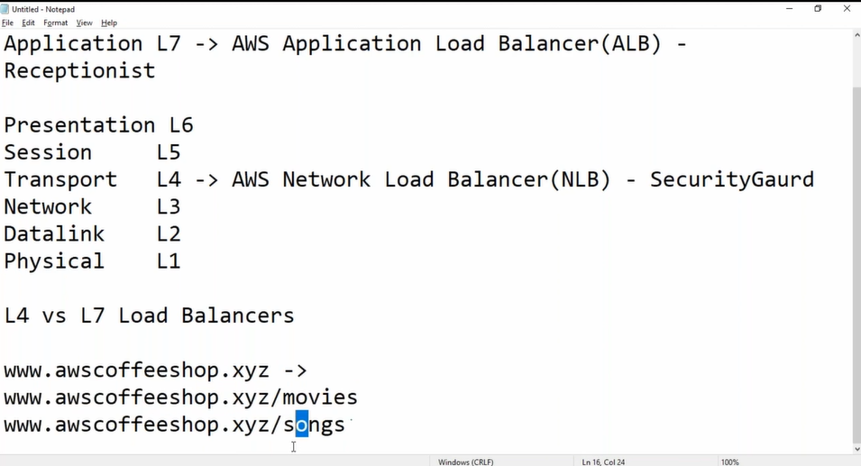

There are two types of Load Balancers:

1, Network Load Balancers:

This lye’s on Transport layer (L4)

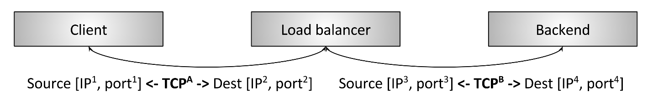

L4 Network Load Balancer is a Traditional Load Balancer, when client request for TCP connection it goes to Load Balancer and from there it goes to back end, from there it comes back to Load Balancer and there to client.

[eg: here Load Balancer can’t understand about what the request is asked by client, here Load Balancer takes request and send to backend]

2, Application Load Balancers:

This lye’s on Application layer (L7)

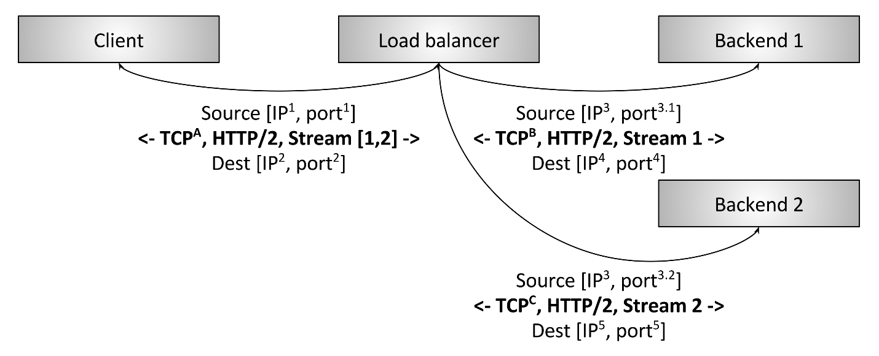

L7 Application Load Balancer is a sophisticated L7 load balancer, when client request for TCP connection it goes to Load Balancer and from there it goes to back end, from there it comes back to Load Balancer and there to client.

[eg: here Load Balancer understand about what the request is asked by client, here Load Balancer takes request and send to backend1 or backend2 which ever client is requested]

Eg: if it is a multiplex site, Load Balancer takes request to movies or songs backend site as per client request

In this class our agenda

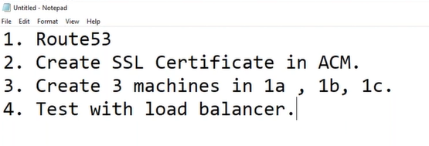

i, Route53 -> Create hosted zone -> Domain name: dheerajpalvai.xyz -> Create hosted zone

copy DNS NS servers

ii, go to GoDaddy dheerajpalvai.xyz -> manage DNS -> and past those NS servers

iii, go to Certificate Manager for SSL Certificates

Services -> Security, Identity, & Compliance -> Certificate Manager

Provision certificates -> Request a public certificate -> *. dheerajpalvai.xyz

|  |
| --- |
| **DNS validation ->** is to say certificate that, the domain name (dheerajpalvai.xyz) that I have given  is own by me, because in go dady we given Route53 DNS server names  (by selecting this it validates from Route53 DNS’s)  ->conform and continue  Then it asks, if you or really owner of that Domain name copy (Name:  _4b764102ac06bb171ce550c00f0c61d6.dheerajpalvai.xyz.) and (Value:  _15bea300c2378d465f6a7e95816df091.zbkrxsrfvj.acm-validations.aws.) and paste in Route53  i, Route53 -> Hosted zones -> dheerajpalvai.xyz -> Create record  Record name: _4b764102ac06bb171ce550c00f0c61d6 (Name)  Ip Address -> CNAME  In box: _15bea300c2378d465f6a7e95816df091.zbkrxsrfvj.acm-validations.aws. (value)  {This record can be created only by Devops administrator, so that Aws certificate knows that this DNS belong to  dheerajpalvai.xyz name}  iv, now we create 3 instances Ec2 -> Launch an instance [Web server 1, Web server 2, Web server 3] in  three different area zones to test load balancer    Here when traffic goes through internet to Route53 it checks with DNS servers then goes to AWS ELB  (Elastic Load Balancer) through port 80 and hits web server1 2 3 & return through same port TCP/80  Here all Web servers are in Backend i.e., target group  V, Target groups:  Create target groups and assign VPC to that  Target group -> create Target group -> Target group name: -> Protocol: TCP & Port:80-> VPC of servers  [here we didn’t assign any servers in target group]  Vi, Load Balancer: Load Balancers be per Region or per VPC basis  EC2 -> Load Balancer -> Create Load Balancer -> Network Load Balancer (it supports all type of port  & and have ultra-high performance)   1. Configure Load Balancer:   Name: AWSB26-NLB  Select VPC, public subnets, Web servers  2. Configure Security Settings  3. Configure Routing  Target group: Existing target (or) New target  group Name: AWS26 (or you can create Target group here itself) (or) AWSB26-NEW TG  4. Register Targets  Select: web server 1 & web server 2  Click on Add to registered  5. Review  Create Load balancer   * Now For load balancer we get DNS Name, if we copy and paste in URL, we can see the Web server 1   And Web Server2 is changing  i, Route53  Now create record and paste That Load balancer DNS URL  www -> ip > past DNS URL -> CNAME   * Now also we can see changing Web server 1 & Web server 2 by giving [www.dheerajpalvai.xyz](http://www.dheerajpalvai.xyz)   V, Target group: now again go to Target group and add Web server 3 and check DNS URL   * Now stop two services and check DNS it stops, that means Load balancer knows it is stopped   When I see the web site at URL it is NOT SURE  Vi, Load Balancer: select Load Balancer -> Listeners  Change Protocol: TLS (Transport Layer Security)  Default action(s) -> Add action -> Forward to... -> “our Target group” ->  Security policy: F-s-1-2 2019  Select ACM (Aws Certificate)  If we keep https:// before our URL it will be secure   * Here in Load Balancer, under “Description” we can add subnets but cannot delete * In Edit attributes -> Cross-Zone Load Balancing     In NLB, Load Balancer sends request equally as per Available zones(33 33 33), when we enable  Cross-Zone Load Balancing Load balancer sends requests as per Servers count  🡺Now if my target is to create go to target group    V, Target Group:    Remove Web server 2 and Web server 3 from existing target group  Create two target group and keep Web server 2 in one target group with port 8000  And Web server 3 in other target group with port 9000 |
|  |