Class 21

Application load balancer (L7 Load balancer): this provides HTTP/HTTPS listener ports for website.

Our Agenda

1, 3rd party SSL (How to generate) (DNS Server)

2, 3 servers in different Target groups

3, ALB (Application Load Balancer)

ALB Must be used: (Layer 7 load balancer)

1. if it is Web application using http or https
2. Path base routing

dheerajpalvai.xyz -> home page

dheerajpalvai.xyz / movies -> movies page

dheerajpalvai.xyz / shows -> shows page

1. Http to Https Redirect

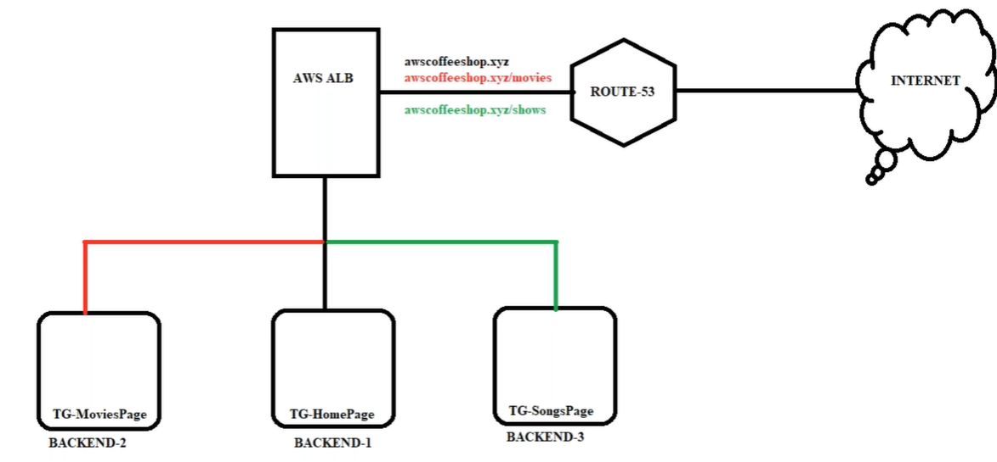

Note: in the above image when we create 3 instances, and add in 3 target groups, configure in ALB, that should connect to Route 53

Lab:

1, Route53 -> Create hosted zone -> copy NS- Dns servers

2, Godaddy.com -> My Products -> DNS -> Nameservers (click on change) -> paste NS- Dns servers

3, Security, Identity, & Compliance -> Certificate Manager -> Provision certificates -> (we need to “Import a certificate” 3rd party SSL certificate, we have to buy it from Trusteed SSL Provider, but now we generate AWS Certificate which belong to AWS) -> Request a certificate -> *.dheerajpalvai.xyz (* means any host name eg: www.)-> DNS validation -> confirm and continue -> click on *.dheerajpalvai.xyz and copy “Name” and “Value”

1, Route53 -> Create a record -> past Name in “Record name” -> IP -> past Value in “Box” -> CNAME

|  |
| --- |
| #!/bin/bash  yum update -y  yum install nginx -y  service nginx start  echo "<h1> MoviesPage</hi>" >>  /usr/share/nginx/html/index.html |

|  |
| --- |
| #!/bin/bash  yum update -y  yum install nginx -y  service nginx start  echo "<h1> ShowsPage</hi>" >>  /usr/share/nginx/html/index.html |

4, create 3 EC2 instances

Home Movies Shows

|  |
| --- |
| #!/bin/bash  yum update -y  yum install nginx -y  service nginx start  echo "<h1>HomePage</hi>" >>  /usr/share/nginx/html/index.html |

Ec2 Movies -> putty ->cd /usr/share/nginx/html/ -> mkdir Movies -> mv *.* Movies -> mv /icons /Movies

Ec2 Shows -> putty ->cd /usr/share/nginx/html/ -> mkdir shows -> mv *.* shows -> mv /icons /shows

By this we can achieve path-based routing

(*.* means all )

5, Target Groups -> Target group name: Home page -> HTTP & 80 -> VPV -> Health check path: / -> target Home page

Target Groups -> Target group name: Movies page -> HTTP & 80 -> VPV-> Health check path: /Movies/ -> target movies page

Target Groups -> Target group name: Shows page -> HTTP & 80 -> VPV-> Health check path: /shows/ -> target shows page

6, Load Balancers -> Application Load Balancer -> Name: AWSB26-ALB -> VPC & AZ -> Existing group & Homepage

Goto Description and copy DNS Name

1, Route53 -> Hosted zones -> select Domain Name -> view details -> create record ->www ->

Alias to Application and classic Load balancer (it directly comes when we create Application load balancer) -> select Region -> we get automatically DNS Name -> A ->

Now our **instance** in **load balancer** is connected to **Route53** which is [www.dheerajpalvai.xyz](http://www.dheerajpalvai.xyz)

Then we must assign ACM or SSL certificate in Load balancer and redirect it from http to https,

6, Load Balancers -> Listeners -> Add listener -> Protocol: Https & port: 443 -> Add action: Forward to..: Homepage

Note: if you check on the website connection is secured, if we click on that we can see SSL/TLS

Secure Sockets Layer / Transport Layer Security (SSL is old certificate and TLS is upgraded certificate).

6, Now I want to Redirect HTTP to HTTPS in URL

Load Balancers -> Listeners -> Listeners id: HTTP:80 -> Rules: view/Edit rules -> click on top pencil symbol -> click on left pencil symbol to edit -> Redirect to HTTPS: 443

6, Now I want to Redirect Movies & shows page

Load Balancers -> Listeners -> Listeners id: HTTPS:443 -> Rules: view/Edit rules -> click on top pencil symbol -> click on top + symbol -> Insert Rule -> Add condition -> Path… -> /Movies/* -> Add action -> Forward to.. -> moviespage

Load Balancers -> Listeners -> Listeners id: HTTPS:443 -> Rules: view/Edit rules -> click on top pencil symbol -> click on top + symbol -> Insert Rule -> Add condition -> Path… -> /shows/* -> Add action -> Forward to.. -> showspage

**Note**: in Route53 we create 2 records, one is for ACM (AWS Certificate Manager) Name & Value

And second is for Load Balancer Dns name

SSL/TLS certificate authority: There are some of the trusted certificate authority, who provides SSL/TLS certificates like Comodo Certificate Authority, DigiCert Certificate Authority, GoDaddy Certificate Authority etc...

One image to show how security works:

