Class 30

EFS: giving access to different users to exchange data, which is on one Linux machine

To access multiple Linux machines for single EFS storage (we call it as “Network File System”)

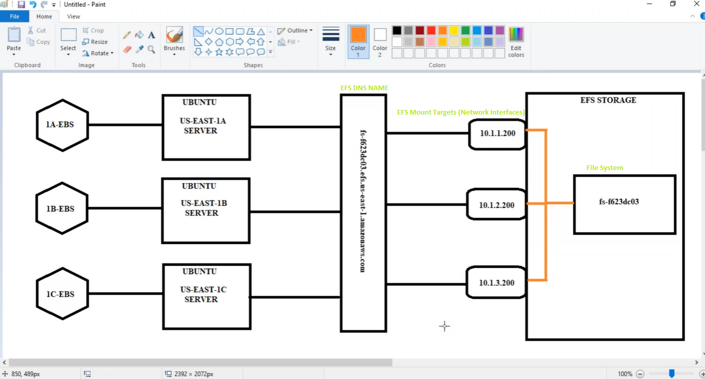

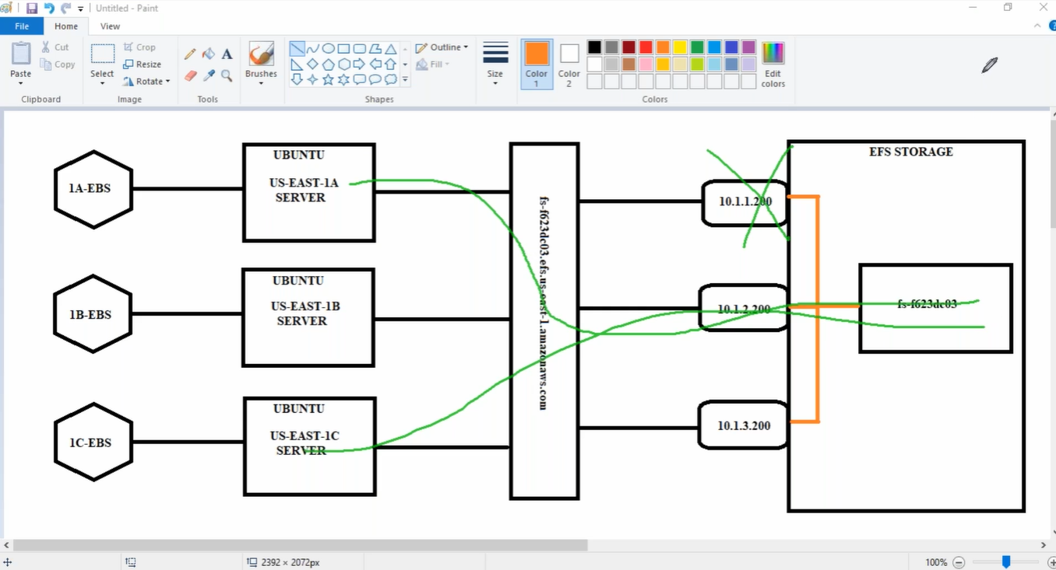

* EFS is shared file system, If I keep a file in AZ US-EAST-1A, we can see same file in 1B & 1C also
* And if one EFS Mount Target (Network Interface) fails also, server is connected to EFS with other Network Interface, so that we don’t get down time
* EFS is done on only Linux machine
* EBS Volume storage = EFS storage (are same),

but if Linux machine is on one Available zone, EBS volume should be on same Available zone.

whereas EFS can connect to multiple Linux machines which are in different Available zone.

Lab:

1, Storage -> EFS- > Create file system ->Name: AWSEFS & VPC -> click on AWSEFS ("can see file system name") -> Attach -> Using the NFS client: ("here we can see filesystem DNS name") -> Manage mount targets -> VPC -> Add mount target ->

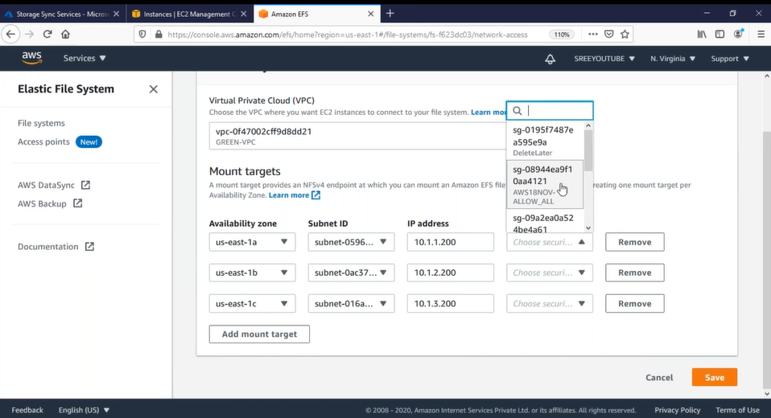

2, Create 3 ubuntu instance. In 3 different Availability zones (where Network interface is connected)

Ec2 -> Ubuntu Server -> 1A & 1B & 1C (to install NFS Driver) #!/bin/bash

apt update

apt install nfs-common -y

3, (1A) putty -> ubuntu -> 1A server ->nslookup fs-54c405a1.efs.us-east-1.amazonaws.com (EFS DNS Name)

Here we can see server is connected to 10.0.1.200 (AZ 1a Network interface)

🡺Mount EFS server to 1A ,1B, 1C

Cd / (change to root)

Mkdir 1A-folder

df -h

(See “EFS_Mouting” Document in my system I can find)

sudo mount -t nfs4 -o nfsvers=4.1,rsize=1048576,wsize=1048576,hard,timeo=600,retrans=2,noresvport fs-54c405a1.efs.us-east-1.amazonaws.com:/ 1A-folder

[mounting the folder to EFS DNS]

Now it is in cash memory so if server is rebooted it will unmount

nano /etc/fstab

fs-54c405a1.efs.us-east-1.amazonaws.com:/ /1A-Folder nfs

umount /1A-Folder (to check)

df -h (can see unmounted)

mount -a

reboot (but we can see 1A-Folder is mounted to EFS permanently)

Do for all servers………...

Now

Go to server 1A-> (go to folder1)-> root@ip-10-0-1-188:/1A-Folder#

for I in {1..10}

> do

> echo $(date) > FILE$I

> sleep 2

> done

Go to server 1B-> watch -n 1 ls -al /1B-Folder/ (watches every second the data )

Go to server 1C-> watch -n 1 ls -al /1C-Folder/ (watches every second the data )

If I keep any files in 1A-Folder, those automatically comes in 1B-Folder & 1C-Folder of other servers

--------------------------

**Using Jenkins:**

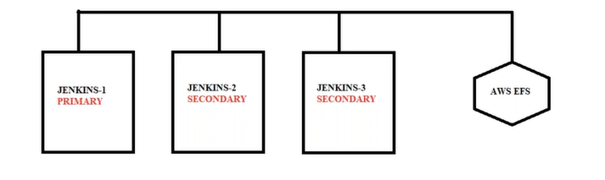

* Now rename /1A-Folder to /var/lib/jenkins/ (Do for all servers)

Umount /1A-server

Nano /etc/fstab

fs-54c405a1.efs.us-east-1.amazonaws.com:/ / var/lib/jenkins/ nfs

install jenkins:

apt update && apt install openjdk-8-jdk -y

java -version (ok installed properly)

open <https://www.jenkins.io/> -> Documentation -> Installing Jenkins -> Linux

wget -q -O - https://pkg.jenkins.io/debian/jenkins.io.key | sudo apt-key add -

sudo sh -c 'echo deb https://pkg.jenkins.io/debian binary/ > \

/etc/apt/sources.list.d/jenkins.list'

sudo apt-get update

sudo apt-get install Jenkins

service jenkins start

get password foe jenkin:

cat /var/lib/jenkins/secrets/initialAdminPassword (copy password)

URL: ec2-3-231-162-171.compute-1.amazonaws.com:8080 (1A-server Public DNS & Jenkins port 8080)

Install -> finish (automatically runs in other two machines also)

Create a job -> Enter an item name: Testjob -> Build: Execute shell

#!bin/bash

for i in {1..10}

do

echo "welcome $i times...."

sleep 1

done

Save -> Build Now

In 1A-server if we go to: ls / var/lib/jenkins/workspace we can see Testjobs

* If we install Jenkins in other two servers and open with jenkins port with Public DNS we can see same “Testjob” folder