zepto

**Title: Zepto Growth Optimization: Enhancing Acquisition, Retention, and Revenue (2022–2024)**

**Business Problem:**

Zepto, a fast-growing grocery delivery startup, aims to enhance its customer acquisition strategy, retention efforts, and revenue growth. The goal is to optimize marketing spend, reduce churn, improve customer lifetime value (CLV), and forecast future growth. This project uses Zepto’s customer acquisition, retention, and revenue data from 2022-2024 to address these business challenges.

**Key Deliverables:**

* Datasets for customer acquisition, retention, and historical trends.
* Excel Analysis for preparing and transforming raw data into clean & structured formats.
* SQL Queries to solve business problems and extract insights.
* Power BI Visualization for an interactive dashboard (Power Query, Data Modeling, DAX).

**Datasets:**

* Customer Acquisition Data - Contains details about Customer ID, Marketing spend, Marketing Channel and customer data from 2022 to 2024.
* Customer Retention Data - Includes retention information, churn date, and customer demographics.
* Revenue Trends Data - Tracks revenue over time and customer spending patterns.

**Key Business Questions:**

These are 8 impactful questions formulated to address Zepto's challenges and align with the provided datasets:

1. What is the average Customer Acquisition Cost (CAC) for Zepto from 2022-2024?
2. What is the overall revenue growth of Zepto over the past two years (2022-2024)?
3. What is the Customer Lifetime Value (CLV) by customer segment?
4. How do marketing spending and CAC correlate with customer acquisition rates?
5. Which marketing channels are driving the most profitable customers?
6. What is the retention rate and Churn Rate by region for Zepto’s customers?
7. What is the Customer Spending by Region and Segment?

**SQL Queries and Solutions:**

**1. What is the Customer Acquisition Cost (CAC) for Zepto from 2022-2024?**

**SQL Syntax-**

SELECT

YEAR(acquisition_date) AS Year,

round(SUM(marketing_spend) / COUNT(DISTINCT customer_id),0) AS CAC_per_customer

FROM customer_acquisition

GROUP BY YEAR(acquisition_date);

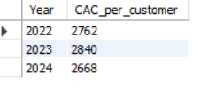

**2. What is the overall revenue growth of Zepto over the past two years (2022-2024)?  
  
SQL Syntax-**

select year(Revenue_date) as year,

ROUND(sum(Revenue),2) as Total_revenue

from revenue_trends

group by year

ORDER BY YEAR

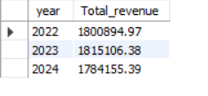

**3. What is the Customer Lifetime Value (CLV) by customer segment?**

**SQL Syntax-**

SELECT Customer_Segment,

round(AVG(total_revenue),2) AS CLV

FROM

(select sum(revenue) as total_revenue,Customer_Segment

from revenue_trends

group by customer_segment)AS subquery

GROUP BY

Customer_Segment;

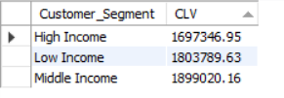

**4. How do marketing spending and CAC correlate with customer acquisition rates?**

**SQL Syntax-**

SELECT Marketing_channel,

round(SUM(marketing_spend),0) AS Total_spend,

COUNT(DISTINCT customer_id) AS Total_acquisitions

FROM customer_acquisition

GROUP BY marketing_channel

order by Total_acquisitions desc;

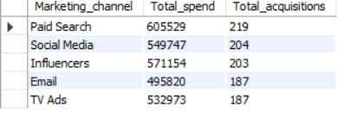

**5. Which marketing channels are driving the most profitable customers?**

**SQL Syntax-**

select Marketing_Channel,

round(sum(revenue),0) as revenue from revenue_trends

group by Marketing_Channel

order by revenue desc;

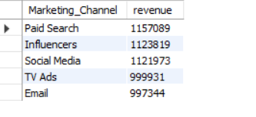

**6. What is the retention and Churn rate by region for Zepto’s customers?**

**SQL Syntax-**

SELECT

Region,

count(CASE WHEN churn_status = 'Active' THEN 1 END) AS Active_customers,

ROUND(SUM(CASE WHEN churn_status = 'Active' THEN 1 END) * 100.0 / COUNT(*), 2) AS Retention_rate,

SUM(CASE WHEN churn_status = 'churned' THEN 1 ELSE 0 END) AS Churned_customers,

ROUND(SUM(CASE WHEN churn_status = 'churned' THEN 1 ELSE 0 END) * 100.0 / COUNT(*), 2) AS Churn_rate

FROM

Customer_retention

group by region

order by region;

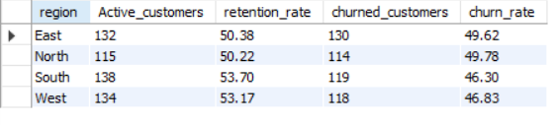

**7.what is the Customer Spending by Region and Segment?**

**SQL Syntax-**

SELECT region, customer_segment,

round(SUM(revenue),0) AS Total_spending

FROM revenue_trends

GROUP BY region, customer_segment

ORDER BY total_spending DESC;

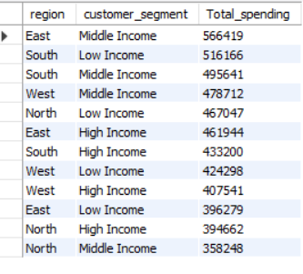

**Solutions-**  
  
**1. Customer Acquisition Cost (CAC):**

**Insight:**

The CAC for Zepto fluctuated between 2022 and 2024. High marketing spends in 2024 did not result in proportional increases in customer acquisitions, indicating inefficiencies.

**Recommendation:**

Reevaluate underperforming marketing strategies contributing to higher costs in 2024.

Invest in marketing channels with consistent customer acquisition rates and optimize campaigns for better ROI.

**2. Revenue Growth:**

**Insight:**

Revenue increased from 2022 to 2023 but saw a decline in 2024, reflecting potential challenges such as customer churn, reduced spending, or market saturation.

**Recommendation:**

Conduct root cause analysis for the revenue dip in 2024—target possible issues like reduced customer loyalty or ineffective promotions.

Relaunch targeted marketing and retention campaigns in 2024 to recapture lost growth momentum.

**3. Customer Lifetime Value (CLV):**

**Insight:**

Premium customer segments consistently show higher CLV compared to other segments, underscoring their importance to overall profitability.

**Recommendation:**

Focus on premium segments by offering exclusive benefits and targeted rewards to improve loyalty.

Explore ways to upsell or cross-sell to other customer segments to elevate their CLV.

**4. Marketing Spend vs. Customer Acquisition:**

**Insight:**

A correlation exists between marketing spend and customer acquisition, with some channels showing higher efficiency.

**Recommendation:**

Shift marketing spend toward high-performing channels and reduce budgets for channels with low acquisition efficiency.

Use A/B testing to refine underperforming strategies and achieve better results.

**5. Profitable Marketing Channels:**

**Insight:**

Certain marketing channels, such as organic and referral channels, are more profitable compared to paid channels.

**Recommendation:**

Enhance focus on organic growth and referral incentives to drive profitability.

Assess low-performing channels and either improve their strategies or reallocate budgets.

**6. Retention Rate and Churn Rate by Region:**

**Insight:**

Retention rates vary across regions, with some regions exhibiting significantly higher churn rates, indicating dissatisfaction or unmet needs.

**Recommendation:**  
Develop region-specific retention strategies, such as personalized offers or better customer support for high-churn areas.

Focus retention efforts on high-value customers in regions with strong retention rates to secure long-term revenue.

**7. Customer Spending by Region and Segment:**

**Insight:**

Premium customer segments and metropolitan regions demonstrate higher spending patterns compared to others.

**Recommendation:**

Introduce tiered pricing and loyalty benefits in regions with lower spending.

Expand marketing in high-spending regions to further capitalize on revenue opportunities.

**Conclusion:**

Zepto’s business data highlights key challenges and opportunities. The decline in revenue in 2024 and the rising Customer Acquisition Cost (CAC) indicate areas for improvement. By optimizing marketing strategies to reduce costs, targeting high-value customer segments, and addressing regional churn issues, zepto can improve customer retention, boost revenue, and enhance overall profitability. Focusing on high-performing marketing channels, premium customer segments, and regional-specific strategies will ensure sustainable growth and long-term success for the business.