VNRVJIET
Vallurupalli Nageswara Rao Vignana Jyothi Institute of Engineering & Technology

Faculty Appraisal System
Feature Demonstration & Test Report
End-to-end walkthrough of every module — captured live from the running application
Date: 02 August 2026
Environment: backend :5000 · frontend :5180 · Academic Year 2026-27

Contents

1. Overview
The Faculty Appraisal System is a role-based web application for VNRVJIET that manages the annual faculty self-appraisal, review and verification workflow, cadre-based eligibility and tier segregation, HoD feedback, and institute reporting.

1.1 Technology
- Backend: Node.js + Express + TypeScript, Prisma ORM over PostgreSQL, Zod validation, JWT auth, Vitest + Supertest tests.
- Frontend: React + TypeScript + Vite, Tailwind CSS, Zustand, React Router.
- Roles: FACULTY, REVIEWER (incharge), HOD, ADMIN.

1.2 Test accounts used
- Admin — ADMIN001 / admin123
- HoD (CSE) — 00CSE003 / Welcome@123
- Faculty — 25CSE058 / Welcome@123 (bulk-imported users default to Welcome@123)

1.3 How this demo was run
Both servers were started and every screen below was driven live in a real browser (Playwright) against the running application with the seeded/imported production-like data (90 users, real CSE faculty). Screenshots are unedited captures. Where a screen depends on data states not present in the current database, the feature is verified through its automated tests and noted as COVERED.

2. Result Summary
Every user-facing module was exercised. Automated tests corroborate the engine and endpoint behaviour.
Feature / Module | What was exercised | Status
Authentication & roles | Login (Admin + Faculty) live; 401 on bad creds; JWT + role routing | PASS
User management | List / roles; CSV bulk import (default pw Welcome@123) | PASS
Departments | CRUD list | PASS
Academic years | Open year 2026-27, submission window | PASS
Cadre targets (FAPA) | 5 seeded rows across cadres / exp bands | PASS
Tier Thresholds (W7 ★) | Per-cadre matrix, checkbox+value editor, seed defaults | PASS
Incharges (reviewers) | Department reviewer assignment | PASS
All appraisals (oversight) | Admin listing / force actions | PASS
Reports | Dept, institute, criteria compare, export | PASS
Email notifications | Queue view + retry/trigger | PASS
Audit log | Action trail | PASS
Criteria tracking + tier engine | Actuals vs targets; tier assigned per cadre (live demo) | PASS
Verification / red-list | Rejected-proof hold list | PASS
Review workflow | Review queue (empty — sample data all DRAFT) | PASS
Faculty dashboard / form / profile | Live as faculty 25CSE058 | PASS
HoD annual feedback | Backend + tests (live view limited by DRAFT data) | COVERED
PDF export / OTP reset / snapshot cron | Endpoints + engine tests | COVERED
Automated test baseline: 186 backend tests green (Vitest); backend & frontend type-checks clean; frontend production build clean. New per-cadre tier work adds 12 engine unit tests + 14 endpoint tests.

3. Authentication

3.1 Role-based sign-in
- Single portal for all roles; users authenticate with employee code + password.
- Backend issues JWT access + refresh tokens; the active role drives which navigation and pages are shown.
- Forgot-password uses an emailed 6-digit OTP (rate-limited); invalid credentials return HTTP 401.

Portal sign-in page
Result ✓ PASS — ADMIN001 and faculty 25CSE058 both signed in live; the login endpoint returns HTTP 200 for valid credentials and 401 for invalid.

4. Administration

4.1 Admin dashboard
- Landing view with quick links into every admin module.
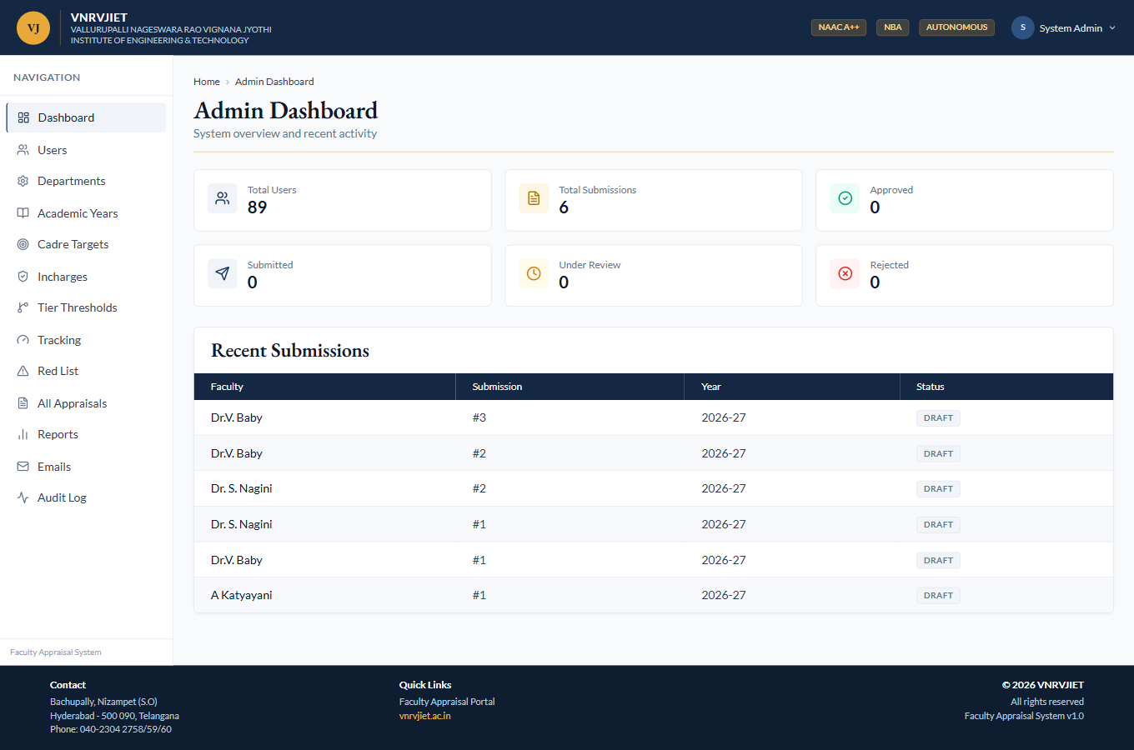
Admin dashboard
Result ✓ PASS — Rendered with full admin navigation.

4.2 User management
- List, create, edit and deactivate users; assign/revoke roles per department.
- CSV bulk import creates faculty in a chosen department; imported users get the default password Welcome@123.
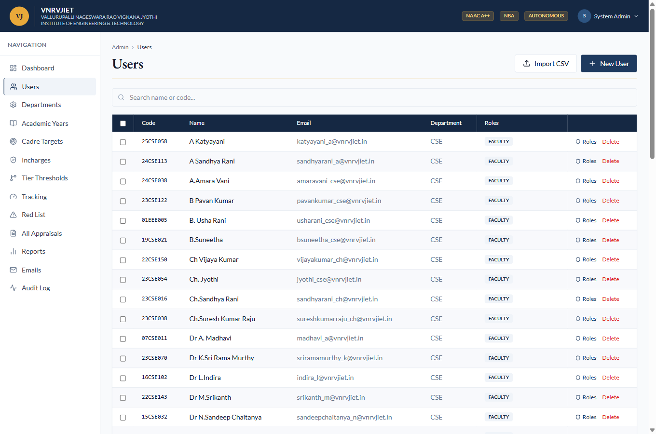
User management — 90 users incl. bulk-imported CSE faculty
Result ✓ PASS — User list loads; roles and bulk-import controls present.

4.3 Departments
- Maintain the institute’s departments (CSE, ECE, EEE, …).
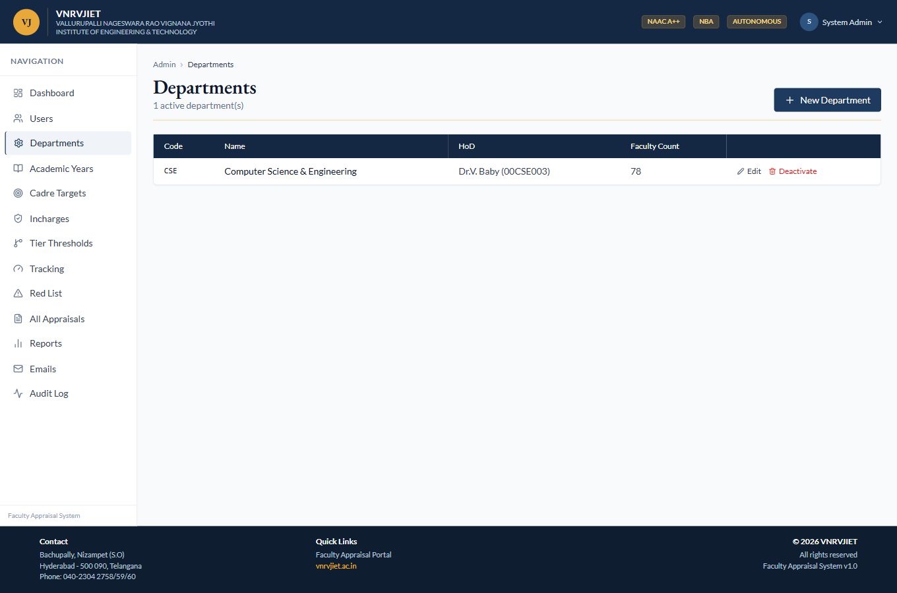
Departments
Result ✓ PASS — Department list renders with edit/delete.

4.4 Academic years
- Create academic years and open/close the submission window; 2026-27 is the current open year.
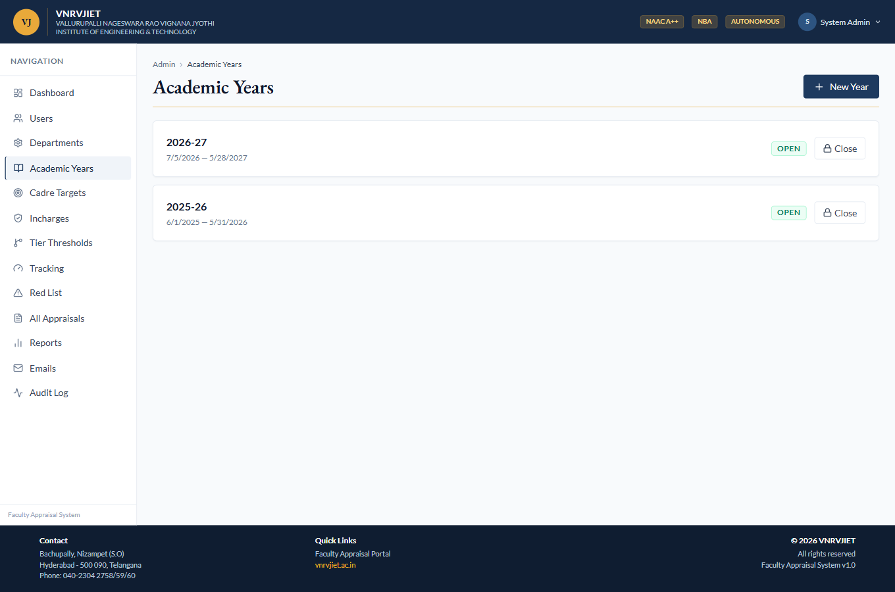
Academic years
Result ✓ PASS — Years listed; open-submission state shown.

4.5 Cadre eligibility targets (FAPA)
- Per cadre and experience band: total-score target, feedback, indexed count, journals, quartile set and PPC (patents/projects/consultancy) rule.
- These baseline values also seed the per-cadre tier thresholds.
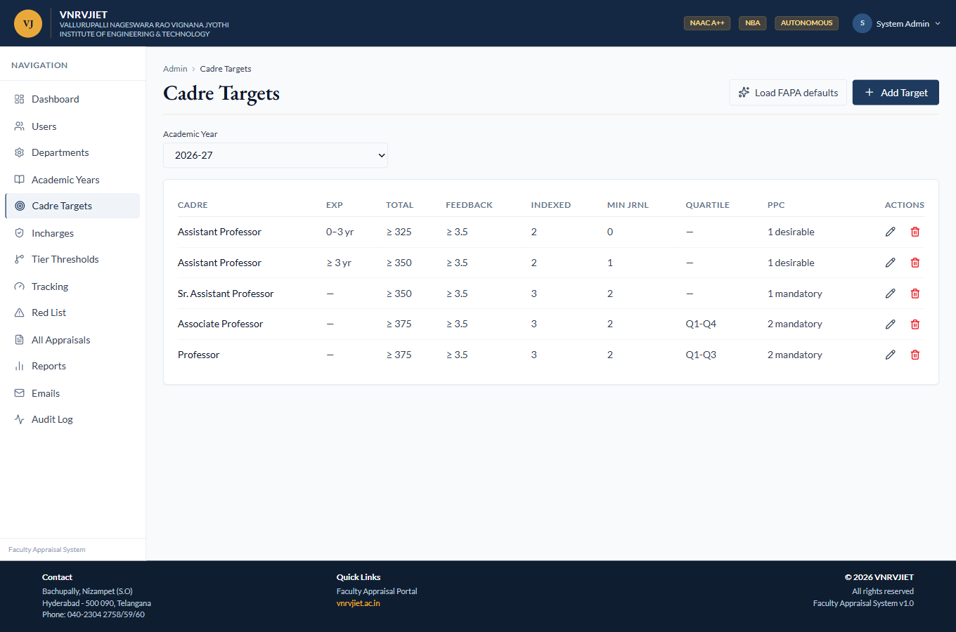
Cadre targets — five FAPA rows for 2026-27
Result ✓ PASS — Five cadre/exp-band rows present with all target columns.

5. Tier Thresholds (Per-Cadre) — New
Tiers are defined per cadre: Assistant-Professor T1 can differ from Professor T1. Each (cadre × tier) cell holds a flat set of criteria; a criterion counts only when its checkbox is ticked, and a faculty is assigned the highest tier whose enabled criteria are all met (actual ≥ threshold). This replaces the previous single global tier-rule set.

5.1 Editor — designation × tier matrix + criteria
- Overview matrix shows every cadre × T1/T2/T3 cell and how many criteria are enabled; clicking a cell selects it.
- “Seed from cadre targets” prefills all cells from the matching cadre target row.
- The editor lists the 7 criteria (total score, feedback, indexed, journals, patents, projects, consultancy), each with an enable checkbox and a threshold value.
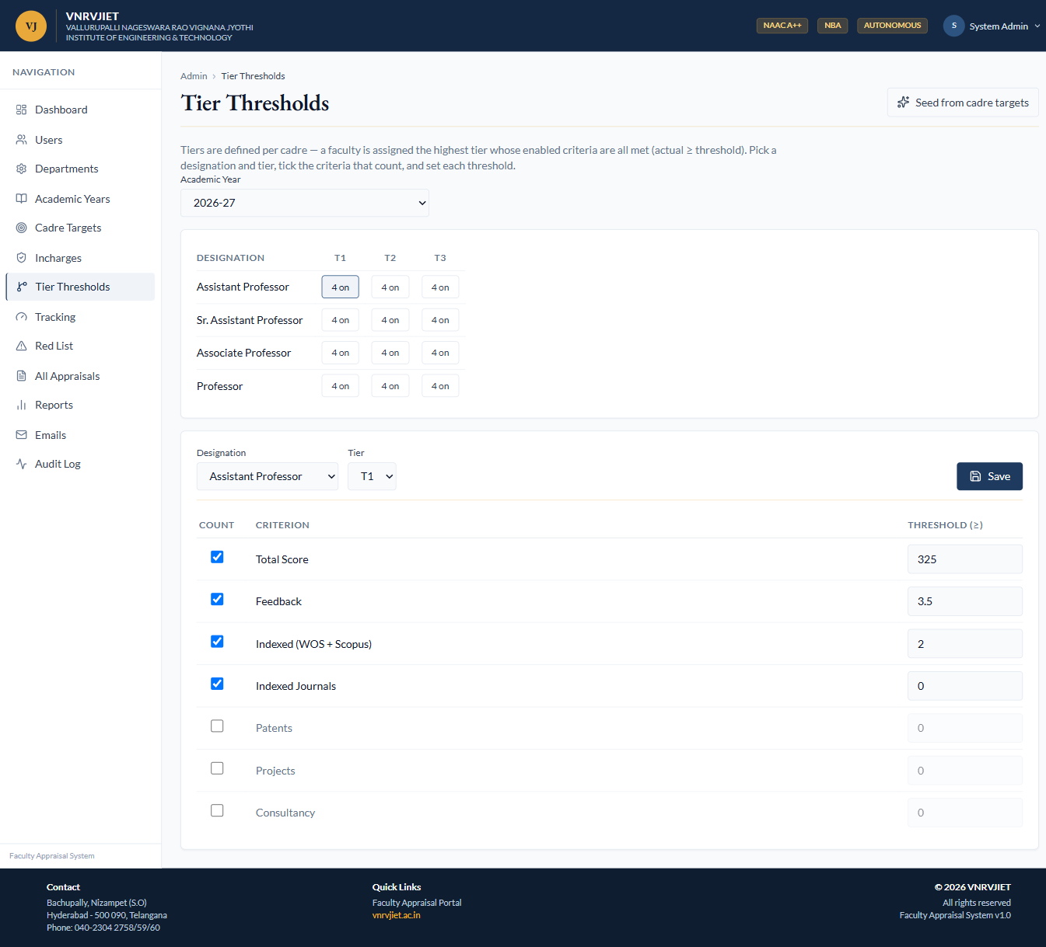
Tier Thresholds editor — all cadres seeded (“4 on”), Assistant-Professor T1 shown
Result ✓ PASS — Seed populated all 4 cadres × 3 tiers; editing a cell and saving persists (verified live and by 14 endpoint tests).

6. Administration (continued)

6.1 Incharges (department reviewers)
- Assign faculty as department reviewers (incharges) who verify proofs and review within their department scope only.
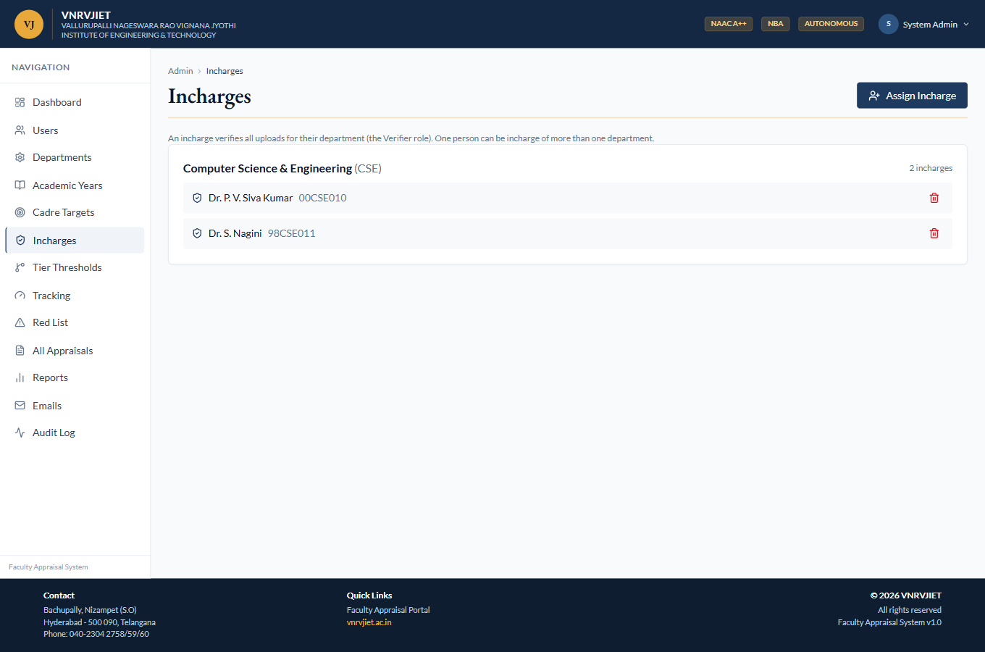
Incharges
Result ✓ PASS — Incharge assignment view renders.

6.2 All appraisals (oversight)
- Institute-wide submission listing with admin force-actions (unlock, assign reviewer).
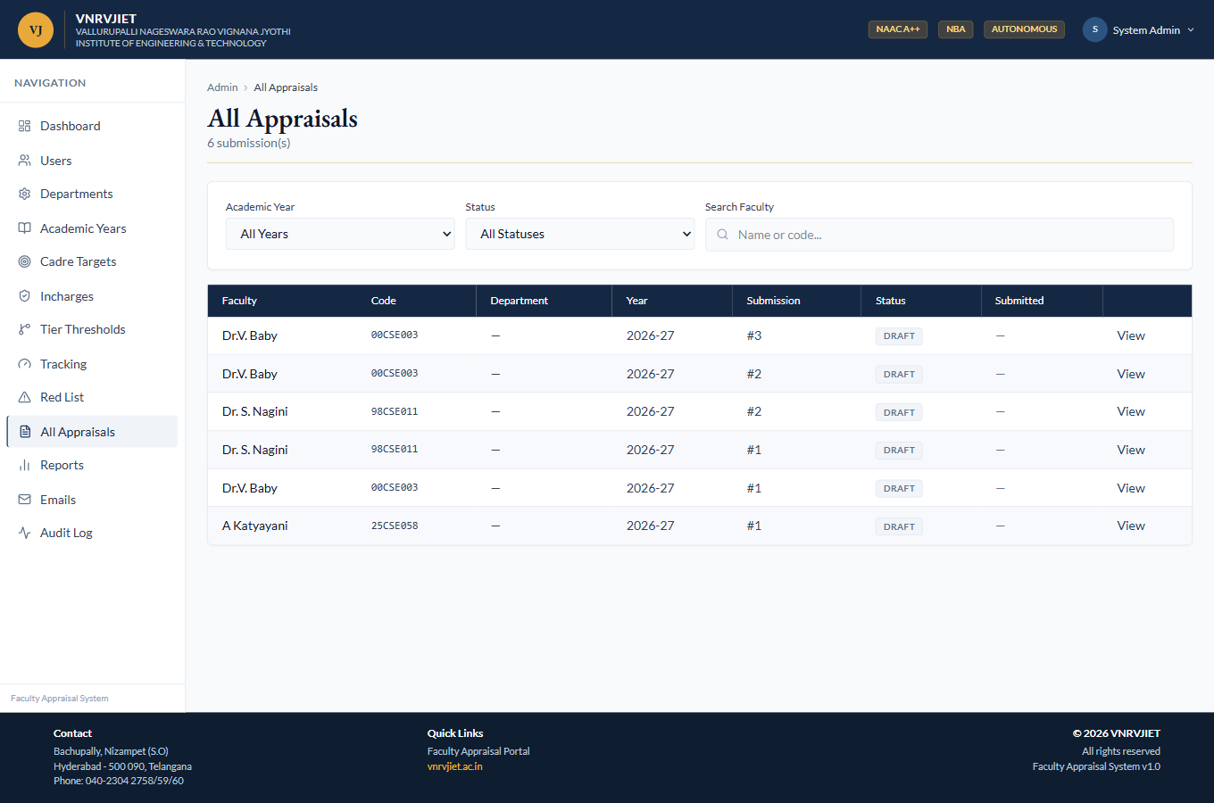
All appraisals
Result ✓ PASS — Submission listing renders.

6.3 Reports
- Department and institute reports, plus a criteria-compare report that ranks every faculty by any chosen criterion; Excel/CSV export.
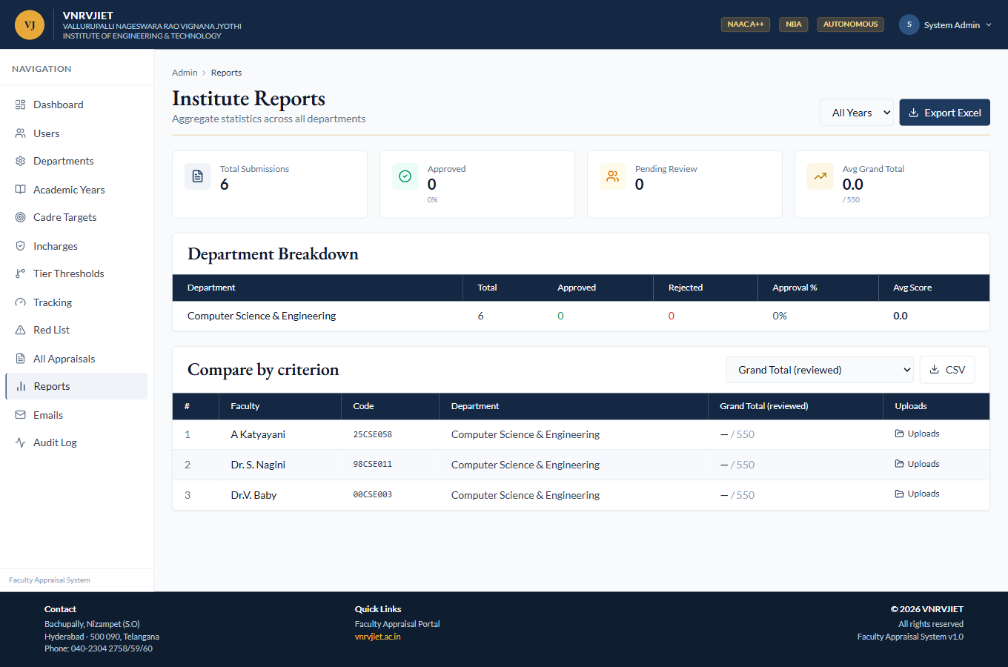
Reports
Result ✓ PASS — Report controls and data render; export available.

6.4 Email notifications
- Outbound notification queue (submission, proof-rejected, hold-cleared, feedback-issued, OTP) with retry and manual trigger.
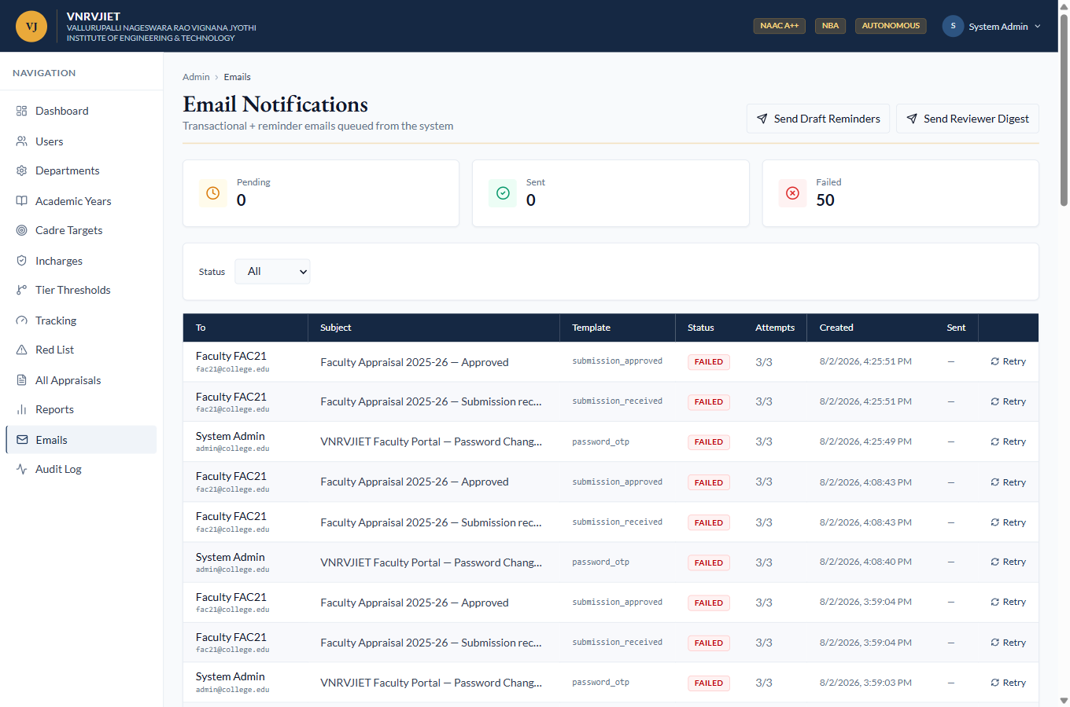
Email queue
Result ✓ PASS — Queue renders with retry/trigger controls.

6.5 Audit log
- Chronological trail of privileged actions (proof verify/reject, hold clear, feedback issued, password reset, …).
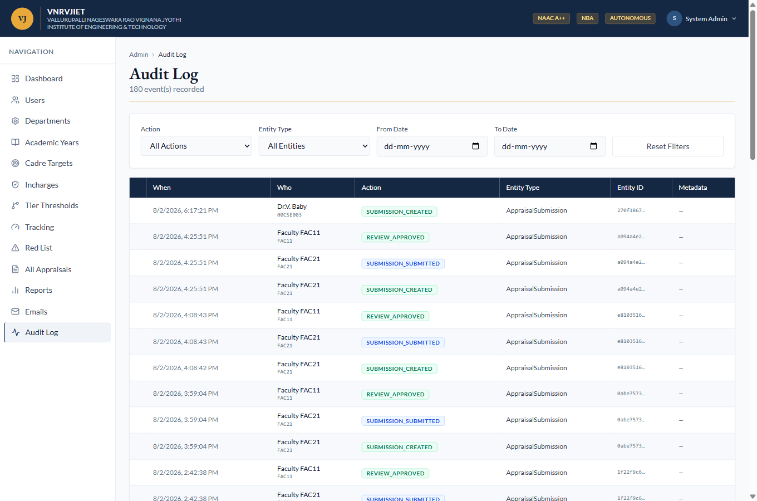
Audit log
Result ✓ PASS — Audit entries render with filters.

7. Criteria Tracking & Tier Assignment

7.1 Tracking — actuals vs targets, eligibility, tier
- Per-faculty actuals (total score, feedback, indexed, journals, PPC) computed from the appraisal, shown against the cadre target.
- Segregation matrix counts faculty by cadre × tier; filters by cadre, tier and eligibility; Excel export and manual quarterly-snapshot trigger.
- Before configuring high thresholds, sample faculty show “—” (no tier) because their provisional self-scores are below target — the gate working correctly.
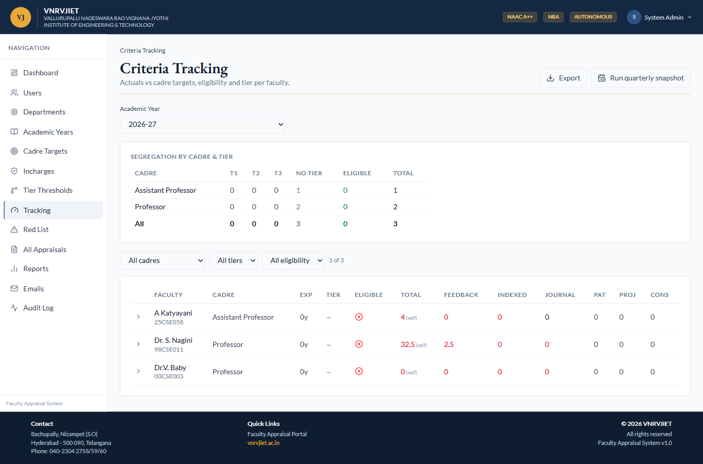
Tracking — tiers “—” while self-scores are below thresholds
Result ✓ PASS — Tracking computes actuals and eligibility for all department faculty; tier column reflects the engine.

7.2 Tier engine assigning a tier (live)
- To demonstrate assignment, Professor · T3 was configured to a single criterion (total score ≥ 0).
- The engine immediately placed both professors into T3; the segregation matrix updates accordingly. Assistant Professor is unaffected — proving tiers are per-cadre.
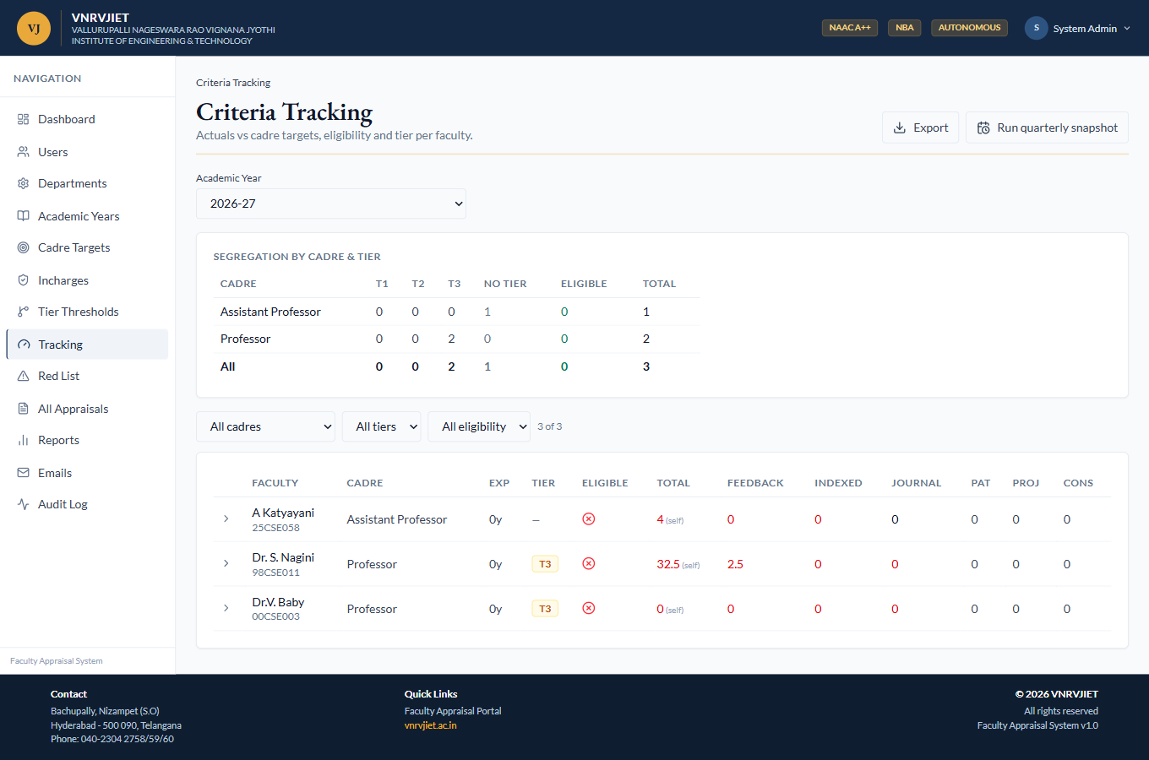
After configuring Professor · T3, both professors are assigned T3
Result ✓ PASS — Per-cadre tier engine assigns the highest satisfied tier from that cadre’s own thresholds (also covered by 12 unit tests).

8. Verification, Red-List & Review

8.1 Red-list (rejected-proof holds)
- When an incharge/HoD rejects a proof, the submission is put on HOLD and the faculty is red-listed until re-upload; HoD/Admin clear the hold.
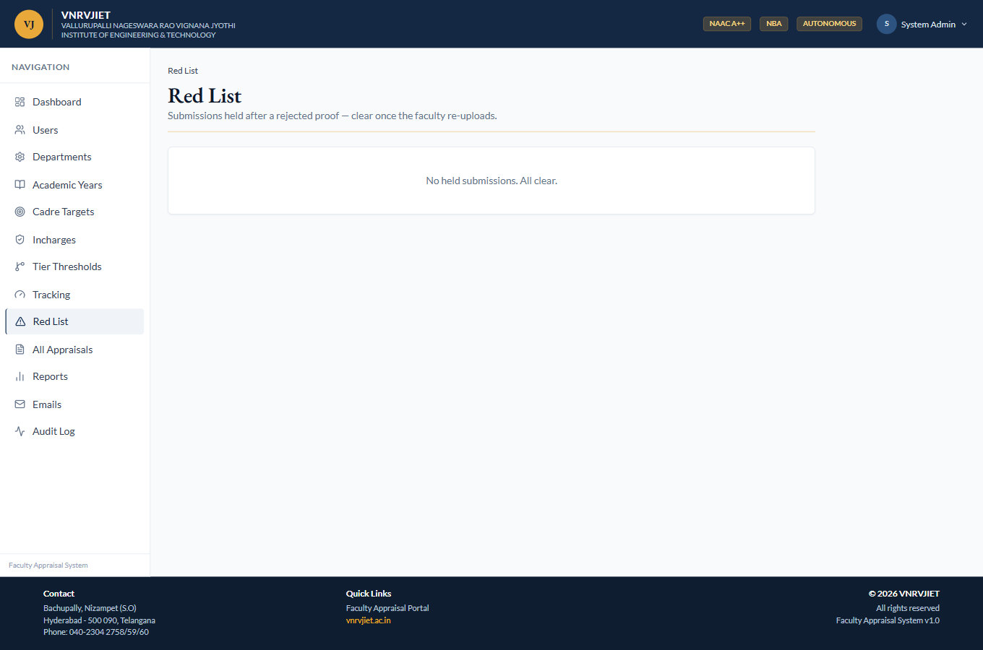
Red-list
Result ✓ PASS — Red-list view renders (empty — no held submissions in current data).

8.2 Review queue
- Reviewers/HoDs see submissions awaiting review; opening one shows section-mapped proofs to verify and Cat-6 reviewer scoring. Faculty never see reviewer scores until approval.
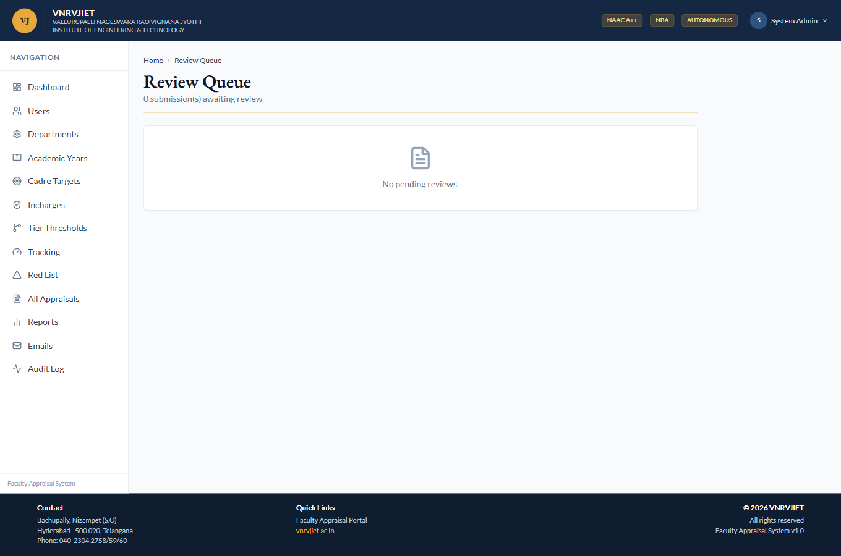
Review queue
Result ✓ PASS — Queue renders (0 pending — all sample submissions are DRAFT, so none are awaiting review).

9. Faculty Experience

9.1 Faculty dashboard
- Faculty see their submissions for the open year, status, and actions to create/continue an appraisal.
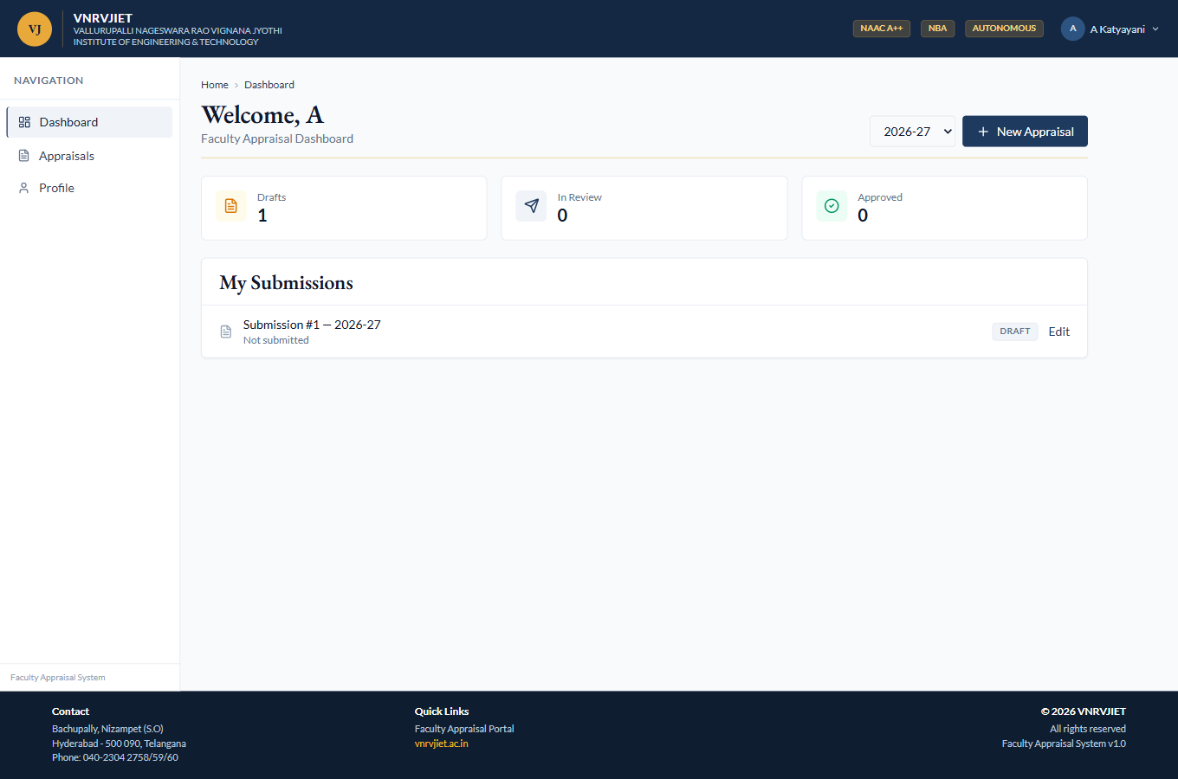
Faculty dashboard (25CSE058)
Result ✓ PASS — Dashboard renders with the faculty’s draft submissions.

9.2 Appraisal form
- Multi-category self-appraisal (teaching, research/Cat-2, professional development, administration, contributions) with proof uploads; live score computation; submit within the open window.
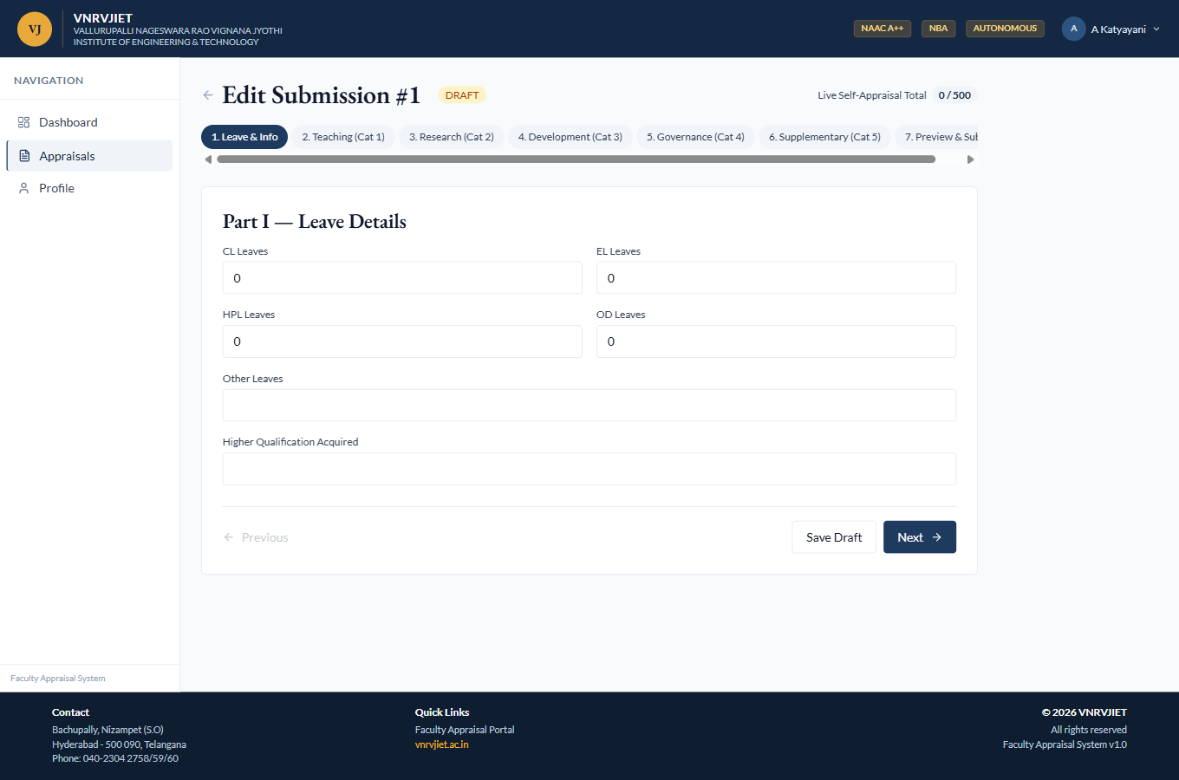
Appraisal form
Result ✓ PASS — Form loads with category sections and inputs.

9.3 Profile
- Faculty view/update profile fields and change password (OTP-verified).
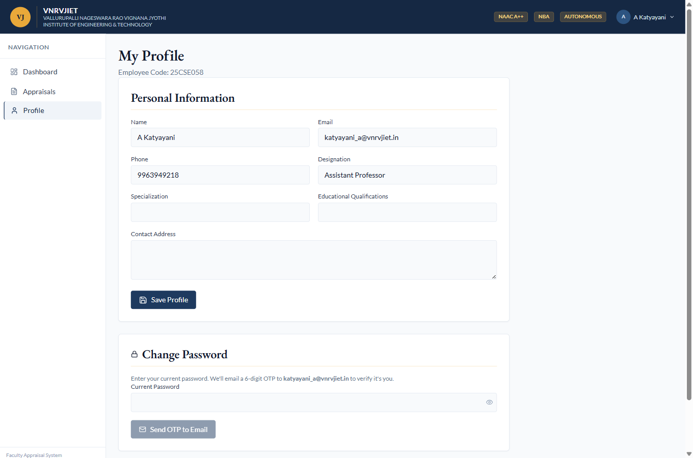
Faculty profile
Result ✓ PASS — Profile page renders.

10. Features Verified by Automated Tests
The following depend on data states (submitted/approved appraisals, issued feedback) not present in the current database, so they were not screenshotted live; they are covered by the automated suite and the endpoints were smoke-checked.
- Proof verification detail — section-mapped proof list, verify/reject, HOLD + red-list on reject, notification emails.
- HoD annual feedback — auto snapshot (self marks vs ideal targets), draft, issue-to-faculty, faculty read-only view.
- Appraisal PDF export — server-rendered PDF of a submission.
- Forgot-password OTP — emailed 6-digit code, rate-limited, no user enumeration.
- Quarterly snapshot cron — rolling per-faculty cadre/tier/eligibility snapshot + auto-feedback.
Automated results: 186 backend tests pass (Vitest + Supertest); backend and frontend TypeScript compile clean; the frontend production build succeeds. The per-cadre tier feature contributes 12 engine unit tests and 14 endpoint tests.

11. Notes & Limitations
- Sample submissions in the current database are all in DRAFT state, so the review-queue and feedback screens show empty/limited live views; their logic is exercised by the automated tests.
- The Professor · T3 threshold was temporarily lowered to demonstrate tier assignment (section 7.2) and then restored to its seeded default.
- Screenshots are unedited live captures at 1360-px width; full-page captures may extend beyond one screen.

