SIMATS ENGINEERING
ASSESSMENT TOOL 2 — CO1 CONCEPT MAPPING (SUBMISSION)
Course Name: Database Management Systems
Course Code: CSA05
CO1: Analyse DBMS architecture, different data models, schema types, and design ER/EER diagrams, relational schemas for case-based scenarios by identifying entities and relationships. (BL1, BL2)

Task 1
Q1. Construct a concept map linking the following terms: DBMS, Schema, Instance, Data Model, ER Diagram, Entity, Attribute, Relationship.
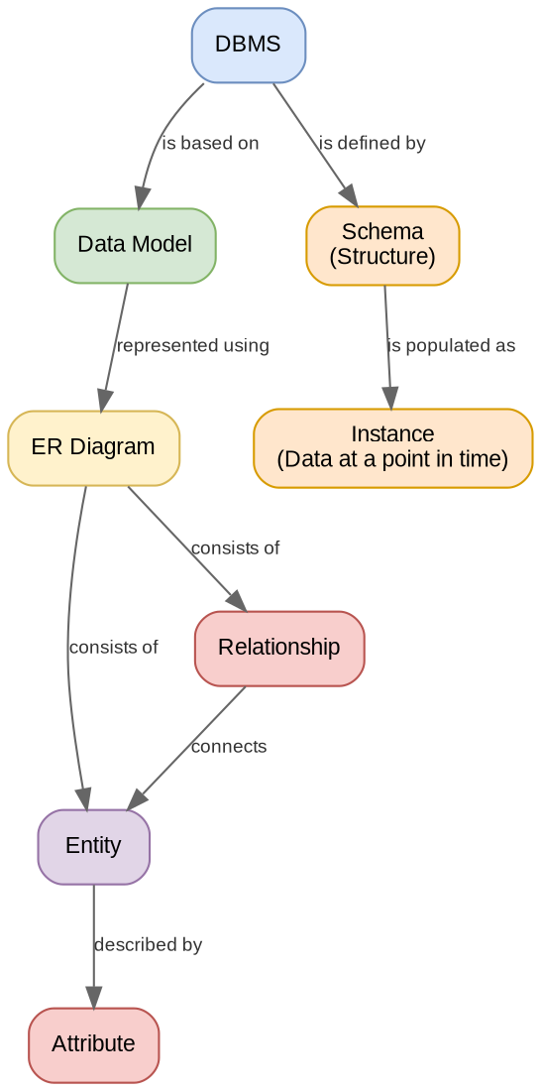
Editable source: CSA05_CO1_AT2_Q1_Concept_Map.drawio (attached separately)

Task 2
Q2. Create a concept map for the three-level ANSI/SPARC architecture showing data independence at each level.
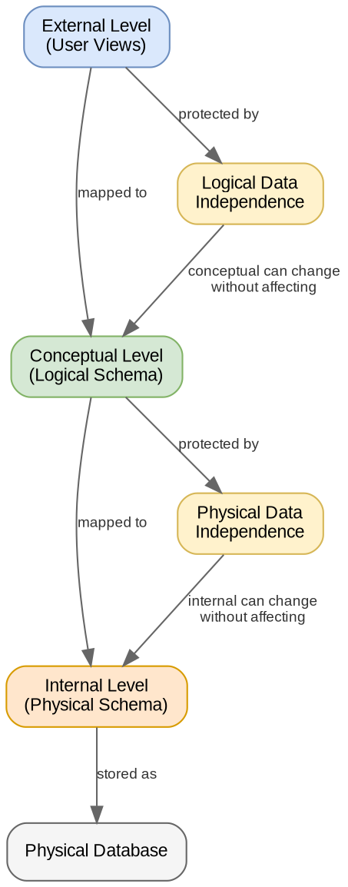
Editable source: CSA05_CO1_AT2_Q2_Concept_Map.drawio (attached separately)

Task 3
Q3. Map the relationship between file-based systems and database systems, highlighting the problems solved by DBMS.
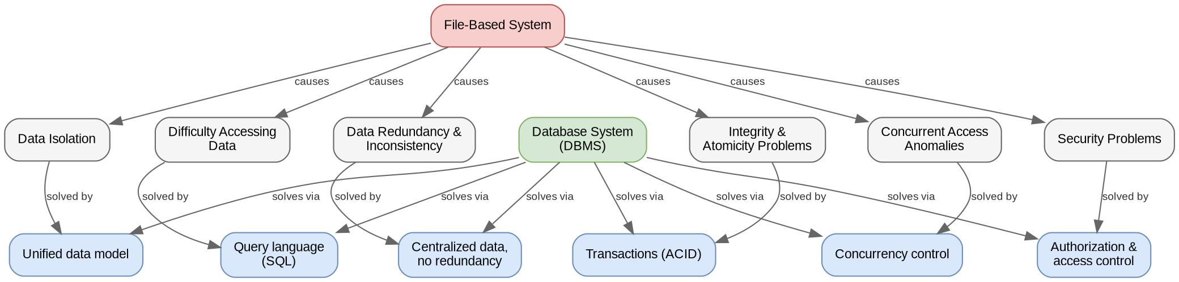
Editable source: CSA05_CO1_AT2_Q3_Concept_Map.drawio (attached separately)

Task 4
Q4. Design a concept map for ER diagram components: entity, weak entity, attribute types, relationship types, and participation constraints.
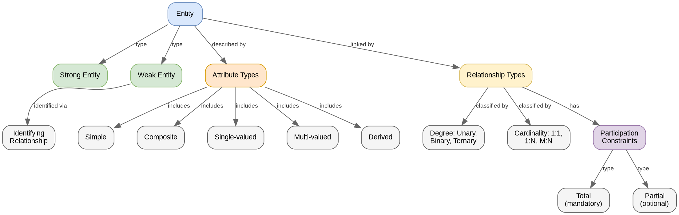
Editable source: CSA05_CO1_AT2_Q4_Concept_Map.drawio (attached separately)

Task 5
Q5. Construct a concept map comparing Hierarchical, Network, and Relational data models with their key properties.
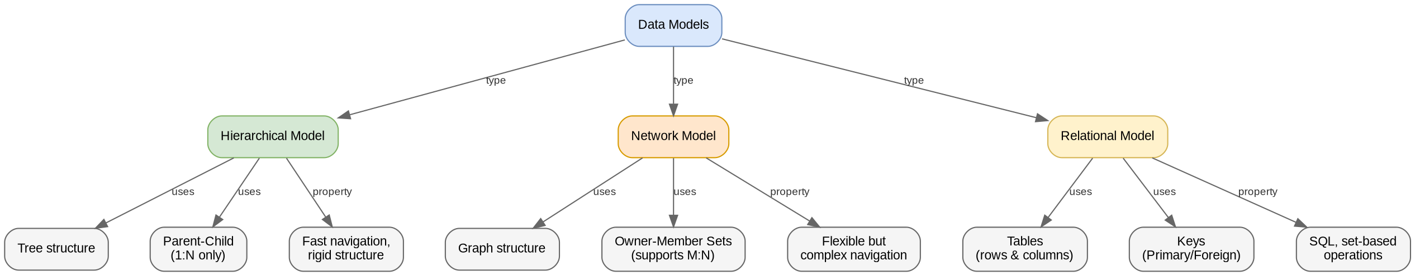
Editable source: CSA05_CO1_AT2_Q5_Concept_Map.drawio (attached separately)

Task 6
Q6. Develop a concept map for the EER model showing how it extends the basic ER model with generalization, specialization, and aggregation.
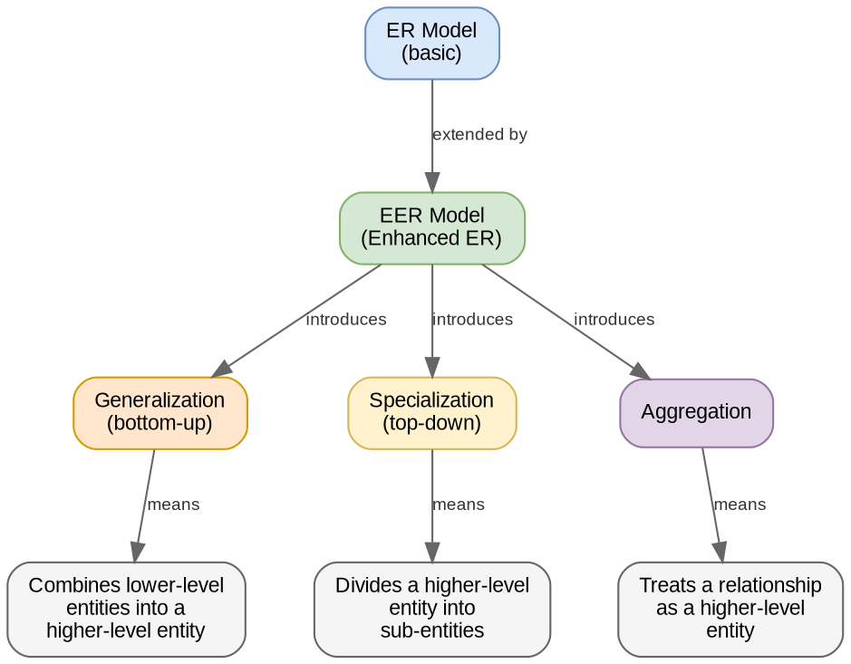
Editable source: CSA05_CO1_AT2_Q6_Concept_Map.drawio (attached separately)

Task 7
Q7. Create a visual concept map for the DBMS software architecture, illustrating the flow from user request to data retrieval.
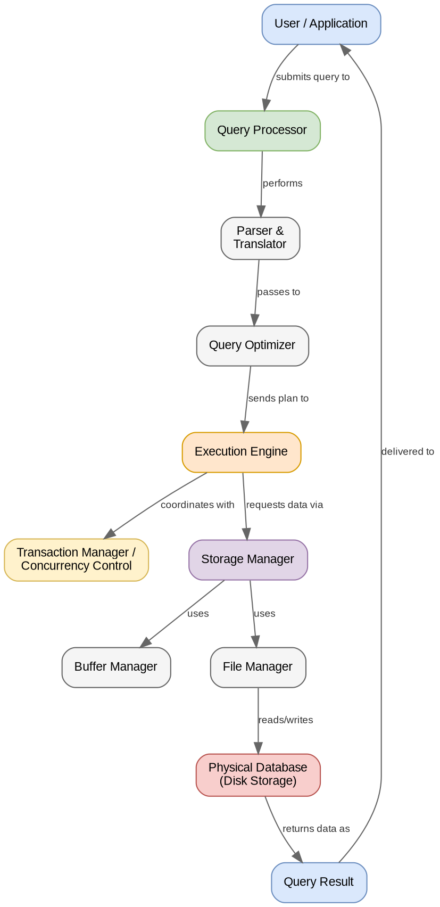
Editable source: CSA05_CO1_AT2_Q7_Concept_Map.drawio (attached separately)

Task 8
Q8. Map the data models discussed in CO1 to real-world applications and explain the suitability of each model.
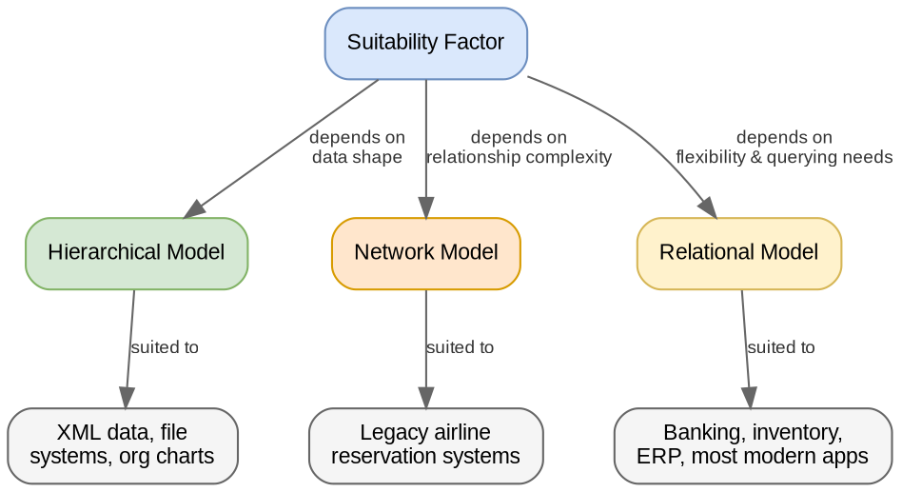
Editable source: CSA05_CO1_AT2_Q8_Concept_Map.drawio (attached separately)

Task 9
Q9. Construct a concept map for schemas and instances, showing how they relate to physical and logical data independence.
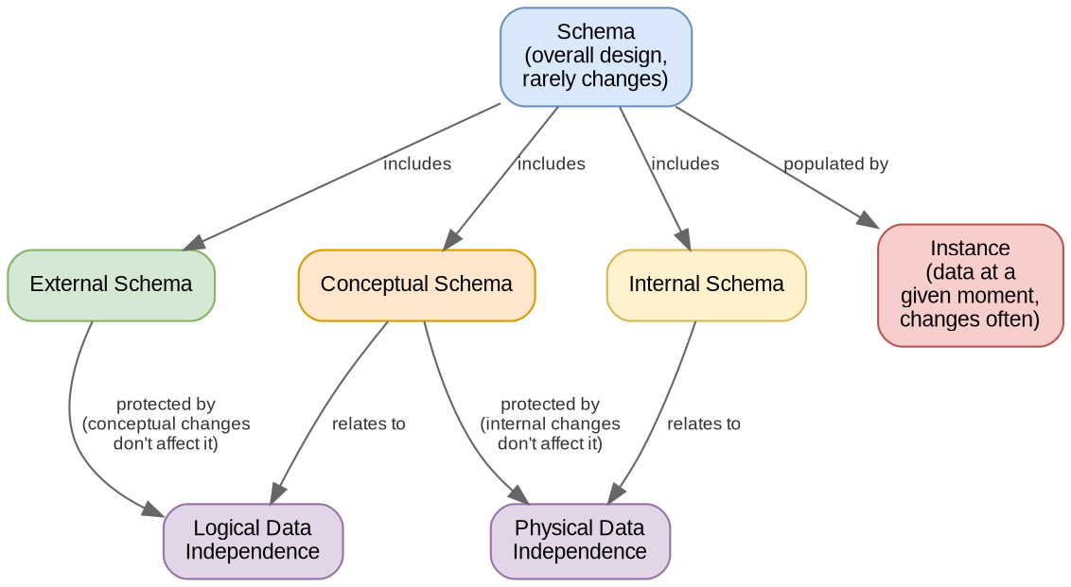
Editable source: CSA05_CO1_AT2_Q9_Concept_Map.drawio (attached separately)

Task 10
Q10. Design a concept map for the roles and responsibilities in a DBMS environment: DBA, End User, Application Developer.
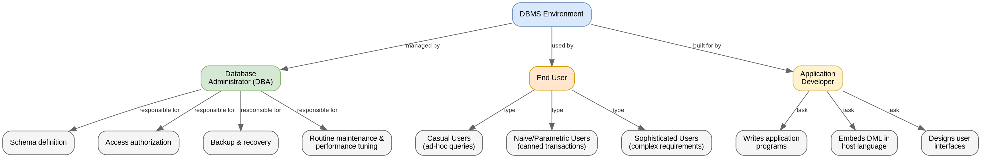
Editable source: CSA05_CO1_AT2_Q10_Concept_Map.drawio (attached separately)

