**PCA**

Method: All images were read from the dataset provided, with each image being flattened to an array of 1x(256^2) dimension. These arrays were all appended to each other to form a matrix of dimensions 520x(256^2).

On applying PCA, the images were reconstructed for dimensions 1 to 250. The following plot was obtained on calculating the mean squared error for each dimension: -

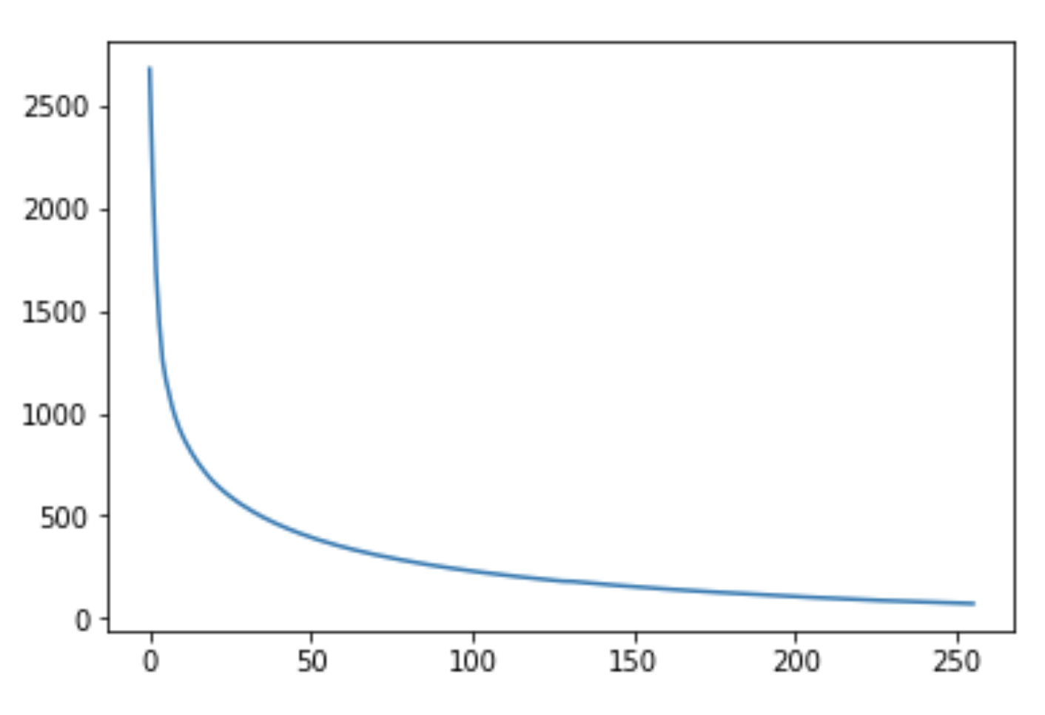

It is clear that after a certain point, the MSE is negligible. However, at dimension=1, the MSE is at it’s highest.

Images are also reconstructed using this technique. An example image that was reconstructed using only 32 dimensions looks as follows: -



On plotting the images in 1D, 2D and 3D spaces, the following scatterplots are obtained: -

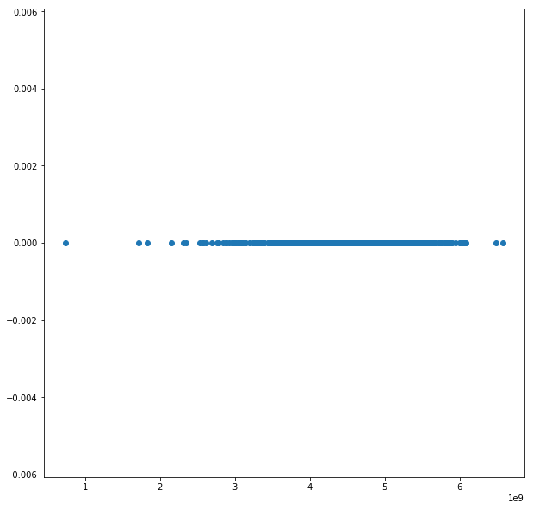

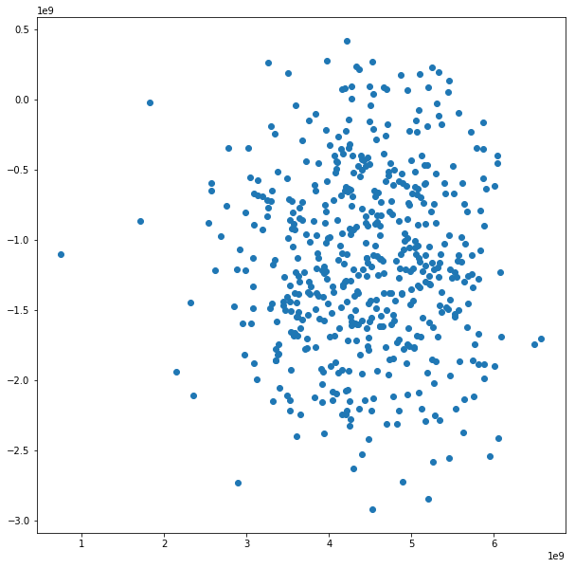

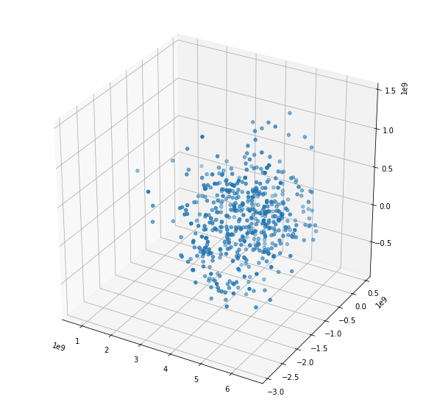

From the plots, it is clear that it is impossible to differentiate/group the points for the first dimension. However, on increasing the dimensions, it becomes slightly easier.