**Assignment-1**

1.1. Write a python program for the following: – Input the string “Python” as a list of characters from console, delete at least 2 characters, reverse the resultant string and print it. Sample input: •python

•Sample output: •ntyp

str=input("Enter the input string:")

# Deleting at least 2 characters from the string

if len(str)>=2:

str=str[:-2]

else:

str=str[:-1]

#reversing the string

print(str[::-1])

Here is some code that will take the input characters from the console and delete at least two characters before reversing the resultant string.

If the length of the string is greater than 2, we remove two characters from the string; otherwise, we remove a single character.

Output for above code:

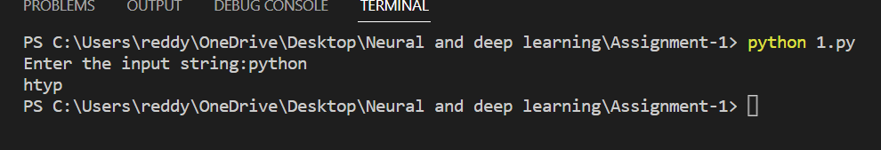

Python is used as the input here. We are removing two characters from this input. We are reversing the string after deletion.

– Take two numbers from user and perform at least 4 arithmetic operations on them.

Here we are required to perform the arithmetic operations on two input numbers given from the console

a=int(input("Enter the Number 1:"))

b=int(input("Enter the Number 2:"))

print(a+b) # addition

print(a-b) #subtraction

print(a*b) #Multiplication

print(a/b) #division

Output for above code:

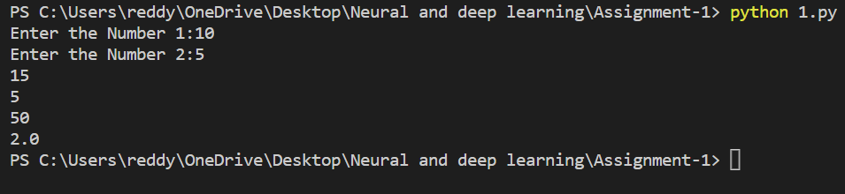

2.Write a program that accepts a sentence and replace each occurrence of ‘python’ with ‘pythons’.

•Sample input: I love playing with python

•Sample output: I love playing with pythons

In this program we should replace the word python with pythons

#input string

input_str=input("Enter the input string:")

#replace the python with pythons

output=input_str.replace("python","pythons")

print(output)

Output for above code:

We provide the words as input, and if the input contains the word python, it is replaced with pythons.

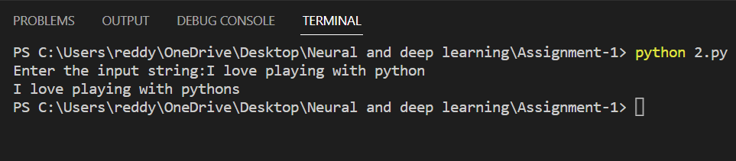

3.Use the if statement conditions to write a program to print the letter grade based on an input class score. Use the grading scheme we are using in this class.

The conditional statements are used here to determine the grade based on the marks entered on the console.

x=int(input("Enter your marks(0-100):"))

def marks(x):

if x>90 and x<=100:

return "A"

elif x>80 and x<=90:

return "B"

elif x>70 and x<=80:

return "C"

elif x>60 and x<=70:

return "D"

else:

return "F"

print("Grade:",marks(x))

Output for above code:

