**Assignment-2**

1. Write a program that takes two strings from the user: first_name, last_name. Pass these variables to fullname function that should return the (full name).

o For example:

▪ First_name = “your first name”, last_name = “your last name”

▪ Full_name = “your full name”

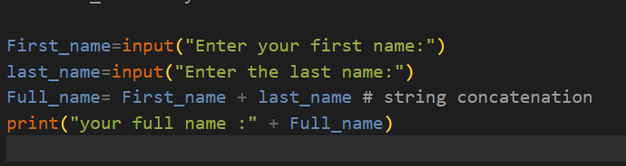

Here, we take firstname and lastname from the console, concatenate the strings, and display the fullname.

Output:

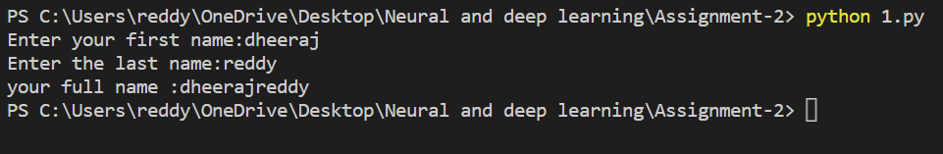

o Write function named “string_alternative” that returns every other char in the full_name string. Str = “Good evening”

Output: Go vnn

Note: You need to create a function named “string_alternative” for this program and call it from main function.

In this case, we are given a string and must print alternative characters in the string. Here, we take the length of the string and if the condition is met, char is appended to output and returned.

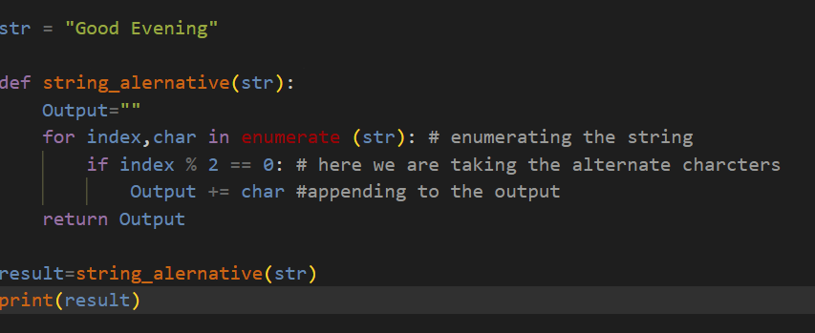

Output:

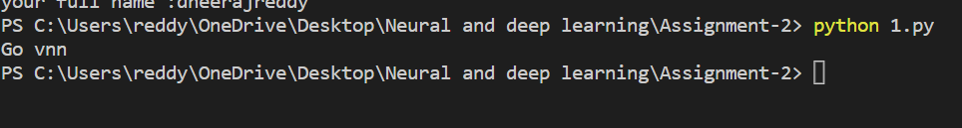

2. Write a python program to find the wordcount in a file (input.txt) for each line and then print the output. o Finally store the output in output.txt file.

Example: Input: a file includes two lines:

Python Course

Deep Learning Course

Output:

Python Course

Deep Learning Course

Word_Count:

Python: 1

Course: 2

Deep: 1

Learning: 1

Here, we take the input from the input textfile, convert the words to lowercase, and then use a regular expression to match the words, count the frequency of the words, and display them in the output text file.

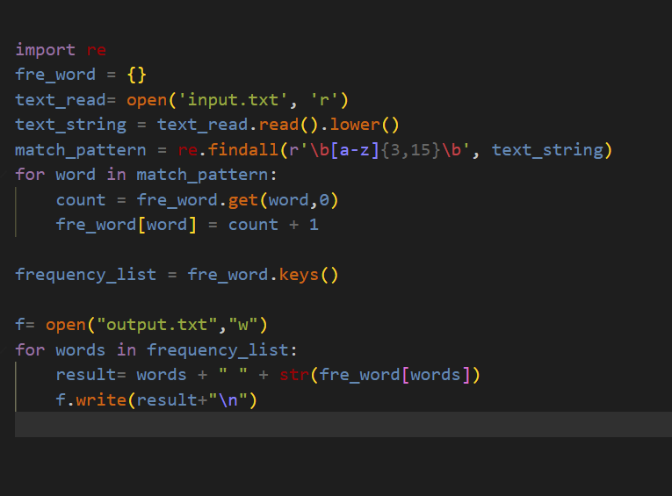

Output:

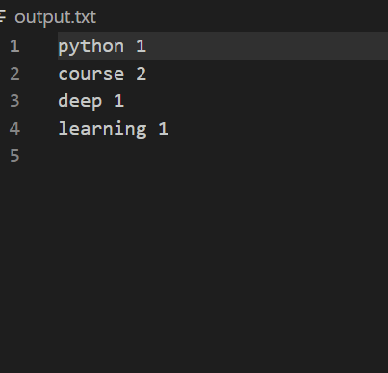

3. Write a program, which reads heights (inches.) customers into a list and convert these heights to centimeters in a separate list using: 1) Nested Interactive loop. 2) List comprehensions

Example: L1: [150,155, 145, 148]

Output: [68.03, 70.3, 65.77, 67.13]

Here, we take the customers' height and convert it from inches to centimeters before displaying the height in centimeters as a list.

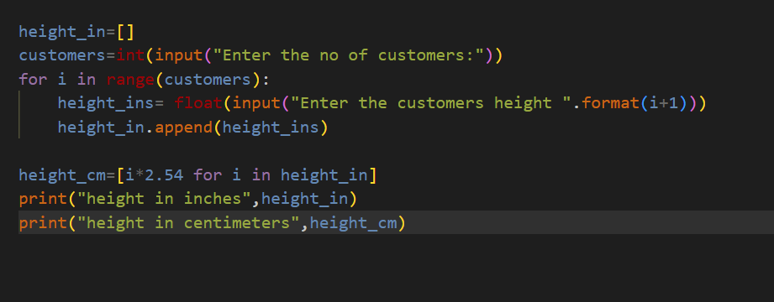

Output:

