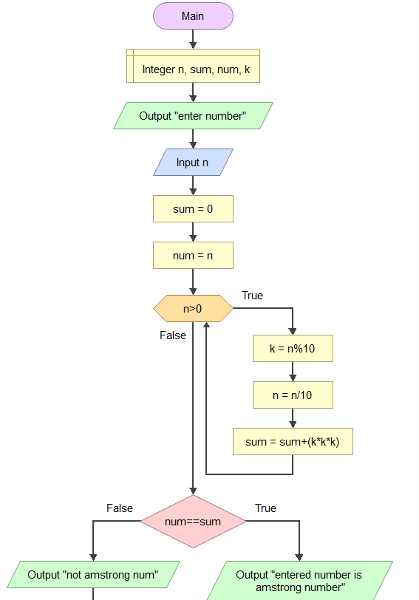

Pseudo code
- Declare variables
n, sum,num,k
- Input number using n
- Assign sum=0
- Assign num=n
- Create a while loop with condition n>0
- Inside while loop :
- assign k=num%10
- n=n/10
- sum=sum+k*k*k
- if the while condition is false,then:
- If num==sum is true,then it is a amstrong number.
- If num==sum is false,then it is not a amstrong number.

