Freight Rate Prediction
Assessment Report
Machine Learning | Regression | Time-Aware Validation

1. Executive Summary
This project builds a machine learning pipeline for forecasting the dollar rate for a freight load. The model was trained on 48,000 historical freight loads from January–October 2025. It was used to predict the rate for 12,000 validation loads in November–December 2025, as well as a rate per day for one fixed route over the entire month of December 2025.
The final model used was HistGradientBoostingRegressor trained on the log-transformed target, log1p(posted_rate). Chronological cross-validation yielded an MAE of about $120.88, an RMSE of approximately $597.54, and R² of 0.8384. The official scorer script confirmed that the prediction outputs met all the required specification checks.

2. Project Description

Objective and Scope
The task was to learn the relationship between features of a freight load and its cost, then apply that relationship to predict the rate for other loads. The target variable is posted_rate—the dollar rate paid for a historical freight load.
- Train a regression model to predict the rate given features of a freight load.
- Apply the model to predict the rate for 12,000 validation loads in November–December 2025.
- Predict a rate per day for one fixed route over the month of December 2025.
- Validate the prediction outputs against the official scoring script.

3. Data Description
The data used for model development comprised pickup and drop-off cities, distance, equipment type, shipment weight, date, market_index, and quote_signal. The training set (train-test.csv) also included the target variable posted_rate—the dollar rate paid for the freight load. Coordinates were available in the data, but distance was used as the measure of route length.
The validation set (validation.csv) did not have a target variable; its rates had to be predicted. The December data used the same route from Lexington to Fort Wayne, 360 miles, Dry Van, 32,000 lb, with date as the only varying feature.
Dataset | Size / Date Range | Purpose
Training set | 48,000 loads, Jan–Oct 2025 | Historical records with target values
Validation set | 12,000 loads, Nov–Dec 2025 | Loads requiring rate predictions
December chart inputs | 31 records, 1–31 Dec 2025 | Inputs for the fixed-route daily chart

4. Data Preparation
Data quality assessment was conducted before processing to identify missing, invalid, or non-finite values that needed special handling during model fitting. The approach retained as many records as possible while flagging invalid measurements as missing for downstream imputation.
Missing values: Missing values were generally retained. Missing categorical values were replaced with “Unknown.” Missingness was flagged where appropriate, including a separate indicator for missing weight.
Invalid weights: Weights that were zero or negative were treated as invalid, and a weight_missing indicator was generated. Weight imputation was fitted on the training data only.
Invalid target values: Rows with invalid negative posted_rate values were dropped during training because negative freight rates are not meaningful for this task.
Feature engineering: Features included month, day of week, weekend indicator, day of year, sine/cosine features for annual seasonality, log-distance, log-weight, distance/weight, and market_index–quote_signal features.
Categorical encoding: Pickup city, drop-off city, and equipment were cleaned and one-hot encoded. Encoding used only categories present in the training data to avoid leakage.
Numerical safeguards: Non-finite numeric values were converted to missing values. Preprocessing was fitted separately within each cross-validation training fold.
As a result, the medians and category encodings used during imputation and encoding were learned only from the data available to the model’s training portion, rather than from the validation portion.

5. Validation
Chronological validation was used because the model is intended to generalize to future data. Validation folds were constructed by partitioning the date-sorted training set into five approximately equal-sized blocks.
- Generate out-of-fold predictions so that every training record is predicted once by a model that did not train on that record.
- Aggregate the out-of-fold predictions and calculate MAE, RMSE, and R² over the combined predictions.
- After selecting the best model configuration, retrain it on the full 48,000-record training set for submission.
The project notes describe the folds as chronological and intended to represent forward-looking validation. For strict forward-chaining validation, each subsequent fold should have a later date than the previous one. The implementation should be checked to confirm that this condition is met.

6. Model Selection and Tuning
HistGradientBoostingRegressor was used, a gradient-boosted decision-tree regressor designed for structured data containing numeric and categorical-derived features. Predictions were compared using the original target and the log1p(target) transform.
The log-transformed target performed better in terms of RMSE. The model was therefore trained using log1p(posted_rate), and predictions were converted back to the original scale using expm1.
Hyperparameter | Selected Value
max_iter | 400
learning_rate | 0.03
max_depth | 6
l2_regularization | 0.5

The parameters were selected from 16 combinations using RMSE as the selection criterion. Lower RMSE was preferred, and the values above represent the best combination reported in the project notes.

7. Performance
Metric | Value | Interpretation
MAE | ≈ $120.88 per load | On average, the predicted rate differs from the actual rate by about $120.88.
RMSE | ≈ $597.54 per load | Penalizes larger prediction errors more heavily than MAE.
R² | ≈ 0.8384 | Indicates that the model explains about 83.84% of the target variation in the reported evaluation.

The strongest feature was distance, with a correlation of approximately 0.91 with posted_rate. Other features had weaker relationships with the target. Prediction errors can be difficult to reduce for loads with highly variable rates per mile; the project notes identify short-haul loads as one example.
The difference between MAE and RMSE suggests that some individual records may have much larger prediction errors. These should be reviewed where possible to check for unusual cases or model limitations. The metrics are reported from chronological five-fold cross-validation and should not be assumed to represent performance on every future prediction.

8. Predictions and Scorer
validation_predictions.csv: Contains 12,000 records with load_id and predicted_rate columns. IDs match the expected template range TE-000001 through TE-012000.
- All predicted rates were positive, with no rates below $1.00.
December predictions: The December output contains predicted_rate for each day in December 2025, while retaining the other fields required by the input format.
The official score.py script was used to check whether the files met the required specifications. According to the supplied project notes, the files passed these checks and the script generated the December chart.

9. December 2025 Fixed-Route Chart
The model predicted a rate for each day in December 2025 for the same route and shipment characteristics: Lexington to Fort Wayne, 360 miles, Dry Van, and 32,000 lb. The date was the only varying feature, so the chart reflects rate changes associated with the date and the seasonality features captured by the model.
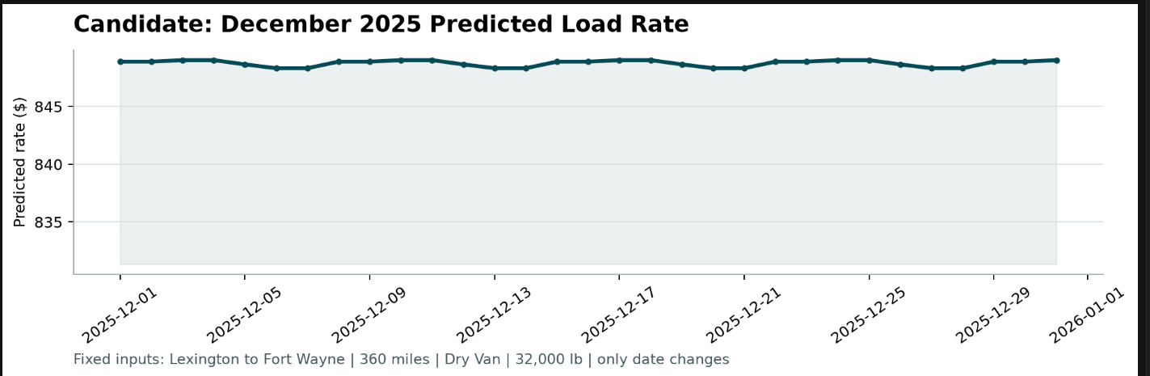
Figure 1. Candidate December 2025 predicted load rate for the fixed Lexington–Fort Wayne route.

10. Streamlit Web Interface
The Streamlit web interface allows end-users to use the model without writing code. It loads the saved model artifact, which contains the fitted estimator, preprocessing steps, and model metadata. The same feature-engineering steps used during training are reused so that transformations match the model’s expected inputs.
Single Load Prediction Tab: A user can enter the details of one freight load and receive a predicted rate.
Batch Prediction Tab: A user can upload a CSV file containing multiple freight loads, review the predicted rates, and download the resulting CSV.
December Chart Tab: Displays the predicted rate for each day in December 2025 for the fixed route.
Model Info Tab: Displays model performance, target transformation, number of cross-validation folds, hyperparameters, and feature-engineering metadata.

11. Implementation Details
The project uses separate code for training, inference, scoring, and the Streamlit application. The model artifact persists the preprocessing steps alongside the estimator so that the application can apply the same feature transformations used during training.
File / Artifact | Role
train_predict.py | Feature engineering, cross-validation, hyperparameter tuning, model fitting, and prediction.
app.py | Streamlit interface for single-load prediction, batch prediction, December chart, and model information.
score.py | Validates prediction outputs and generates the December chart.
model.joblib | Persisted model artifact containing the estimator and preprocessing steps.
cv_fold_metrics.csv, cv_pooled_metrics.csv, oof_predictions.csv | Model performance tracking and out-of-fold prediction files.
requirements.txt, README.md | Project dependencies and usage instructions.

12. Design Decisions
Decision | Reason
Time-aware validation | Better represents the future-prediction setting.
Fold-local preprocessing | Helps prevent data leakage.
Pooled out-of-fold metrics | Summarizes performance across all out-of-fold predictions.
Log-transformed target | Can help handle a right-skewed target distribution.
Gradient boosting | Captures non-linear relationships in structured data.
Persist preprocessing with model | Ensures consistent feature transformations at inference time.

13. Conclusion
The project provides an end-to-end freight-rate prediction solution. It handles data-preparation issues, engineers useful features, selects a regression model, and evaluates performance in a setting that accounts for temporal effects. The final model achieved an R² of approximately 0.8384, MAE of approximately $120.88, and RMSE of approximately $597.54 on the reported pooled cross-validation set. The official scorer was reported to have confirmed that the prediction files met the required specifications. Key practical strengths include time-aware validation, fold-local preprocessing, and a convenient Streamlit interface.
Assessment note: This report represents the supplied project description and technical notes. The code and CSV files were not executed while preparing this document; therefore, the metrics and scorer-validation status are reported based on the supplied information.

