**ACKNOWLEDGEMENT**

Our sincere thanks to Dr. P Ithaya Rani in the Lab for her outstanding support throughout the project for the successful completion of the work.

We express our gratitude to Dr. P Ithaya Rani the instructor and Dr. K. Vijaya Sree Course Co-Ordinator for the course **Big Data Analytics, 19CS3275P** in the Computer Science and Engineering Department for providing us with adequate planning and support and means by which we can complete this project-based Lab.

We express our gratitude to **Mr. V. HARIKIRAN,** Head of the Department for computer science and Engineering for providing us with adequate facilities, ways and means by which we can complete this project-based Lab.

We would like to place on record the deep sense of gratitude to the honorable Vice Chancellor, K L University for providing the necessary facilities to carry the project-based Lab.

Last but not the least, we thank all Teaching and Non-Teaching Staff of our department and especially our classmates and our friends for their support in the completion of our project-based Lab.

### Name of the student

|  |  |
| --- | --- |
| **Student Name** | **ID Number** |
| R vishnu teja | 190031408 |

**TABLE OF CONTENTS**

**CHAPTERS PAGENO**

LITERATURE SURVEY… 6

MODEL BUILDING… 7

CONCLUSION and FUTURESCOPE 14

REFERENCES 14

## LITERATURE SURVEY

Xu Zhang and his team worked on stock market prediction by deep learning model using Long-Short term memory (LSTM).They would gather the data from 2018 to 2020.And the results are measured by three evaluation metrics. This experiment shows that the single factor group is better than the prediction results of Multiple factor group In prediction of stock market rise and fall.

SHILE CHEN and CHANGJUN ZHOU proposed the model on the China construction bank dataset and the CSI 300 stock dataset demonstrate that the GA-LSTM model can out perform all baseline models for time series prediction. They used LSTM to perform this model analysis . They successfully build the model they got that the large number of stock factors are selected.

HONGBING OUYANG and his team predict stock index patterns through analysis of multivariate time series. Their motivation is based on the notion that financial planning guided by pattern discovery and prediction of stock index prices maybe more realistic and effective than traditional approaches. They used to proposed three stage by using architecture of TICC, TPA-LSTM, Multivariate LSTM-FCNs. And they got the result the portfolio based on the proposed three-stage architecture presents better performance than the market-based portfolio.

Hiransha Gopalakrishnan and Vijay Krishna Menon and soman together publish a journal in science directive .In this journal they used stock market Prediction using Deep learning Models .They used MLP and RNN and LSTM and CNN with stock price of Maruti from NSE stock Market .And they conclude that DL models are outperforming ARIMA model. CNN has performed better than other

three networks as it is capable of capturing the abrupt changes in the system. And their model is 85% accurate.

## Model building

Based on the literature survey, I have done the project by taking the data from the yahoo finance

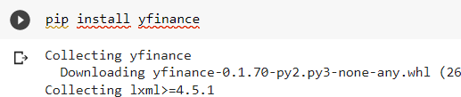

Then we will fetch Gail stock data by using the API We can take 5 years of data using 1 day interval

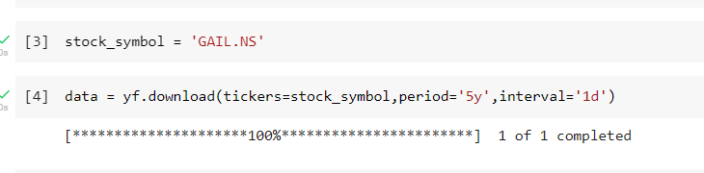

Then we can check the data

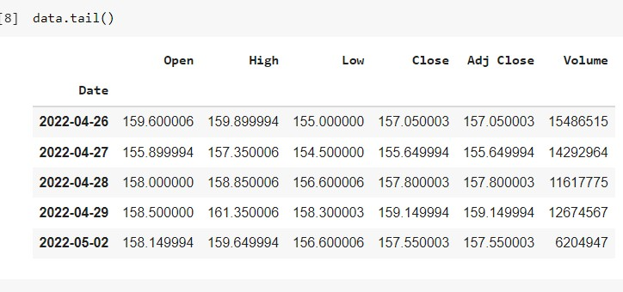

Then I will take the open price of the data and predict it.

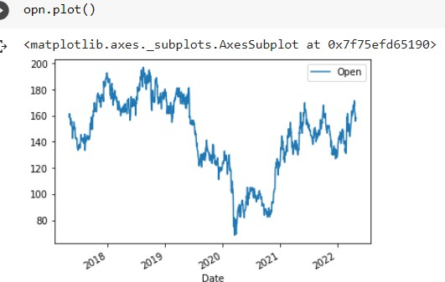

We can see that the open price of the stock data will successfully predicted Then I will convert It into array and again I will plot the data

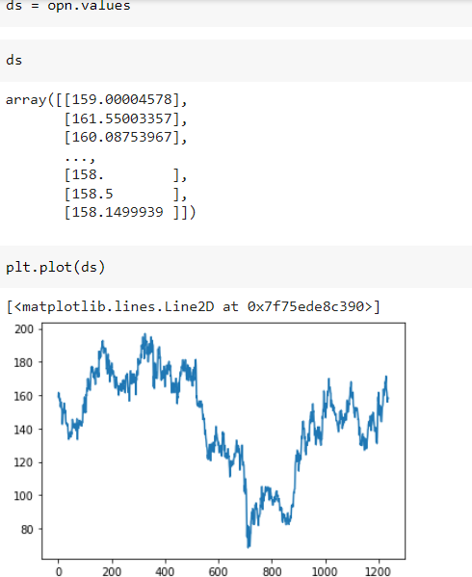

Then I will use min max scaler in order to give values

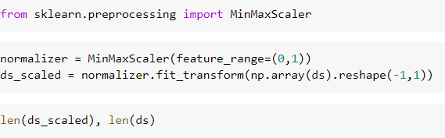

Then will train and test the data

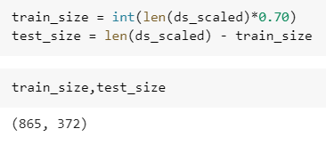

Creating and training the data sets in the lstm model

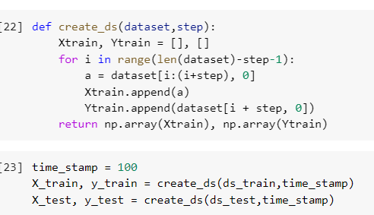

And then we can take 100 values as input in order to predict future values

And then we can reshape and we can create the lstm model using keras

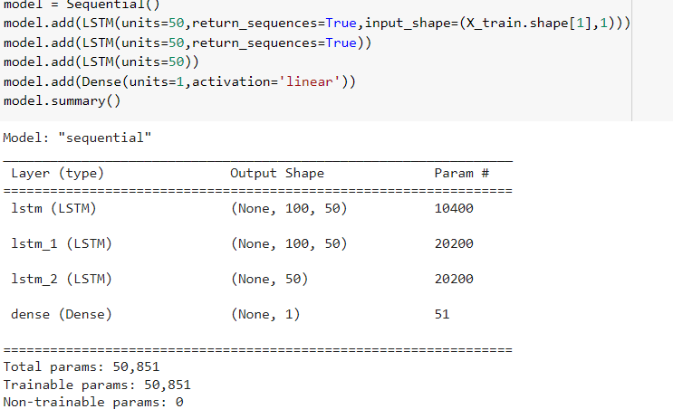

And then train the model with mean square optimizer function

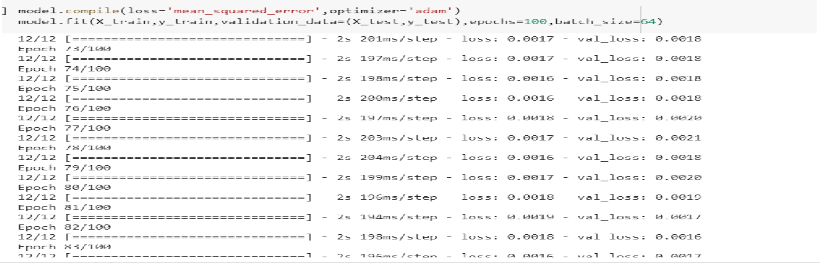

Then we can predict the loss

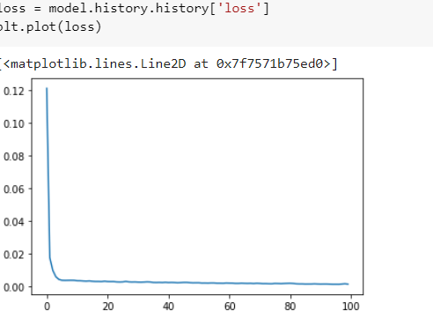

Then we will train and test and predict the data set and we will inverse transform the data set inorder to get actual values of the data set

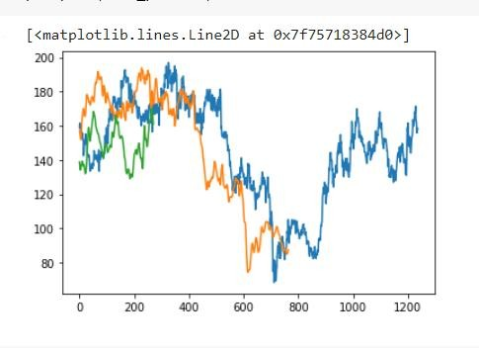

Yearly Stock

## Here we can see that orange colour is the actual value and the blue colour will be predicted value of the data set and green will be test data predicted value

Then we will predict both actual and the predicted values in a graph the graph will Will be like this

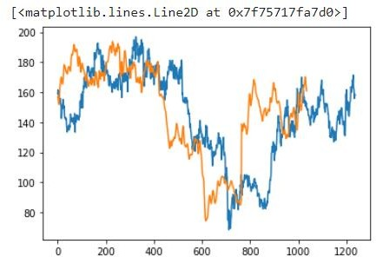

Then will will forecast for the next 30 days now by using the below algorithm

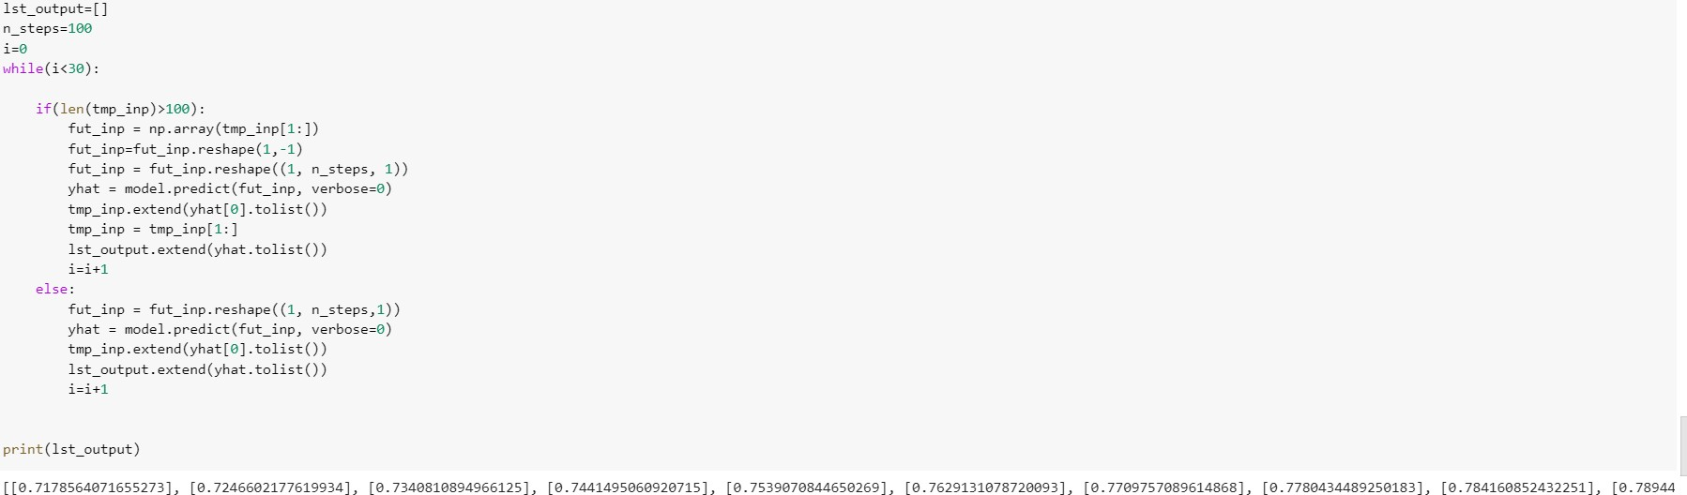

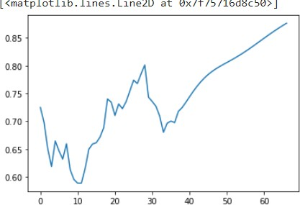

This is the graph for the next 30 days if we see the graph with whole graph then the graph will be :-

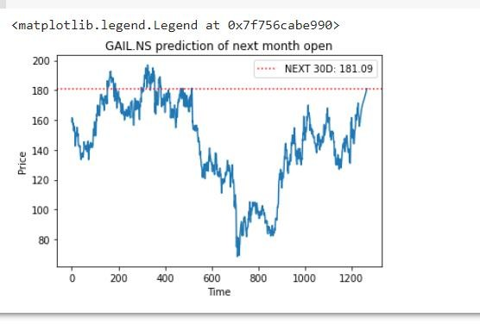

## Conclusion:

In this work I have used Gail stock market data and predict the next 30 days open price of the stock successfully by using lstm. It is quite good when compared to RNN .

These predictions can be extremely useful for those wishing to gain some insight into the future price movement of a stock even though predicting the future isn’t possible.

## Future Scope:

LSTM takes lots of time and more memory allocation to run we can use other models than lstm In order to solve that time consuming problem.

## References:

1. Kim K.J., Han I.Genetic algorithms approach to feature discretization in artificial neural networks for the prediction of stock price index
2. HONGBING OUYANG1, XIAOLU WEI 2, AND QIUFENG WU 31Department of Economics, Huazhong University of Science and Technology, Wuhan 430074, China
3. Jimmy Ming-Tai Wu et al., "A graph-based CNN-LSTM stock price prediction algorithm with leading indicators", Multimedia Systems, pp. 1-20, 2021
4. Pasala SandhyaVignan’s Institute of Information Technology (A), Visakhapatnam,

AP, India

.

1. Deep learning book by Deep Learning Yoshua Bengio