A Major Project Synopsis on

**IoT Device Monitoring and Management Using Eclipse Ditto and Digital Twin Technology**

Submitted to Manipal University, Jaipur

Towards the partial fulfillment for the Award of the Degree of

**MASTER OF COMPUTER APPLICATIONS**

2023-2025

by

**Dheeraj Sharma**

**23FS20MCA00065**



Under the guidance of

Dr. Arpana Sinhal

**Department of Computer Applications**

**School of AIML, IoT&IS, CCE, DS and Computer Applications**

**Faculty of Science, Technology and Architecture**

**Manipal University Jaipur**

**Jaipur, Rajasthan**

**2025**

1. Title of the project

IoT Device Monitoring and Management Using Eclipse Ditto and Digital Twin Technology

1. Team Details

Dheeraj Sharma(23FS20MCA00065)

1. Introduction

* The rapid advancement of the Internet of Things (IoT) has led to an increasing demand for systems that can efficiently manage, monitor, and control a growing number of connected devices. In this project, we implement a robust IoT monitoring system using Eclipse Ditto, an open-source framework for digital twins. The project integrates a variety of technologies, including MQTT protocol, ESP boards, MongoDB, and Apache Kafka, to create a real-time data monitoring solution.
* The goal of this system is to provide seamless communication between IoT devices and a central platform, allowing users to monitor sensor data and control devices remotely. By leveraging Eclipse Ditto’s capabilities, the project ensures efficient synchronization between physical devices and their digital twins, offering real-time insights, configuration management, and responsive control.
* The system is designed to be scalable, secure, and flexible, making it suitable for applications in various domains such as smart cities, industrial automation, and environmental monitoring. Through the integration of data storage, real-time processing, and visualization dashboards, the project demonstrates a comprehensive approach to IoT device management and monitoring.

1. Objectives

• **Develop a Real-Time IoT Monitoring System:**

Implement a robust platform that can capture and display real-time sensor data from IoT devices using Eclipse Ditto, MQTT, and ESP boards.

• **Integrate Digital Twin Technology:**

Utilize Eclipse Ditto to create digital twins for IoT devices, allowing for remote monitoring, control, and configuration management in real-time.

• **Enable Efficient Data Communication:**

Use MQTT protocol to ensure lightweight, fast, and reliable communication between IoT devices (ESP boards) and the backend system.

• **Implement Scalable Data Storage:**

Leverage MongoDB as the primary database to store large volumes of sensor data, enabling efficient retrieval and analysis of historical data.

• **Stream Data for Real-Time Dashboards:**

Employ Apache Kafka to stream sensor data in real-time, ensuring that dashboards provide up-to-date visualizations of device status and environmental metrics.

• **Provide User-Friendly Dashboards:**

Design interactive dashboards that allow users to monitor the state of IoT devices, view sensor data, and control the devices remotely.

• **Ensure System Scalability and Flexibility:**

Build a modular system that can easily scale to accommodate a large number of IoT devices and expand functionality in response to future needs.

• **Improve IoT Device Management:**

Allow for efficient monitoring and control of IoT devices, enabling quick responses to device malfunctions or environmental changes through automated or manual interventions.

• **Support Future Expansion:**

Design the system architecture to support the integration of additional devices, sensors, and analytics platforms as needed in the future.

E. DFD (Data Flow Diagram)

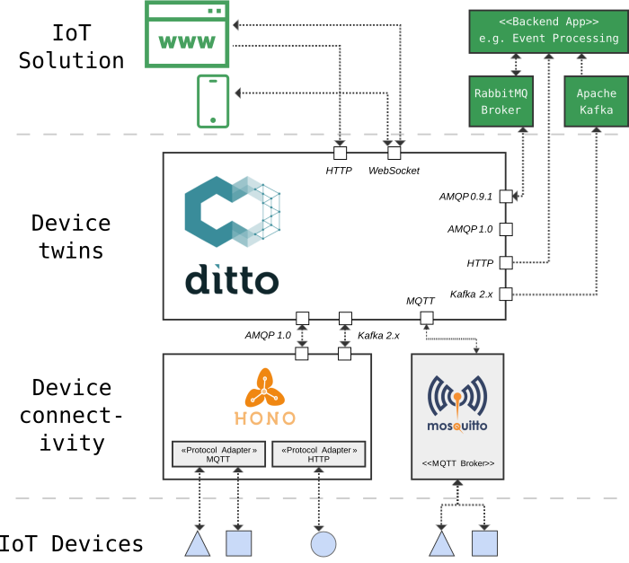

**Level 1**

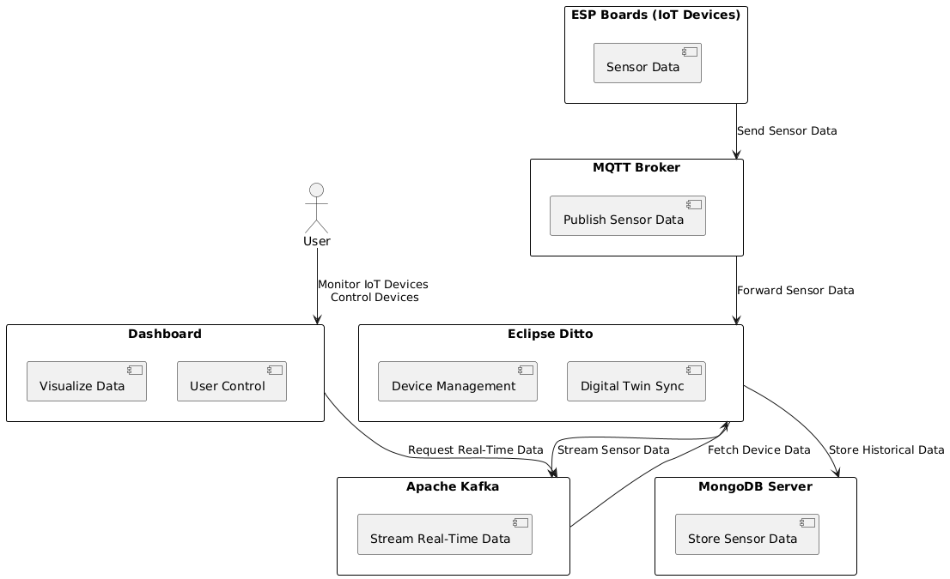

**Level 2**

F. ER Diagram(Detailed)

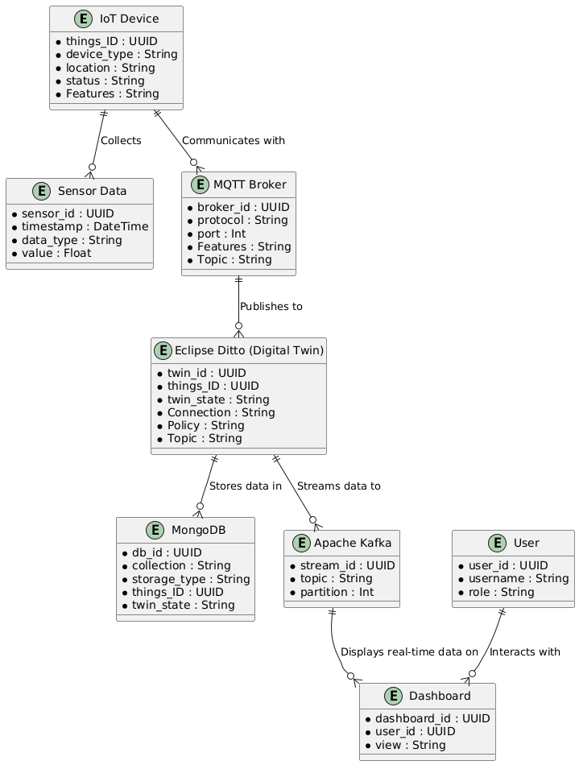

G. Project Timeline: (01 Feb 2025 To 30 May 2025)

**Week 1-2:** Requirement gathering and planning

**Week 3-4:** IoT sensors Setup and MQTT broker deployment

**Week 5:** Docker Containerization and Deployment of Ditto

**Week 6:** Database setup (MongoDB)

**Week 7:** Infrastructure Development and setup (AWS)

**Week 8:** Setting Up Apache Kafka and Grafana

**Week 9:** Customizing dashboards for data monitoring

**Week 10:** Final review and presentation

H. Tools / Platform, Hardware and Software Requirement Specifications:

**Devices to deploy:**

* ESP32 sensor with wifi capability and running tasmota firmware
* Sensors to monitor events like DHT22 sensor for Temperature and Humidity

**Backend:**

* Eclipse Ditto services
* Private MQTT Broker
* MongoDB
* Self-hosted Apache Kafka server

**Deployment tools:**

* EC2 for backend hosting
* MongoDB database
* Docker for image deployment of services
* Nginx for Basic auth and hosting of webserver
* Apache Kafka and Grafana for dashboards

**Hardware Requirements:**

* Development machines with at least 8 GB RAM
* Network connection for accessing AWS

**Software Requirements:**

* Code editor (e.g., VS Code)
* Docker Engine installed
* Database client for MongoDB like MongoDB compass
* AWS account for deployment