IMMERSED IN THE SOUNDS OF SPACE

Project Summary

The project represents an exciting fusion of science, art, and technology, offering a multisensory approach to understanding and appreciating the rich information contained within multispectral imagery. It has the potential to broaden our perspectives on how we interact with and interpret scientific data while fostering creativity and accessibility.

Detailed Project Description

The project involves the transformation of 2D multispectral images into a rich auditory experience through the process of sonification. This innovative approach leverages both visual and auditory senses to convey information contained within multispectral data, offering a novel way to explore and interpret scientific and artistic aspects of these images.

Project Goals

1. Sonification of Multispectral Data: The primary objective is to convert multispectral images into meaningful soundscapes, where different image properties are represented as distinct auditory elements.

2. Data Exploration: Enable users, including scientists, researchers, and the general public, to explore and analyze multispectral data in an intuitive and immersive manner through sound.

3. Cross-Modal Perception: Facilitate cross-modal perception, allowing users to gain insights into the characteristics and variations within multispectral data by both seeing and hearing it.

4. Accessibility and Inclusivity: Make scientific data more accessible to individuals with visual impairments by providing an auditory representation of the information.

5. Artistic Expression: Encourage artists and creative individuals to use multispectral image sonification as a medium for artistic expression, potentially leading to unique audiovisual experiences.

Project Components

1. Multispectral Image Processing: Develop algorithms to preprocess multispectral images, extracting relevant data and translating it into parameters suitable for sonification.

2. Sonification Techniques: Utilize various sonification techniques, such as mapping image properties to pitch, volume, or timbre, to create meaningful and aesthetically pleasing sound representations.

3. Interactive Interfaces: Create user-friendly interfaces that allow users to explore multispectral data and manipulate sonification parameters in real-time.

4. Scientific Integration: Collaborate with scientists and researchers to ensure that the sonified data accurately reflects the scientific information contained within the multispectral images.

5. Educational Resources: Develop educational materials and tutorials to help users understand the relationship between the visual and auditory representations of multispectral data.

6.Accessibility Features: Implement accessibility features, such as audio descriptions and screen reader compatibility, to make the sonified data accessible to individuals with disabilities.

Project Timeline:
The project timeline will consist of phases for image processing, sonification development, interface design, scientific validation, artistic collaboration, user testing, and outreach. The duration of each phase will depend on the complexity of the data and the project's scope.

IMAGE TO MATRIX

25 | 253 | 169
145 | 14 | 89
164 | 124 | 87

Image pixel matrix
Represents pixel brightness

(Image Matrix, Piano frequencies)
Maps Pixel brightness to Piano frequencies

Base waveform = sin(x)
Harmonics= [1*sin(x), 4*sin(x), 8*sin(x)…]
Amplitude damping=[Harmonics [0]*amp, Harmonics[1]*amp/2… ]
Piano waveform +=Base waveform + Amplitude damping
Piano waveform to song

Playing sine wave

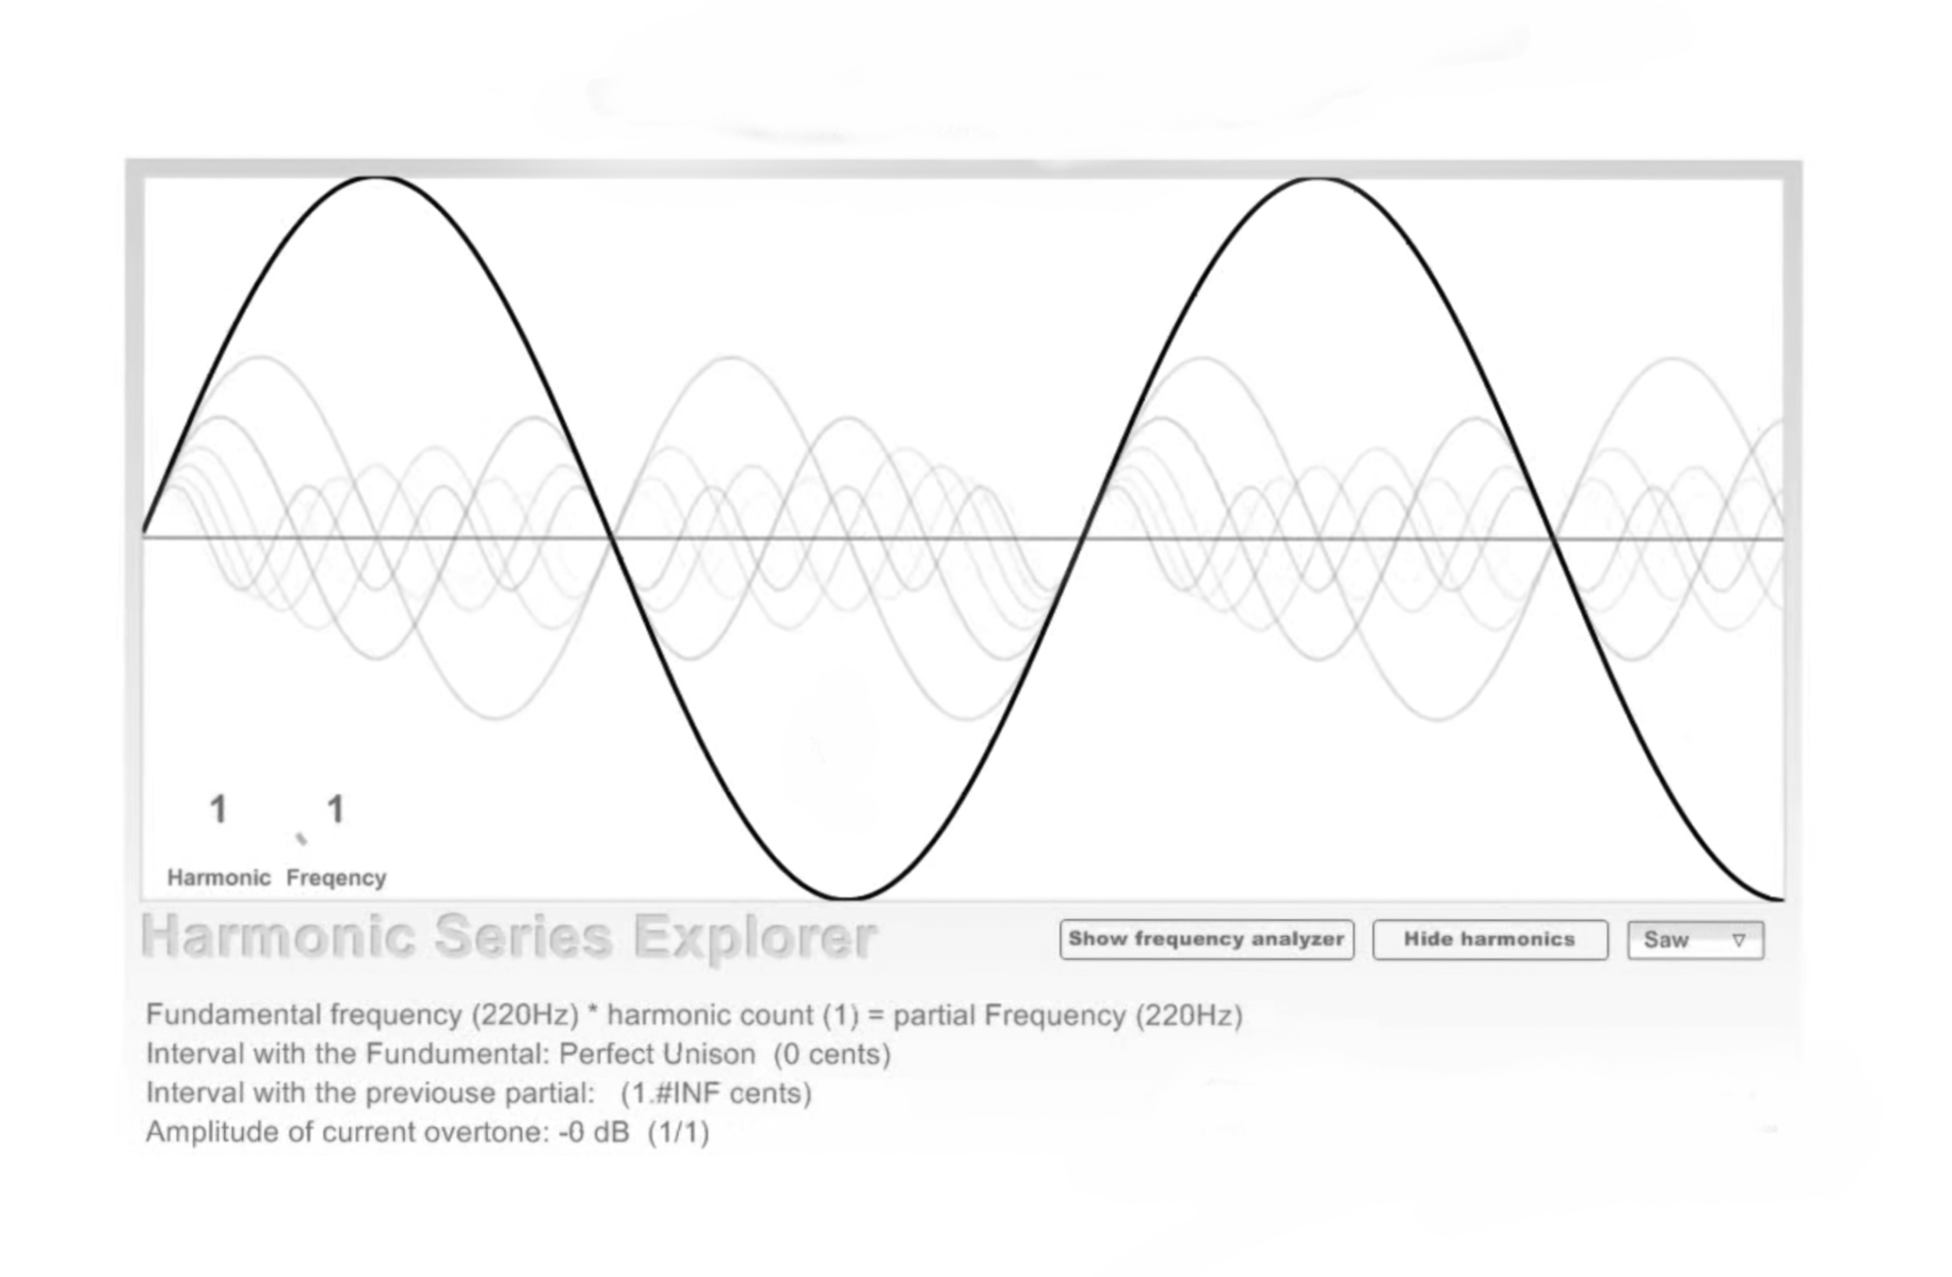

Playing sine wave after adding harmonics
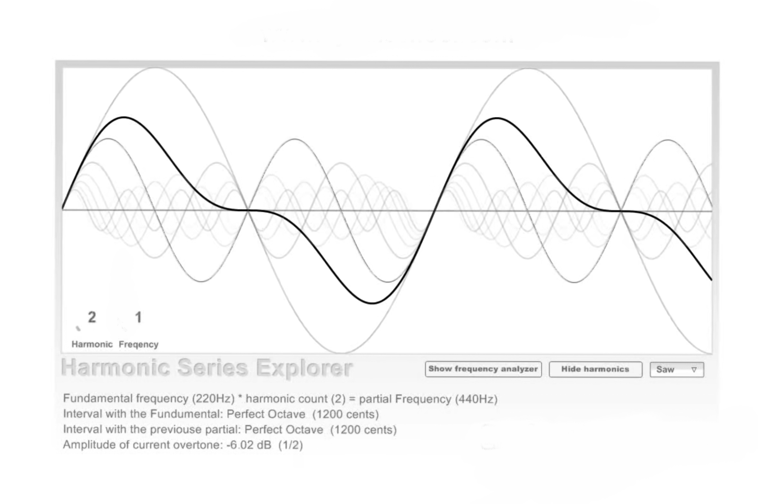
Hackathon Journey

Choosing Bangalore as the local event to solve the challenge was wonderful at Jain(Deemed-to-be University). It was very exciting to work with all the skilled team members. Each and every minute of 48 hours has been utilized by our team in getting the best output possible for the project. Some of us didn't even sleep for the whole night working on the flaws and to tackle the challenge that we had accepted. And we all are excited to participate in the upcoming Nasa space app challenges. The challenge helps us figure out the abilities/skills that we have and enhance them.

Space Agency Data

We used the multi band image data from NASA WISE.

References
- Making Music From Images in Python
- Sonifications - NASA Science
- Wide-field Infrared Survey Explorer (WISE) and NEOWISE
- What are Hyperspectral Images?. How are they different from the digital… | by Sarthak Panigrahi | Towards Data Science
- Hyperspectral Imaging - eoPortal
- Play, Record, Process live audio with Numpy | Scientific Computing
- https://ieeexplore.ieee.org/abstract/document/6194485
- https://www.mdpi.com/1424-8220/20/11/3222
- https://github.com/A-Ordem/Immersed-in-the-Sounds-of-Space/blob/main/backend/3dSound/sonification.js
- Images of multi bands

Videos

- Generating Sound from Sine Waves in Python
- Generating Musical Notes in Python using Sine Waves
- Overtones, harmonics and Additive synthesis

Tags

#arts #astrophysics#earth#softwarem

