Topics: Confidence Intervals

- For each of the following statements, indicate whether it is True/False. If false, explain why.

- The sample size of the survey should at least be a fixed percentage of the population size in order to produce representative results.
- Answer:- False. The sample size of a survey doesn’t need to be a fixed percentage of the population size to produce representative results. Generally for a population of 500, the sample of 100 is enough to produce required results.

- The sampling frame is a list of every item that appears in a survey sample, including those that did not respond to questions.
Answer:- True

- Larger surveys convey a more accurate impression of the population than smaller surveys.
Answer:- True

- PC Magazine asked all of its readers to participate in a survey of their satisfaction with different brands of electronics. In the 2004 survey, which was included in an issue of the magazine that year, more than 9000 readers rated the products on a scale from 1 to 10. The magazine reported that the average rating assigned by 225 readers to a Kodak compact digital camera was 7.5. For this product, identify the following:

- The population
- PC magazine readers, only if we are into the readers of pc magazines, else the population also includes users of different brands of electronics.
- The parameter of interest
- Population size
- Average
- Sample size
- Rating scale
- The sampling frame
- Every reader responds by rating the products.
- The sample size
- According to the magazine report 225 people rated the product.
- The sampling design
- Voluntary response
- Any potential sources of bias or other problems with the survey or sample
- For the sample selection there are no bias results involved, but the surveys conducted by the magazines often has the non-responsive bias and also the source of the data is from reader who read the PC magazine when compared with the whole population that don’t read the PC magazine yet they did use these different brands of electronics.

- For each of the following statements, indicate whether it is True/False. If false, explain why.

- If the 95% confidence interval for the average purchase of customers at a department store is $50 to $110, then $100 is a plausible value for the population mean at this level of confidence.
Ans:- True
- If the 95% confidence interval for the number of moviegoers who purchase concessions is 30% to 45%, this means that fewer than half of all moviegoers purchase concessions.
Ans:- False.
From the statement only 30% to 45% of moviegoers are at 95% confidence further more we don’t have any accurate information for 100% results.
- The 95% Confidence-Interval for μ only applies if the sample data are nearly normally distributed.
Ans:- False.
The 95% confidence interval can be also applied for the distribution which are not normal, however they can be understood easily and clearly when they are distributed symmetrically. Generally the mean of the data is normally distributed when the sample size Is sufficiently large.

- What are the chances that ?

- ¼
- ½
- ¾
- 1
Answer:- code
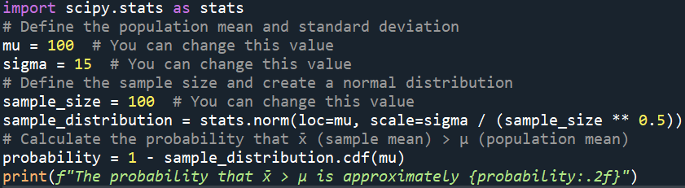
Output:-

- In January 2005, a company that monitors Internet traffic (WebSideStory) reported that its sampling revealed that the Mozilla Firefox browser launched in 2004 had grabbed a 4.6% share of the market.

- If the sample were based on 2,000 users, could Microsoft conclude that Mozilla has a less than 5% share of the market?
Ans:-
Code:-

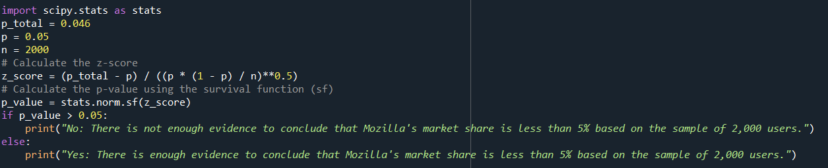
Output:-
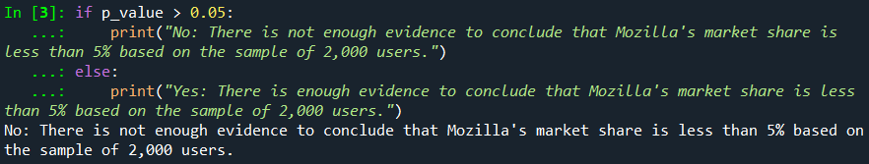

- WebSideStory claims that its sample includes all the daily Internet users. If that’s the case, then can Microsoft conclude that Mozilla has a less than 5% share of the market?
Ans:- Code:-
Output:-


- A book publisher monitors the size of shipments of its textbooks to university bookstores. For a sample of texts used at various schools, the 95% confidence interval for the size of the shipment was 250 ± 45 books. Which, if any, of the following interpretations of this interval are correct?

- All shipments are between 205 and 295 books.
Ans:- Incorrect.
- 95% of shipments are between 205 and 295 books.
Ans:- Correct.
The shipments are between 205 and 295.
- The procedure that produced this interval generates ranges that hold the population mean for 95% of samples.
Answer:- Correct
"The procedure that produced this interval generates ranges that hold the population mean for 95% of samples."

- If we get another sample, then we can be 95% sure that the mean of this second sample is between 205 and 295.
Answer:-Correct
"If we get another sample, then we can be 95% sure that the mean of this second sample is between 205 and 295."

- We can be 95% confident that the range 160 to 340 holds the population mean.
Answer:-Incorrect

- Which is shorter: a 95% z-interval or a 95% t-interval for μ if we know that σ =s?

- The z-interval is shorter
- The t-interval is shorter
- Both are equal
- We cannot say
Ans:- code
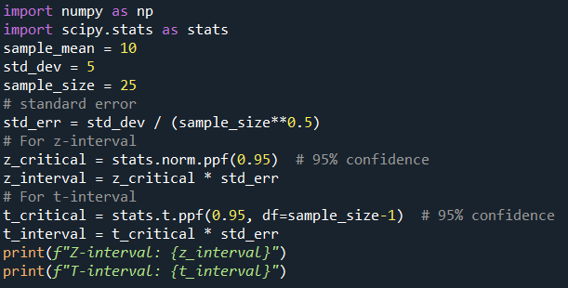
Output:-
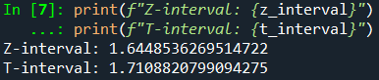

Questions 8 and 9 are based on the following: To prepare a report on the economy, analysts need to estimate the percentage of businesses that plan to hire additional employees in the next 60 days.

- How many randomly selected employers (minimum number) must we contact in order to guarantee a margin of error of no more than 4% (at 95% confidence)?

- 600
- 400
- 550
- 1000
Answer:- Code
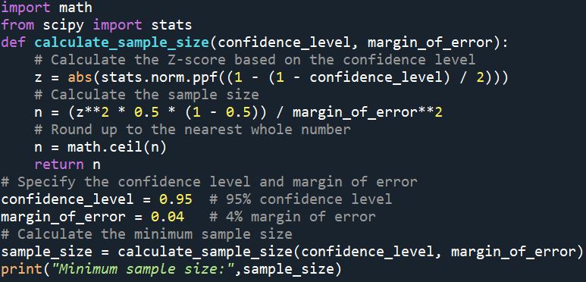
Output:-

- Suppose we want the above margin of error to be based on a 98% confidence level. What sample size (minimum) must we now use?

- 1000
- 757
- 848
- 543

Answer:- Code
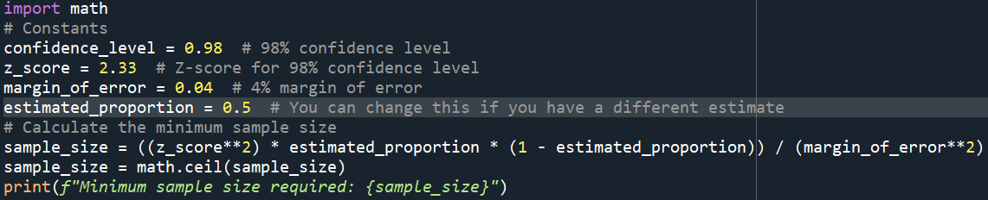
Output:-

