Assignment1

Submitted By Dheeraj Varshney

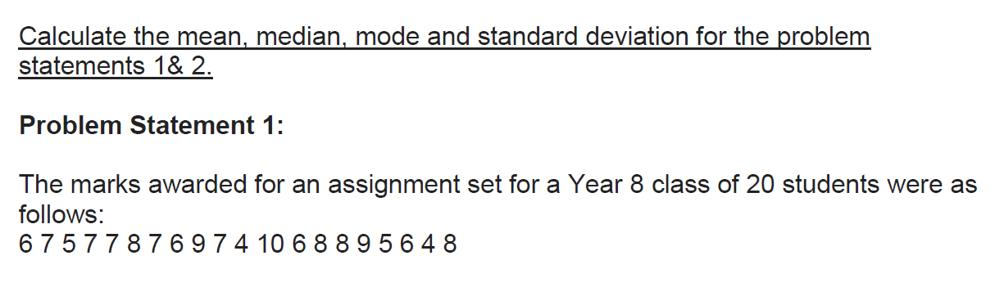

Mean = 137/20 = 6.85

Median

Arranging the data

4 4 5 5 6 6 6 6 7 7 7 7 7 8 8 8 8 9 9 10

N is even I =10

Median = (7+7)/2 = 7

**Mean = 6.85 Median = 7 Mode = 7**

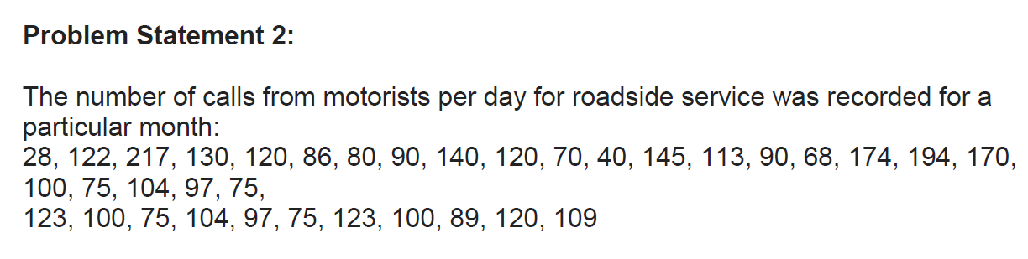

Mean = 3763/35 = 107.514

Median

Arranging the data set

28, 40, 68, 70, 75, 75, 75, 75, 80, 86, 89, 90, 90, 97, 97, 100, 100, 100, 104, 104, 109, 113, 120, 120, 120, 122, 123, 123, 130, 140, 145, 170, 174, 194, 217

Median 100

Mode = 75

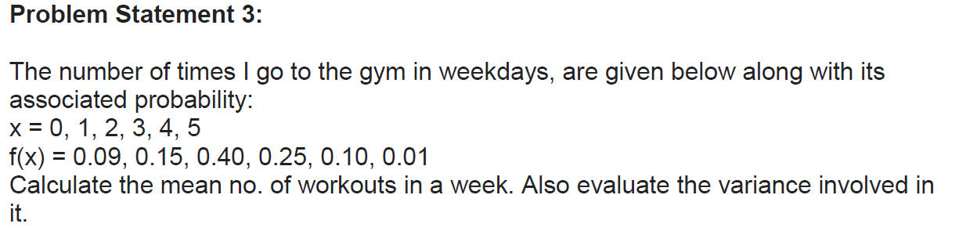

|  |  |
| --- | --- |
| x | f(x) |
| 0 | 0.09 |
| 1 | 0.15 |
| 2 | 0.40 |
| 3 | 0.25 |
| 4 | 0.10 |
| 5 | 0.01 |

Mean = 1.00/6 =0.166

Variance = 0.0888/6 = 0.0148

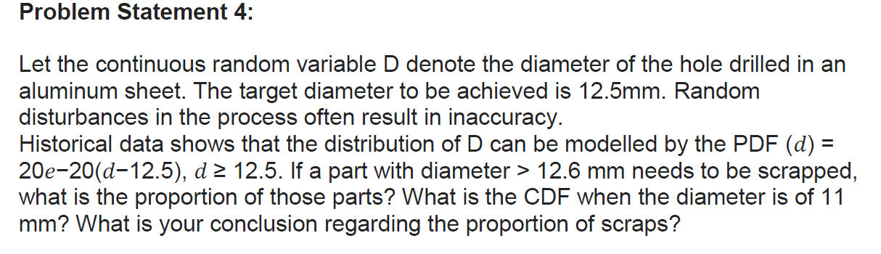

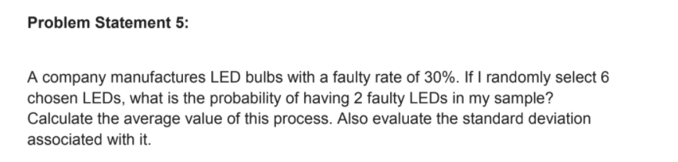

This is Binomial distribution problem

P(n|N) = (N/n) p^n q^N-n

P(faulty) = 0.3 =q

P(correct) = 0.7 =p

N=6

n = 2

P(2|6) = (6/2) (0.7^2)(0.3^4)

**=0.059535 Ans**

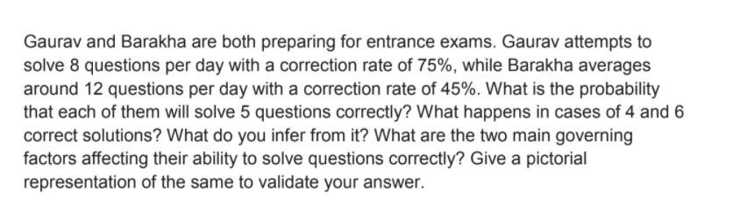

**This can be considered a Binomial distribution problem.**

**Case 1 Gaurav**

**N=8 p=0.75 q = 0.25 n=5**

**8C5(0.75^5)(0.25^3)**

**P of solving 5 questions correctly=0.207641**

**Case of P(4)**

**8C4(0.75^4)(0.25^4)**

**P of solving 4 questions correctly =0.086517**

**Case of P(6)**

**8C6(0.75^6)(0.25^2)**

**P of solving 6 questions correctly =0.311462**

**Case2 Barakha**

**N=12 p=0.45 q=0.55 n=5**

**12C5(0.45^5)(0.55^7)**

**P of solving 5 questions correctly=0.222498**

**Case of P(4)**

**12C4(0.45^4)(0.55^8)**

**P of solving 4 questions correctly =0.169963**

**Case of P(6)**

**12C6(0.45^6)(0.55^6)**

**P of solving 6 questions correctly =0.212384**

**2 main governing facors**

1. **No. of questions solved correctly**
2. **NO. of questions solved in a day**

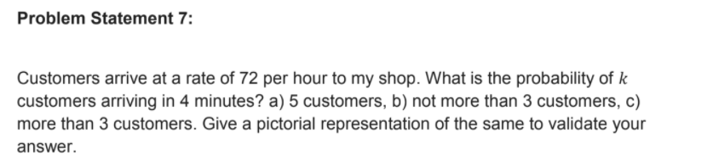

**60min – 72 customers**

**1 min – 72/60=1.2**

**4 min – 1.2*4 = 4.8**

1. **5 customers**

**P(k=5)**

**= e^-1.2 (1.2^5)/5!**

**=0.301194 * 0.020736**

**=0.00624**

1. **P(k<3)**

**=P(k=0)+p(k=1)+p(k=2)**

**=e^-1.2(1.2^0)/0! + e^-1.2(1.2^1)/1! + e^-1.2(1.2^2)/2!**

**=0.301194 + 0.361432+0.216859**

**=0.879485**

1. **P(k>3)**

**=P(k=4)**

**=e^-1.2(1.2^4)/4!**

**=0.026023**

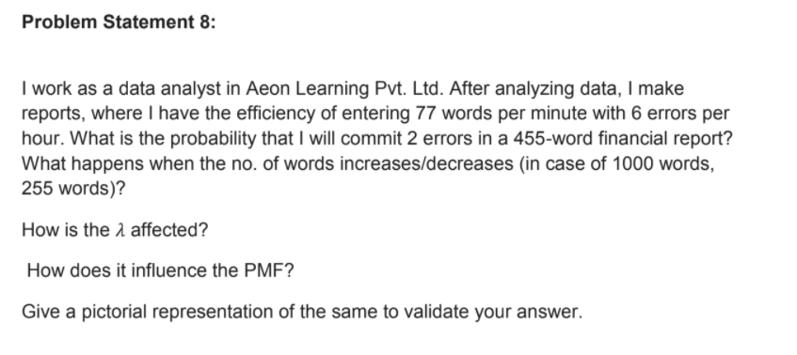

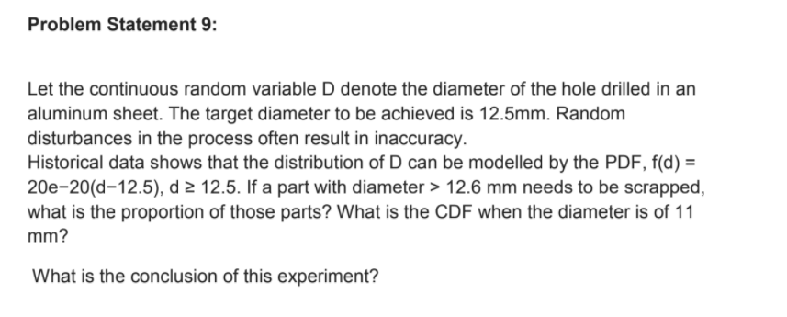

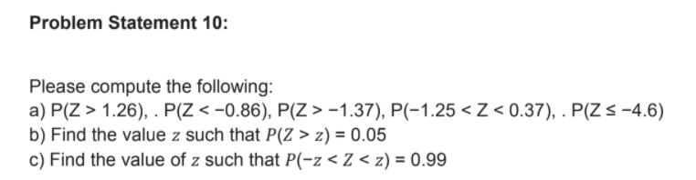

**P(z>1.26) = 0.8962**

**P(z<-.86) = 0.1949**

**P(z>-1.37) = 0.0853**

**P(-1.25<z<0.37) = -0.1056+ 0.6443 = 0.5387**

**P(z<=-4.6)=cant be calculated as it s invalid the maximum we can calculate is 3.4**

**P(Z>z) = 0.05**

**-1.64**

**P(-z<Z<z) = 0.99**

**2.33**

