Statistics Assignment 2

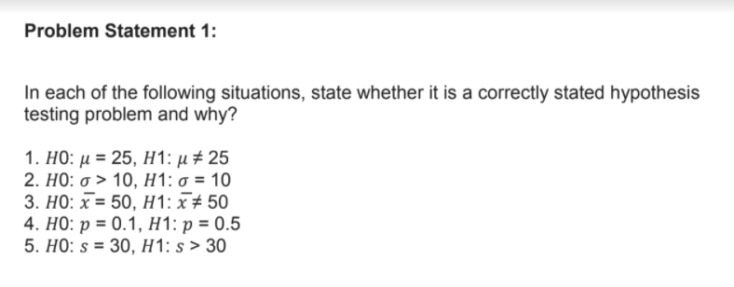

1. Correct stated hypothesis as either mu will be 25 or it will not be equal to 25
2. Incorrect stated hypothesis as either sigma will be greater than 10 or less than 10
3. Correct as x bar will be either equal to 50 or it wont be equal to 50
4. Incorrect stated hypothesis as either p will be equal to 0.1 or not equal to 0.1
5. Incorrect as s is either equal to 30 or not equal to 30

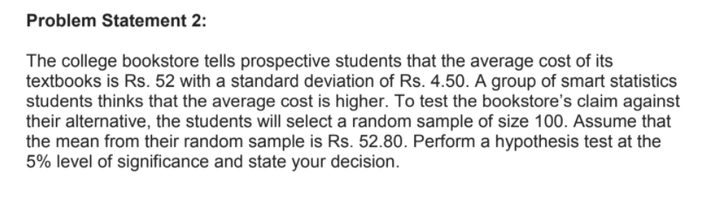

H0: population mean <= 52

H1: population mean > 52

SE= 4.5/sqrt 100 = 0.45

z- test = 52.8-52/0.45

= 1.78

Z(0.05) = 1.64

Ztest>z(0.05)

Hence, we will accept null

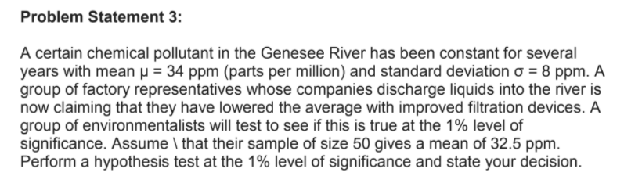

H0: mean > = 34

H1: mean <34

SE = 8/sqrt50=1.131

Ztest=32.5-34/1.131 =-1.32

Z(0.01) = -2.33

Z(test)>z(0.01)

We will accept null hypothesis

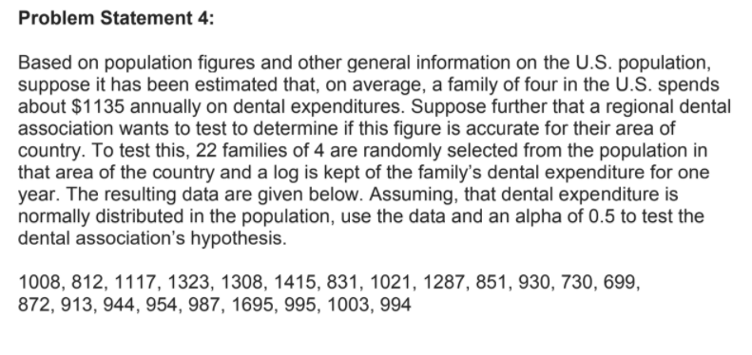

H0: Expenditure = $1135

H1 Expenditure != 1135

< >1135

Mean =22689/22 = 1031.31

Alpha = 0.5

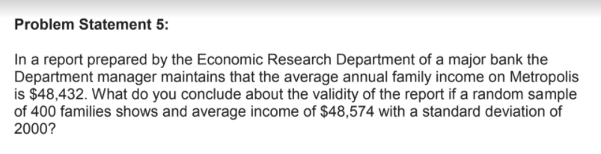

SE = 2000/sqrt400=100

Z test = 48574-48432/100

Z test =1.42

Z(0.05) = 1.64

Z(0.05)>z test

We can reject null hypothesis

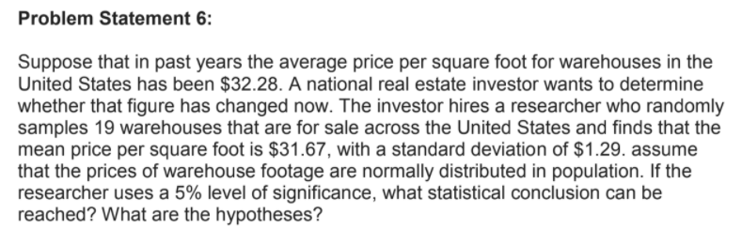

SE = 1.29/sqrt19=0.29

t test = 31.67-32.28/0.29=-2.10

t(0.05) = 2.120

-2.120<-2.10<2.120

We can accept null hypothesis

