**Follow below steps to setup and run the application**

Clone repository from Github using link below

https://github.com/dheerajvats/turvo-demo.git

Move to project base location ( where settings.gradle file is present )

Open terminal at base location and execute below command

gradle build

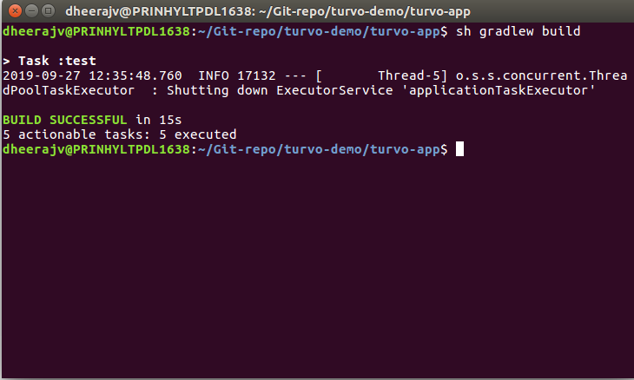

Go to below folder to get the jar.   
 build/libs   
Jar created by above command will be there

Run below command to start the jar

java -jar <jar-name.jar>

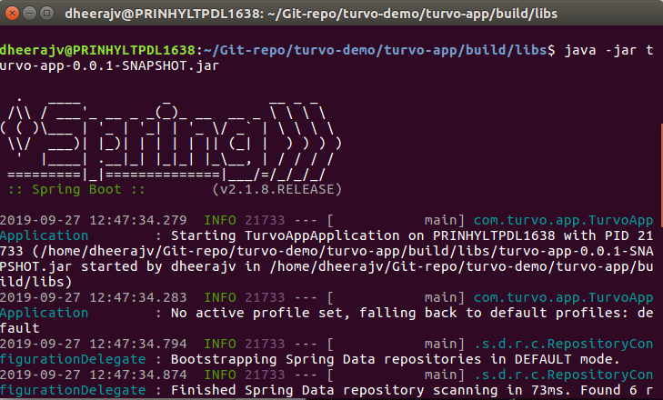

Search for the below highlighted line to verify that jar has strated properly

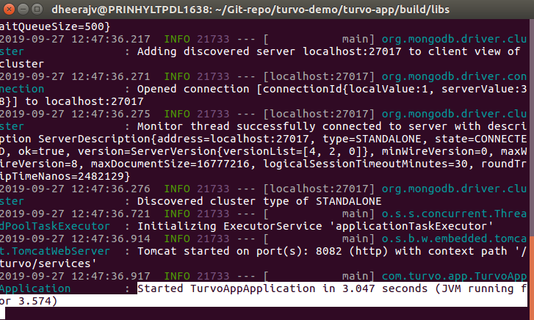

APIs Postman collection has been shared along

Use below link to import or use the shared file.

Link :- <https://www.getpostman.com/collections/9f10c2702e4aef3c2493>

