Human Action Recognition from depth maps and Postures using Deep Learning

In this paper author is using CNN (Convolution Neural Networks) algorithm to recognize human action as this algorithm will extract important features by filtering same data multiple times in order to maximize chances of accurate action classification, CNN channels are trained with different inputs features which will not happen in existing RGB Depth algorithm which will get train on two features such as images and skeleton data.

As existing algorithm are not efficient so author using CNN algorithm which already proves its success in various fields such as image classification, weather and stock prediction etc.

To train CNN algorithm author is using MSRAction3D skeleton dataset which contains 20 different actions such as 'high arm wave', 'horizontal arm wave', 'hammer', 'hand catch', 'forward punch', 'high throw', 'draw x', 'draw tick', 'draw circle', 'hand clap', 'two hand wave', 'side-boxing', 'bend', 'forward kick', 'side kick', 'jogging', 'tennis swing', 'tennis serve', 'golf swing', 'pick up & throw'.

All this actions data are taken from MSRAction3D dataset and below is the screen shots of that dataset

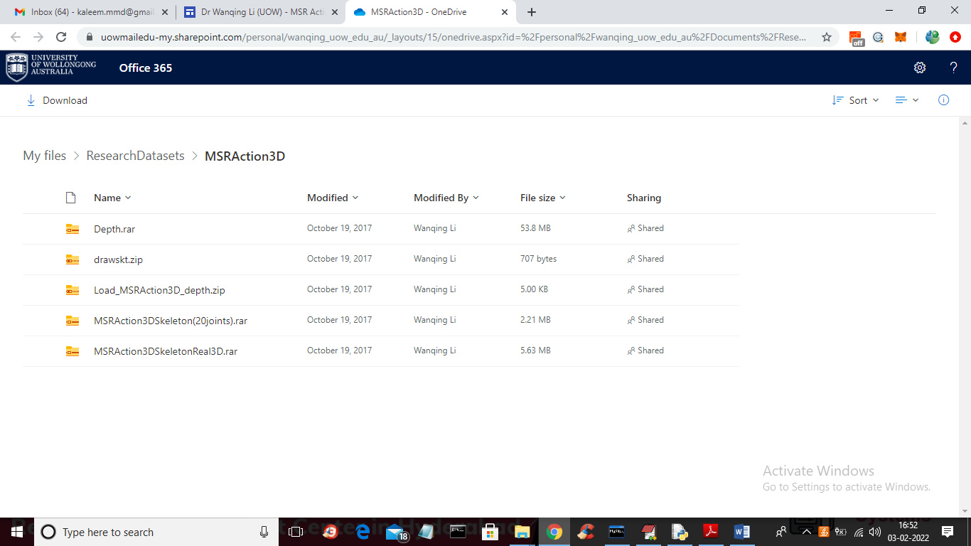

From above page we downloaded ‘MSRAction3DSkeleton(20joints)’ dataset and this dataset is captured using DEPTH cameras so it will record only skeleton values and below are the dataset files screen shot

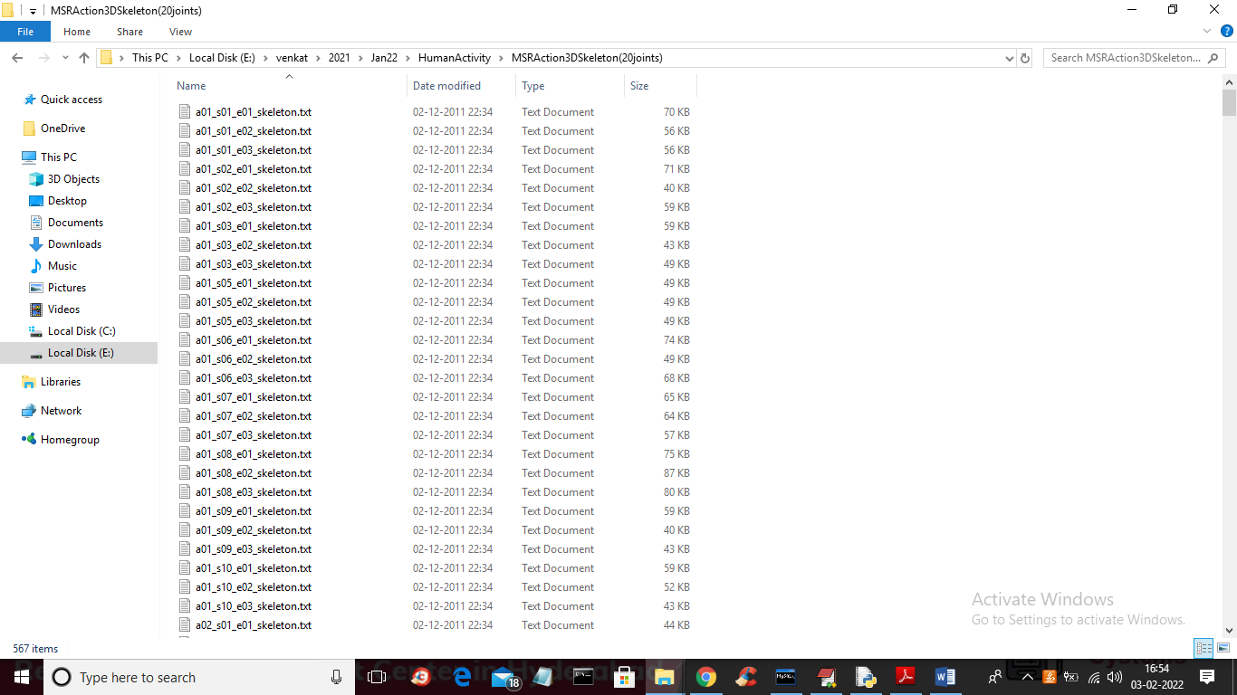

In above dataset screen each file contains skeleton data and in file name a01 refers to action 1 (actions are from 1 to 20) and s01 is the subject id and e01 is the instance ID. From above files we are training CNN with action details only so after training when we upload any file then CNN will predict action from that file. Each file will contains skeleton values as below screen

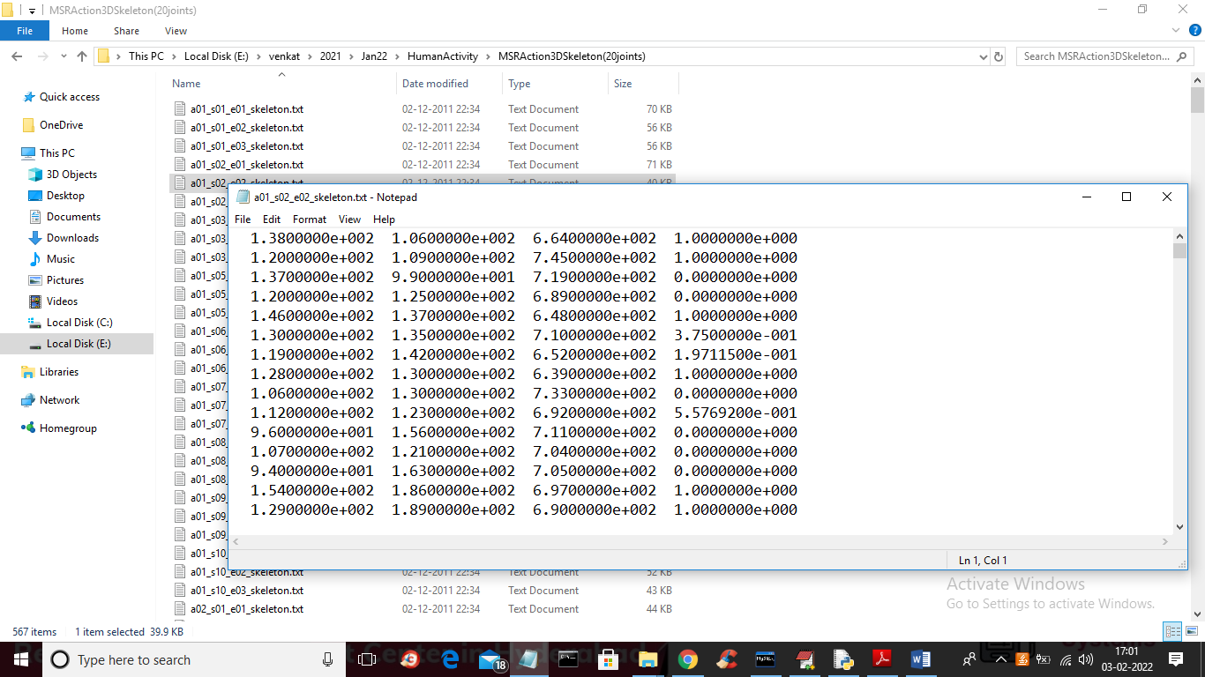

To implement this project we have designed following modules

1. Upload MSRAction3D Image: using this module we will upload action dataset to application
2. Features Extraction: using this module we will read each file and then extract features (dataset values) values and action value will be consider as class label and then we will visualize movement in graph format
3. Train CNN Algorithm: using this module we will input extracted features to CNN and then CNN will get trained and then will apply TEST data on trained model to calculate accuracy and confusion matrix graph
4. Predict Action from Test Data: using this module will upload test file and then CNN will read features from that test file and then identify action from that test file

SCREEN SHOTS

To run project double click on ‘run.bat’ file to get below screen

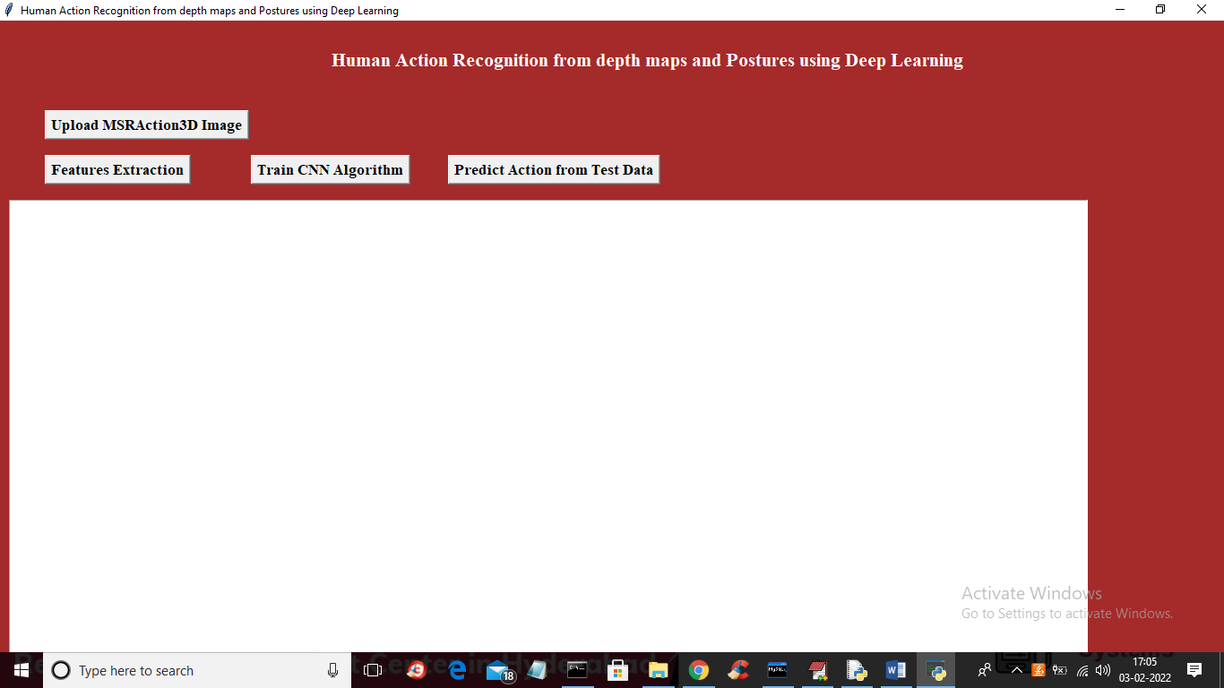

In above screen click on ‘Upload MSRAction3D Image’ button to upload dataset and to get below screen

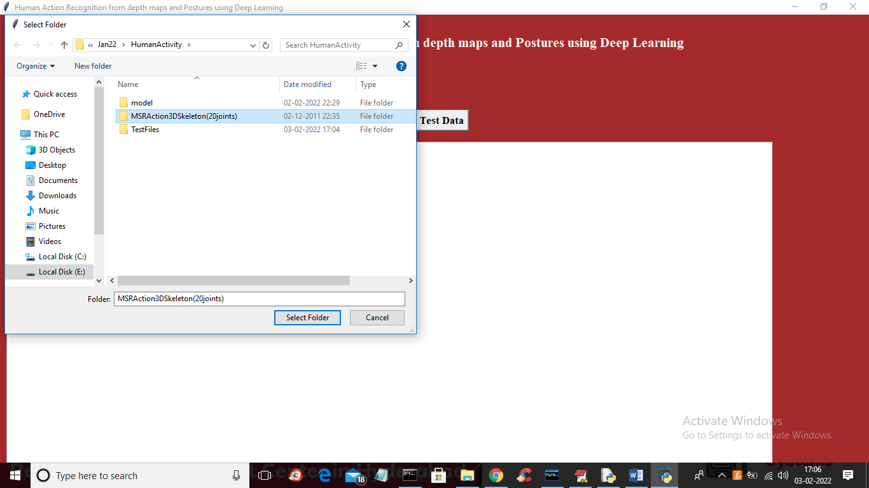

In above screen selecting and uploading MSRACTION dataset and then click on ‘Select folder’ button to load dataset and to get below screen

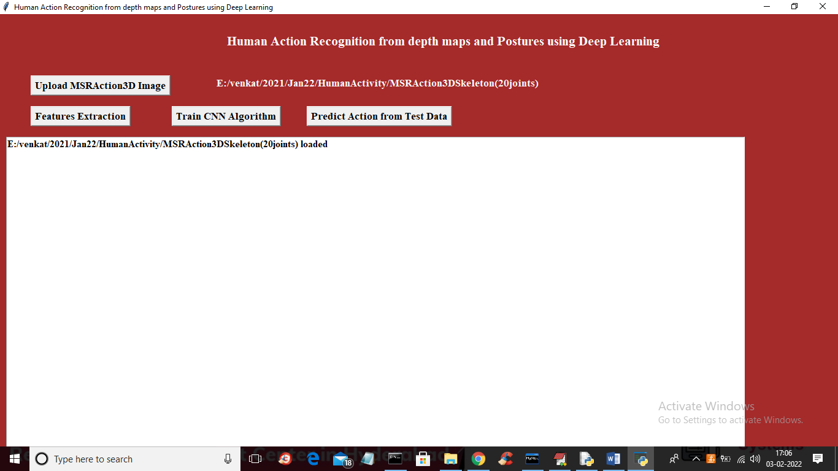

In above screen dataset loaded and now click on ‘Features Extraction’ button o read all files then build a features array and then visualize one skeleton image

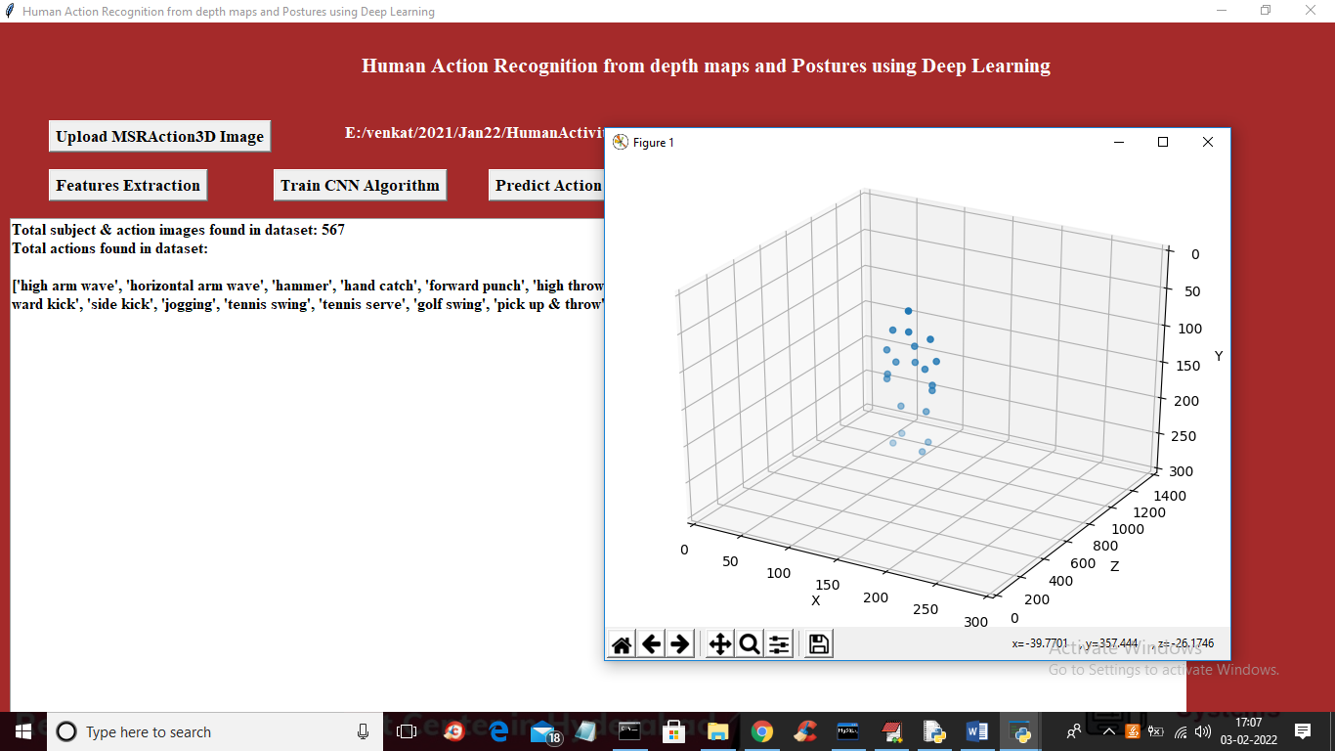

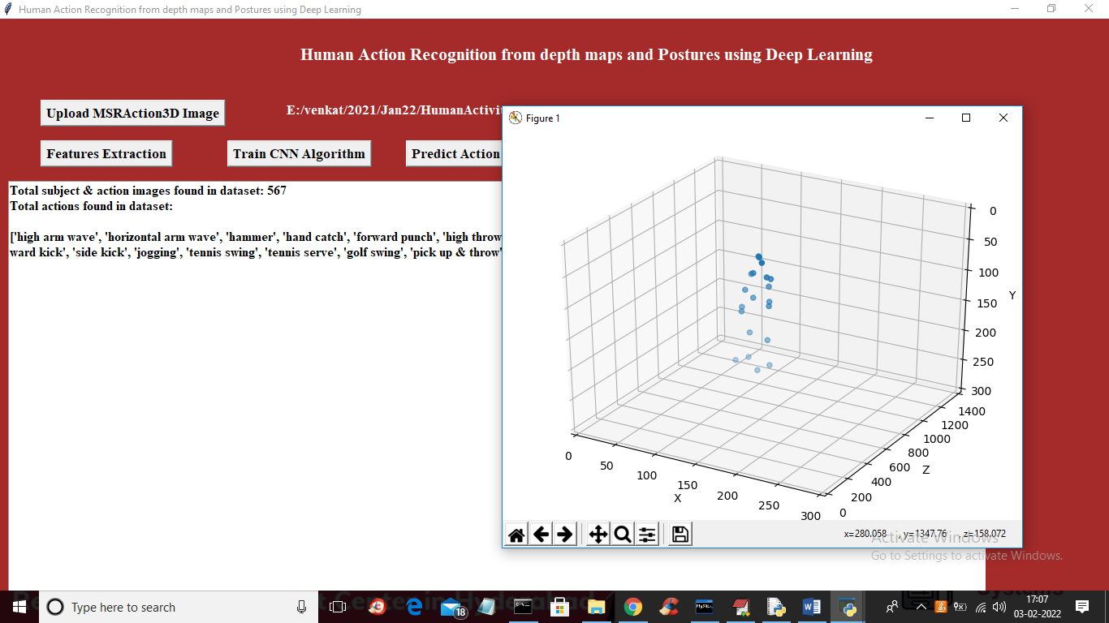

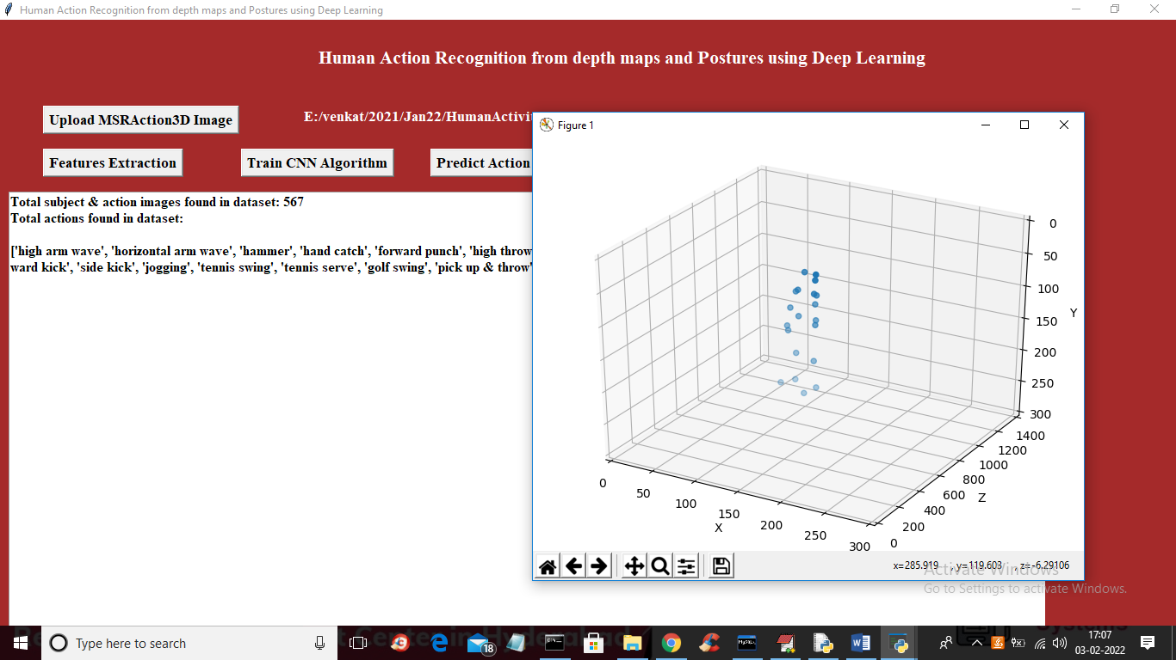

In above screen I am displaying total files found in dataset as 567 and displaying available 20 various actions such as ‘high arm wave’, ‘horizontal arm wave’ etc. In above graph you can see skeleton is moving which indicate action of person in dataset. When you upload then you will see skeleton movement in graph. After seeing close that graph and then click on ‘Train CNN Algorithm’ button to train CNN and to get below output

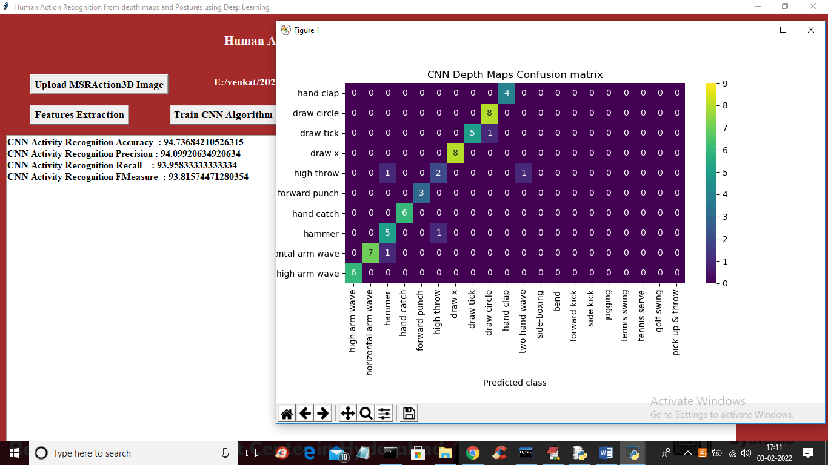

In above screen with CNN we got action recognition accuracy as 94% and in confusion matrix graph x-axis represents predicted action classes and y-axis represents original classes and we can all classes prediction values showing in diagnol boxes are the correct prediction and out of diagnol are the wrong prediction and very few value are there out of diagnol so CNN performance is good and it got 94% accuracy also. Now close above graph

Now click on ‘Predict Action from Test Data’ button to upload test data file and then CNN will recognize action from that test file data.

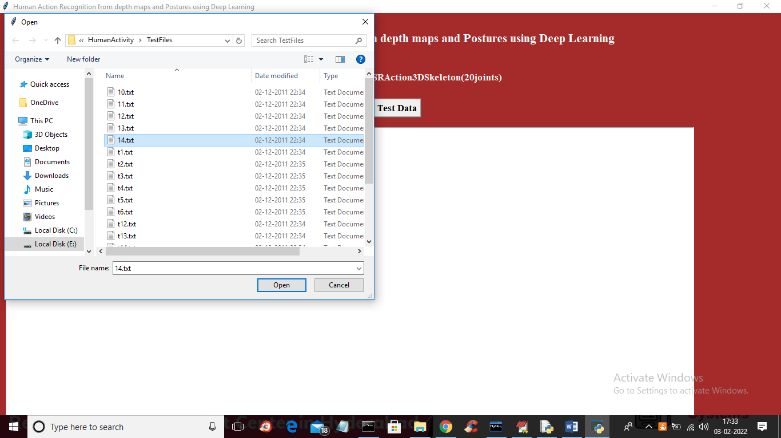

In above screen selecting and uploading ’14.txt’ file and then click on ‘Open’ button to load test file and to get below action recognition result

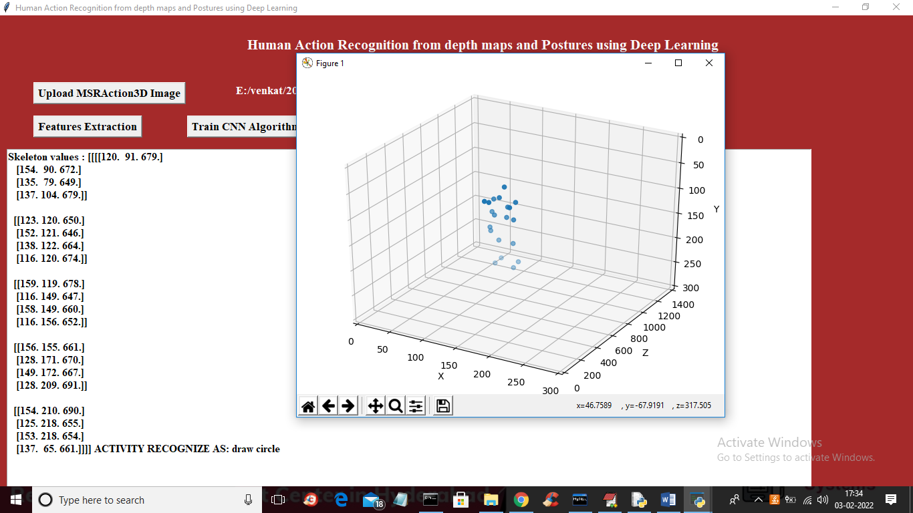

In above screen all values in square bracket are the skeleton values and in last line we got output as ‘Activity Recognized as ‘draw circle’ and in graph we can see the movement of the skeleton

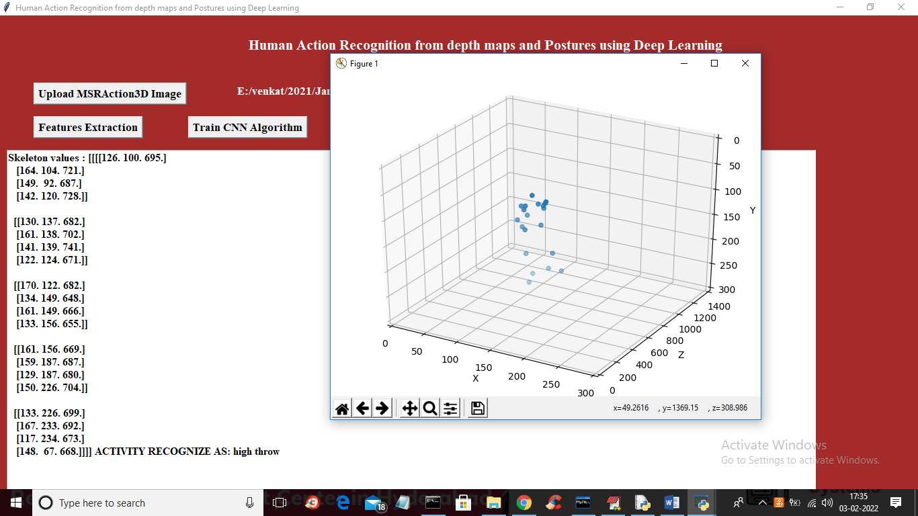

In above screen action recognized as ‘high throw’

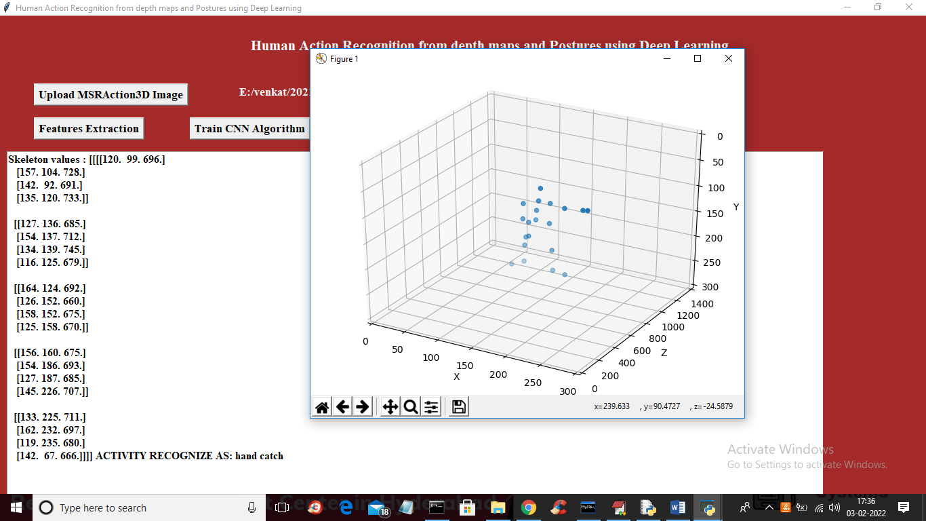

In above screen action recognized as ‘hand catch’ and similarly you can upload other files and test them