5.8

a)

The sampling distribution of the mean is symmetric, unimodal, and looks approximately normal. Below the histogram is a plot of the ecdf, which also confirms that the distribution is symmetrical and approximately normal.

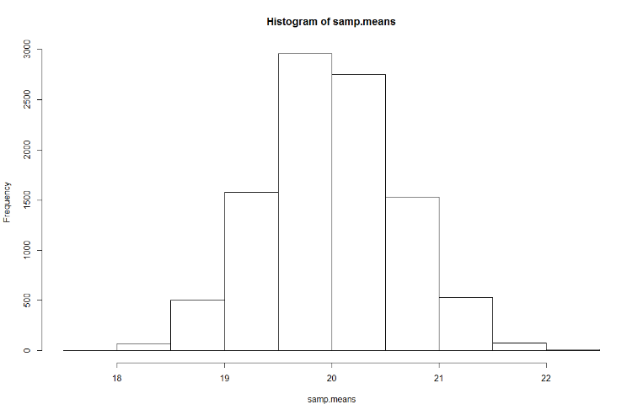

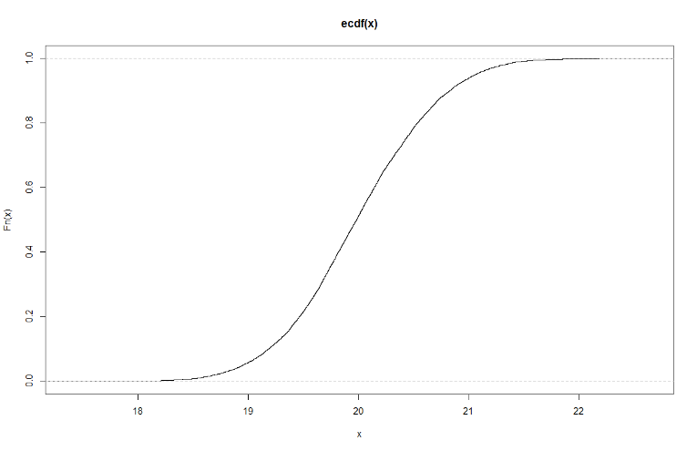

b)

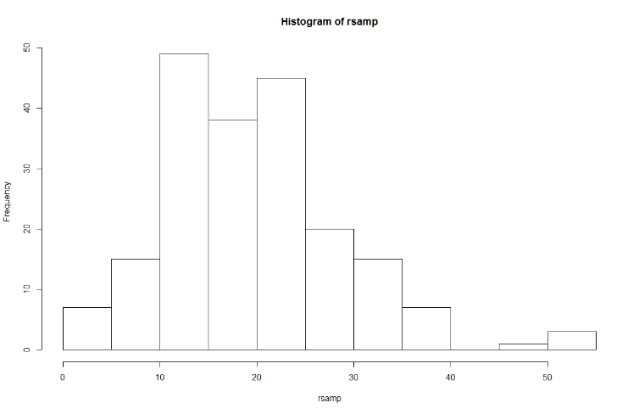The mean of the sample is 19.7322, which is close to the expected value of our population – 20. The sample standard deviation is 9.320915, which is close to the standard deviation of our population 8.944 (4 x sqrt(5)). Looking at the histogram of our sample we can see that it is a little right-skewed.

c)

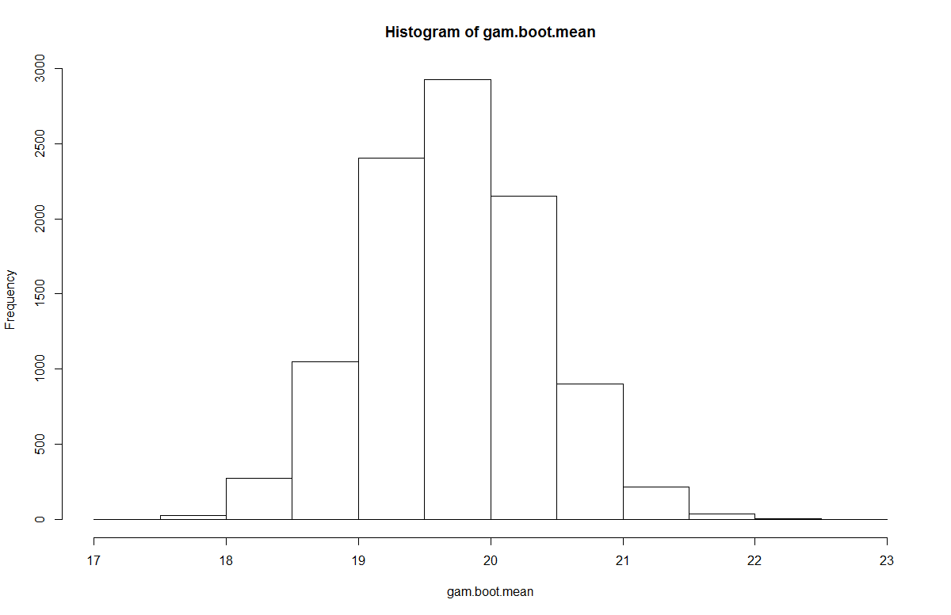

The bootstrap distribution of the mean is appears to be approximately normal, which is in-line with the CLT. The mean of the bootstrap distribution is 19.717, which is approximately near the mean of our sample, as well as near the expected value from the given population. The standard error of the bootstrap distribution is .656.

d)

|  |  |  |
| --- | --- | --- |
|  | Mean | Standard Deviation/Error |
| Population | 20 | 4 x sqrt(5) |
| Sampling Distribution of Xbar | 20.0025 | .630 |
| Sample | 19.732 | 9.32 |
| Bootstrap | 19.717 | .65 |

e)

n = 50

|  |  |  |
| --- | --- | --- |
|  | Mean | Standard Deviation/Error |
| Population | 20 | 4 x sqrt(5) |
| Sampling Distribution of Xbar | 19.997 | 1.26 |
| Sample | 17.219 | 8.18 |
| Bootstrap | 17.201 | 1.15 |

n = 10

|  |  |  |
| --- | --- | --- |
|  | Mean | Standard Deviation/Error |
| Population | 20 | 4 x sqrt(5) |
| Sampling Distribution of Xbar | 19.985 | 2.79 |
| Sample | 22.25 | 7.78 |
| Bootstrap | 22.324 | 2.324 |

Comparing the bootstrap distributions across sample sizes – n = 10, 50, and 200 – we can see that as our sample size decreases, our bootstrap distribution reflects more bias as shown by the increasing standard error of our distribution. If we think back to our first random sample of size 200 this makes sense, because we noted that we were slightly right-skewed. If we think about a population described by a gamma distribution, we note that has our rate increases, our overall distribution tends to be right-skewed. Thus, our observation that the decrease in sample size increases the bias towards this distribution makes sense.

5.17

a)

Math and Sciences Histogram

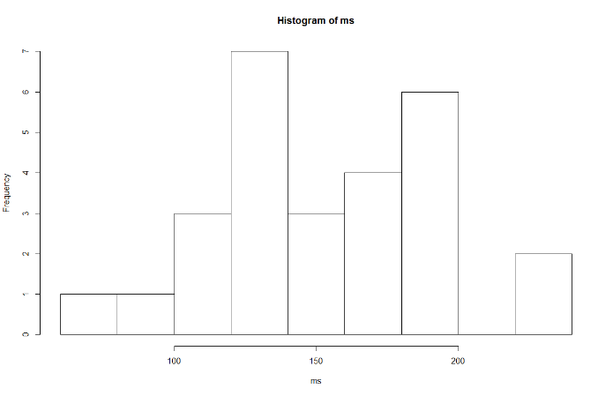The prices of the math and sciences textbook seem to be bimodal, slightly right-skewed, and not symmetric. The mean

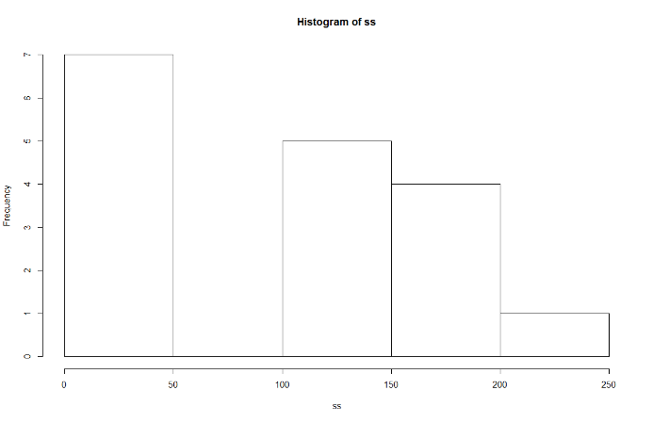Social Sciences Histogram

The prices of the social sciences textbooks seem to be left-skewed. The mean of these books is 98.99, while the median is 136, which confirms the fact the distribution is left-skewed.

b)

Bootstrap of mean Math and Science

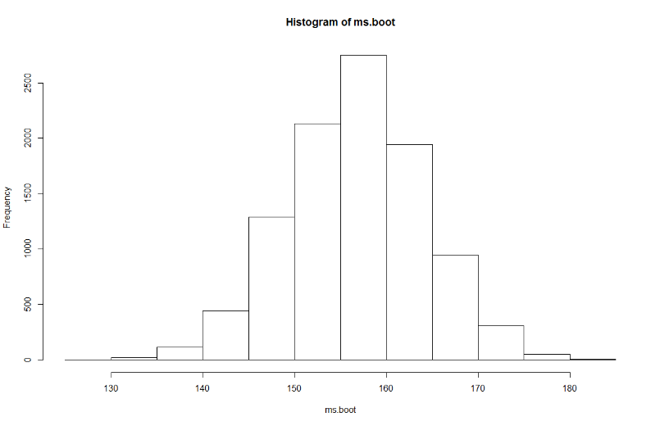The distribution of the bootstrapped mean is approximately normal.

Bootstrap of mean Social Sciences

The distribution of the bootstrapped mean for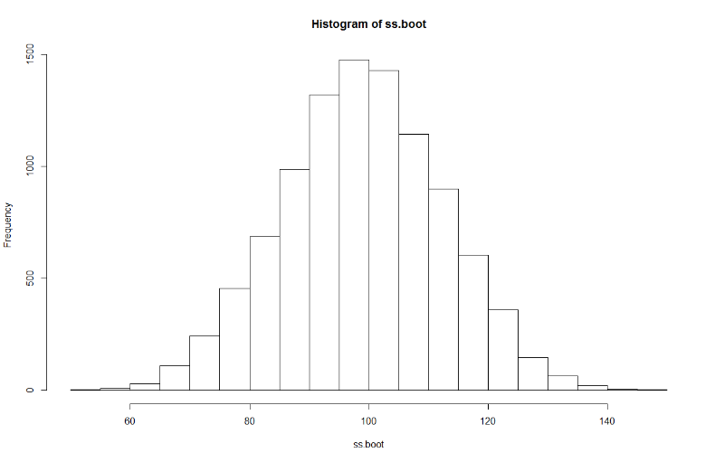 the social sciences textbooks is also approximately normal.

c)

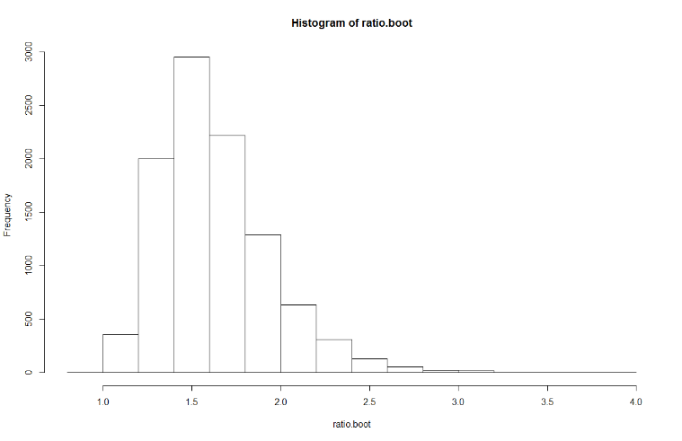The histogram for the bootstrapped ratio of the means is unimodal, and is approximately normal. However, it appears to be right skewed. Looking at the means of our two samples, we can see that the mean of the Math and Science textbooks is much higher than the mean of the Social Sciences textbooks. In my code for this bootstrap I took the mean of the Math and Science texts over the mean of the Social Sciences texts. This is what explains the fact that this distribution is right-skewed.

d)

The mean of the bootstrapped ratio of means is 1.6311. The 95% confidence interval for the bootstrapped ratio of means is bounded by 1.1723 and 2.3876. Essentially, what this interval represents is the fact that we are 95% confident that our bootstrapped mean is between 1.1723 and 2.3876.

e)

The bootstrap estimate of bias is .047837, and the bias represents .1515 or approximately 15.15% percent of the bootstrap standard error.