David Heisler

HW 6

2.2

Is $f\left(\overline{x}\right)= \breve{x}?$ Where $\breve{x}=mean of the transformed data$

No, see appendix for code and calculations

Is $f\left(m\right)=\breve{m}$? Where $\breve{m}=median of transformed data$

No, see appendix for code and calculations

2.5

a)

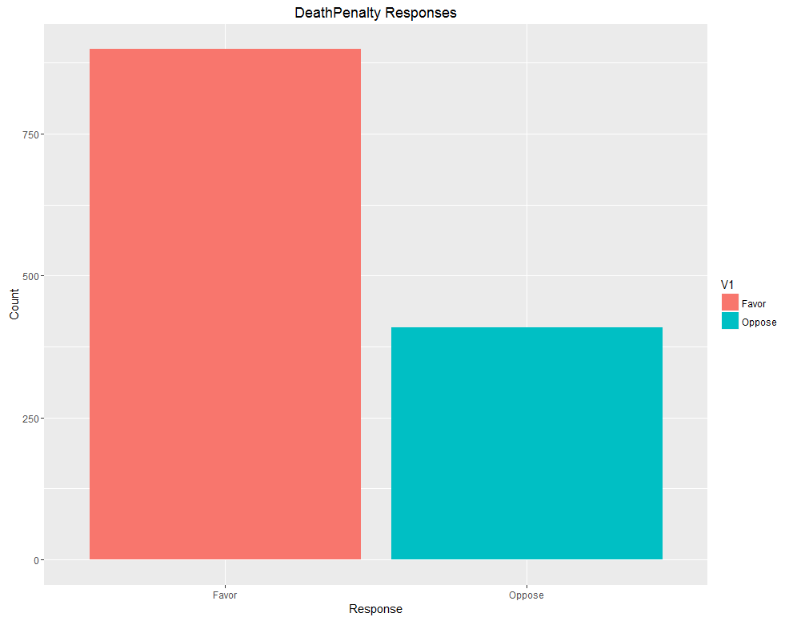Bar Chart

Table

|  |  |
| --- | --- |
| Favor | Oppose |
| 899 | 409 |

b)

The summary commands gives you the same information as the table command, as well as the number of NA values in the OwnGun variable.

No: 605, Refused: 9, Yes: 310, NA’s: 1841

While the table function call gives a similar output to question (a), which is a count of each unique response in the variable.

c)

|  |  |  |  |
| --- | --- | --- | --- |
|  | No | Refused | Yes |
| Favor | 375 | 7 | 243 |
| Oppose | 199 | 2 | 59 |

d)

Using the contingency table, we can see that the proportion of gun owners that favor the death penalty is 243/302 = 80%, and the proportion of people that do not own guns that favor the death penalty is 375/574 = 65%. So, yes, they are different.

2.6

a)

Summary of Di.Change

|  |  |  |  |  |  |
| --- | --- | --- | --- | --- | --- |
| Min | 1st Quartile | Median | Mean | 3rd Quartile | Max |
| 1.019 | 2.712 | 3.915 | 3.996 | 5.116 | 8.919 |

|  |  |  |  |  |
| --- | --- | --- | --- | --- |
| MAD | Range | IQR | Trimmed Mean | SD |
| 1.78 | 7.9 | 2.4 | 3.831 | 1.79 |

Summary of Ht.Change

|  |  |  |  |  |  |
| --- | --- | --- | --- | --- | --- |
| Min | 1st Quartile | Median | Mean | 3rd Quartile | Max |
| 8.3 | 23.2 | 30.10 | 30.93 | 38.17 | 51.50 |

|  |  |  |  |  |
| --- | --- | --- | --- | --- |
| MAD | Range | IQR | Trimmed Mean | SD |
| 11..49 | 43.2 | 14.975 | 30.825 | 11.0493 |

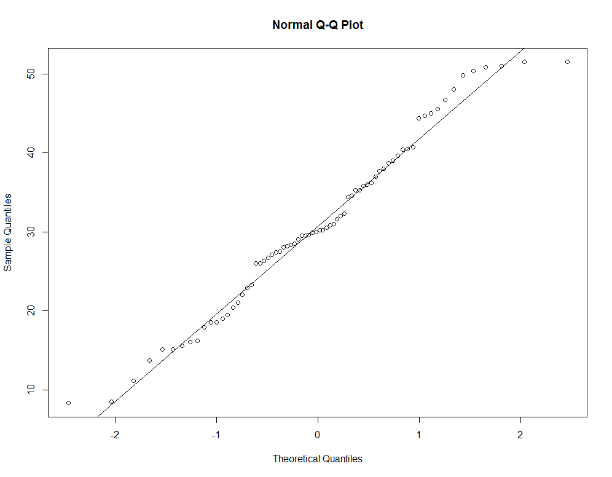b)

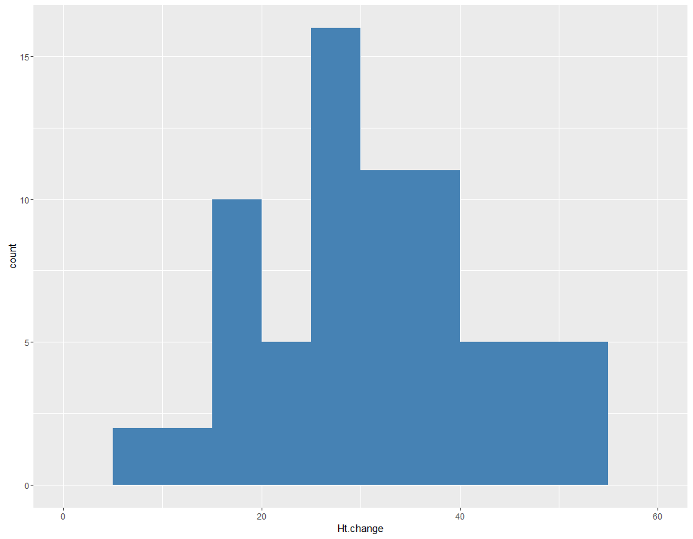

c)

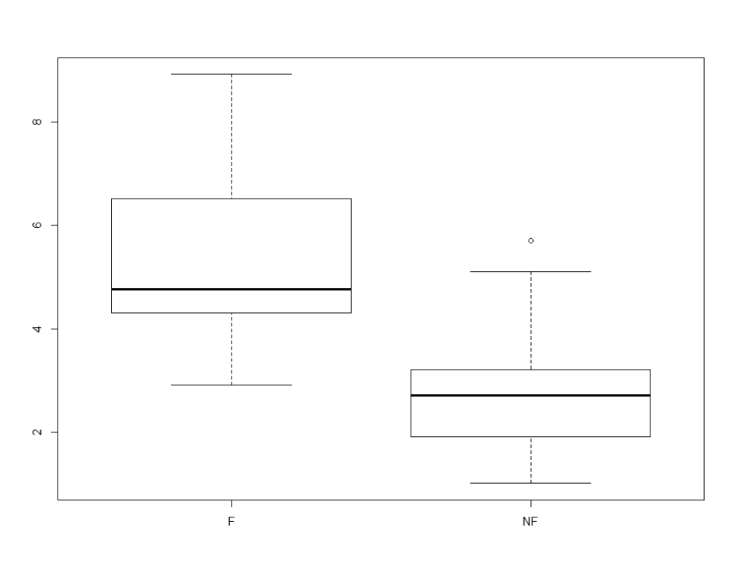

d)

|  |  |  |
| --- | --- | --- |
|  | F | NF |
| MAD | 1.186 | 1.042 |
| Range | 6 | 4.69 |
| IQR | 2.2 | 1.25 |
| SD | 1.38 | 1.1 |
| Mean | 5.27 | 2.72 |
| Trimmed Mean | 5.06 | 2.57 |
| Median | 4.76 | 2.71 |

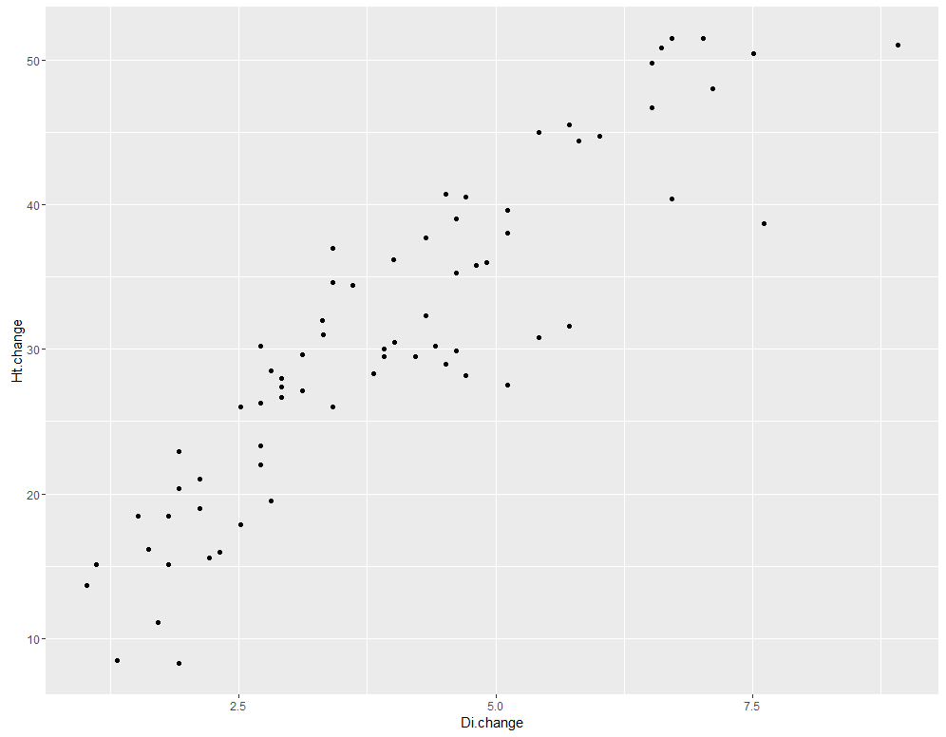e)

8

a)

10

1. To find this we used the qnorm function in R, with p = c(.3, .6), mean = 10, sd = 17 and we get an answer of 30th percentile at 1.085191 and the 60th percentile at 14.306901