CHAPTER I
INTRODUCTION
1.1 Project Context
The use of information technology in education has largely revolutionized the manner in which academic institutions handle documents and assure academic integrity. Computerized repositories and plagiarism detection software have become a must to ensure quality education and intellectual dishonesty.
Even in local colleges, document submission and plagiarism detection remains in part manual in most academic institutions. Students present research papers, and instructors use independent tools or go through a manual check to confirm the originality. This disjointed method can lead to inefficiency, procrastinations and variation in the assessments of academic work.
According to observations and general institutional practices, there are a number of loopholes including the slow checking of plagiarism, absence of centralized repositories, inability to identify partial similarities, and poor access control systems. These problems may undermine academic integrity and deter proper document management.
Driven by these difficulties, this project seeks to build an academic repository (with web-based interface) with inbuilt plagiarism detection through TF-IDF and cosine similarity. The system aims to offer an integrated, effective and safe platform of management of academic documents.

1.2 Purpose and Description
This study aims to design and develop a web-based academic repository with automated plagiarism detection in the quest to enhance the management of documents and originality of academic submissions.
The system has three user types namely: Guest Users, Registered Users, and Administrators. Guest users have access to restricted information, registered users are able to post and analyze documents, administrators are able to manage the system and track reports. JWT-based authentication is used to enforce access control, and secure that only authorized users are allowed to perform a certain action.
1.3 Objectives
1.3.1 General Objective
The proposed solution is to design and develop a web-based academic repository algorithmic plagiarism detection based on TF-IDF and cosine similarity to enhance the management and integrity of academic documents.
1.3.2 Specific Objectives
- To analyze the existing document management and plagiarism checking processes
- To create a web-based application to upload and store documents.
- To test how effective the systems are at identifying similarities.
- To implement the system in the cloud.

1.4 Significance of the Study
This research has the advantage of offering an effective means of handling academic work and identifying plagiarism to institutions of learning. Students will have a better access to originality checking, and faculty members will be able to spend less time on manual work and enhance evaluation processes.
Administrators are provided with centralization and monitoring. The technical skills of the student developers in the system design and algorithm implementation are also developed by the project.
The research contributes to Sustainable Development Goals, including Quality Education, Innovation, and Strong Institutions, as it allows fostering fairness and transparency in academic evaluation.

1.5 Scope and Delimitation
The system encompasses uploading of documents, managing metadata, plagiarism, and generating reports. It supports PDF, DOCX, and TXT and is based on TF-IDF and cosine similarity algorithms.
However, the system lacks advanced AI-based deep learning models, full multilingual functionality, and fully plagiarizing the whole internet. External APIs and the available datasets can also be important to the system performance.

CHAPTER II
REVIEW OF RELATED LITERATURE
2.1 Related Literature on Academic Digital Repositories
The role of institutional repositories in education is known to play an important role in preserving and sharing scholarly output in higher education. Lynch (2003) stressed that repositories are not just closed-box storage but organizational pledges of stewardship, access and permanence in scholarly view. This point of view is supported by literature on DSpace whereby Smith et al. (2003) introduced repository architecture as a strategic reaction to the fast rise in volume of born-digital academic material and the requirement of institutional ownership of knowledge resources.
Sustainability, interoperability, and policy governance are also shown as a key determinant of repository success in early implementation studies. Smith et al. (2004) presented the topic of operational realities following initial deployment, and outlined that balancing open access aspirations, quality of preservation and sustainability of software architecture should be considered in repository systems. Practically, it justifies the necessity of modular platforms with the assigned roles, metadata discipline, and workflow auditing.
Repository ecosystems were also developed through interoperability standards. The formal scheme adopted was the Open Archives Initiative Protocol for Metadata Harvesting (OAI-PMH) that provided a formal scheme of exposing and harvesting metadata in repositories (Van de Sompel et al). The model of its data provider and service provider illustrates how distributed discovery can be facilitated by repositories without giving up on local control. In case of academic repository projects, this literature assists in making design choices regarding the consistency of metadata, versioning of records and standards-conscientious system development.
2.2 Related Literature on Plagiarism Detection
Detection of plagiarism studies developed to be more exact matching up till the more effective lexical, structural and semantic. A structural route is document fingerprinting, in which representative text signature denotes are compared to find out a match effectively. One of the most referenced methods is the winnowing (Schleimer, Wilkerson, and Aiken, 2003) method that proposed local fingerprinting methods that could be used to find similarities in large volumes of text.
The other large stream is based on text representation in a vector-space. Salton, Wong and Yang introduced a model of automatic indexing as a vector space, and Sparsck Jones gave a statistical interpretation of term specificity, subsequently used to give inverse document frequency weighting. Their works continue to be the centre of focus in contemporary educational plagiarism software due to their explainable character, computational feasibility and document ranking criteria.
Recent reviews indicate that plagiarism detection is a multi-dimensional problem. Alzahrani, Salim and Abraham studied linguistic patterns, textual characteristics and method families applied in detection pipelines. Eisa, Salim and Alzahrani decided to offer the systematic mapping of the techniques and revealed gaps in the detection of the idea plagiarism, visual artifacts, and heavily transformed content. Kakkonen and Mozgovoy studied systems in applied educational contexts found that plagiarism systems differ greatly based on the type of plagiarism, with none being robustly applied in all strategies to conceal the plagiarism.

There is also the role of community benchmarking in the method validation. A collection of evaluation frameworks of plagiarism detection was suggested by Potthast, Stein, Barron-Cedeño and Rosso (2010) so that the comparability of tools and methodologies could improve. This literature would favor the design principle that system outputs would be quantifiable, reproducible and analyzable on multi levels (document-level and segment-level) instead of using a single similarity measure.
2.3 System Technical Background
The system suggests combining the literature-proven methods with the current web architecture. TF-IDF-inspired term weighting and cosine similarity are used in the detection core to rank documents and localize suspicious overlaps by comparison at a paragraph level. This is consistent with information retrieval fundamentals (Salton et al.; Spärck Jones; Manning, Raghavan, and Schütze), but deals with real world educational application, revealing interpretable scores and match contexts.
The implementation of the system comprises a client-server implementation. It has a browser-based presentation interface, an application based on RESTful services, and a data layer comprised of users, documents, paragraphs, and similarity results stored in a relational database. Role-based access control does operationalize repository governance issues pervasive in repository literature by imposing policy limits between guesting, registered user and administrator activity.
Security and reliability are seen as engineering needs as opposed to optional add-ons. Authentication using tokens, hashed passwords, middleware to protect endpoints, upload restrictions, and limited processing flows make the deployment in academic environments safer. It also has an architecture that allows incremental addition of features, e.g. semantic checks and internet-assisted matching, without substituting the underlying explainable detection pipeline.
2.4 Synthesis and Research
The literature on the topic has validated institution repositories as well as plagiarism detectors as mature fields but viable gaps still exist in small-to-medium sized academic setting. A lot of institutions continue to have challenges with integrating repository governance, user-based access policies and understandable similarity analytics into one platform of operation. Current solutions tend to be disjointed: either they concentrate on storing and retrieving, or the ones that check similarities without necessarily having to manage the repository lifecycle in their entirety.
The research gap that the study aims to fill is that repository management and algorithmic plagiarism detection ought to be integrated into a single policy-aware web application that suits academic processes. The project transforms existing literature into an institutional system being implemented by using role-conscious repository features, metadata acquired, document / paragraph similarity, and report-based access control.

REFERENCES
Alzahrani, S. M., Salim, N., & Abraham, A. Understanding plagiarism linguistic patterns, textual features, and detection methods. IEEE Transactions on Systems, Man, and Cybernetics, Part C (Applications and Reviews), 42(2), 133–149. https://doi.org/10.1109/TSMCC.2011.2134847
Cao, L., & Ramesh, B. Agile requirements engineering practices: An empirical study. IEEE Software, 25(1), 60–67. https://doi.org/10.1109/MS.2008.1
Eisa, T. A. E., Salim, N., & Alzahrani, S. Existing plagiarism detection techniques: A systematic mapping of the scholarly literature. Online Information Review, 39(3), 383–400. https://doi.org/10.1108/OIR-12-2014-0315
Fielding, R. T., & Taylor, R. N. Principled design of the modern Web architecture. In Proceedings of the International Conference on Software Engineering (ICSE), 407–416. https://doi.org/10.1145/337180.337228
George, B., & Williams, L. A structured experiment of test-driven development. Information and Software Technology, 46(5), 337–342. https://doi.org/10.1016/j.infsof.2003.09.011
Jones, M., Bradley, J., & Sakimura, N. JSON Web Token (JWT) (RFC 7519). IETF. https://doi.org/10.17487/RFC7519
Kakkonen, T., & Mozgovoy, M. Hermetic and web plagiarism detection systems for student essays: An evaluation of the state-of-the-art. Journal of Educational Computing Research, 42(2), 135–159. https://doi.org/10.2190/EC.42.2.A
Lynch, C. A. Institutional repositories: Essential infrastructure for scholarship in the digital age. ARL Bimonthly Report, 226. https://www.arl.org/newsltr/226/ir/
Manning, C. D., Raghavan, P., & Schütze, H. Introduction to Information Retrieval. Cambridge University Press. https://doi.org/10.1017/CBO9780511809071
Nagappan, N., Maximilien, E. M., Bhat, T., & Williams, L. Realizing quality improvement through test-driven development: Results and experiences of four industrial teams. Empirical Software Engineering, 13(3), 289–302. https://doi.org/10.1007/s10664-008-9062-z
Potthast, M., Stein, B., Barrón-Cedeño, A., & Rosso, P. An evaluation framework for plagiarism detection. In Proceedings of the International Conference on Computational Linguistics (COLING), 997–1005.
Provos, N., & Mazières, D. A future-adaptable password scheme. In Proceedings of the USENIX Annual Technical Conference, 81–92. https://www.usenix.org/legacy/events/usenix99/provos/provos_html/
Rafique, Y., & Misic, V. B. The effects of test-driven development on external quality and productivity: A meta-analysis. IEEE Transactions on Software Engineering, 39(6), 835–856. https://doi.org/10.1109/TSE.2012.28
Salton, G., Wong, A., & Yang, C. S. A vector space model for automatic indexing. Communications of the ACM, 18(11), 613–620. https://doi.org/10.1145/361219.361220
Sandhu, R. S., Coyne, E. J., Feinstein, H. L., & Youman, C. E. Role-based access control models. Computer, 29(2), 38–47. https://doi.org/10.1109/2.485845
Schleimer, S., Wilkerson, D. S., & Aiken, A. Winnowing: Local algorithms for document fingerprinting. In Proceedings of the ACM SIGMOD International Conference on Management of Data, 76–85. https://doi.org/10.1145/872757.872770
Smith, M., Barton, M., Branschofsky, M., McClellan, G., Walker, J. H., Bass, M., Stuve, D., & Tansley, R. DSpace: An open source dynamic digital repository. D-Lib Magazine, 9(1). https://doi.org/10.1045/january2003-smith
Smith, M., Rodgers, R., Walker, J., & Tansley, R. DSpace: A year in the life of an open source digital repository system. In Research and Advanced Technology for Digital Libraries, 38–44. https://doi.org/10.1007/978-3-540-30230-8_4
Spärck Jones, K. A statistical interpretation of term specificity and its application in retrieval. Journal of Documentation, 28(1), 11–21. https://doi.org/10.1108/eb026526
Van de Sompel, H., Lagoze, C., Nelson, M., & Warner, S. The Open Archives Initiative Protocol for Metadata Harvesting (Version 2.0). Open Archives Initiative. https://www.openarchives.org/OAI/2.0/openarchivesprotocol.htm

Conceptual Framework of the Web-Based Academic Repository
- User Credentials
- Document Files
PDF/DOCX/TX
- User Actions
Scan, Analyze, Browse
INPUT
- Text Extraction
- TF-IDF & Cosine
Similarity Analysis
- Similarity Scoring
PROCESS
- Organized
Repository Records
- Similarity Scores &
Matched References
- Flagged
Paragraphs
- Role-Based
Report Visibility
OUTPUT

Figure 1. Conceptual Farmwork IPO model
The IPO model demonstrates how the system work converts the user credentials, document files and the user actions into value outputs. The system can also produce the similarity scores, match content, and organize role-based results by employing such processes as text extraction and TF-IDF cosine analysis of similarity.

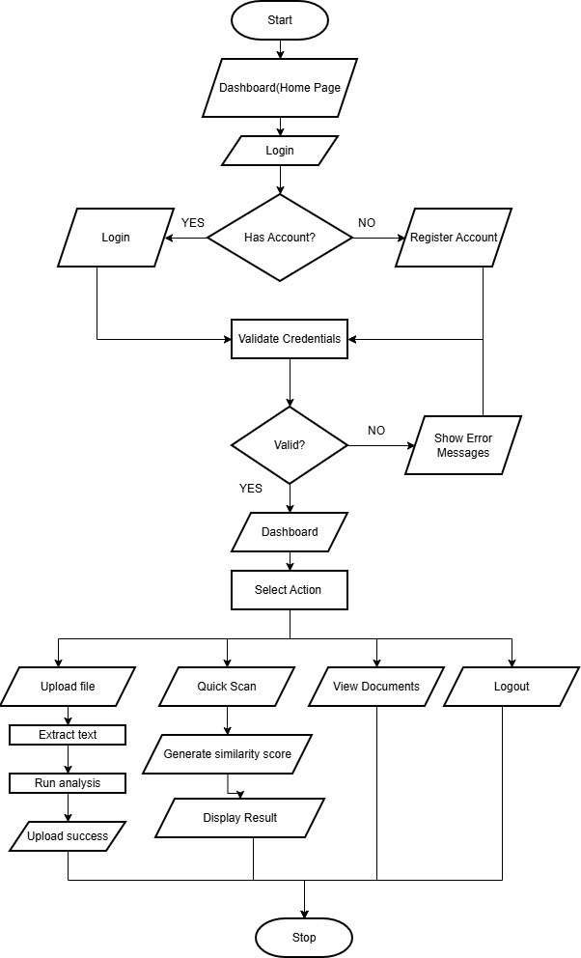
Figure 2. System flowchart diagram
The flowchart shows the system process from user login or registration to accessing the dashboard, where users can upload files, analyze documents, view records, or log out, ending the session.

