CHAPTER I
INTRODUCTION
This chapter presents the background of the study, purpose and description of the proposed system, statement of the problem, objectives, significance, and scope and delimitation. It introduces the need for a web-based academic repository that can store documents and check document similarity in a more organized and measurable way.
Project Context
Information technology has changed the way educational institutions manage academic documents and protect academic integrity. Web-based repositories are now used to store research outputs, organize documents, and make academic records easier to access. Plagiarism detection systems also help institutions check the originality of submitted works and support fair academic evaluation.
In many local academic institutions, document submission and plagiarism checking are still partly manual. Students submit research papers and other academic documents, while instructors or administrators check originality using separate tools or manual review. This process may take time and may produce inconsistent results because the documents are not stored and checked in one centralized platform.
Based on observation of the existing process, common problems include slow plagiarism checking, lack of a centralized repository, difficulty in detecting partial similarities, and limited access control. These problems may affect the quality of document management and the protection of academic integrity.
To address these problems, this study proposes an Academic Repository with Plagiarism Detection using TF-IDF and Cosine Similarity. The system is a web-based platform that allows academic documents to be uploaded, stored, analyzed, and monitored in a more organized and secure manner.
Purpose and Description
This study aims to design and develop a web-based academic repository with automated plagiarism detection. The purpose of the system is to improve academic document management and provide a simple way to check document similarity.
The system has three types of users: guest users, registered users, and administrators. Guest users can access limited information. Registered users can upload documents and check similarity results. Administrators can manage user accounts, uploaded documents, and plagiarism reports. The system uses secure authentication and access control to make sure that only authorized users can perform specific actions.
The plagiarism detection feature uses text extraction, TF-IDF, and cosine similarity. After a document is uploaded, the system extracts the text, computes word importance, compares the document with saved documents, and displays the similarity score and matched text.

Statement of the Problem
The current process of managing academic documents and checking plagiarism is still difficult because some tasks are done manually. Documents are not stored in one central place, checking originality takes time, and similar content is difficult to identify. This study seeks to answer the following questions:
1. What problems are encountered in the current process of managing and checking academic documents?
2. How can a web-based repository improve the storage, management, and retrieval of academic documents?
3. How can TF-IDF and cosine similarity be used to detect document similarity and support plagiarism checking?
OBJECTIVES
This section presents the goals of the proposed system. It describes the objectives of the study for the development of Academic Repository with Plagiarism Detection using TF-IDF and Cosine Similarity. There are two objectives, general objective and specific objectives.
General Objective
The general objective of this study is to design and develop a web-based academic repository with plagiarism detection using TF-IDF and cosine similarity for storing, managing, and checking academic documents.

Specific Objectives
- To conduct a comprehensive assessment of the current academic document management and plagiarism detection workflows to identify inefficiencies, security gaps, and technical limitations.
- To design and develop a secure, web-based repository capable of hosting academic documents, providing users with Scalable tools to upload, organize, and retrieve files in PDF, DOCX, and TXT formats.
- To integrate an intelligent similarity detection module utilizing text extraction, TF-IDF (Term Frequency-Inverse Document Frequency), and Cosine Similarity algorithms to quantify relatedness between academic works.
Significance of the Study
This study is significant to students because it gives them a convenient way to upload academic documents and check the originality of their work. The system can help students become more aware of proper academic writing and avoid possible plagiarism.
The study is useful to teachers because it reduces the time needed for manual checking. Through automatic similarity checking, teachers can review submitted documents more efficiently and focus more on evaluating the quality of the content.
The system is also helpful to administrators because it provides a centralized platform for monitoring users, documents, and plagiarism reports. This supports better document organization and strengthens academic integrity in the institution.
Future researchers may use this study as a reference for developing related systems involving document repositories, plagiarism detection, text mining, and similarity analysis. Student developers may also gain knowledge in web development, database design, and algorithm implementation.
Scope and Delimitation
The scope of this study focuses on the development of a web-based academic repository with plagiarism detection. The system allows users to register, log in, upload documents, extract text, check similarity, view results, and generate reports. It supports PDF, DOCX, and TXT file formats. The system uses TF-IDF to represent document terms and cosine similarity to compute similarity scores.
The study is limited to documents uploaded within the system database. It does not check the whole internet and does not use advanced artificial intelligence or deep learning models. The system also does not provide full multilingual plagiarism detection. Its accuracy depends on the quality of extracted text and the available documents stored in the repository.

CHAPTER II
REVIEW OF RELATED LITERATURE/SYSTEM TECHNICAL BAGROUND
This chapter presents the literature and studies related to academic repositories, plagiarism detection, web-based systems, and document similarity algorithms. These references support the development of the proposed system and show the importance of using digital tools in academic document management.
Related Literature
The academic repository is crucial in educational institutions as it offers a digital environment for the storage and organization of academic documents. These stores can be used to organize and manage research papers, reports, and other school documents for students, teachers and administrators.
A web-based repository is a repository that is accessible via a browser and is used to upload, search, retrieve and monitor documents rather than having them stored separately in folders and/or physical files.
The usefulness of digital repositories in education is related to teaching, learning and sharing documents. Aboraya (2022) described how digital repositories can be used in education to facilitate the dissemination of learning materials and enhance access to education resources.
This is relevant to the proposed system as the academic repository can act as a central storage for academic documents and research products.

Many schools continue to submit their academic documentation manually, and they still have to manually review it. This can lead to issues like lost files, delayed document retrieval, and submission tracking challenges.
These issues can be solved by storing files in a centralized system; thus, the centralized repository can help. It may additionally support administrators to track uploaded documents and take care of academic records extra efficiently.
Academic institutions have another worry about plagiarism. When a student takes words, ideas, or content from another source and fails to give credit to the source. According to Arabi and Akbari (2022), plagiarism is a problem in academic and research work and checking plagiarism manually is hard and time-consuming in the case of a large number of documents to compare.
This is to support the importance of an automated plagiarism detection system.
An academic plagiarism detection web-based academic repository can aid in the protection of academic integrity. It supports uploading of documents and similarity checking with documents in the system.
This type of system not only keeps the file but also assists the users in determining if there is any possibility of copied content. Due to this, the suggested system could enhance the management of documents as well as originality checking.
Related Studies
Davoodifard (2022) discussed automatic plagiarism detection using TF-IDF and cosine similarity. The study explained that many plagiarism detection methods use lexical features, TF-IDF, and similarity measures such as cosine similarity to find similarities between documents. This is directly related to the proposed system because it also uses TF-IDF and cosine similarity to compare uploaded documents with stored documents.
The same study stated that TF-IDF and cosine similarity are common methods in automatic plagiarism detection because they can quickly retrieve source documents that may match the suspicious document. This supports the proposed system because the uploaded document is converted into a vector, compared with existing documents, and given a similarity score.
Arabi and Akbari (2022) proposed plagiarism detection methods that use TF-IDF weighting together with other similarity techniques. Their study shows that plagiarism detection can be improved by comparing suspicious documents with source documents and analyzing similar text patterns. This supports the proposed system because it also follows the idea of comparing one uploaded document with existing stored documents.
Sari (2023) conducted a study on cosine similarity-based plagiarism detection for electronic academic documents. The study focused on identifying similarities in academic thesis documents. This is related to the proposed system because academic papers and research documents are also the main files being stored and checked in the repository.
Halim and Lasut (2024) developed a web-based document plagiarism detection application using TF-IDF and cosine similarity. Their study explained that the application processes documents through preprocessing, TF-IDF calculation, and cosine similarity calculation to produce percentage results. This is very similar to the proposed system because it also uses a web-based platform and produces similarity results after document comparison. The related studies show that TF-IDF and cosine similarity are useful methods for text-based plagiarism detection. These methods are simple, explainable, and suitable for academic document comparison. They are also easier to implement than advanced artificial intelligence models, making them appropriate for a student-developed web-based system.
System Technical Background
Web-Based System
A Web-based system is a program that is available to the user via a Web browser. It doesn't need to be installed on each machine as the main system is sent via the browser and server. The proposed system allows the user to register and login to the system, upload documents, view similarity results, and view the report, all via a browser.

An academic repository is ideal for this type of system as students, teachers and administration have access to the system from various devices. It also simplifies document management, as documents are kept in a single repository. This helps in quicker retrieval, monitoring and reports generation.
HTML, CSS, and JS
The technologies employed in the development of the user interface of the system are: HTML, CSS and JavaScript. Content is organized into web pages using HTML, web pages are designed using CSS, and interaction and system functions are added using JavaScript. These technologies are used to build pages like the landing page, Log in page, dashboard, upload page, and similarity result page.
The proposed system can also use JavaScript to validate forms, interact with files, and communicate with the back-end server. This enhances the system responsiveness and easier system to use for students, teachers and administrators.
Database and Storage
The system can use database to store data and as the database. database features authentication, databases, and file storage. database documentation says this: "RLS provides a way to secure data access, particularly when data is accessed by the browser.

database Storage allows uploading of files like images, documents, pdfs, and more. It can also be used to control access to stored files with Row Level Security policies. Useful for the proposed system as it is necessary to protect the uploaded academic documents and to allow access to them only by the authorized users.
The proposed system can store user details, uploaded documents, extracted text, similarity scores, matched text, and plagiarism reports in database. This reinforces the importance of having an organized and centralized repository for academic documents.
Upload documents and files.
File upload is one of the key features of the system because users have to upload academic documents to be stored and compared for similarity. With the File API, web apps can work with files when the user chooses them via the file input or drag-and-drop functionality. This helps to support the document upload feature of the proposed system.
The Form Data interface also has a use in web applications that enable the sending of form values and files to the server through web requests. The reason for this is the proposed system requires uploading PDF, DOCX or TXT documents to the backend to be extracted, checked and transferred from the browser.

Text Extraction
The task of extracting readable text from a document uploaded file is called Text Extraction. This process is required for the proposed system to be able to conduct plagiarism checking. The system validates the file format, reads the content of the document and extracts the text, cleans the text, and prepares it for analysis.
The function of text extraction is that raw PDF or DOCX files cannot be directly compared by TF-IDF and cosine similarity. The system needs to extract the document into plain text first. Once they have been extracted, the text can be separated into words and compared to other text documents stored.
TF-IDF Algorithm
TF-IDF is the acronym for Term Frequency-Inverse Document Frequency. It is used for determining the significance of a word in a document. High values may be assigned to words that have a high frequency in one document but are not frequent in many other documents. The lower values typically apply to common words.
In the proposed system, the document text is first converted into numbers by means of tf-idf. These values are the significance of the terms in the document. On completion of this process, the document can be compared with other documents using cosine similarity.

TF-IDF is important because it allows for the documents to be compared in a more measurable way. The system does not just compare to see if two documents contain the same words, but it also compares to see how important the words are to the document collection. This enables to get a more meaningful similarity result from the system.
Cosine Similarity Algorithm
Cosine similarity is a technique to determine the similarity between two documents in terms of their vector values. Plagiarism Detection: Each document can be represented as a vector with the TF-IDF values. Cosine similarity score is used to determine the closeness and relation between two document vectors.
The document uploaded is compared with the stored documents in the database in the proposed system. In the case where the cosine similarity score is high, it indicates that the document uploaded is highly similar to an existing document. The lower the score, the less similar the documents are.
Cosine similarity is a good choice for the proposed system because it gives a numerical similarity score. This score may be shown to the user as a score or percentage score. It can also be used by the administrator and teacher to check on the matched text to determine if there is a possible plagiarism in the document.
Synthesis
The literature reviewed and studies conducted reveal that academic repositories assist educational institutions to store, organize, and manage academic documents. They make the retrieval of documents easier and facilitate the monitoring of academic outputs. It is an advantage to the proposed system as it will be designed to centrally store and maintain academic documents.
The reviewed studies also demonstrate that plagiarism detection is significant for ensuring Academic Integrity. Manual checking is tedious and might not find all the similarities, particularly if you have numerous documents to compare. As a result, automated tools are required to more quickly and reliably find potential instances of copied content.
Text-based plagiarism detection can be effectively done using TF-IDF and cosine similarity. TF-IDF can be used to determine which words are more significant in a document and cosine similarity indicates the similarity between two documents. These are the methods that are appropriate for the proposed system because they are simple, measurable and explainable.
The reviewed literature, studies, and technical background confirmed that there is a gap in manual academic document management and manual plagiarism checking which the Academic Repository with Plagiarism Detection can help fill. It includes an integrated system for storing documents, extracting text, computing TF-IDF, similarity checking, display of similarity results, and report generation on a web platform.

CHAPTER III
METHODS
This chapter presents the methods used in the development of the Academic Repository with Plagiarism Detection. It includes the development model, data gathering process, requirements analysis, system design, algorithms, implementation, and testing procedure.
Model / SDLC
The system uses the Agile Software Development Life Cycle (SDLC) model. Agile was selected because it allows the proponents to develop the system step by step and improve the system based on testing and feedback. Each module is designed, developed, tested, and improved before moving to the next feature.
The Agile model is suitable for this study because the system includes several modules such as user registration, login, document upload, text extraction, plagiarism checking, result viewing, and admin management. These modules can be developed and tested in small parts.
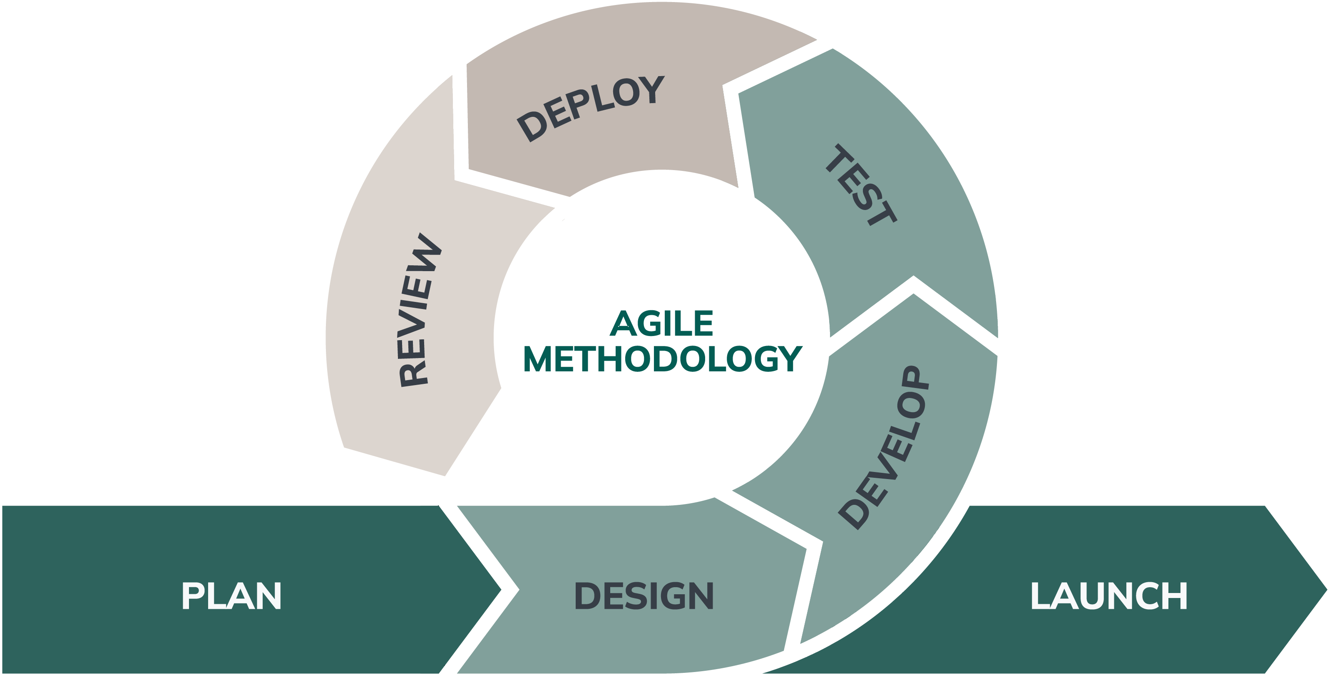
Figure 1. Agile SDLC Model
Figure 1 shows the Agile SDLC model used in the development of the system. It presents the process from planning, data gathering, design, development, testing, deployment, and maintenance.
The development steps are:
Planning
The system and the users of the system. The users include the students, teachers and administrators. Issues with the current system were also identified. A plan was developed to develop the system.
Data Gathering
The proponents interviewed students and teachers to find out their issues and needs. They also did some observations on how the documents are submitted and verified. This gave them an idea of what to include in the system.

Design
During this phase, the proponents made the system design. This covers the database, system flow and user interface. Basic diagrams were drawn to illustrate the user interface and user interactions.
Development
Each module such as logging in, file upload and plagiarism check was developed separately. The parts were then joined to make the system.
Testing
The proponents tested all the features to ensure that they are functional. Problems were detected and solved. The system was tested repeatedly to ensure that it is safe and easy to use.
Deployment
The system was tested and then put out for use. It was posted so users can access it via a browser. So, the system can be used by users.
Maintenance
The system is tracked after it is deployed. Bugs can be resolved, and additional features can be added. The system can be upgraded to enhance efficiency and effectiveness.
Data Gathering
Data gathering was conducted at College of Computer Studies at Sulu State University to understand the existing process of academic document submission and plagiarism checking. The researcher used interviews, observation, and document review to identify the problems and system requirements.
Interviews were conducted with students and teachers to know how academic documents are submitted, stored, and checked. The responses helped identify the need for a faster and more organized system.
Observation was also done to understand the current manual process. The proponents observed that document submission and checking can be time-consuming when there is no central repository.
Document review was used to examine sample academic files and existing forms or records. This helped the proponents identify the needed data fields, file types, and reports for the proposed system.
Requirements Analysis
After gathering information, the researcher analyzed the needs of the users and the problems in the existing process. The main problems identified were the lack of a centralized document repository, slow plagiarism checking, difficulty in comparing documents, and limited monitoring of academic submissions.
The functional requirements describe what the system must do. These include user registration, login, document upload, text extraction, similarity checking, result display, and admin management. The non-functional requirements describe how the system should perform. These include security, usability, reliability, speed, and accessibility through a web browser.

Requirements Documentation
The requirements documentation presents the functional and non-functional requirements of the system. These requirements serve as a guide for the development and testing of the proposed system.
Table 1. Functional Requirements
Req. No | Requirement Description | Priority
FR-01 | The system shall allow users to register an account. | High
FR-02 | The system shall allow users to log in securely. | High
FR-03 | The system shall allow users to upload PDF, DOCX, and TXT documents. | High
FR-04 | The system shall extract text from uploaded documents. | High
FR-05 | The system shall compute TF-IDF values from extracted text. | High
FR-06 | The system shall compare documents using cosine similarity. | High
FR-07 | The system shall display similarity score and matched text. | High
FR-08 | The system shall allow administrators to manage users, documents, and reports. | High

Table 2. Non-Functional Requirements
Req. No | Requirement Description | Priority
NFR-01 | The system shall be easy to understand and use. | High
NFR-02 | The system shall protect user accounts and uploaded documents. | High
NFR-03 | The system shall be accessible through modern web browsers. | High
NFR-04 | The system shall process documents within a reasonable time. | Medium
NFR-05 | The system shall store and retrieve records reliably. | High
NFR-06 | The system shall be maintainable for future improvements. | Medium

Table 3. User Roles and Access Rights
User Role | Access Rights
Registered User | Can register, log in, upload academic documents, check document similarity, and view the similarity results of their own uploaded documents.
Administrator | Can manage user accounts, monitor uploaded documents, view similarity reports, manage system records, and generate reports.

Design of Software, Systems, Product, and/or Processes
This section presents the design of the proposed Academic Repository with Plagiarism Detection. It includes the conceptual framework, system components, system process flow, and user interface process.
Conceptual Framework
The conceptual framework follows the Input-Process-Output (IPO) model. The input includes user credentials and uploaded documents. The process includes text extraction, TF-IDF computation, cosine similarity checking, and report generation. The output includes similarity score, matched text, plagiarism report, and stored document records.
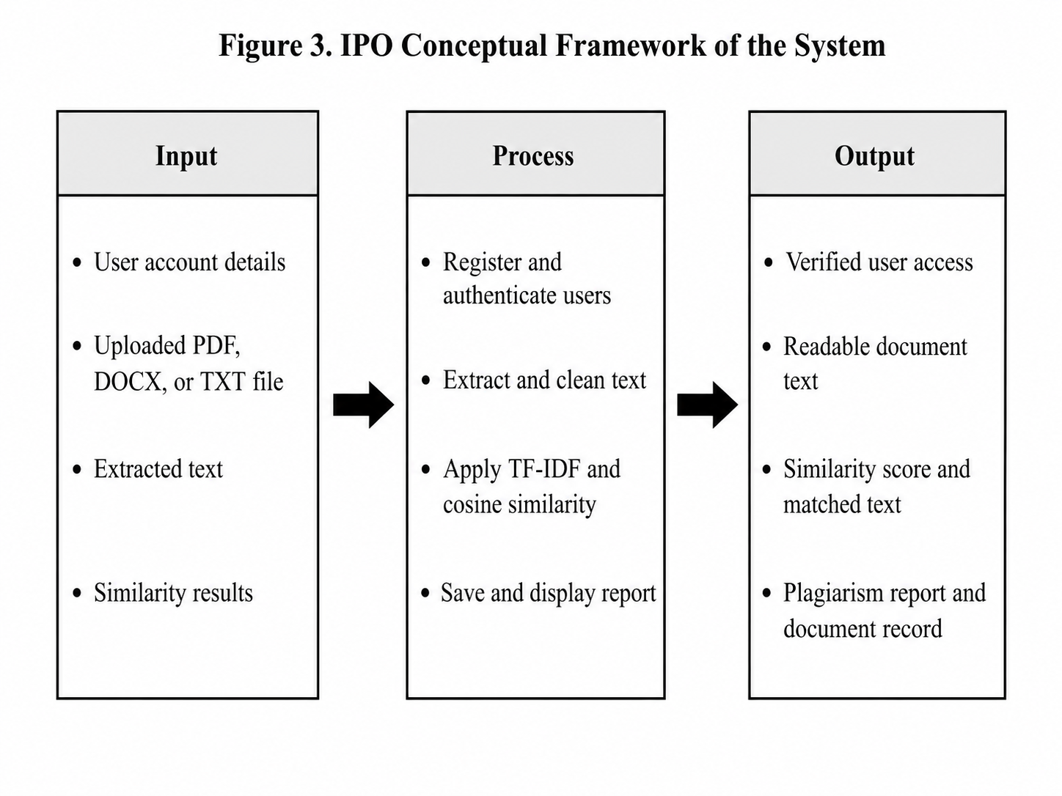Figure 2. IPO Conceptual Framework of the System

Detailed Design
The system is designed with three main layers: presentation layer, application layer, and data layer. These layers work together to provide the complete function of the system.
The presentation layer contains the web pages used by the users and administrators. The application layer contains the backend logic for validation, document processing, TF-IDF computation, and cosine similarity checking. The data layer stores user accounts, documents, extracted text, and plagiarism results.
Table 4. System Components
Component | Description
Frontend | Displays the web pages used by guest users, registered users, and administrators.
Backend | Handles file upload, text extraction, TF-IDF computation, cosine similarity, and API requests.
Database | Stores user accounts, documents, extracted text, and similarity reports.
Authentication | Protects user access through secure login and role-based permissions.

System Architecture Diagram
The system architecture for Academic Repository with Plagiarism Detection System is illustrated in Figure.
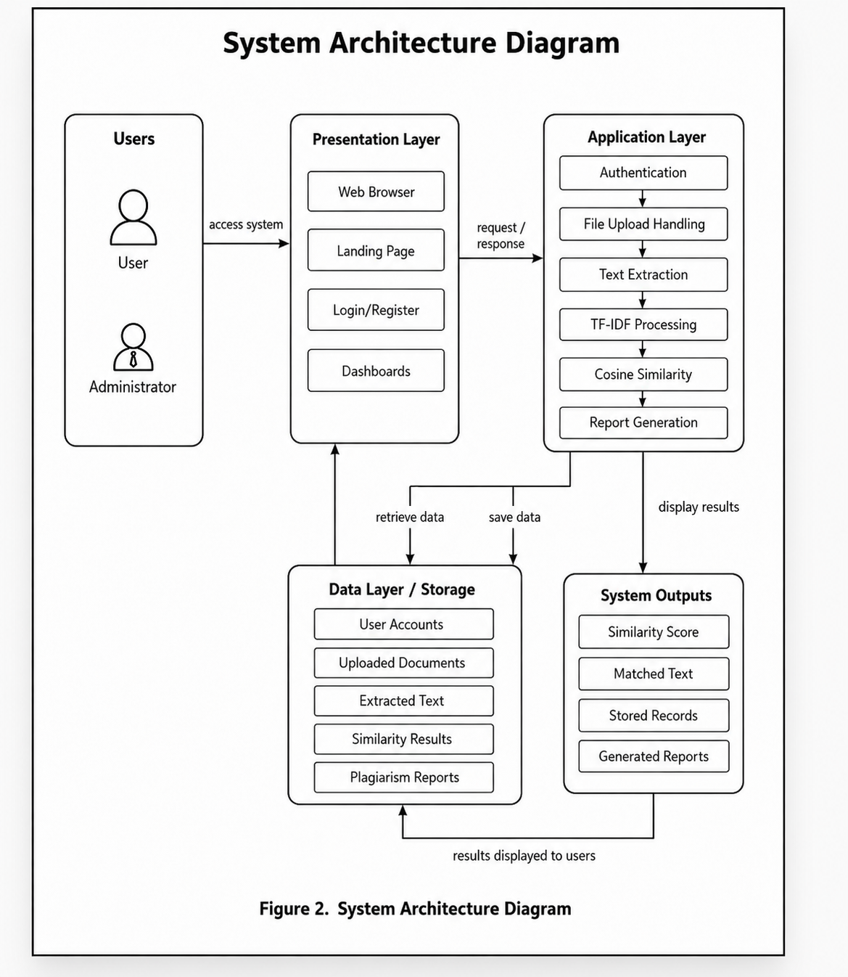
Figure 3. system achitecture Diagram
The system architecture of Academic Repository with Plagiarism Detection System is shown in Figure 2. A web browser is used to open the system by the User and the Administrator.
The presentation layer displays the pages of the system including the landing page, login/register page and dashboards.
The main process of the application layer is: user login check, file upload, text extraction, TF-IDF process, cosine similarity check, report creation.
The data layer stores the user accounts, uploaded documents, extracted text, similarity results, and plagiarism reports. Once completed, the system shows users the similarity score, matched text, records in the system and generates reports.
Admin Account Flowchart
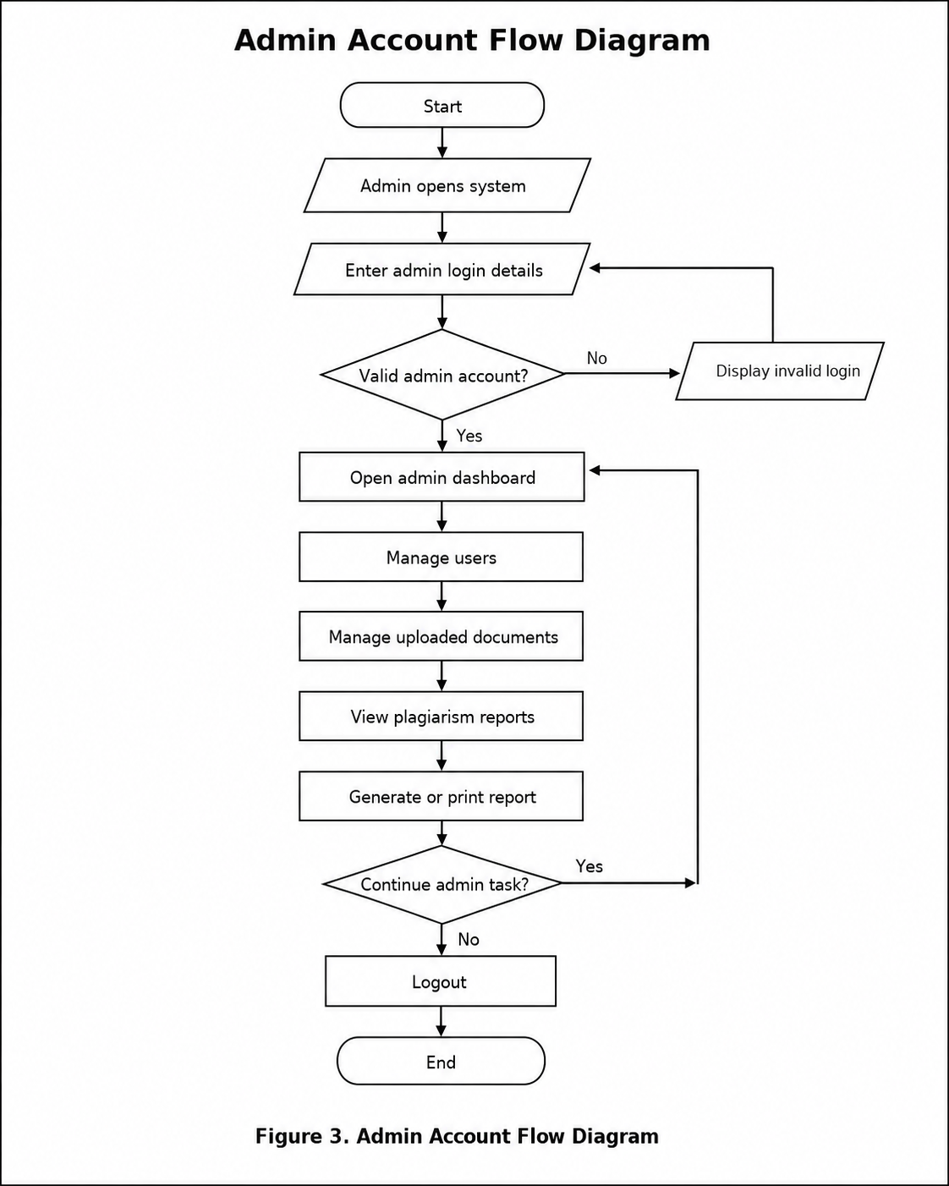
Figure 4. Admin Account Flowchart
The administrator logs in to the system and enters the admin login information. The system verifies whether the admin account is valid or not.
If it is not a valid login password, the system will show invalid login and request the admin to log in again. When the login is successful, the admin dashboard will appear.
The administrator can control users, control documents uploaded, view plagiarism reports and create or print reports. Once the task is completed, the admin may select to continue with another task or log out to end the process.
User Account Flowchart
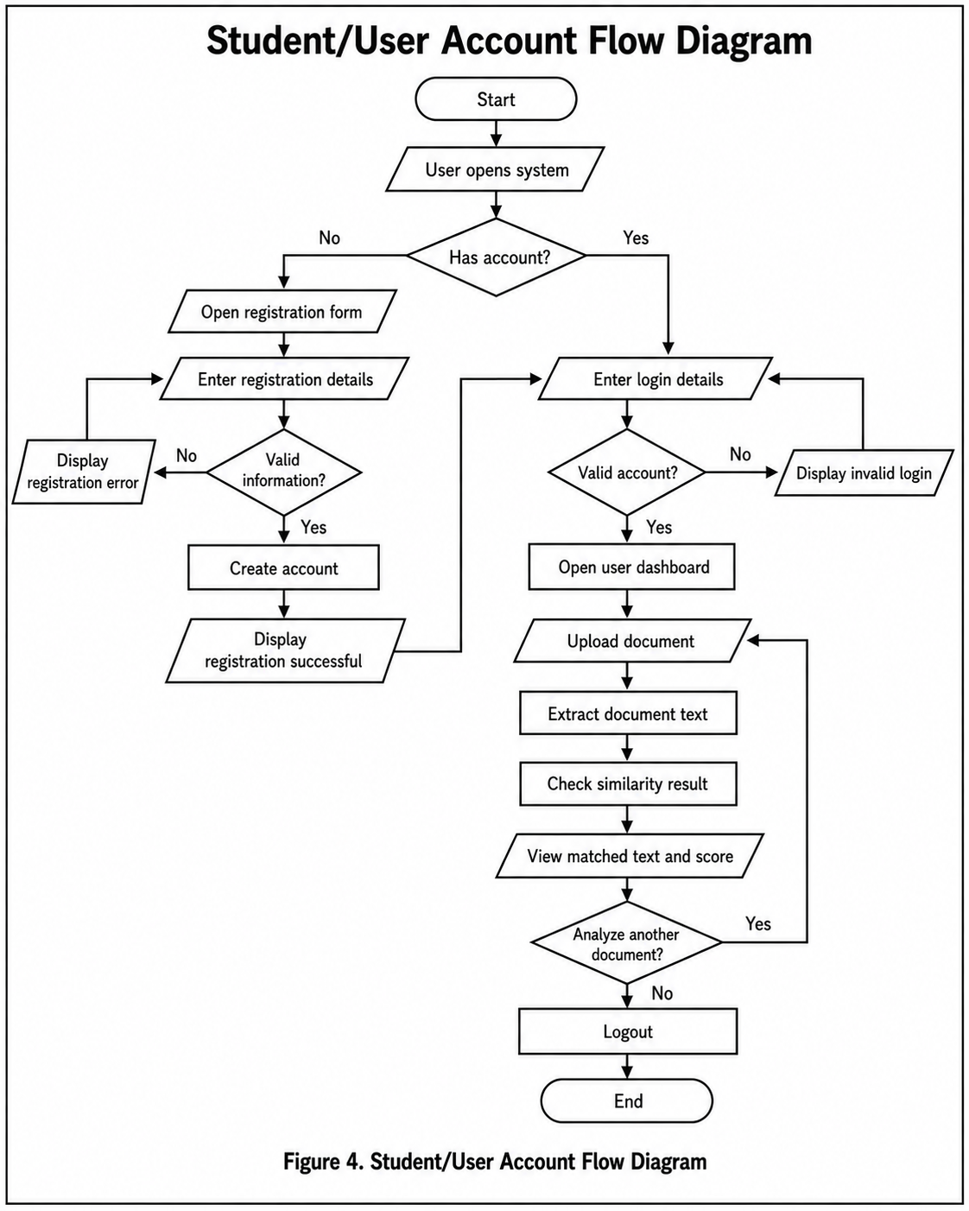
Figure 5. Student/User Account Flowchart
This process begins when user opens the system. System checks to see if user has an account. If a user does not have an account, then the user is presented with a user registration form. The user inputs the registration information, and the system verifies the information. When information is not valid, the system will show a registration error. If the information is correct, the system is able to generate the account and display a success message. Then the user can type in the log in information.
If user has already an account, the user will enter the credentials directly. The system verifies whether the account is valid or not. In case of an invalid login, an invalid login message is displayed. If the login is correct then the user's Dashboard appears.
The user can then upload a document, extract the document text, check the similarity result and see matched text and score. If the user wishes to analyze another document, it starts over with document upload. Otherwise, the user logs out and the procedure is terminated.

System Process Flowchart
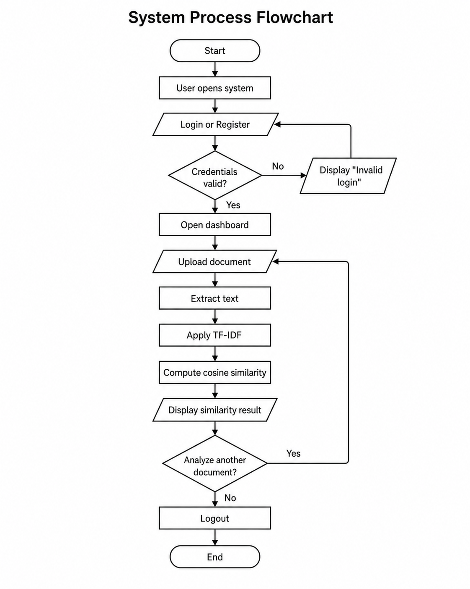
Figure 6. System Process Flowchart
This figure shows overall process of the system. The user first logs in or registers an account in the system. If the username and/or password are not correct, an invalid login message is displayed. Once the login is successful, the user can open the dashboard then upload a document.
The system reads the text, calculates its TF-IDF and cosine similarity. Once this is done, the system shows the similarity results. The user can analyze another document, or log out to finish.
Text Extraction Algorithm
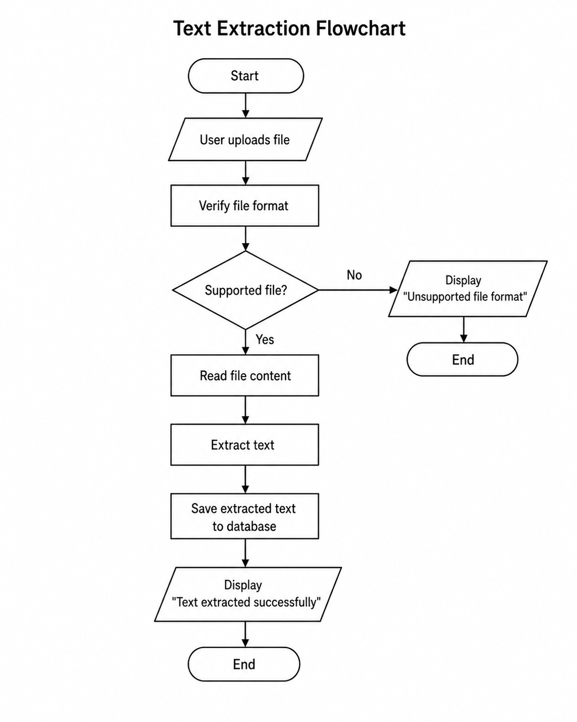
Figure 7. Text Extraction Flowchart
This figure shows the Text extraction process of getting readable text from an uploaded document. When the user uploads a file, the system checks the file type. If the file is valid, the system reads the document, extracts the text, cleans the text, and saves it in the database for plagiarism checking.
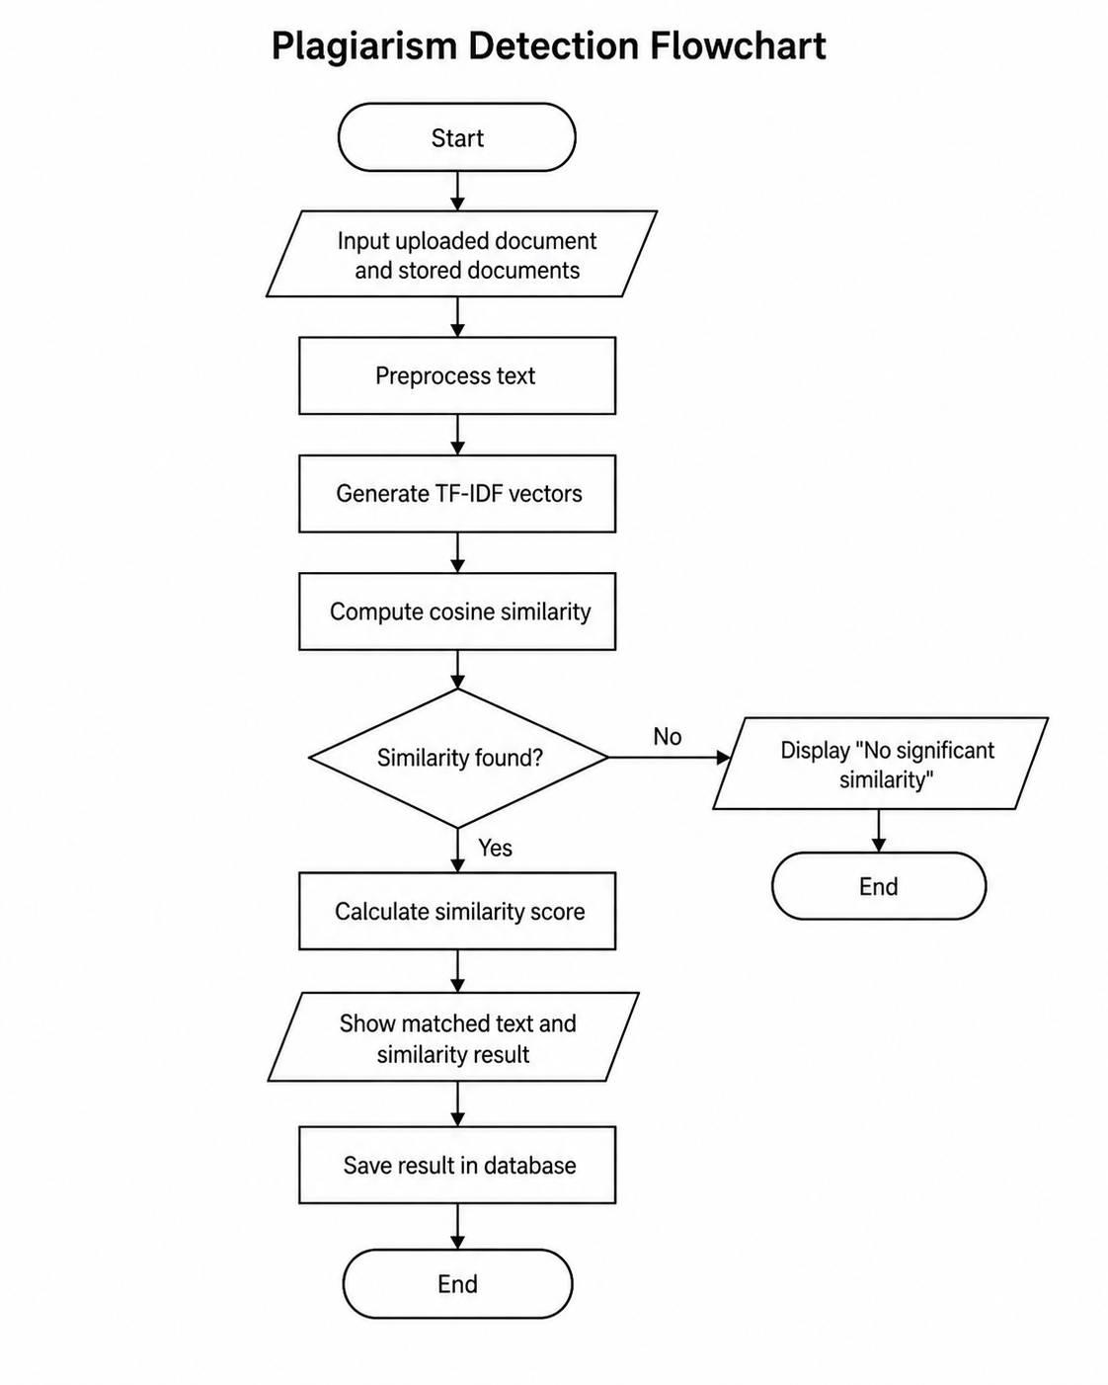
Figure 8. Plagiarism Detection Algorithm Flowchart
This figure shows the plagiarism detection process of the system. The process begins with the user uploading a document and then also searching the documents in the database that are stored.
The TF-IDF vectors are computed on a cleaned and prepared text. Once this, cosine similarity is calculated to compare the uploaded document with the existing documents.
No similarity will be displayed if no similarity is found. When similarity is detected, the system will calculate the similarity score, display the matched text and result, and store the result in the database.
Algorithms
The system uses text extraction, TF-IDF, and cosine similarity algorithms. These algorithms allow the system to read document content, identify important words, and compute the similarity between documents.
TF-IDF Algorithm
TF-IDF means Term Frequency-Inverse Document Frequency. It is used to determine the importance of a word in a document. Common words receive lower values, while important or rare words receive higher values. The formula is:
TF-IDF = TF x IDF
TF refers to how often a word appears in a document. IDF refers to how important or rare the word is across all documents. The system uses the TF-IDF result to create a document vector for comparison.
Cosine Similarity Algorithm
Cosine similarity measures how similar two documents are based on their TF-IDF vectors. The result ranges from 0 to 1. A score closer to 0 means the documents are less similar, while a score closer to 1 means the documents are more similar.
Cosine Similarity = (A · B) / (|A| x |B|)
In this system, the uploaded document is compared with the documents stored in the database. The system calculates the similarity score and displays the matched content to the user.
User Interface Design
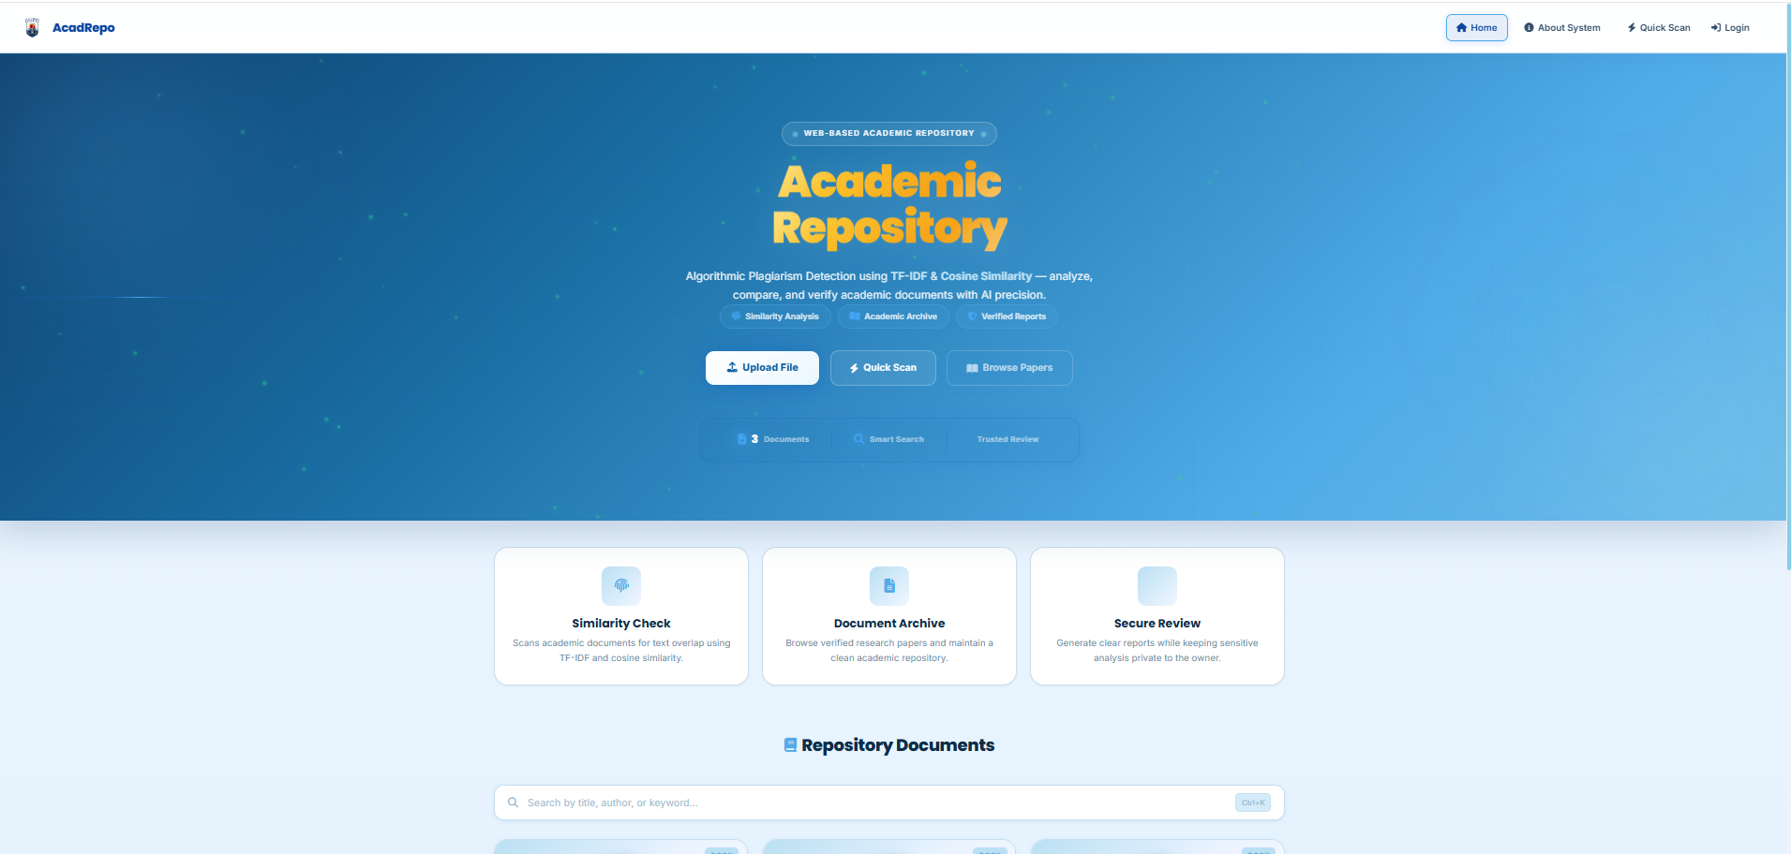
Plate 1. Main Dashboard of the System
The design of the user interface displays the real screens of the Academic Repository and Plagiarism Detection System. These screenshots demonstrate the way the users interact with the system, such as the login page, dashboard, document upload page, similarity checking page and the admin dashboard. The interface was made to be simple, clear and easy to use.

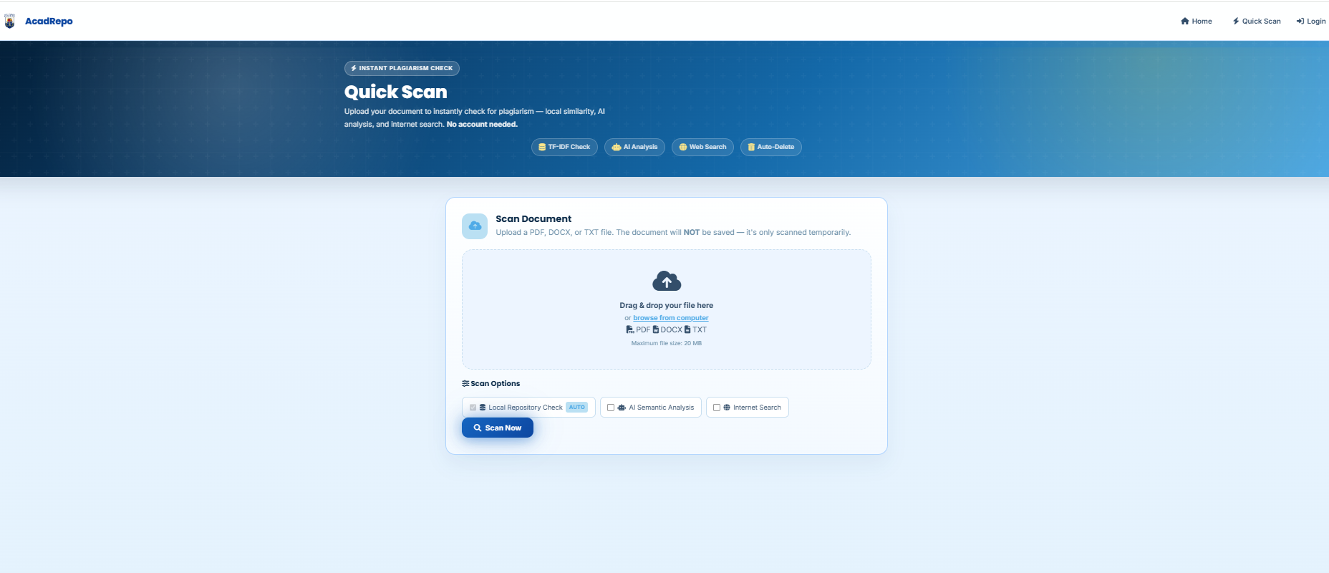
Plate 2. Quick Scan Page
The Quick Scan page of the system is displayed in Plate 2. On this page, users will be able to upload a document and scan it for plagiarism. Popular academic documents like PDF, DOCX and TXT can be handled by the system. The user can drag n drop the file or browse the file from the computer.
This page also shows scanning options like "Check local repository," "Check semantic context with AI" and "Search on internet. Once they have chosen the required option they can click on the Scan Now button to begin the checking process. This screen is significant because it is the first point in the plagiarism checking process.
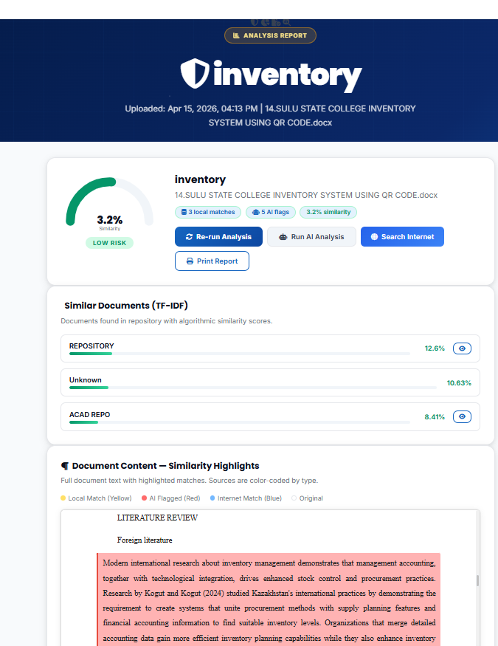
Plate 3. Analysis Report Page
The plagiarism analysis report. This is the output of the document check procedure. It displays the similarity percentage, risk level, number of local matches, AI flags, and similar documents in the repository.
Highlighted matched content are also displayed in the document. This helps users easily identify which parts of the document may have similarity with other sources. There are also buttons to re-run the analysis, use AI analysis, search the internet and print the report on the page. The significance of this page is that it provides an unambiguous outcome of the plagiarism checking procedure to the user, and lets the user see it for themselves.
Capstone Element
Software Requirements and Development
The following software tools are used to develop and run the proposed system.
Table 5. Software Requirements
Software / Tool | Purpose
HTML5 | Used for creating the structure of web pages.
CSS3 | Used for designing the system interface.
JavaScript | Used for client-side functions and interaction.
Node.js / Backend API | Used for server-side document processing and system logic.
Supabase / Database | Used for storing users, documents, extracted text, and results.
Visual Studio Code | Used as the code editor during development.
Web Browser | Used to access and test the web application.

Implementation
The system is implemented as a web-based application that can be accessed through a browser. Users can register, log in, upload documents, and view plagiarism checking results.
When a document is uploaded, the system extracts the text and stores it in the database. The system then applies TF-IDF to represent the document and uses cosine similarity to compare it with other saved documents.
The administrator module allows the admin to view users, uploaded documents, and similarity results. This helps the institution manage academic documents in one centralized system.
Testing and Validation
Testing was conducted to check if the system functions work correctly. Each major feature was tested using input and expected output. The testing helped determine whether the system meets the identified requirements.
Table 6. Testing and Validation Results
Test Case | Expected Result | Actual Result | Status
User Registration | User can create an account. | Account created successfully. | Passed
Login | User can log in using valid credentials. | User logged in successfully. | Passed
Upload Document | User can upload a valid file. | File uploaded successfully. | Passed
Text Extraction | System extracts text from the file. | Text extracted successfully. | Passed
Similarity Checking | System computes and displays similarity result. | Result displayed correctly. | Passed
Admin Dashboard | Admin can view users, documents, and reports. | Records displayed successfully. | Passed
Logout | User can exit the system. | User logged out successfully. | Passed

Based on the testing results, the system meets the main requirements of the study. It can store documents, extract text, compute similarity, display results, and support administrator monitoring. The system also improves the existing process by centralizing academic documents and making plagiarism checking faster and easier.

CHAPTER IV
RESULTS AND DISCUSSION
The results of the development, implementation and testing of the Academic Repository with Plagiarism Detection using TF-IDF and Cosine Similarity is presented in this chapter. It covers the important functions of the developed system, functional testing results, and functional testing performance of the system.
The information in this chapter is based on the features that were implemented and testing activities that were carried out by the proponents. Some of the limitations encountered while testing the system are also taken into consideration in the discussion. The system was designed so that there is a central place to store academic documents and help people to verify the similarity of documents uploaded to the system with documents stored in the system.
System Implementation
The Academic Repository with Plagiarism Detection has been developed as a Web based system to be accessed by a web browser. The system offers various functions for the registered users and system administrators. Main functions are account registration, log in, document upload, text extraction, similarity checking, viewing of results and administrative monitoring.
The system was built using HTML5, CSS3, JavaScript, Node.js/Backend API, Database and Visual Studio Code. The technologies were selected, as mentioned in Chapter III, as the significant software needs in the development.
System design presented in the previous chapter was followed for implementation. The user enters the system via a web browser, and logs in or registers a user account. Once the user has been authenticated, he/she will be able to view the dashboard and upload an academic document. The uploaded document is fed into the system and then the text of the document is extracted and similarity analysis is conducted.
The outcome of the major system modules is presented in 4.2 Results of Major System Modules.
4.2.1 User Registration and Login
The registration and login module enables the user to register and log in with the credentials. The system validates the user credentials and if they are incorrect, it will alert the person. Test results indicated that the process of registration and log on was functioning as intended.
4.2.2 Document Upload
The document upload module lets users upload PDF, DOCX and TXT documents. Uploaded document(s) are kept within the system and applied to the similarity checking. Successful upload of valid documents was determined by testing.

4.2.3 Text Extraction
The text extraction module gets the readable text from uploaded documents. The text obtained is pre-processed for similarity check by using TF-IDF and cosine similarity. The documents tested were found to have successfully extracted text.
4.2.4 Similarity Checking
Similarity checking module is used to compare the uploaded document with documents in the repository using TF-IDF and cosine similarity. Similarity result is shown in the system after the comparison. The result of the similarity can be calculated and displayed in the system.
4.2.5 Analysis Report
The similarity percentage, matched content and similar documents found in the repository are displayed in the analysis report. This enables the user to see the outcome of the checking of the document. But result is based upon documents contained in repository.
4.2.6 Administrator Dashboard
Administrator Dashboard displays similarity, users and uploaded documents. The necessary records were presented during the test and the test was successful. These records can be utilized by the administrator to keep an eye on the system and assess the similarity outcomes.

4.3 Functional Testing Results
Functional testing was performed to determine whether the major functions of the system produced the expected results. The tests focused on user registration, login, document uploading, text extraction, similarity checking, administrator dashboard access, and logout.
Table 7 presents the functional testing results based on the documented testing activities.
Test Case | Expected Result | Actual Result | Status
User Registration | User can create an account. | Account was created successfully. | Passed
Login | User can log in using valid credentials. | User logged in successfully. | Passed
Upload Document | User can upload a valid document. | File was uploaded successfully. | Passed
Text Extraction | System extracts text from the uploaded file. | Text was extracted successfully. | Passed
Similarity Checking | System calculates and displays a similarity result. | Similarity result was displayed. | Passed
Admin Dashboard | Administrator can view users, documents, and reports. | Records were displayed successfully. | Passed
Logout | User can exit the system. | User was logged out successfully. | Passe
Table 7. Functional Testing Results

CONCLUSION AND RECOMMENDATION
Conclusion
The study was able to successfully create an Academic Repository containing TF-IDF and Cosine Similarity for the Plagiarism Detection. The system offers a web-based interface to register, login and upload academic documents and get information about document similarity.
The major functions of the system were tested and it was found that the registration and login of the user, uploading of documents, extraction of text, similarity checking, analysis report, and monitoring of the administrator have been functioning during the testing period.
The system facilitates the organization of academic documents within one repository as well as a quick way of identifying possible similarities between documents. The similarity result should, however, be presented only as a "guide" since the system primarily compares documents that are in the repository. Does not ensure that all plagiarism is discovered.

In general, the developed system is able to fulfill the primary objectives, and can be used as a basic system for academic document management and similarity checking.

Recommendation
The findings and restrictions of the study are discussed and the following are recommended
- The system can be evaluated with further number of users and academic documents to test the performance of the system once again.
- The similarity checking capability could be expanded to cover additional kinds of documents and various document text formats.
- Other security testing may be performed to further secure user accounts and uploaded academic documents.
- TF-IDF and cosine similarity may be complemented with other advanced similarity detection methods to enhance the system.
- The researchers in the future can extend this work by integrating internet-based checking or other external sources to have a better coverage of similarity detection.
- In the future, student feedback, teacher feedback, and administrator feedback can be used to further enhance the user interface and further add features to the program.

REFERENCES
Aboraya, W. (2022). Exploring the need for using digital repositories to enhance teaching and learning in Omani schools: Teachers’ perceptions. International Journal of Learning, Teaching and Educational Research, 21(5). DOI: 10.26803/ijlter.21.5.1.
Arabi, H., & Akbari, M. (2022). Improving plagiarism detection in text document using hybrid weighted similarity. Expert Systems with Applications, 207, 118034. DOI: 10.1016/j.eswa.2022.118034.
Cauilan, B. P. (2025). Assessment of open access policies in institutional repositories. Philippine E-Journals.
Chang, C. Y., et al. (2021). Using word semantic concepts for plagiarism detection in text documents. Information Retrieval Journal. DOI: 10.1007/s10791-021-09394-4.
Davoodifard, M. (2022). Automatic detection of plagiarism in writing. Studies in Applied Linguistics and TESOL, 21(2), 54–60. DOI: 10.52214/salt.v21i2.9058.
El-Rashidy, M. A., et al. (2024). An effective text plagiarism detection system based on feature selection and SVM techniques. Multimedia Tools and Applications. DOI: 10.1007/s11042-023-15703-4.

Halim, J., & Lasut, D. (2024). Document plagiarism detection application using web-based TF-IDF and cosine similarity methods. bit-Tech, 7(2), 202–213. DOI: 10.32877/bt.v7i2.1697.
Sari, L. P. (2023). Cosine similarity-based plagiarism detection on electronic documents. Journal of Computer Science Application and Engineering, 1(2), 44–48. DOI: 10.70356/josapen.v1i2.14.
Setu, D. M., et al. (2025). A comprehensive strategy for identifying plagiarism in academic submissions. Journal of Umm Al-Qura University for Engineering and Architecture. DOI: 10.1007/s43995-025-00108-1.
Yalcin, K., et al. (2022). An external plagiarism detection system based on part-of-speech tag n-grams and word embedding. Expert Systems with Applications.

APPENDICES
Relevant Source Code
Home page(index)
<!DOCTYPE html>
<html lang="en">
<head>
<meta charset="UTF-8" />
<meta name="viewport" content="width=device-width, initial-scale=1.0" />
<title>Academic Repository — Browse Documents</title>
<link rel="stylesheet" href="css/style.css" />
<link href="https://fonts.googleapis.com/css2?family=Poppins:wght@400;500;600;700;800;900&family=Inter:wght@400;500;600;700&display=swap" rel="stylesheet">
<link rel="stylesheet" href="https://cdnjs.cloudflare.com/ajax/libs/font-awesome/6.5.0/css/all.min.css" />
<link rel="preconnect" href="https://fonts.googleapis.com" />
<link rel="preconnect" href="https://fonts.gstatic.com" crossorigin />
<link href="https://fonts.googleapis.com/css2?family=Inter:wght@400;500;600;700;800;900&display=swap" rel="stylesheet" />
</head>
<body>

<!-- ===== NAVBAR ===== -->
<nav class="navbar">
<div class="nav-brand">
<img src="img/SSC_logo.png" alt="Sulu State University" />
<span>AcadRepo</span>
</div>
<button class="hamburger" id="hamburger" aria-label="Toggle menu">
<i class="fas fa-bars"></i>
</button>
<ul class="nav-links" id="navLinks">
<li><a href="index.html" class="active"><i class="fas fa-home"></i> Home</a></li>
<li><a href="about.html"><i class="fas fa-circle-info"></i> About System</a></li>
<li id="navAuthLinks"></li>
</ul>
</nav>

<!-- ===== HERO ===== -->
<header class="hero hero-enhanced">
<canvas id="heroCanvas"></canvas>
<div class="hero-orb hero-orb-1"></div>
<div class="hero-orb hero-orb-2"></div>
<div class="hero-orb hero-orb-3"></div>
<div class="hero-content">
<div class="hero-badge">
<span class="hero-eyebrow-dot"></span>
<span>Web-Based Academic Repository</span>
<span class="hero-eyebrow-dot"></span>
</div>
<h1 class="hero-title">
<span class="hero-title-line">Academic</span>
<span class="hero-title-line hero-title-accent">Repository</span>
</h1>
<p class="hero-desc">Algorithmic Plagiarism Detection using <strong>TF-IDF</strong> &amp; <strong>Cosine Similarity</strong> &mdash; analyze, compare, and verify academic documents with AI precision.</p>
<div class="hero-feature-pills">
<span class="hero-pill"><i class="fas fa-fingerprint"></i> Similarity Analysis</span>
<span class="hero-pill"><i class="fas fa-book-open"></i> Academic Archive</span>
<span class="hero-pill"><i class="fas fa-shield-halved"></i> Verified Reports</span>
</div>
<div class="hero-actions">
<a href="login.html" class="btn hero-btn-primary btn-glow" id="heroUploadBtn">
<i class="fas fa-upload"></i> Upload File
</a>
<a href="quick-scan.html" class="btn hero-btn-secondary">
<i class="fas fa-bolt"></i> Quick Scan
</a>
<a href="#browseSection" class="btn hero-btn-ghost">
<i class="fas fa-book-open"></i> Browse Papers
</a>
</div>
<div class="hero-stats-bar">
<div class="hero-stat-item" id="heroStatDocs">
<i class="fas fa-file-alt"></i>
<span class="hero-stat-num-sm">&mdash;</span>
<span class="hero-stat-lbl">Documents</span>
</div>
<div class="hero-stat-sep"></div>
<div class="hero-stat-item">
<i class="fas fa-magnifying-glass"></i>
<span class="hero-stat-lbl">Smart Search</span>
</div>
<div class="hero-stat-sep"></div>
<div class="hero-stat-item">
<i class="fas fa-shield-check"></i>
<span class="hero-stat-lbl">Trusted Review</span>
</div>
</div>
</div>
</header>

<!-- ===== MAIN CONTENT ===== -->
<main class="container" style="max-width:1200px;" id="browseSection">

<section class="feature-strip" aria-label="Platform highlights">
<div class="feature-card">
<div class="feature-icon"><i class="fas fa-fingerprint"></i></div>
<h3>Similarity Check</h3>
<p>Scans academic documents for text overlap using TF-IDF and cosine similarity.</p>
</div>
<div class="feature-card">
<div class="feature-icon"><i class="fas fa-file-lines"></i></div>
<h3>Document Archive</h3>
<p>Browse verified research papers and maintain a clean academic repository.</p>
</div>
<div class="feature-card">
<div class="feature-icon"><i class="fas fa-shield-check"></i></div>
<h3>Secure Review</h3>
<p>Generate clear reports while keeping sensitive analysis private to the owner.</p>
</div>
</section>

<!-- Section Header -->
<div class="section-header">
<h2><i class="fas fa-book"></i> Repository Documents</h2>

</div>

<!-- Search -->
<section class="search-bar-enhanced">
<i class="fas fa-search search-icon-lg"></i>
<input type="text" id="searchInput" placeholder="Search by title, author, or keyword…" />
<span class="search-shortcut">Ctrl+K</span>
</section>

<!-- Document Grid -->
<section class="doc-grid" id="docGrid">
<div class="loading-state">
<div class="loading-spinner"></div>
<p>Loading documents…</p>
</div>
</section>

<!-- Empty State -->
<section class="card empty-state hidden" id="emptyState">
<div class="empty-icon-wrap">
<i class="fas fa-folder-open fa-3x"></i>
</div>
<h3>No Documents Available</h3>
<p class="text-muted">There are no approved documents in the repository yet.</p>
</section>

</main>

<footer class="footer footer-enhanced">
<div class="footer-inner">
<div class="footer-brand">
<i class="fas fa-graduation-cap"></i> AcadRepo
</div>
<p>&copy; 2026 AcadRepo — Web-Based Academic Repository with TF-IDF &amp; Cosine Similarity Plagiarism Detection</p>
<div class="footer-links">
<span><i class="fas fa-code"></i> Built with Node.js</span>
<span><i class="fas fa-database"></i> Supabase</span>
</div>
</div>
</footer>

<script src="js/nav-auth.js"></script>
<script src="js/client-browse.js"></script>

<script>
// ── Neural Particle Canvas ─────────────────────────────────────────────────
(function () {
var canvas = document.getElementById('heroCanvas');
if (!canvas) return;
var ctx = canvas.getContext('2d');
var particles = [];
var MAX = 55;

function resize() {
var h = canvas.parentElement;
canvas.width = h.offsetWidth;
canvas.height = h.offsetHeight;
}
window.addEventListener('resize', resize);
resize();

function rand(a, b) { return Math.random() * (b - a) + a; }

function Particle() {
this.x = rand(0, canvas.width);
this.y = rand(0, canvas.height);
this.vx = rand(-.35, .35);
this.vy = rand(-.35, .35);
this.r = rand(1.5, 3);
this.a = rand(.3, .8);
}
Particle.prototype.update = function () {
this.x += this.vx;
this.y += this.vy;
if (this.x < 0) this.x = canvas.width;
if (this.x > canvas.width) this.x = 0;
if (this.y < 0) this.y = canvas.height;
if (this.y > canvas.height) this.y = 0;
};

for (var i = 0; i < MAX; i++) particles.push(new Particle());

function draw() {
ctx.clearRect(0, 0, canvas.width, canvas.height);
// connections
for (var i = 0; i < particles.length; i++) {
for (var j = i + 1; j < particles.length; j++) {
var dx = particles[i].x - particles[j].x;
var dy = particles[i].y - particles[j].y;
var dist = Math.sqrt(dx * dx + dy * dy);
if (dist < 130) {
ctx.beginPath();
ctx.strokeStyle = 'rgba(16,185,129,' + ((1 - dist / 130) * .35) + ')';
ctx.lineWidth = 0.8;
ctx.moveTo(particles[i].x, particles[i].y);
ctx.lineTo(particles[j].x, particles[j].y);
ctx.stroke();
}
}
}
// dots
particles.forEach(function (p) {
ctx.beginPath();
ctx.arc(p.x, p.y, p.r, 0, Math.PI * 2);
ctx.fillStyle = 'rgba(52,211,153,' + p.a + ')';
ctx.shadowColor = '#34D399';
ctx.shadowBlur = 6;
ctx.fill();
ctx.shadowBlur = 0;
p.update();
});
requestAnimationFrame(draw);
}
draw();
})();

// ── Scroll-Reveal ──────────────────────────────────────────────────────────
(function () {
var els = document.querySelectorAll('.about-card, .step-card, .doc-card-enhanced, .section-header');
els.forEach(function (el) { el.classList.add('scroll-reveal'); });
var obs = new IntersectionObserver(function (entries) {
entries.forEach(function (e) {
if (e.isIntersecting) { e.target.classList.add('visible'); obs.unobserve(e.target); }
});
}, { threshold: 0.1 });
els.forEach(function (el) { obs.observe(el); });
})();

// ── Typewriter for hero-desc ───────────────────────────────────────────────
(function () {
var desc = document.querySelector('.hero-desc');
if (!desc) return;
var original = desc.innerHTML;
// Only run once on load
desc.style.opacity = '0';
setTimeout(function () {
desc.style.transition = 'opacity .4s';
desc.style.opacity = '1';
desc.innerHTML = original;
}, 800);
})();

// ── Stat counter animate ─────────────────────────────────────────────────
// (handled by client-browse.js, this just adds glow on update)
var _origSet = Object.getOwnPropertyDescriptor(Node.prototype, 'textContent');
</script>

</body>
</html>

Users Guide
WEB-BASED ACADEMIC REPOSITORY WITH PLAGIARISM DETECTION
USER GUIDE
Getting Started
1 Accessing the System
- Open a modern web browser.
- Open the system website.
- The system will display the main or landing page.
- Select Login to access an existing account.
- If you do not have an account, select Register to create one.
2 Creating an Account
- Open the Register page.
- Enter the required registration information.
- Check the information before submitting.
- Click Register or the corresponding registration button.
- If the information is valid, the system creates the account.
- Use the registered credentials to log in.
3 Logging In
- Open the Login page.
- Enter your registered credentials.
- Click Login.
- If the credentials are correct, the system will open your dashboard.
- If the credentials are incorrect, the system will display an error message.

4. User Dashboard
After a successful login, the user is directed to the dashboard.
The dashboard provides access to the main functions of the system, including:
- Uploading academic documents
- Quick document scanning
- Viewing uploaded documents
- Checking similarity results
- Viewing document information
The available options may depend on the user's account permissions.

5. Uploading a Document
The Upload Document feature allows users to add academic documents to the repository.
Steps:
- Open the Upload page from the system menu.
- Select Choose File.
- Select the document from your computer.
- Make sure the file is in a supported format:
  - PDF
  - DOCX
  - TXT
- Enter the required document information, such as:
  - Title
  - Author
  - Category
  - Abstract, if required
- Review the information entered.
- Click Upload.
- Wait for the system to process the document.
- After successful processing, the document will be stored in the repository.
Important
Make sure that the uploaded document contains readable text. Poorly formatted or difficult-to-read files may affect the text extraction and similarity checking process.

6. Quick Scan
The Quick Scan feature allows users to check text without necessarily uploading it as a repository document.
Steps:
- Open the Quick Scan page.
- Enter or paste the text into the provided text area.
- Review the text before scanning.
- Click Scan or the corresponding scan button.
- Wait for the system to process the text.
- Review the similarity result displayed by the system.
The result may include the similarity percentage and available matching information.

7. My Documents
The My Documents section allows users to view documents that they have uploaded to the system.
Depending on the available system functions, users can:
- View document information
- View similarity results
- Open or download available documents
- Manage their uploaded documents
To access this section:
- Log in to your account.
- Open My Documents from the menu.
- Select the document that you want to review.
- View the available document information or result.

8. Viewing Similarity Results
After a document has been analyzed, the system displays the available similarity results.
The result may include:
Similarity Percentage
The similarity percentage shows the amount of textual similarity detected between the uploaded document and available documents used for comparison.
A higher percentage means that more similar text was detected, while a lower percentage means less similarity was detected.
Matched Content
The system may display portions of text that match content found in the available documents.
Users can review the highlighted or matched text to understand which parts of the document produced the similarity result.
Similar Documents
The system may display documents from the repository that have similar content to the uploaded document.

9. Analysis Report
The Analysis Report presents the result of the document checking process.
The report can contain information such as:
- Similarity percentage
- Similarity or risk information
- Number of available matches
- Similar documents
- Matched or highlighted text
The report helps users and administrators review the result more easily.
Important
A similarity result is only an indication of matching content. Users, teachers, or administrators should review the matched content before deciding whether the similarity represents plagiarism.

10. Administrator Guide
The administrator has additional access for monitoring and managing the system.
10.1 Administrator Login
- Open the administrator login page.
- Enter the administrator credentials.
- Click Login.
- After successful authentication, the administrator dashboard will be displayed.
10.2 User Management
The administrator can view and manage registered user accounts.
The administrator can use this section to monitor the users registered in the system and manage available user records.
10.3 Document Monitoring
The administrator can view documents uploaded to the repository.
This allows the administrator to monitor academic documents stored in the system and review their available information.
10.4 Similarity Reports
The administrator can view similarity results and reports generated by the system.
These reports can be used to assist in reviewing documents that have detected matching content.
10.5 Administrator Logout
After completing administrative tasks:
- Select Logout.
- Wait for the system to end the session.
- The system will return to the appropriate login or landing page.

10. Tips for Using the System
For better results, users are encouraged to follow these guidelines:
- Use supported file formats such as PDF, DOCX, or TXT.
- Make sure the document contains readable text.
- Enter correct document information.
- Review the document before uploading it.
- Review the similarity result instead of relying only on the percentage.
- Check the matched text and similar documents when available.
- Properly cite sources used in academic work.
- Log out after using the system, especially when using a shared computer.

Test Results
Functional Testing Results
Test Case | Expected Result | Actual Result | Status
User Registration | User can create an account. | Account was created successfully. | Passed
Login | User can log in using valid credentials. | User logged in successfully. | Passed
Upload Document | User can upload a valid document. | File was uploaded successfully. | Passed
Text Extraction | System extracts text from the uploaded file. | Text was extracted successfully. | Passed
Similarity Checking | System calculates and displays a similarity result. | Similarity result was displayed. | Passed
Admin Dashboard | Administrator can view users, documents, and reports. | Records were displayed successfully. | Passed
Logout | User can exit the system. | User was logged out successfully. | Passe

