**Piper Alpha Explosion**

The Piper Alpha disaster serves as a poignant ethical case study, highlighting the critical importance of safety regulations and emergency response protocols in the offshore oil and gas industry. The lack of responsibility to ensure practices that uphold the safety of all involved is, ultimately, what caused the disaster.

**Factors leading up to the incident**

Piper alpha was a large semi-submersible offshore oil pumping rig stationed off the coast of Scotland. These rigs are powered by oil pumps that turn some of the pressure energy of the oil into usable electric energy. Piper alpha had two pumps, A and B, so that in the event of a failure, oil could be diverted to the other to maintain power. The day before the incident, pump A had been taken down for maintenance, but maintenance could not be completed in one day. To prepare for the night, the lead engineer placed a cover where pump A’s safety valve would be, and filed the proper paperwork stating that pump A should be used under no circumstances. That night, when shifts were changing over, the night engineer taking over for the day engineer was busy, and the paperwork was not passed into his hands, but instead it was left on the table.

Later that night, pump B failed due to an ice buildup. After visually inspecting pump A and failing to see the issue, as well as looking for paperwork and failing to find the form the previous engineer had left, the engineer decided to turn on pump A to avoid a power loss aboard the vessel. Shortly after, many alarms went off signaling large leaks of natural gas for pump B. Before anything could be done to shutoff the pump, a spark ignited the natural gas and created a massive explosion and fireball that killed all the crew in the control room and many others throughout the closer parts of the vessel.

As time went on, natural gas and oil poured all around the vessel and caused more explosions and widespread fire. Many crew members were faced with the decision to jump overboard, a massive fall that has a high chance of death. Finally, after a few hours of burning, the supports gave out, and the vessel slowly began to sink, causing anyone who was not able to leave the vessel beforehand to perish.

**Ethics Takeaways**

In the offshore oil and gas industry, ethical responsibilities of companies extend to ensuring the safety of their operations and the well-being of their employees. The National Society of Professional Engineers (NSPE) Code of Ethics, specifically Canon 1, highlights that engineers must prioritize the safety, health, and welfare of the public in the fulfillment of their professional duties (NSPE, 2021). However, in the case of Piper Alpha, the pursuit of profit and the absence of previous safety issues led to a lackadaisical approach to safety (W Douglas Cullen & Great Britain. Department Of Energy, 1991). This lax attitude was further evident in the Piper Alpha disaster, as poor and outdated procedures resulted in the inoperability of the automatic fire extinguishing system and the manual control of the fire-fighting system during routine maintenance, despite prior concerns about its necessity (Drysdale & Sylvester-Evans, 1998).

Ethical obligations regarding safety regulations and their enforcement lie not only with the companies but also with regulatory bodies. The American Society of Mechanical Engineers (ASME) emphasizes compliance with codes and standards. For engineers, Canon NSPE 3 underlines the importance of issuing public statements objectively and truthfully (NSPE, 2021). Negligence in this regard was evident in the Piper Alpha disaster, where poor procedures led to the inoperability of critical safety systems, such as the automatic fire extinguishing system. Additionally, the fire-fighting system was put under manual control during a routine dive, which was not only unnecessary but also impossible to enable due to the evacuation of the control room (Drysdale & Sylvester-Evans, 1998).

Transparent communication between companies, employees, and regulatory authorities is ethically significant, as it aligns with the commitment to honesty and integrity in the ASME and NSPE codes of ethics. Canon NSPE 1a emphasizes the importance of notifying authorities when engineers’ judgments are overruled in situations that endanger life or property (NSPE, 2021). In the context of the Piper Alpha disaster, a lack of transparent communication played a critical role. Important documents were not adequately managed, and vital information was not relayed as required. For instance, the engineer who removed the emergency pressure release valve and placed the blank (Fig 1) did not personally ensure that the night shift was aware of these critical issues (Pate-Cornell, 1993).

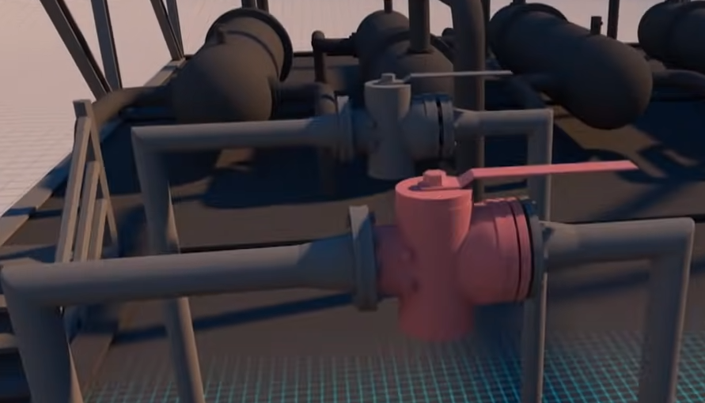 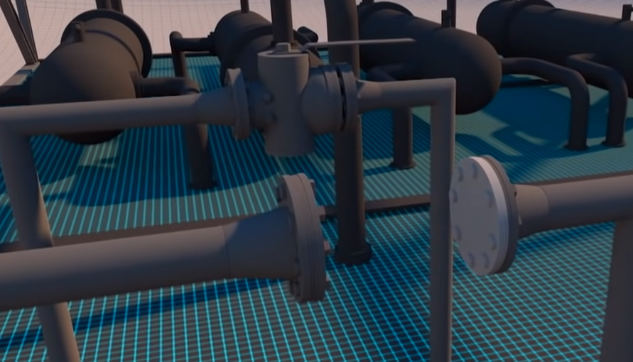

**Fig 1** before and after the safety valve was removed and blank was placed (Smithsonian Channel, 2017).

Companies in the offshore oil and gas industry are ethically obligated to maintain robust emergency response plans and well-prepared teams, in line with ASME’s commitment to safeguarding public safety. These ethical obligations extend to ensuring the protection of human lives and the environment, to safeguard public health. In accordance with Canon ASME I, engineers must prioritize the safety, health, and welfare of the public (ASME, 2021). However, the Piper Alpha disaster illustrates the consequences of inadequate emergency response.

The Piper Alpha disaster serves as a tragic reminder of the ethical lapses and their catastrophic consequences in the offshore oil and gas industry. It is imperative to reflect on the ethical progress made since that disaster, as it has had a lasting impact on industry practices, regulations, and safety culture. The lessons learned from the Piper Alpha disaster have, over time, influenced improvements in the offshore oil and gas industry. These lessons have contributed to a greater emphasis on safety, responsible practices, and transparent communication.

**References**

Drysdale, D. D., & Sylvester-Evans, R. (1998). The Explosion and Fire on the Piper Alpha platform, 6 July 1988. A Case Study. *Philosophical Transactions of the Royal Society of London. Series A: Mathematical, Physical and Engineering Sciences*, *356*(1748), 2929–2951. <https://doi.org/10.1098/rsta.1998.0304>

*Learning From Major Disasters - Piper Alpha Oil and Gas Platform Explosion and Fire*. (2017, March 18). Web.archive.org. <https://web.archive.org/web/20170318145904/http://www.parthenon.uk.com/disaster-piper-alpha-fire.htm>

NSPE. (2019, July). *NSPE Code of Ethics for Engineers*. Nspe.org; National Society of Professional Engineers. <https://www.nspe.org/resources/ethics/code-ethics>

Pate-Cornell, M. E. (1993). Learning from the Piper Alpha Accident: A Postmortem Analysis of Technical and Organizational Factors. *Risk Analysis*, *13*(2), 215–232. <https://doi.org/10.1111/j.1539-6924.1993.tb01071.x>

Smithsonian Channel. (2017). What Caused the Giant Piper Alpha Oil Rig Explosion? In *YouTube*. <https://www.youtube.com/watch?v=VXZRx7sE1qc>

W Douglas Cullen, & Great Britain. Department Of Energy. (1991). *The public inquiry into the Piper Alpha disaster*. H.M.S.O.