**Nimble Maps**

**Problem Statement:** ‘**Tracking of potholes and measurement of Noise level (dB) & illumination level (Lux) in cities and mapping these on Google maps – Smart City enabler ‘** - Develop a system to measure and map noise and illumination levels in a city along with the tracking of potholes for the comfort and safety of commuters as well as improvement of urban planning.

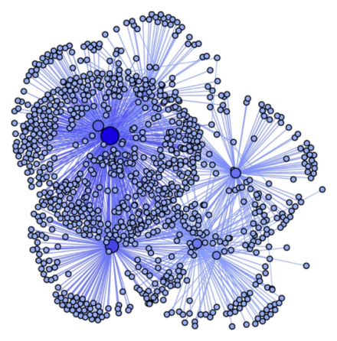**ABSTRACT:**

**Noise data** from all over the city will be mapped and color coded. Then classification will be done based categories with the use of Machine Learning algorithms which will produce a color shade over the map (each shade pertains to a noise level). This will then be interfaced with any popular GPS map application to be used as a feature at users’ requirement.

An API will be responsible for collecting **Potholes and illumination** data which will be taken by all the users with coordinate information(extracted by GPS). The validation of the data will be done and then it will be categorized based on **illumination level/pothole size**. Each of which will be placed in the same GPS map application. For illumination street lights and building lights will be used and the potholes information will be taken as a photo evidence with coordinate (latitude & longitude) information both of which will then be plotted on the map.

Important Features and Improvements:

* Apps that can facilitate direct information for the dataset which will be used after validation by crowd validation and categorized by Machine Learning Techniques
* Initial data for the system will be taken for a 24 Hr timeline so as to present the factors based on time the day **(illumination and noise level are subject to change at day and night)**
* User can view the changes of noise and illumination level based on day and night time making the system much more accurate and safe from outliner data
* Dataset is easy to update making the system predictions highly accurate with the real world. Dynamic updates on the map with respect to time
* Block chain network will be used in improvement phase to validate the data provided by the user and removal of duplicate data provided by different users