Chapter 3
Coliving Reservation and Billing System for Woke Coliving Inc.
Introduction
The primary goal of this project is to provide Woke Coliving Inc. With a streamlined system to manage reservations and billing efficiently. The proponent examined the company’s existing methods to design a system that automates key processes. This system aims to enhance operational efficiency by reducing manual record-keeping and improving accuracy in tracking reservations, expenses, and tenant information.
System Design and Specification
Admin:
• Log-in
This module includes a user ID and password for secure access to the system. To log in, the administrator will need to provide valid credentials for authentication.
• Main
This module pertains to the administrative side of the proposed system. It allows the administrator to access and manage the system’s other modules, including reservations, billing records, utilities, maintenance, and settings. This centralized module provides a comprehensive overview of coliving operations, ensuring seamless management and monitoring.

• File
This module contains information related to tenants, reservations, billing records, and utility management.
▪ Tenants
This module enables the admin to add and manage tenant information.
▪ Reservations
This module allows the admin to record and manage room reservations, including booking through multiple channels such as Facebook Messenger, phone calls, and walk-ins.
▪ Utilities
This module enables the admin to track and manage utility costs, including water charges per tenant and electricity based on room consumption.

▪ Parking
This module allows the admin to manage parking slots and track fees for cars and motorbikes, whether monthly or daily.
▪ Expenses
This module allows the admin to input and track all maintenance and miscellaneous expenses.

• Reports
This module allows the user to generate and input detailed reports on reservations, billing, utilities, and expenses.
• User Logs
Records the names of personnel who access the system, tracking their login and logout times.
• Database Backup and Restore
This module allows the administrator to save and restore system data, ensuring data recovery in case of accidental deletion or system errors.

• Admin Account
Allows the administrator to add, edit, and delete login credentials and other administrative information.

• Activity Log
Enables the administrator to track all actions performed within the system for better monitoring and auditing.
• Backup and Restore
This module allows the administrator to create a backup of the specified record or database and restore files if the system experiences a database crash.

• Log-out
This module allows the user to log out of the system.

User:
• Log-in
This module includes a user ID and password for logging into the system. To log in, the user will simply need to provide their user ID.

• Main
This module pertains to the proposed system’s user side. This module pertains to the proposed system’s administrative side
Resources
Every computer is composed of two basic components: hardware and software. Hardware refers to the physical components you can touch, such as the monitor, case, keyboard, mouse, and printer. Software is responsible for activating and controlling the hardware, including programs and data management.
The following outlines the minimum and recommended hardware and software requirements necessary to operate the Coliving Reservation and Billing System.
Minimum Requirement for PC

Hardware: Software:
- 2 GB RAM Memory Microsoft Windows 10
- Intel Core 2 Duo Processor Microsoft Office 2016
- USB Keyboard
- USB Mouse
- At least 200 GB HDD
Recommended Requirements for PC
Hardware: Software:
- 4 GB RAM Microsoft Windows 10
- Intel Core i5 Processor Microsoft Office 2016
- USB Keyboard
- USB Mous
- At least 200 GB SSD

Database Design
MySQL is used for the database design of the Dormitory Reservation and Billing System, structuring tables for tenant information, room details, reservations, billing, payments, and utilities. It stores and manages all essential data to ensure accuracy and consistency across the system. The database helps in tracking room availability, tenant records, and monthly bills efficiently, providing a reliable foundation for the system’s operations.

Database Description
The proponents required specific applications when constructing the system. The system employs Adobe Photoshop CS3 for graphic design, Visual Basic 6.0 for system development, and Microsoft Access for database management.

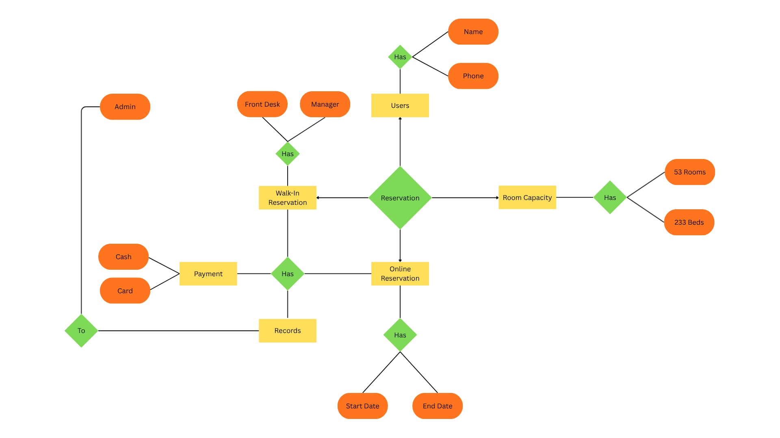
Entity Relationship Diagram (ERD)

Data Flow Diagram
The Data Flow Diagram (DFD) illustrates how data flows through the Dormitory Reservation and Billing System, from room reservation to payment processing and report generation. It presents the processes such as receiving reservation requests from tenants, verifying room and bed availability, managing billing and utilities, and generating reports for the administrator. This ensures an organized and efficient workflow of input and output between the admin, staff, and tenants, allowing the system to operate smoothly and accurately.

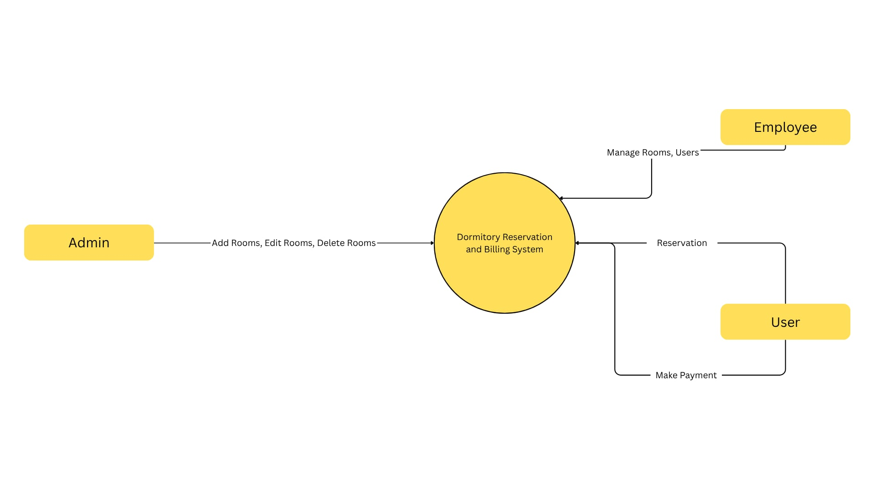
Context Level Diagram

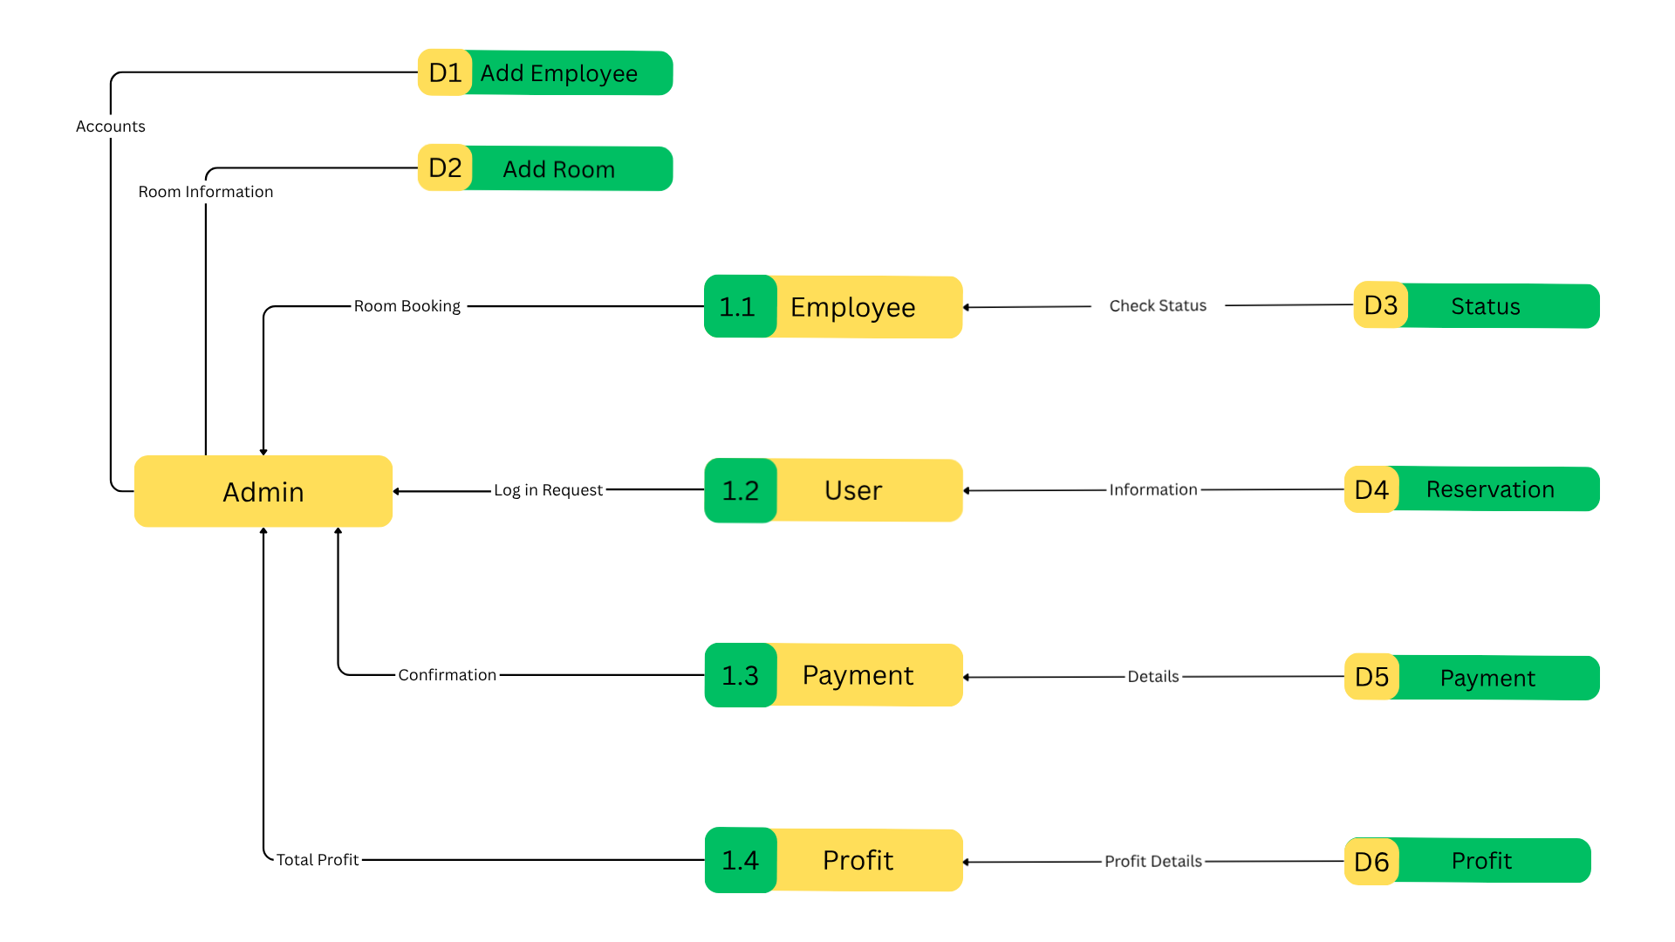
Top Level Diagram

Child Diagram
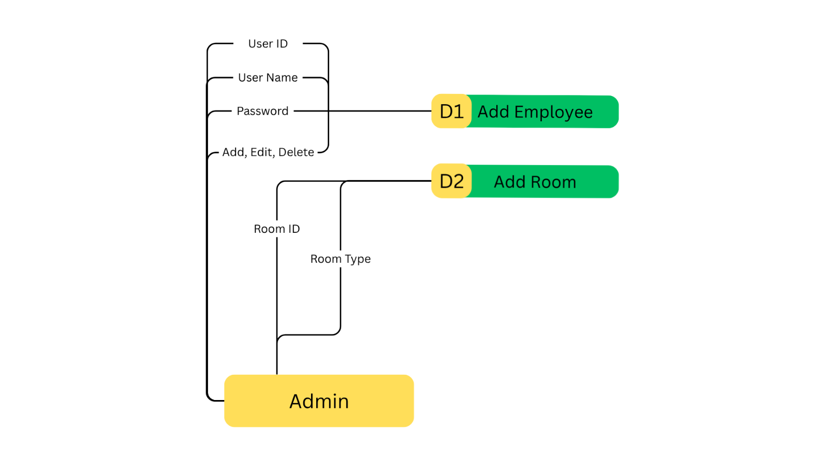
Child Diagram 1.0

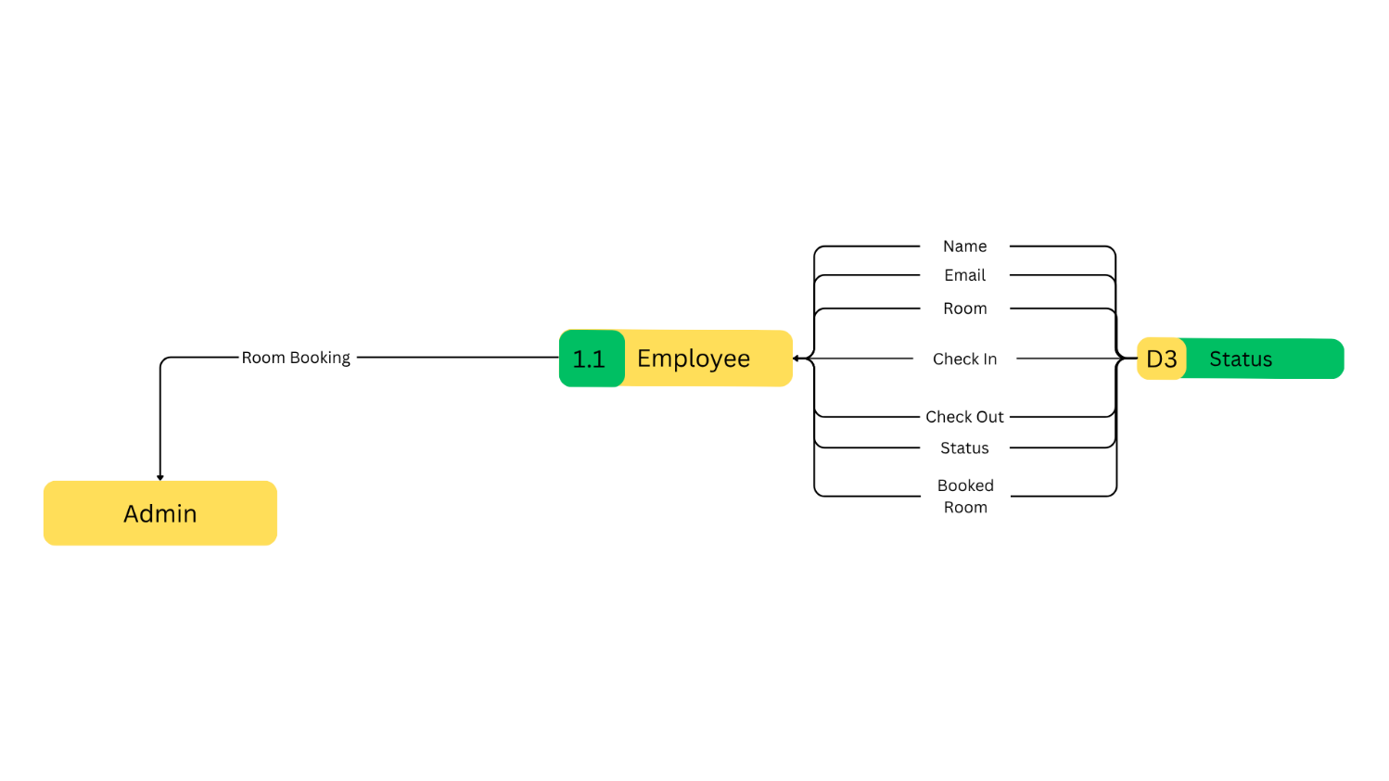
Child Diagram 1.1
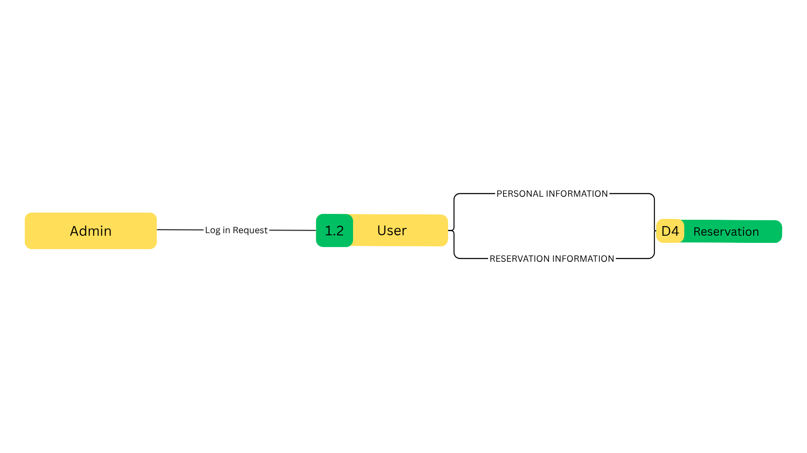
Child Diagram 1.2

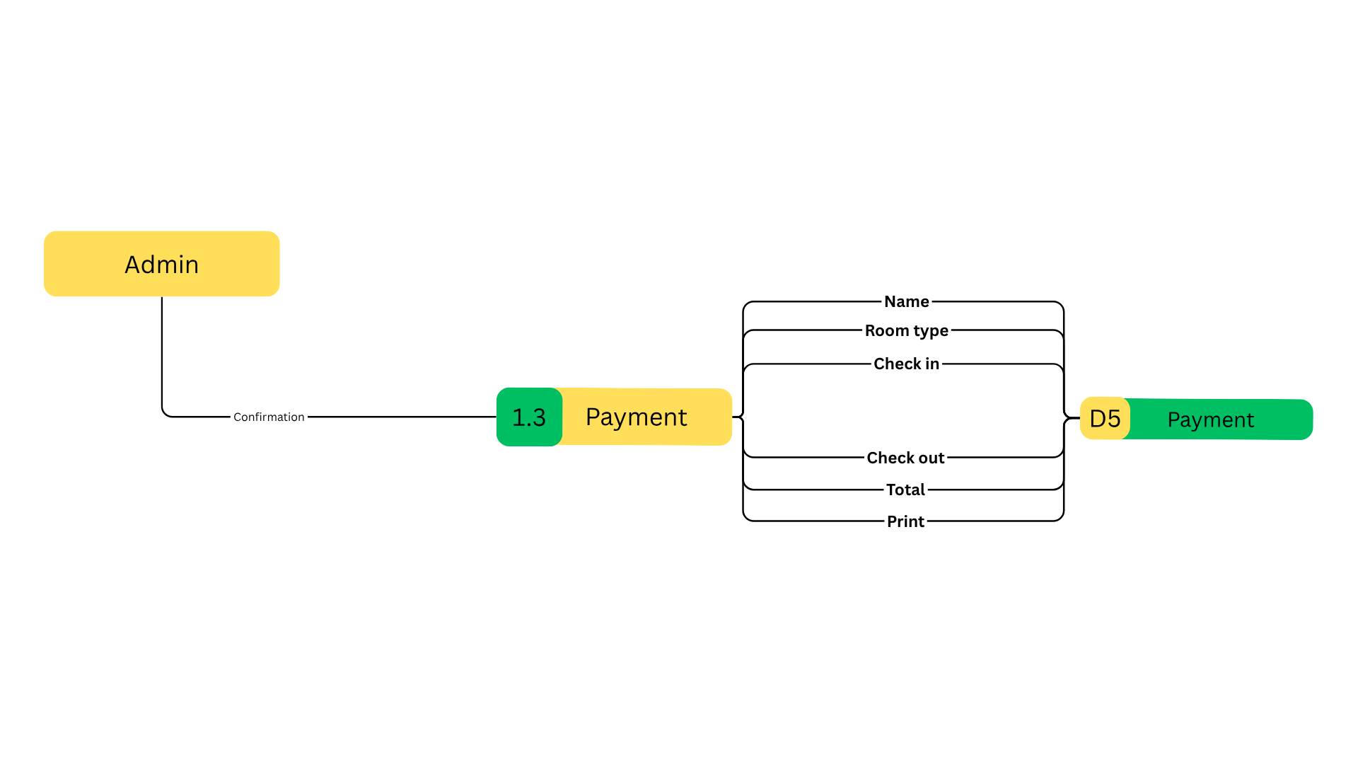
Child Diagram 1.3

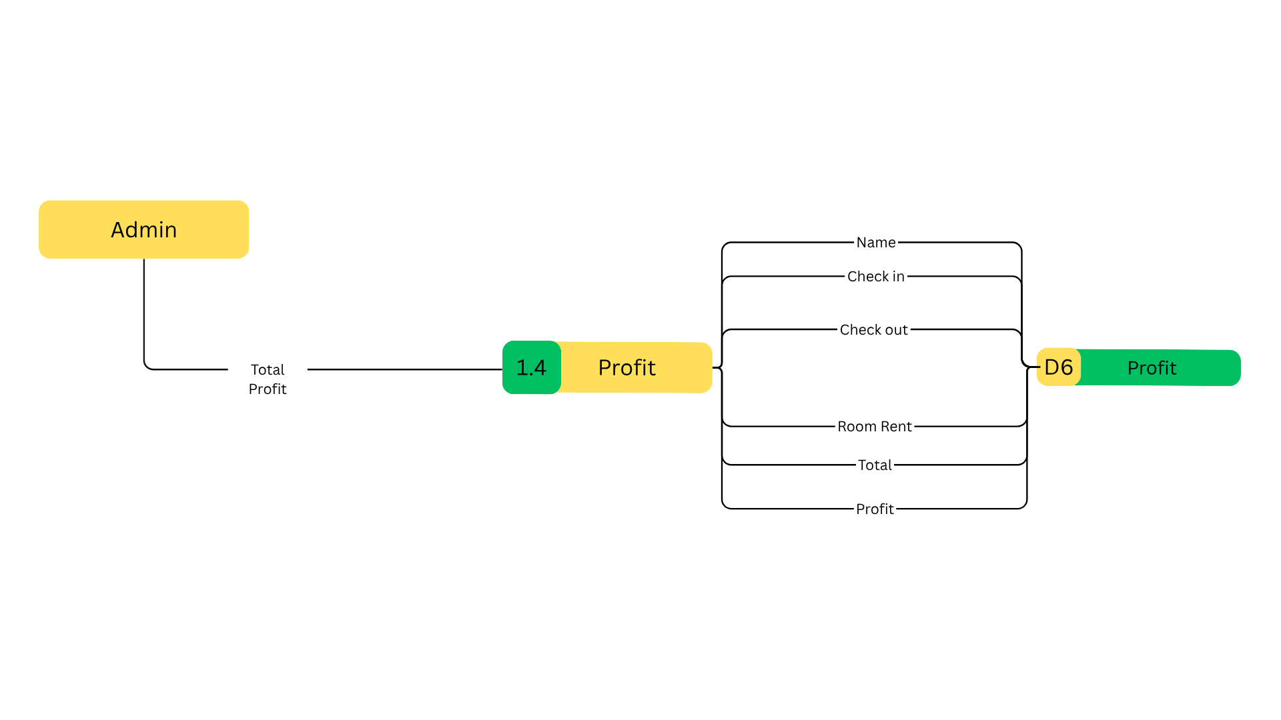
Child Diagram 1.4

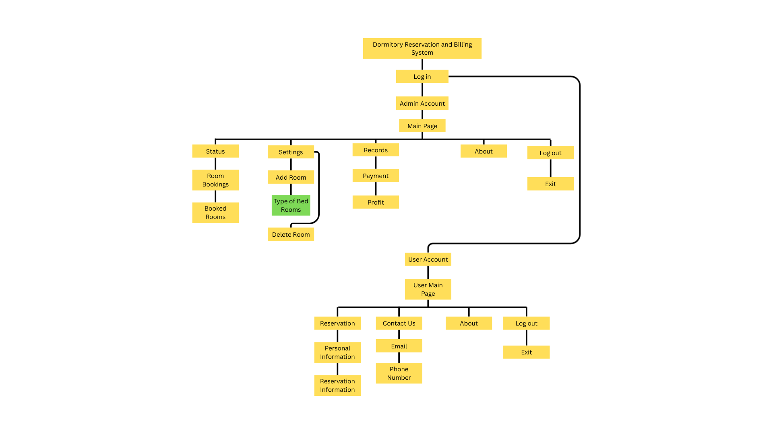
Hierarchical Diagram

3.7 Summary
The Coliving Reservation and Billing System for Woke Coliving Inc. is designed to streamline the management of reservations, tenant information, utilities, and billing processes. This system automates key tasks such as tracking reservations from multiple channels, monitoring utility consumption, managing parking fees, and maintaining accurate expense records. By reducing manual record-keeping and improving data accuracy, the system enhances operational efficiency and ensures organized and reliable tracking of all coliving-related transactions.

