**Rethinking Unemployment – Overview**

**1999-2019 Analysis**

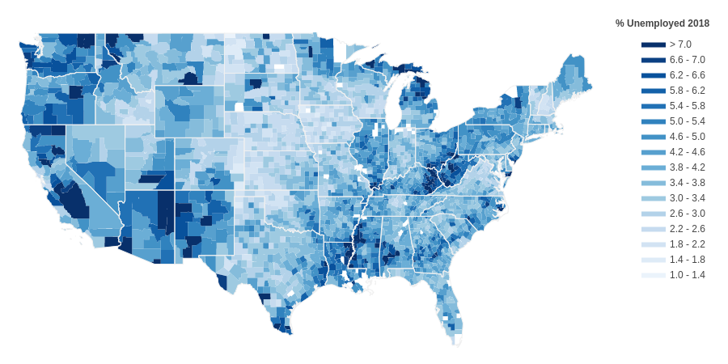

1. **Background**
   1. Describe the basic building blocks of the unemployment rate calculation by defining who is counted as unemployed, who as employed, who as being in the labor force and who not in the labor force. Also specify who is included within the relevant population and who is not. These definitions pertain to the U3 rate, which is the most commonly cited rate. The U6 rate will be discussed later, and the differences between the definitions laid out here will be made apparent.
      * Unemployed
        + Those not working and who have been looking for a job within past month
        + Those on Layoff
      * Employed
        + Both at work and employed but currently absent
        + Full-time: 35+ Hours per week
        + Part-time: <35 Hours per week
      * Labor Force
        + Employed + Unemployed = Labor Force
      * Not In Labor Force (NILF)
        + Those who have not been looking for work in the past month, are discouraged, retired, or disabled, among other population segments
      * Overall Relevant Population
        + Adult Civilian Non-Instititionalized 16+ (Excludes Active Military and Incarcerated)
        + Employed + Unemployed + NILF = Relevant Population

**Adult Non-Institutionalized Civilian Population Segments (16+)**

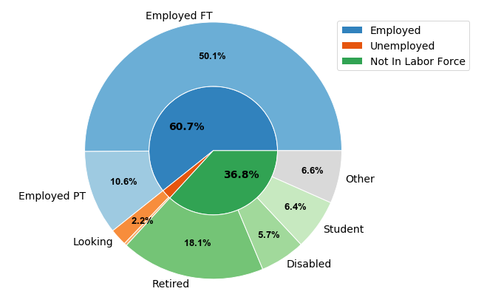

**2018 Labor Force Segments**

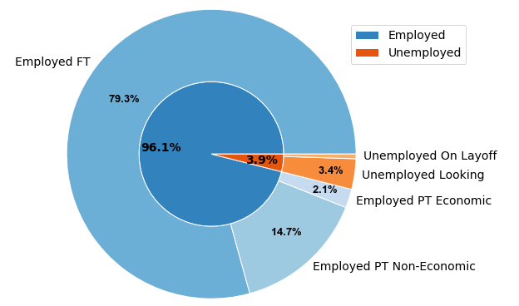

**\*FT = Full-time, PT = Part-time**

The first pie chart shows the percentages of employed, unemployed and not in labor force groups within the relevant population. It also shows the percentages of subgroups of these 3 categories within the population. An important point to make is the 2.2% unemployment figure in pie chart 1 does not correspond to the unemployment rate, as those with the NILF group are excluded from the calculation. Only those deemed in the labor force are used in the unemployment rate calculation. Pie chart 2 depicts this group, where you can see the unemployment rate of 3.9%.

A note on pie chart 2: Economic and Non-Economic refer to categories of reasons given as to why a Part-time worker is not working Full time. This importance of this distinction will become clear later when the U6 calculation is discussed.

* 1. Data Sources Used
     + U.S. Census Current Population Survey Responses
     + U.S. Census Population Estimates
     + Bureau of Labor Statistics (BLS) Local Area Unemployment Statistics
     + Bureau of Justice Statistics
     + ICPSR Incarceration Data
     + Prison Policy Initiative Incarceration Statistics
  2. Statistics: There are 3 statistics related to unemployment which are important to discuss. Not only is the unemployment rate relevant, but also the labor force participation rate and the population growth rate. These rates apply not only to the whole population but also to individual subgroups (ex: white rural males between 20-24).
     + Unemployment Rate
       - Unemployed/Labor Force
     + Labor Force Participation Rate
       - Labor Force/Population = (Employed+Unemployed)/Population
     + Population Growth Rates
       - Ex: Percent of population that is retired over time
  3. Subpopulations (this is not a complete list, just many of the ones I’ve identified)
     + Sex, Race, Origin, Age, State
     + Metropolitan vs. Non-metropolitan
     + Educational Attainment
     + Students (Full-time and Part-time)
       - Students who work (Full-time and Part-time)
     + Retired (65+,under 65)
     + Disabled (Including estimate of on-the-job disabilities)
  4. Rate Calculation Methodology: The Census Bureau first takes the CPS survey responses and properly weights them to ensure that the responses as a whole are adjusted to be representative of the relevant population (The Adult Civilian Non-Institutionalized Population 16+). These weighted rates are reported, but so are seasonally adjusted rates, which account for the predictable annual rise and fall of employment and unemployment throughout different points in a typical year.
     + Current Population Survey (CPS) respondents may not reflect Adult Civilian Non-Institutionalized Population
       - For example: 46% of responses could be from males, whereas males may account for 49% of those within the population. Male responses would then be weighted more heavily than female responses, all other weighting factors being equal
       - Weight survey respondents by Age, Race, Origin, Sex and State
     + Rates are adjusted for recurring annual business cycle fluctuations
       - Seasonal Adjustment (Time Series Moving Average calculation)
       - Both seasonally adjusted and non-seasonally adjusted rates are released
  5. U3 vs. U6 unemployment and labor force participation rates
     + U3 rates are based on the definitions provided thus far
       - Employed = Those at work + those currently absent from work but still employed
       - Unemployed = Those not employed who have looked for a job in the past month + those on layoff from work
     + U6 methodology adds back into the unemployment category a number of different segments of the population considered not in the labor force under U3 rate methodology
       - These segments include: discouraged workers, those who have looked in past year (but not month), and those who aren’t looking for certain reasons (ex. - don’t think they have necessary skills)
       - Workers who work part time for economic reasons (and considered fully employed under U3 methodology) are counted as fully unemployed
     + U6 Unemployment rates typically between 1.5-2x higher than U3 rates

1. **New Rate Calculation**
   1. In order to begin constructing my own unemployment rate, I had to make sure I was able to recreate the U3 and U6 rates to the closest degree possible. This involved using the CPS Survey data and any information I could find on how the Census weighted and seasonally adjusted the response figures to experiment with different calculation before I was sufficiently close to the official stated rates.
      * Weighting
        + Use Census Population Estimates Data to get population counts by year, age, sex, origin, race and state
        + Group ages into bins (16-19,20-24,etc..)
        + Weight responses by 5 weighting factors (binned ages, sex, origin, race and state), using the population counts to determine proper population percentages for each variation of these 5 weighting factors and adjusting survey responses by dividing population percentages by survey percentages
          - Example:

White female hispanics population % = 3%

White female hispanics survey % = 1.5%

White female hispanics weighting (all other factors equal) = .03/.015 = **2**

* + - Seasonal adjustment
      * Calculate seasonally adjusted rates using moving averages
    - My efforts at manually recreating the U3 and U6 unemployment rates resulting in the following differences which account for both overestimation and underestimation:
      * U3 (Not seasonally adjusted): 1.3% difference on average
      * U3 (Seasonally adjusted): 2.0% difference on average
      * U6 (Not seasonally adjusted): 2.5% difference on average
      * U6 (Seasonally adjusted): 2.75% difference on average
  1. New Rate Methodology: While I believe the U6 rate to depict a much clearer picture of unemployment than the U3 rate, there were still methodological changes I would make to the calculation of the rate. So I used the U6 rate as a framework and thought hard about my justifications for including or excluding certain segments of the population from the unemployment counts, as well as from the relevant population entirely. It’s important to note that these changes are based on normative grounds and different people may come to different conclusions as to who they would include and who they would not include within those they consider to be unemployed. A central purpose of this paper is to provide the framework for people to come to their own conclusions about this matter as opposed to accepting numbers they are told are “correct” and which they don’t really understand.
     + Similarities to U6 rate methodology
       - Includes Discouraged workers, those who aren’t looking for specific reasons, those looking for work in past 12 months (but not last month), accounts for part-time workers not being fully-employed(although deals with this phenomenon differently)
     + Differences to U6 rate methodology
       - Excludes High School Students and Full Time University Students working Full Time Hours from Population entirely
       - Counts individuals disabled on the job as unemployed (~29% of total disabled)
         * These individuals are considered Not In The Labor Force. As per existing research almost a third of all those disabled in the country became disabled through work. It seems reasonable to me to include them within the unemployment ranks since barring unsafe working conditions and/or excess mandated work hours, these individuals would be employed and productive members of society. An economic system which valued worker safety would experience much lower rates of worker injuries and disabilities.
       - Add nonviolent drug offenders (~22% of total incarcerated) into relevant population, consider them unemployed
         * Many of those incarcerated today do in fact work, but for nearly no pay. This is not limited to nonviolent drug offenders, which makes this addition a conservative one. The United States has more incarcerated people than anywhere in the world, and there are more African American men and women in our jails and prisons today than there were slaves during the height of slavery in this country. Apart from the obvious moral outrage of these facts, the economic toll on our nation is real and should absolutely be accounted for in my opinion.
       - Only a fraction of Part-time workers provide a reason as to why they work part-time as opposed to full time (categorized into economic vs. non-economic reasons). The U6 rate seems to only account for those who provided specific reasons – the majority who don’t are categorized as non-economic reasons and therefore still considered to be fully employed. I extend the proportion of legitimate reasons (economic ones as well as a few others not considered to be economic in nature) to all part-time workers, regardless of whether or not they provide a reason. This estimation provides a better picture of the total number of part-time workers who would work full-time if they were able to.
         * Calculate proportion of PT workers with legitimate reasons (Essentially that they would like to work full time but can’t because of factors out of their control) relative to all PT workers who provided any reason as to why they were PT
         * Extend this proportion to all PT workers to include those who did not provide specific reason as to why they were working PT as opposed to FT
         * Instead of considering all PT workers with legitimate reasons to be unemployed, calculate the average number of hours worked by PT workers and calculate proportion of FT hours not worked. Then subtract (proportion of hours not worked)*(# part time workers with legitimate reason for not full time) from employed counts, add this same number to unemployed counts

Example: Average part-time worker works 17.5 hours

Proportion of full time hours worked on average = (35-17.5)/35 = ½

10,000 Part time workers who would otherwise work full time in not for legitimate reason

10,000 % ½ = 5,000

# Employed = # Employed – 5,000

# Unemployed = # Unemployed + 5,000

* + - * + This calculation treats part-time workers as partially employed as opposed to fully employed or not employed at all
        + All part-time workers who do not want to work full-time or whose reason for not working full time is legitimate (Ex: Deal with personal/family matters) are considered fully employed, as is the same under the U3 and U6 methodologies
  1. New Rate - Limitations
     + Had to run many tests to get as close to official U6 Unemployment Rates as possible since precise calculation is not made available (which survey response items to tally up)
       - My estimates differ from official U6 unemployment rate figures by 2.5% on average, giving me some room for improvement as my U3 rate estimates differ by only 1.3% (likely due to slightly different weighting methodology)
     + Limited data available on incarcerated population
       - Yearly data available (up until 2016) on total # incarcerated broken out by gender and race/origin, but not by age or state
       - Could only find high-level statistics on types of crimes committed by incarcerated population (ex.- drug offenders, burglaries, etc..) but not detailed data on individual cases
     + Detailed Population data available only until 2018
       - Use 2018 population data when calculating 2019 figures in my analysis – once the 2020 census data is released will be able to calculate using up-to-date figures
  2. New Rate - Results
     + Difference between observed new rate and U3 and U6 rates (for total population as well as population subsegments)
     + Include Labor Force Participation Rates under each of these 3 rate methodologies into analysis
     + Include analysis of population growth for various population segments (emphasizing noteworthy trends)

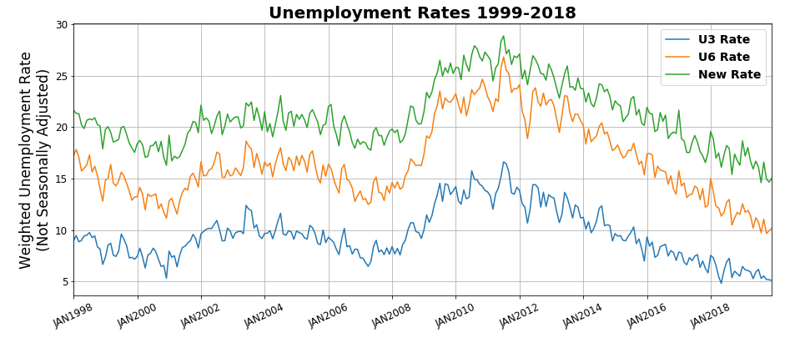

1. **Conclusion**
   1. Takeaways
      * Newly calculated unemployed rate x% points above U6 and U3 rates for entire population (around 3-5 percentage points higher than U6 on average or so)
      * Discuss subpopulations where there are meaningful differences between these rates and deviations or interesting trends in comparison with entire population
      * Discuss noteworthy trends in LFPR for different subpopulation segments
      * Emphasize importance of using the LFPR and UR in combination to understand true picture of unemployment
      * Revisit population and subpopulation growth data, pointing out any interesting trends/findings that come up
      * Mention current economic crisis and intention to update analysis once enough data is made available to extend analysis
   2. Future Direction
      * Try calculating additional unemployment rates using different methodologies
        + For example: Can add all nonviolent incarcerated into unemployment totals
      * Research and implement seasonal adjustments which reflect Census’s methodology more accurately (they employ a proprietary seasonal adjustment calculation)
      * Improve upon U6 rate estimates by finding correct combination of survey response items which when tallied up produce rates as close to official figures as possible
      * Create web application allowing users to specify subpopulations, rate methodologies etc. in order to calculate their own unemployment rates based on what they believe to make sense (who to include as unemployed and who not to include) while providing them with the “official” rates as benchmarks
      * Data on the incarcerated population is quite fragmented and scattered – need to spend more time researching