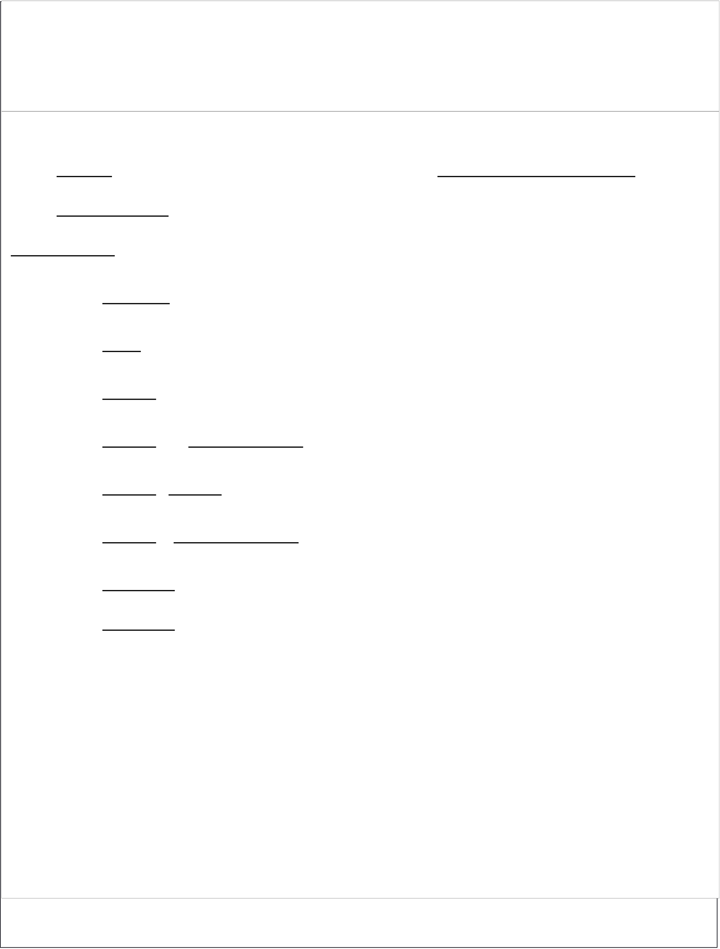

**EX.NO: 1 P.G.NO DATE:- REQUIREMENT ANALYSIS AND SPECIFICATION**   
  **1**

**AIM:-**To write any of the case tools practice **Requirement Analysis Specification** for different firms.

**Algorithm:-**  
 **Step 1:-Start** the process.

**Step 2:-**Goto **File->New->project**.

**Step 3**:- Then Goto file and select **shape->Flowchart**.

**Step 4**:-A Small toolbox will appear on the **left** hand side of the window. **Step 5**:-**Circle** is used to declare the **Elication Validation**.

**Step 6**:- **Rectangle Box** is used to declare the **user & problem Domain Step 7:-** Display the **result**.

**Step 8:- stop** the process.

1

|  |
| --- |
| **OUTPUT:-**  **REQUIREMENT ANALYSIS AND SPECIFICATION** **DIAGRAM**    **Result:-**  The Above **Diagram Has** Been Successfully created. |
| 2 |

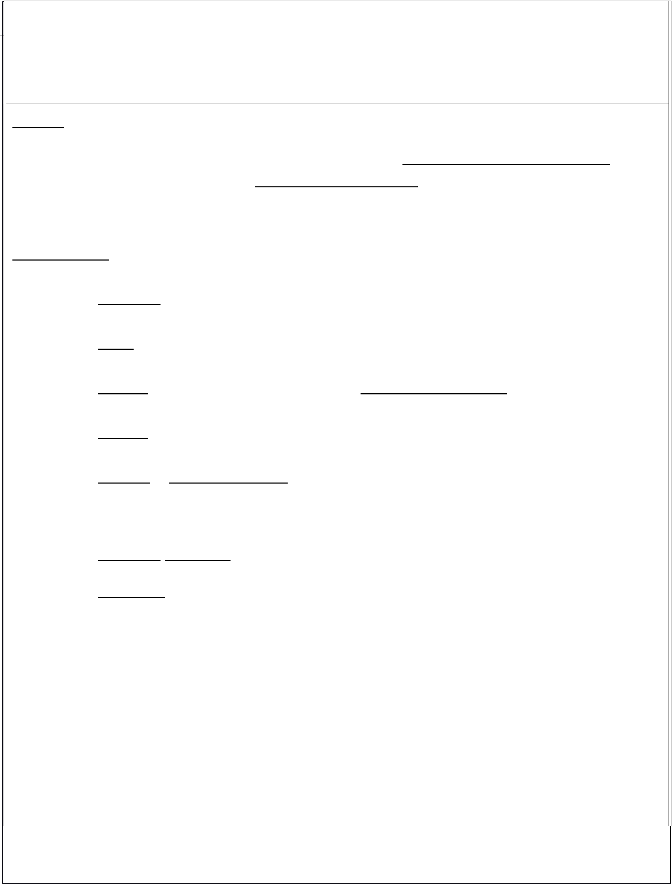

**EX.NO:2 P.G.NO**

**DESIGN PRINCIPLES FOR IMPLEMENTATION**   
 To write a c program to traverse through **Binary Search Tree Using DATE:- 3**  **Traversals.**

**AIM:-**  
 **Algorithm:-**  
 To write any of the case tools practice for **DESIGN PRINCIPLES FOR**  **IMPLEMENTATION. Step 1:-**Start the program.

**Step 2:-**Declare the variables.

**Algorithm:-**  
 **Step 3**:- Using **Malloc()** function allocate the space for the data.

**Step 1:-Start** the process.

**Step 4**:-Using **Struct** keyword declare the structure for the data.

**Step 2:-**Goto **File->New->project**.

**Step 5**:-Get the new node using Struct node* newNode(**int** data) **Step 3**:- Then Goto **file** and select **shape->Flowchart**.

.**Step 6**:- Perform traversal (**Pre-Order,Post-Order,In-Order**)   
**Step 4**:-A Small toolbox will appear on the **left** hand side of the window.

**Step 5**:- **Rectangle Box** are used to design and declare the concepts in

flowchart wisely   
**Step 8:-**Stop the Program.

**Step 6:- projects** was delivered finally to the user environment.

**Step 7:- stop** the process.

**BINARY SEARCH TREE TRAVERSALS**

**CODING:-**

#include <stdio.h>

3

|  |
| --- |
| **OUTPUT:-**  **DESIGN PRINCIPLES FOR IMPLEMENTATION**  **DIAGRAM**    **Result:-**  Thus the above **Diagram** was created Successfully.  4 |

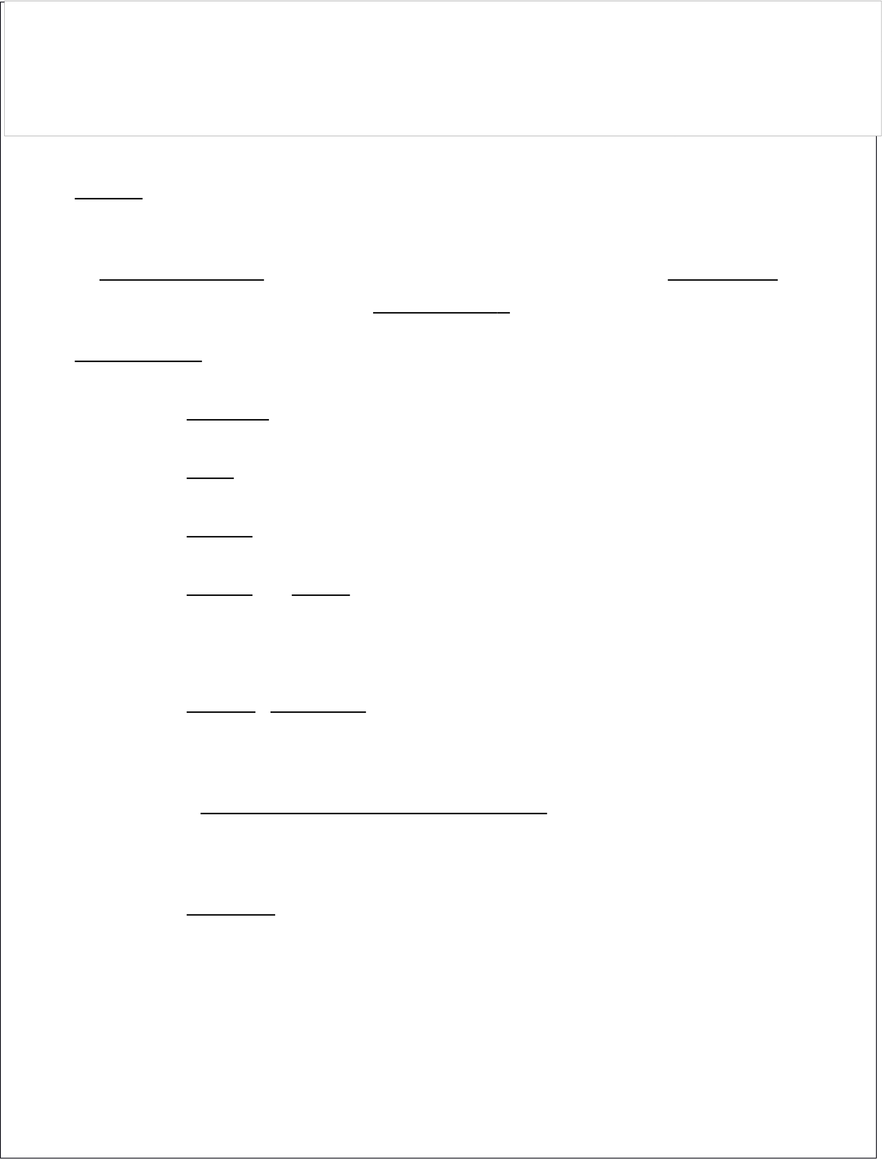

**EX.NO:3 PG.NO**  **ANALYSIS PHASE FOR A REAL TIME**   
 **APPLICATION**   
**DATE:- 5**

**AIM:-**  
 To write a practice for creating software documentation for the **Analysis Phase** of software development life cycle for a **Real Time**  **Application** .

**Algorithm:-**  
 **Step 1:-Start** the process.

**Step 2:-**Goto **File->New->project**.

**Step 3**:- Then Goto **file** and select **shape->Flowchart**.

**Step 4**:-A Small toolbox will appear on the **left** hand side of the window.

**Step 5**:-**Elication** was connected into specification and also connected the validation into specification .

S**tep 6:User & Problem Domain** was connected into the Specification rectangle are based   
**Step 7:- stop** the process.

5

|  |
| --- |
| **OUTPUT:-**  **ANALYSIS PHASE FOR A REAL TIME APPLICATION**  **DIAGRAM**    **Result:-**  Thus the Above **Diagram** was created Successfully.  6 |



**Ex.No.4 Pg.No**  **DEVELOPMENT PHASE FOR A REAL**   
**Date:- TIME APPLICATION 7**

**AIM:-**  
 To write a practice for creating software documentation for the **Development phase** of software development life cycle for a **Real**  **Time Application**.

**Algorithm:-**  
 **Step 1:-Start** the process.

**Step 2:-**Goto **File->New->project**.

**Step 3**:- Then Goto file and select **shape->Flowchart**.

**Step 4**:-A Small toolbox will appear on the **left** hand side of the window.

**Step 5**:-Development Organization linked the rectangle shape box of database of past projects .

**Step 6**:- The above boxes are related to four recharge boxes are **sizing stage,please distribution** ,**Productivity stage ,risk analysis**.

**Step 7:-** Display the **result**.

**Step 8:- stop** the program.

7

|  |
| --- |
| **OUTPUT:-**  **DEVELOPMENT PHASE FOR A REAL TIME APPLICATION**  **DIAGRAM**    **Result:-**  Thus the Above **FLOWCHART** was created successfully .  8 |

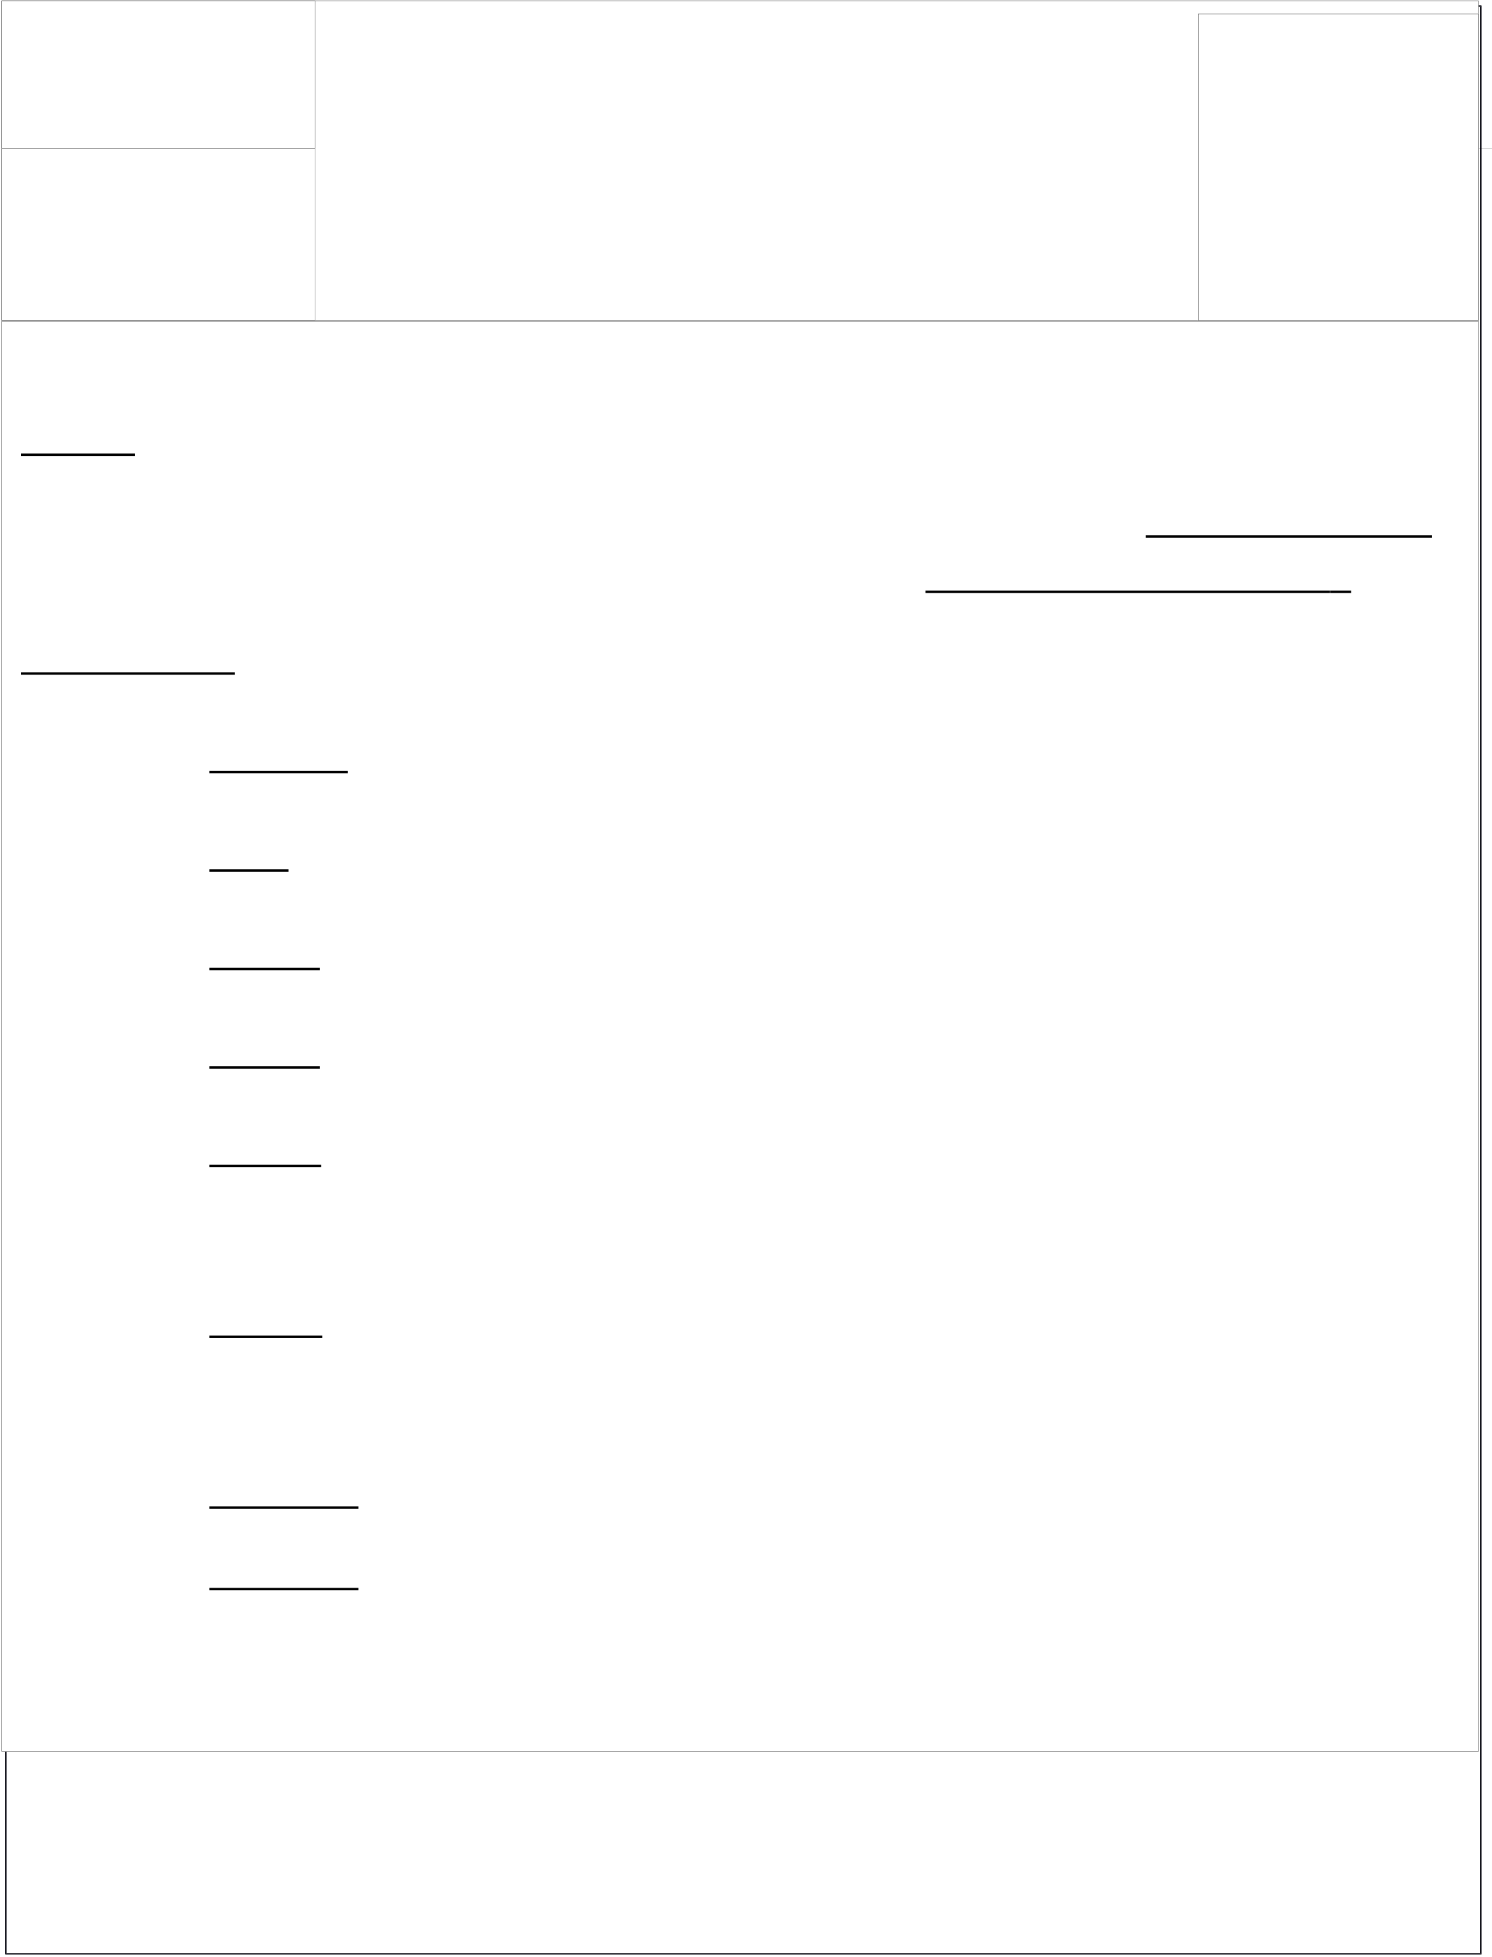

EX.NO:-5   
 **IMPLEMENTATION PHASE FOR A REAL**  **PG.NO**

Queue Underflow

**TIME APPLICATION**

|  |  |
| --- | --- |
| **DATE:-** | **9** |

**AIM:-**  
 To write a practice for creating software documentation for the **Implementation**  phase of software development life cycle for a **Real Time Application** .

**Algorithm:-**  
 **Step 1:-Start** the process.

**Step 2:-**Goto **File->New->project**.

**Step 3**:- Then Goto file and select **shape->Flowchart**.

**Step 4**:-A Small toolbox will appear on the **left** hand side of the window.

**Step 5**:-The characteristics of the software to develop are in the recharges boxes .

**Step 6**:- They were created in one to another & Database of past project are also related to them.

**Step 7:-** Display the **result**.

**Step 8:- stop** the process.

9

|  |
| --- |
| **OUTPUT:-**  **IMPLEMENTATION PHASE FOR A REAL TIME APPLICATION**  **DIAGRAM**    **Result:-** Thus the Above **flowchart** Has Been created Successfully.  10 |

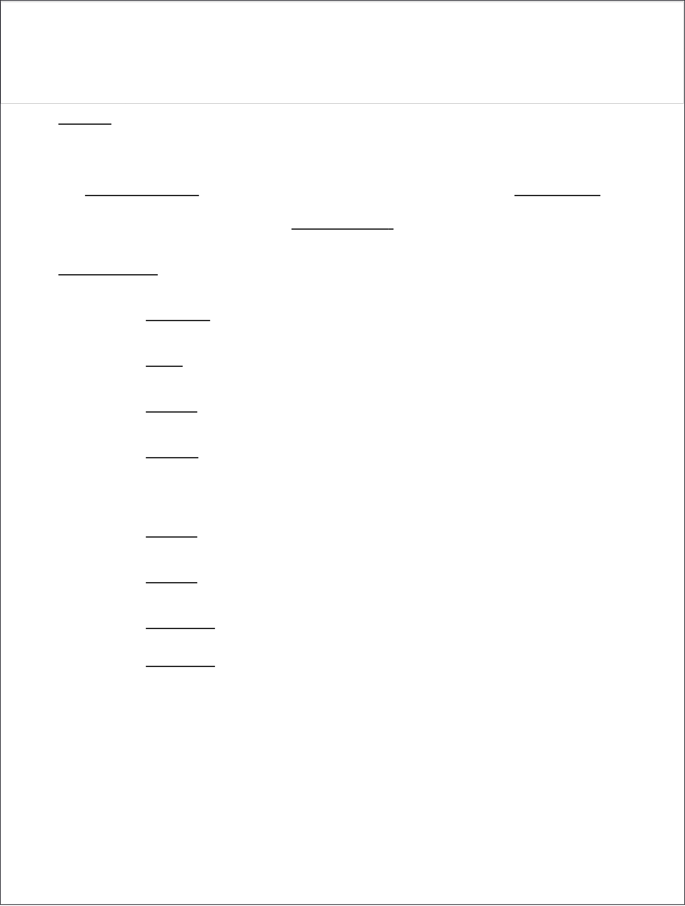

**EX.NO:6 P.G.NO**  **TESTING PHASE FOR A REAL TIME APPLICATION**   
**DATE:- 11**  **AIM:-**  
 To write a practice for creating software documentation for the **Testing phase**of software development life cycle for a **Real Time**  **Application** .

**Algorithm:-**  
 **Step 1:-Start** the process.

**Step 2:-**Goto **File->New->project**.

**Step 3**:- Then Goto file and select **shapes->Flowchart**.

**Step 4**:-A Small toolbox will appear on the **left** hand side of the window.

**Step 5**: Vehicle, car, ford are connected to talits.

**Step 6**:- Mustang are connected to Taurus and thunderbird.

**Step 7:-** print the **result**.

**Step 8:- stop** the program.

11

|  |
| --- |
| **OUTPUT:-**  **TESTING PHASE FOR A REAL TIME APPLICATION**  **DIAGRAM**    **Result:-** The Above **Flowchart** Was Created Successfully.  12 |

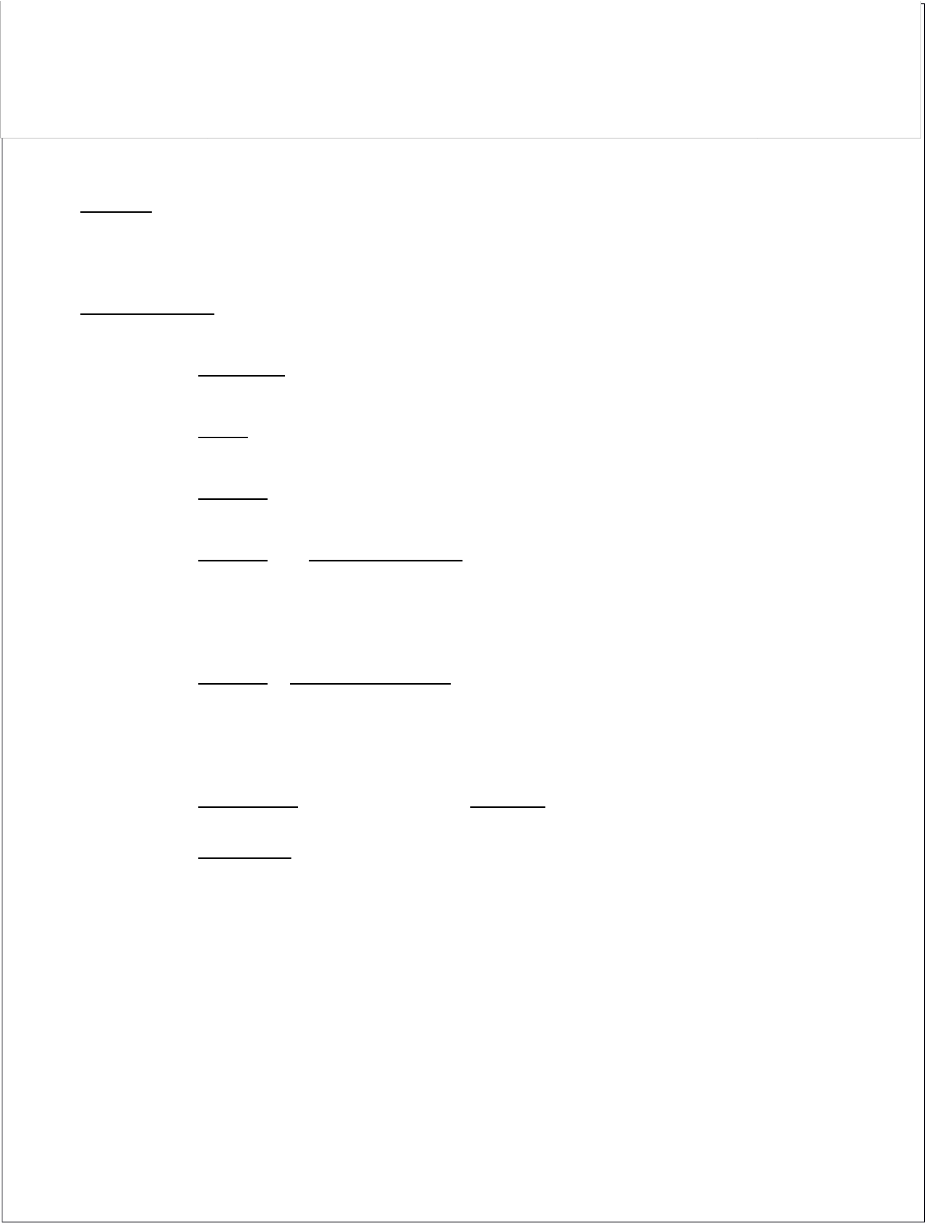

**EX.NO:7 P.G.NO**  **PRACTICE OF FUNCTION ORIENTED DESIGN**   
**DATE:- 13**

**AIM:-**  
 To Practice of **FUNCTION ORIENTED DESIGN.**

**Algorithm:-**  
 **Step 1:-Start** the process.

**Step 2:-**Goto **File->New->project**.

**Step 3**:- Then Goto file and select **shape->Flowchart**.

**Step 4**:-A **Small toolbox** will appear on the **left** hand side of the window.

**Step 5**:- **Rectangle Box** can be used in current process it start with shared memory and shared **F1&F2 &F3&F4 &F5.**

**Step 6:-** Finally we used **arrow** to connect the symbol. **Step 7:- stop** the process.

13

|  |
| --- |
| **OUTPUT:-** **PRACTICE OF FUNCTION ORIENTED DESIGN DIAGRAM**    **Result:-**  The Above **Flow Chart** was created successfully.  14 |

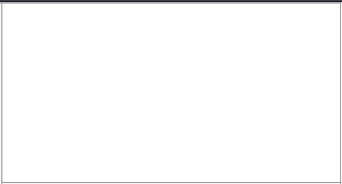



|  |  |  |
| --- | --- | --- |
| P.G.NO **OBJECT ORIENTED DESIGN FOR IMPLEMENTATION**   OJVLF8Y;OOHJVHJ  15  DATE:- | | |
|
|

|  |
| --- |
| **OUTPUT:-**   **OBJECT ORIENTED DESIGN FOR IMPLEMENTATION**  **DIAGRAM**    **Result:-** The Above **Flow Chart** was created Successfully.  16 |

|  |  |  |
| --- | --- | --- |
| **EX.NO:9** | **PREPARE THE PROJECTMANAGEMENT PLAN** | PG.NO |
| DATE: | 17 |
| AIM:- TO PREPARE**THE PROJECT MANAGEMENT PLAN Algorithm:-**  **Step 1:-Start** the process.  **Step 2:-**Goto **File->New->project**.  **Step 3**:- Then Goto **file** and select **shape->Flowchart**.  **Step 4**:-A **Small toolbox** will appear on the **left** hand side of the window.  **Step 5**:- Rectangle Can be used in current processit start With **intitation, planning and design, execution** and **Monitoring** the control.  **Step 6:- stop** the process.  17 | | |

|  |  |  |
| --- | --- | --- |
| **OUTPUT:-**   |  |  | | --- | --- | | **PREPARE THE PROJECT** | **MANAGEMENT PLAN** |   **DIAGRAM**    **Result:-**The Above **Flow Chart** was created Successfully.  18 |

|  |  |  |
| --- | --- | --- |
| **Ex.No:-10** | **CASE STUDY OF COST ESTIMATION MODEL** | PG.NO |
| **DATE:-** | **19** |
| **AIM:-**To Write **CASE STUDY OF COST ESTIMATION MODEL of Tsa College of Computer Science Students.**  **Algorithm:-**  **Step 1:-Start** the process.  **Step 2:-**Goto **File->New->project**.  **Step 3**:- Then Goto **file** and select **shape->Flowchart**.  **Step 4**:-A **Small toolbox** will appear on the **left** hand side of the window.  **Step 5**:- Rectangle Can be used in current processit start With **Schedule of IBSC(CS),IIBSC(CS),IIIBSC(CS), IBCA, IIBCA,IIIBCA,IMSC(CS),IIMSC(CS)** Students. **Step 6:- stop** the process.  19 | | |

|  |
| --- |
| **OUTPUT:-**  **CASE STUDY OF COST ESTIMATION MODEL**  **DIAGRAM**    **RESULT:-** The Above **Flowchart** Was Created Successfully**.**  20 |