ToxiAlert Web Application Developer Manual

I. Overview and Foundational Architecture
The ToxiAlert web application is a high-speed, computational toxicology screening tool designed to provide an immediate, quantitative assessment of a molecule's risk profile. As a developer, you should understand that the architecture is a classic decoupled system, using a Single Page Application (SPA) frontend that communicates with a powerful, modular RESTful API backend. This separation allows for clean, easy-to-manage code and maximum performance. The core mission is to help chemists and biologists rapidly screen compound libraries by combining structural pattern recognition (toxicophore matching) with essential physicochemical property analysis.

II. Core Technology Stack and Frontend Structure
The application is built on a modern, accessible, and high-performance stack. The frontend is a responsive Single Page Application (SPA) built purely with HTML5, CSS3, and vanilla JavaScript (ES6+), avoiding complex frameworks to ensure ease of understanding and rapid deployment. Data visualization, like the drug-likeness radar chart, is handled by the simple and powerful Chart.js library. The user interface is broken into distinct, manageable views (home-view, analysis-view, batch-table-view), which are toggled using simple JavaScript functions (switchView), ensuring seamless navigation without full page reloads.

III. The Computational Engine and Workflow
The heart of ToxiAlert is its backend, implemented using Python and the Flask micro-framework, which is fantastic for creating simple, scalable APIs. The deep cheminformatics work is powered by the industry-standard RDKit library.
The computational workflow, which is the sequence of steps taken for every molecule, is straightforward and follows this path:
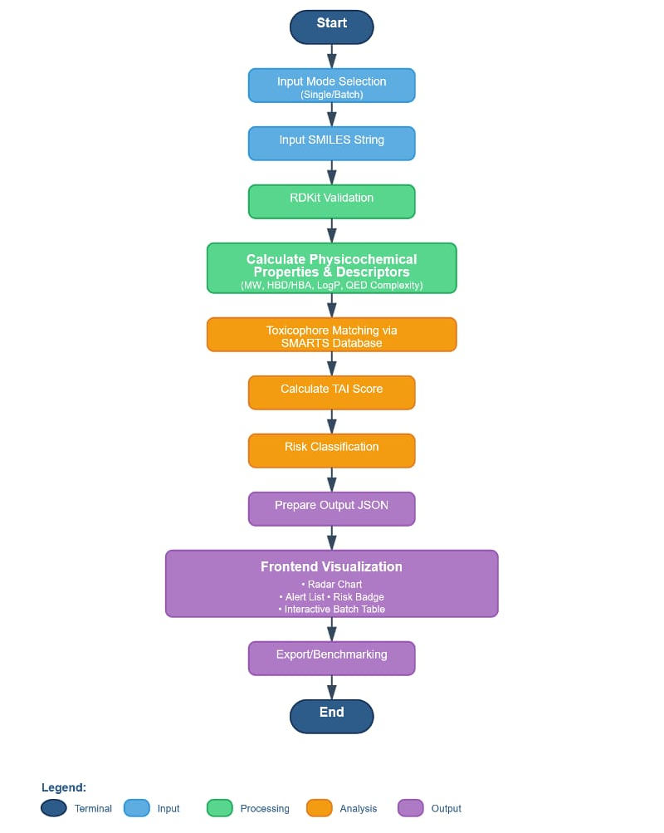
- Input and Validation: A molecule's structure is submitted as a SMILES string (Standard Simplified Molecular-Input Line-Entry System). RDKit validates the string for chemical correctness.
- Property Calculation: RDKit computes essential drug-likeness descriptors, including Molecular Weight (MW), LogP (Lipophilicity), Hydrogen Bond Donors (HBD), and Hydrogen Bond Acceptors (HBA).
- Toxiphore Matching: The system scans the molecule against a validated internal SMARTS Database (Toxicophore Library) that defines known high-risk chemical substructures, such as Nitro groups or Aromatic Amines.
- TAI Score Derivation: Finally, the Toxicity Alert Index (TAI) is calculated. This quantitative score is determined by summing a total severity value derived from the detected structural alerts and any physicochemical property risks.

IV. API Design and Asynchronous Data Flow
The frontend communicates with the backend via JSON data transported over a REST API. This modular design makes the tool easily integrable with other systems.
- Endpoint Interaction: The primary analysis request is typically a simple fetch request (HTTP POST) to the main analysis endpoint (e.g., /api/analyze), sending the SMILES string in the request body.
- Handling Batch Processing: One of the most elegant features is the handling of batch analysis. When multiple SMILES strings are submitted, the JavaScript uses Promise.all to make asynchronous, concurrent API calls for each molecule. This technique is essential for maintaining a smooth, non-blocking User Interface (UI), even when processing large, complex datasets. The results are then aggregated and presented in an interactive table (val-table).
- Result Structure: The API returns a JSON object containing the calculated TAI score, the determined Risk Level (e.g., LOW, MODERATE, SEVERE), a full list of computed physicochemical properties, and a detailed list of any detected structural alerts, including suggested mitigation strategies.

