**AI ASSISTED CODING:**

Assignment 4.1:

Task 1:

Write a Python function that validates an Indian mobile number. The function must ensure the number starts with 6, 7, 8, or 9 and contains exactly 10 digits. The function should return True if the number is valid and False otherwise.

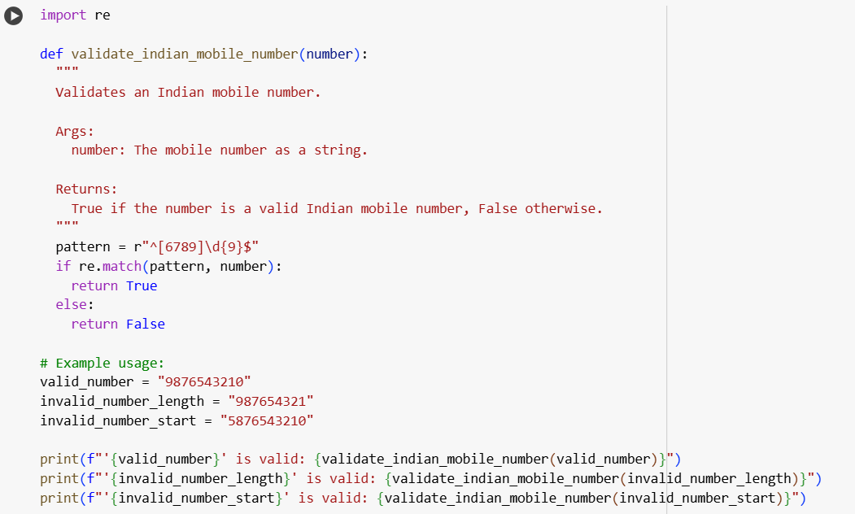

OUTPUT:

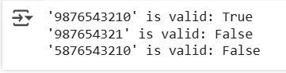

EXPLANATION:

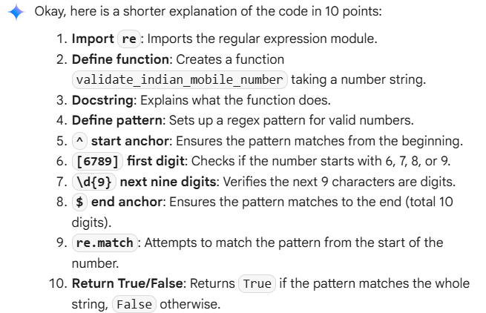

Task 2:

Write a Python function that calculates the factorial of a number. The function must handle 0! correctly (return 1) and return an appropriate message if the input is negative.  
Example: Input = 5, Output = 120."

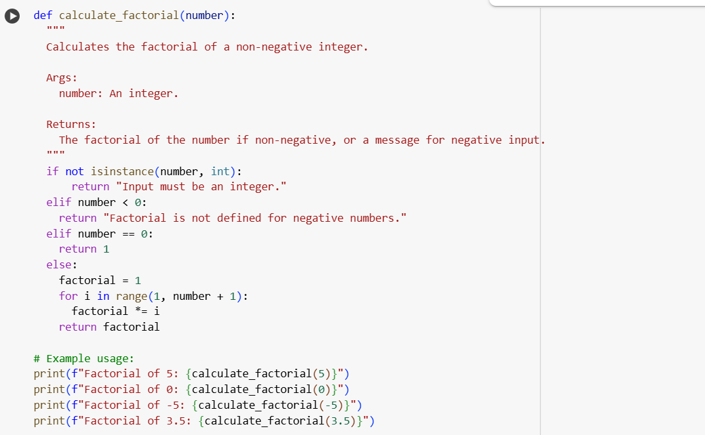

OUTPUT:

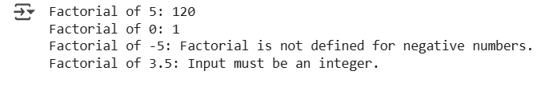

EXPLANATION:

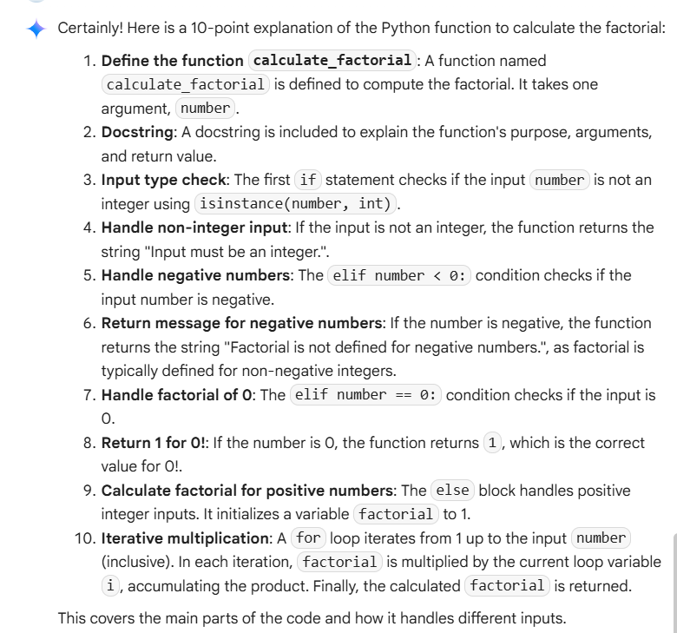

TASK 3:

Write a Python function that extracts student information from a nested dictionary. The function should return the student’s Full Name, Branch, and SGPA.  
Example 1:  
Input = {  
 "student": {  
  "name": {"first": "Amit", "last": "Sharma"},  
  "details": {"branch": "CSE", "sgpa": 8.7}  
 }  
}  
Output = {"Full Name": "Amit Sharma", "Branch": "CSE", "SGPA": 8.7}

Example 2:  
Input = {  
 "student": {  
  "name": {"first": "Priya", "last": "Verma"},  
  "details": {"branch": "ECE", "sgpa": 9.1}  
 }  
}  
Output = {"Full Name": "Priya Verma", "Branch": "ECE", "SGPA": 9.1}

The function should work for any similar nested dictionary structure.

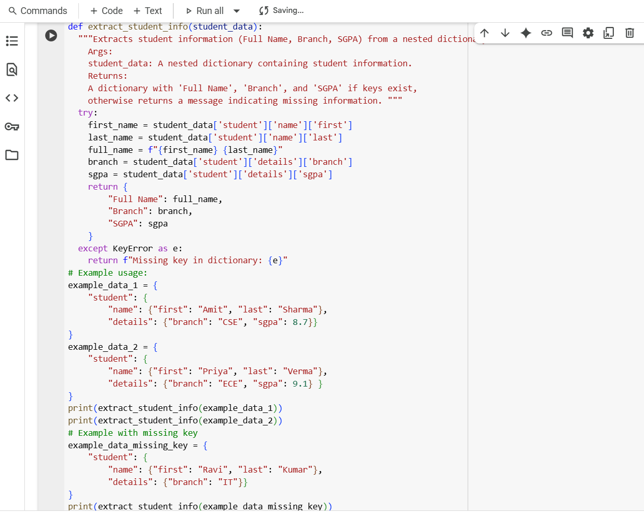

OUTPUT:

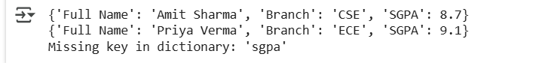

EXPLANATION:

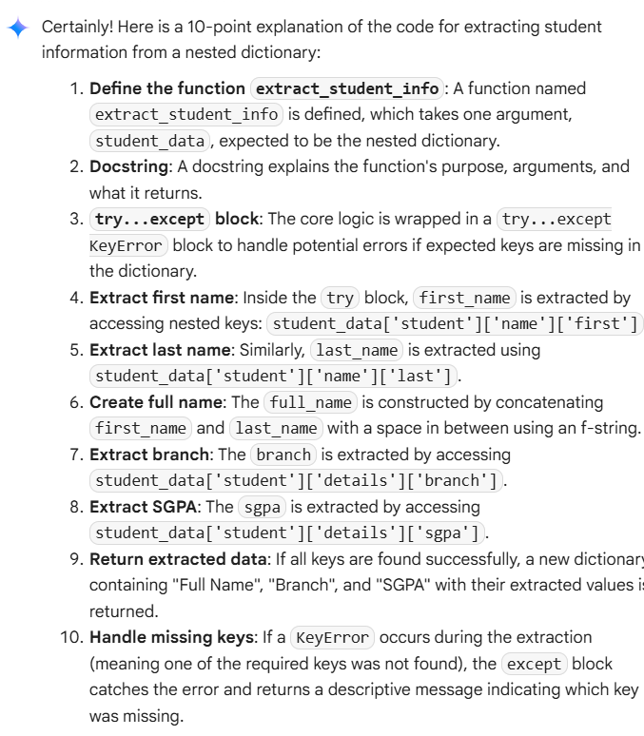

TASK 4:

Generate Python functions using three different prompting styles—**zero-shot**, **one-shot**, and **few-shot**—to perform CSV file analysis.

Each function should:

* Read a .csv file
* Return the total number of rows
* Count the number of empty rows
* Count the total number of words across the file

>> Zero-Shot Prompt

Write a Python function that reads a CSV file with 10 rows, 2 empty rows, and 100 words.  
Output: {'Total Rows': 10, 'Empty Rows': 2, 'Word Count': 100}

Example 2:  
Input: A CSV file with 3 rows, 0 empty rows, and 15 words.  
Output: {'Total Rows': 3, 'Empty Rows': 0, 'Word Count': 15}

Now generate a Python function that works for similar CSV files and returns the correct analysis.

Code:

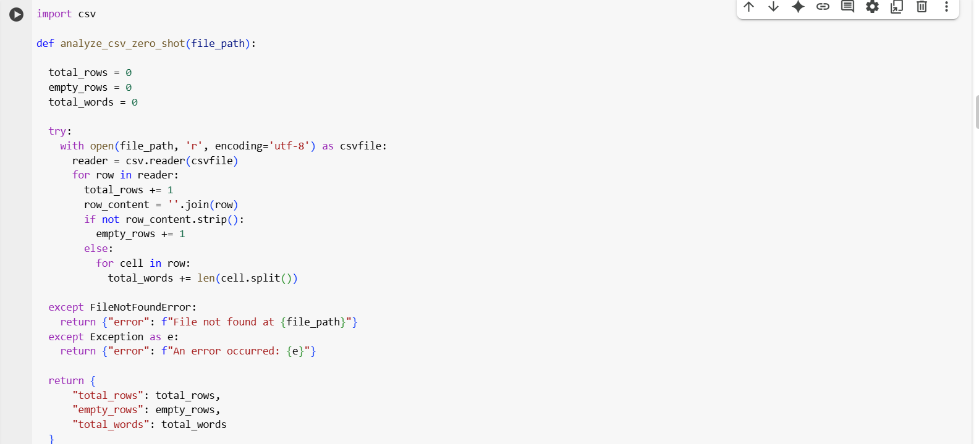

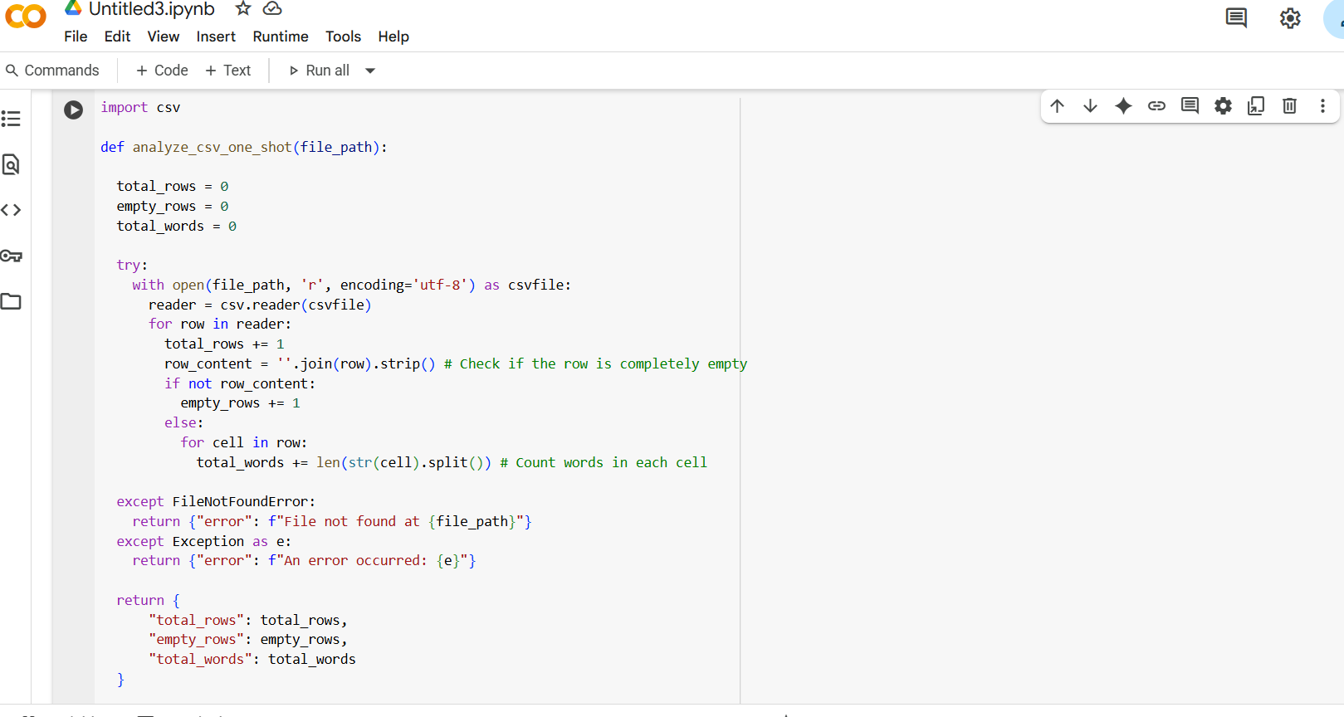

Output:

Explanation:

Task5:

Write a Python function called most_frequent_word(text) that accepts a paragraph as input and returns the most frequently used word. The function must:

* Convert all text to lowercase
* Remove punctuation
* Analyze word frequency
* Return the word that appears most often

Example 1

Input: "Data science is fun. Data is powerful. Science is evolving."  
Output: "is"

Example 2

Input: "Python is great! Python is versatile. Python is popular."  
Output: "python"

Example 3

Input: "AI tools are transforming industries. AI is the future. Tools help us adapt."  
Output: "ai"

Now generate the function most_frequent_word(text) that works for these examples and similar ones.

Code:

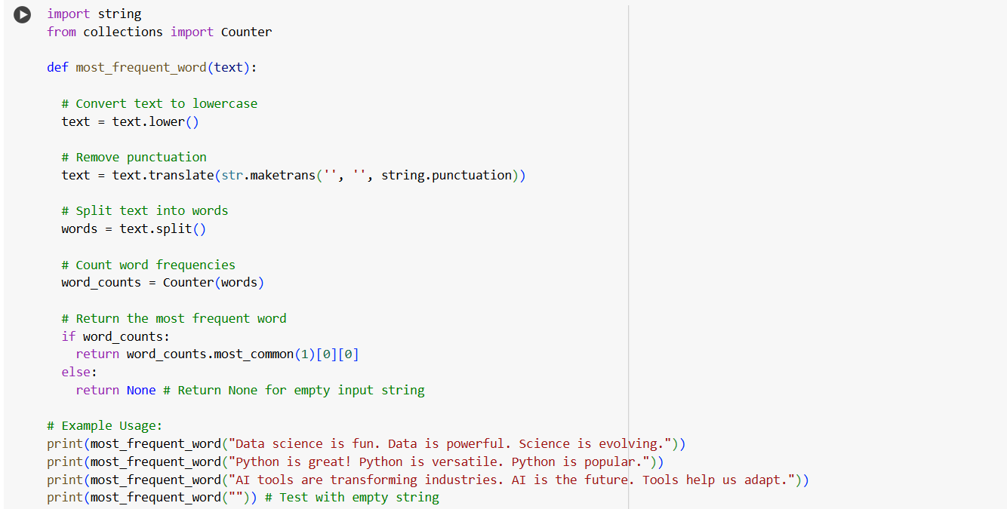

Output:

Explanation:

