AI ASSISTED CODING:

LAB4:

TASK 1:

Write a python program to check whether the year is leap year using functions.

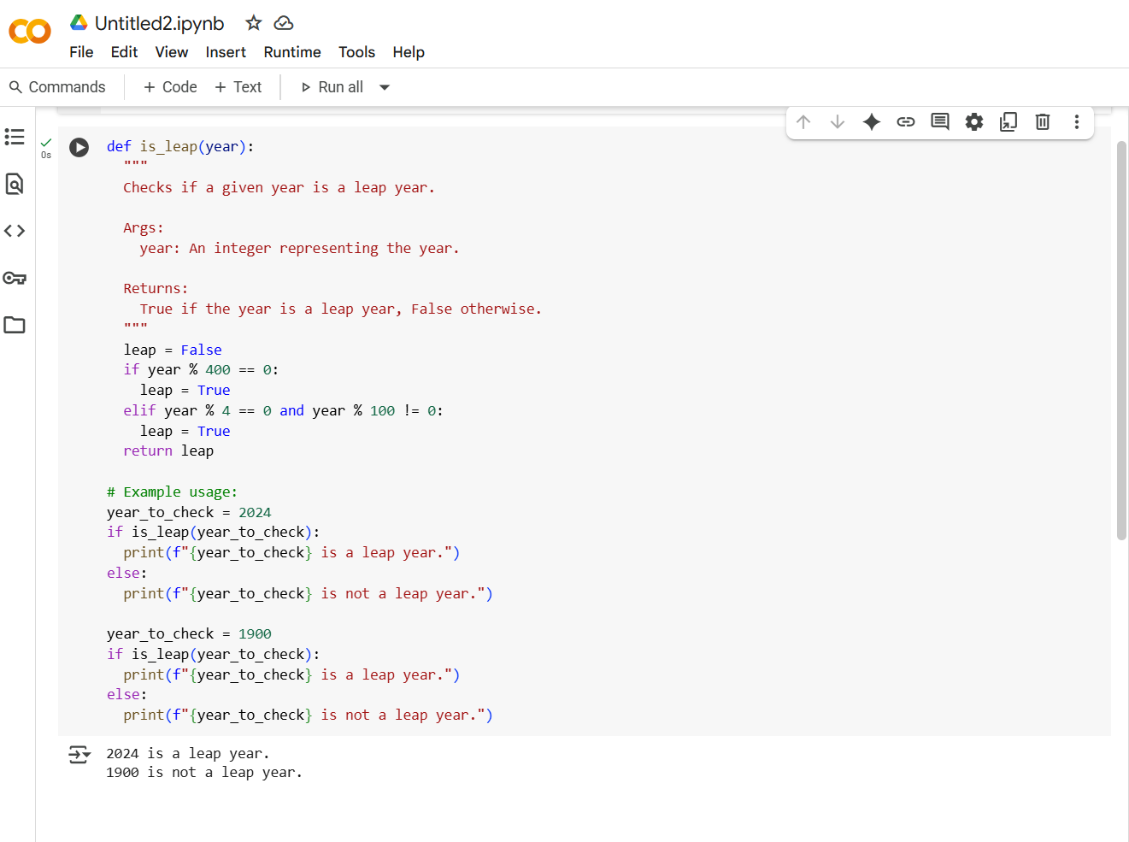

OUTPUT:

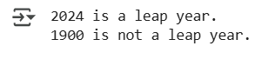

EXPLANATION:

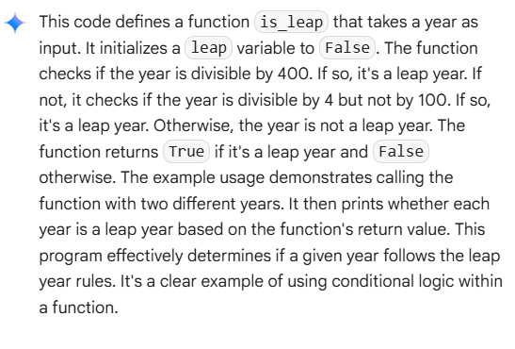

TASK 2:

Generate a python program using functions which coverts centimeters to inches using 1 inch = 2.54 centimeters. Give the result rounded to 2 decimal places.

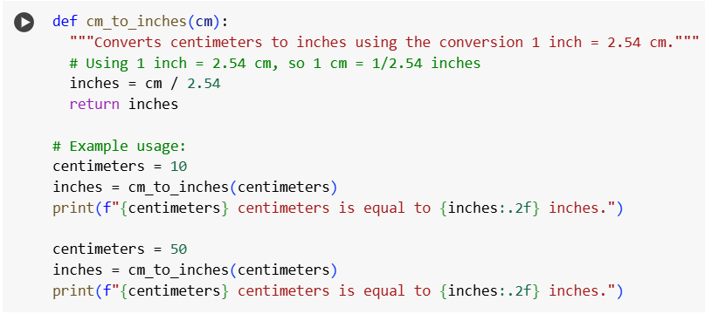

Output:

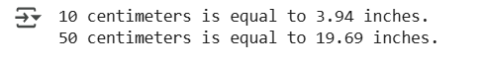

Explanation:

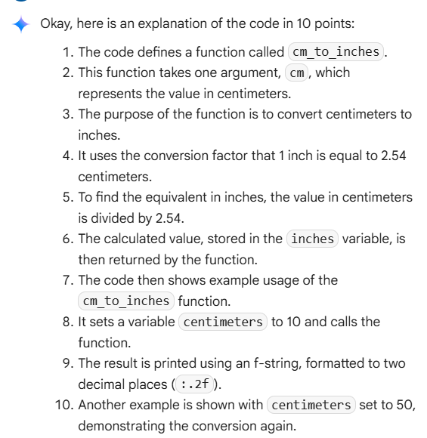

TASK 3:

Write python code that converts full names and format full names as last and first names. ex Vardineni Vaishnavi as Vaishnavi Vardineni ex2: Burgadda Akshitha as Akshitha Burgadda.

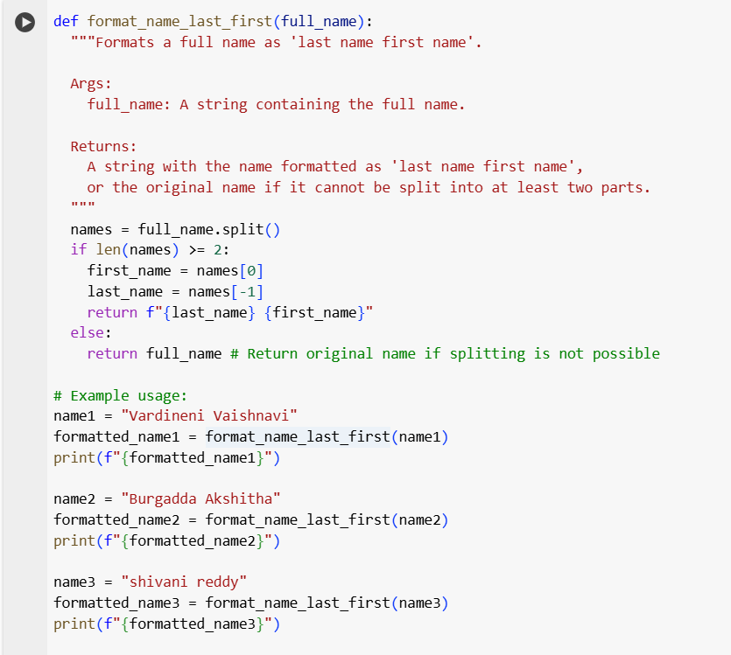

OUTPUT:

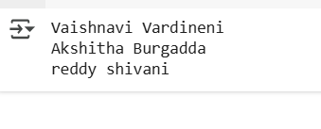

EXPLANATION:

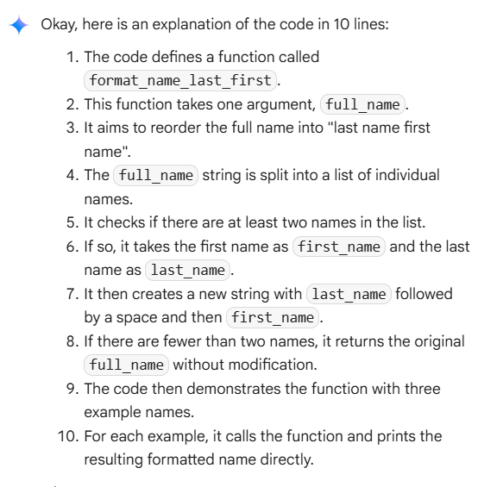

TASK 4:

**Zero shot**: Write a Python function count_vowels(text) that returns the number of vowels (a, e, i, o, u) in a given string.

**One shot**:Write a Python function that counts the number of vowels (a, e, i, o, u) in a string.

Examples:

Input 1: "hello"Output: 2

Input 2: "OpenAI"Output: 4

Now, write a Python function count_vowels(text) that follows the same pattern.

**CODE**:

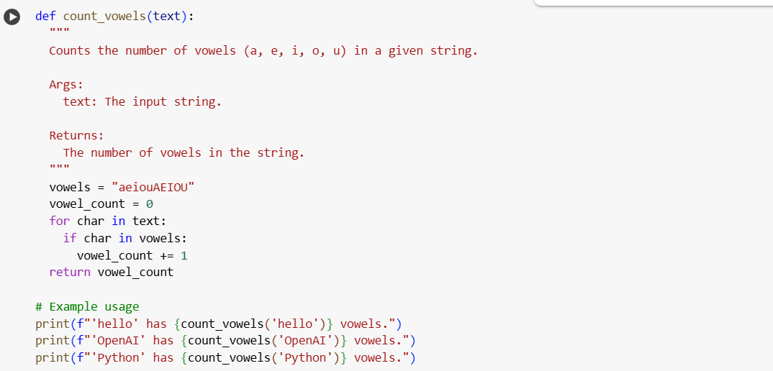

OUTPUT:

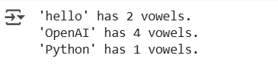

EXPLANATION:

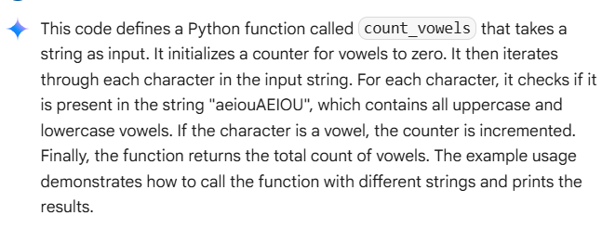

**TASK5:**

Generate a Python function that reads a .txt file and returns the number of lines. For example:  
Input: sample.txt with 3 lines → Output: 3  
Input: empty.txt → Output: 0

**CODE:**

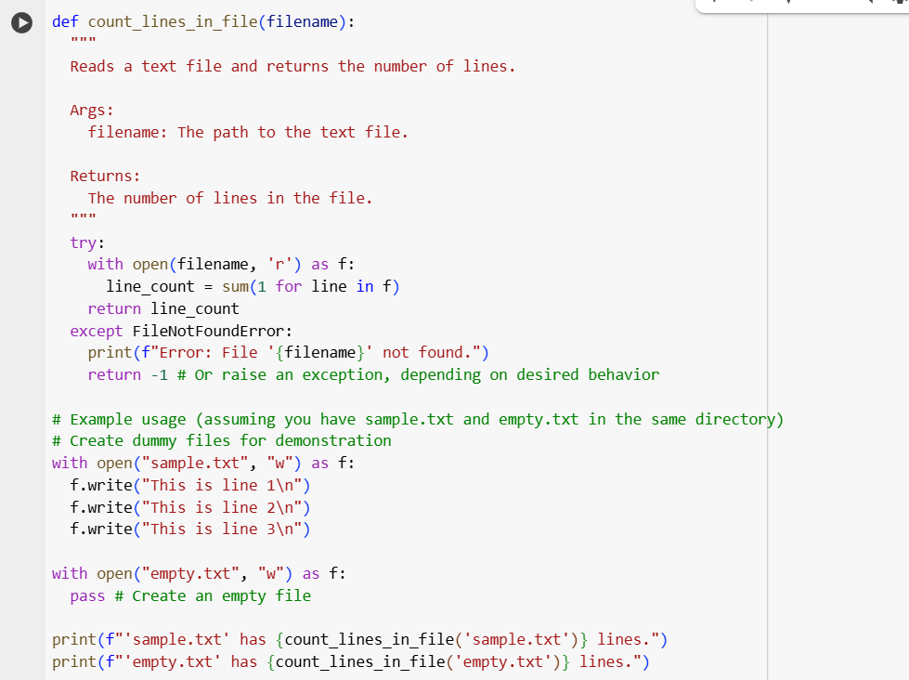

**OUTPUT:**



**EXPLANATION:**

